2007 Races & Events
Annual Meeting Saturday 03 March 2007 - Severn Inn (Annapolis)
The Severn Inn proved to be a nice change from the usual potluck venues of recent years and a reasonable location for most people to get to. The food was good, the prices reasonable and the parking lot was almost adequate. The view of the river and the Naval Academy added to the atmosphere as catboaters easily adapted. There was a group sense that this location would be good to use next again year. It seemed to be a central location for most travelers of our rather dispersed membership.
In another change from our usual planning, we asked for and received RSVPs for a fairly accurate headcount. Thirty-four committed up until the morning of, where a few pluses and minuses settled us into a final count of about 30. There were several members we hadn’t seen in a few years as well as some we had never seen, but who faithfully had been paying their dues. All were welcome and several new members attended. First timers included the Clarks, the O’Malley’s, the Bradley’s, Deborah Keir, Phil Livingston and Pete McCrary to name a few. Catboat sailors present represented most points of the compass including several from Pennsylvania, as well as Delaware, Virginia and of course Southern Maryland, where Steve and Lois Flesner announced an overt effort to start their own flotilla. This move was interpreted by some as a “catboat act of “southern aggression” but only punctuated the expected independent nature the group.
The Flesners set up an exhibit table with books of interest to Catboaters, as available through the national Catboat Association. There were photographs of several boat restorations in progress on the table, (see photo below) while others brought albums of their particular boats to show. The relaxed atmosphere and warm weather brought the latest in boating attire (shorts) worn by Stefan Marculewicz and Steve Flesner. The Severn Inn was equally happy with our attendance and may even give us the option of their larger and more private separate room, which would make exhibits and socializing a bit easier. It would also allow some privacy for the business portion of the get together.
As most were finishing their lunch, the business meeting started. Commodore (without portfolio) Cruder conducted the meeting with minimum formality. He once resorted to Roberts Rules of Order but only accidentally. We are, after all, an eclectic and profoundly informal group. Introductions were made around the room. Butch Miller reported out on the Catboat Association’s Annual Meeting in Newport, RI, while Steve Flesner announced that there would be a couple more weeks for folks to pay their dues before the directory would be produced and distributed according to member's references. Each scheduled event organizer, AKA point of contact, stood, was recognized, gave a brief discussion of their event and answered any questions which were raised. Don Dunn discussed the Hoover/Dunn modified Portsmouth handicap system used by Chesapeake Catboat race committees. There was discussion of the separation of the Marshall Sanderlings into three rating groups based on racing trim, cruising trim and inboard engine modification. Rating numbers were adjusted slightly to attempt to equalize the boats of different trim. Sanderling in cruising trim are 100, racing trim are 98 and inboard modified are 102. All the other numbers are unchanged from last season. A question was raised about how to rate a boat, which did not have a Portsmouth number to begin with. Don explained that the handicap system is a statistical procedure, which evolves with experience. A new boat with no prior information will be given a rating based on a boat which has a rating to which the handicap committee (Don Dunn and David Morrow) believe it is most similar to. The rating will be adjusted the following year based on the new boat's performance the first year it joins the Association. Webmaster Butler Smythe agreed to post the handicap numbers on a tab on the website so everyone can check their own boat type. He also took the opportunity to welcome input and content to the club website, which all agreed was looking great. The meeting ended with the key volunteers receiving an informal vote of confidence to continue their work another year.
After the business portion of the meeting a drawing was held to award a handmade Catboat Carpet, which was a donation, by Claire Murry Inc. with retail outlet on Main Street in Annapolis. Each family put one entry into the bag. New member Brenda Clark drew the name. Mr. and Mrs. K. O'Malley, who sail Crabby Cat out of Harve de Grace won the carpet. With the season successfully planned, all were encouraged to get their boats in the water, check the website regularly for changes and make the most out of the upcoming season.
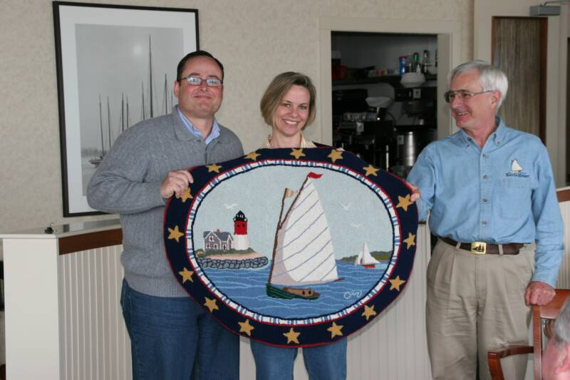
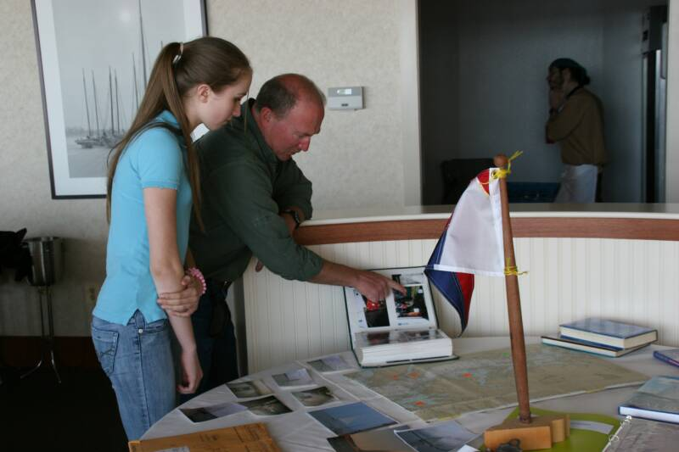
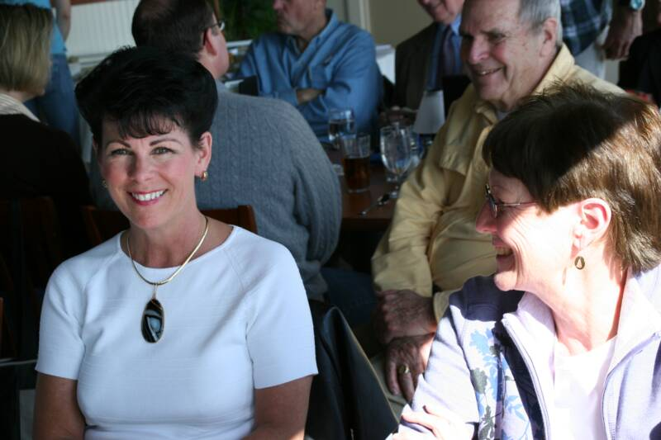
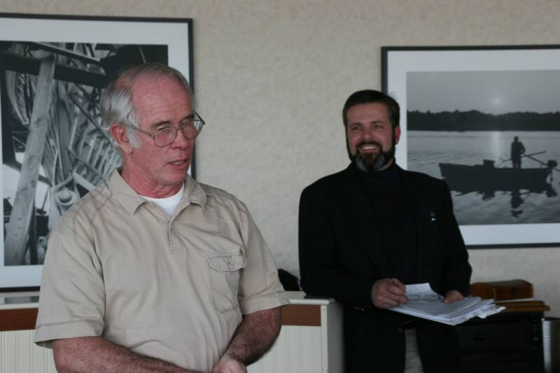

2007 Patuxent River Shootout
The second annual “Shootout” was held June 30th with a turnout of 8 boats. Marc Cruder’s Wanderer and Dave Bleil’s Gull were positioned at the Flesner’s dock after the long cruise two weeks earlier. Jeannie Griffin got Heron in the water on the 28th and bent the sail on the 29th making her “race ready’ the following day. Not to be outdone by last minute preparations, Steve Flesner launched Scotty hours before the race…”keeps the bottom clean” was his only comment…although he did look a bit flustered! Butch and Denise Miller trailered Dusty over from the Eastern Shore. Jim Ohlmacher took over Gull for Dave who couldn’t make the race.
The Southern MD catboats arrived in mass…Heron with Jeannie, Rob Dale and Deborah Kier, Scaredy Cat with Ned Sprague and Capt. Gerry LaMarque, Caerulean III with Butler Smythe and Alouette sporting a new flag sail with Gary and Monique Milhollin and some “ringer” for a helmsman along with a spare tiller in case the “crack got bigger”...rounded out the fleet. Although somewhat reluctant (he just finished the varnish work!), Steve turned Scotty over to Rich and Wade McLaughlin who had driven down from PA…3 hours. What a sport! Using a triangular course that would take them across the river, then up the river and back to the entrance of St. Leonard Creek. The race started at 2:05 with a strong flooding tide and less than 10 kt of wind from the southwest. Unfortunately the committee boat had great difficulty holding its position in the current at the starting line. As the race began the distance narrowed and some comments about threading a needle could be heard as the fleet passed. The committee boat was duly embarrassed. Once under way the fleet moved out in a close pack and stayed that way to the finish line. A brief shower on the down river leg to the finish blotted out a few boats, but as they passed the finish line, a hatch flew open on the committee boat with a head sticking out to blow the horn and get the time…and indication that there was too much beer on the committee boat!
Upon returning to the Flesner’s dock, Smythe and Cruder worked out the placings using the Portsmouth-based CCBA handicap. Scotty 1st, Gull 2nd and Wanderer 3rd. Trophies were presented and a cookout along with festivities followed.
Gull, Wanderer and Dusty stayed overnight at the dock. Dusty and crew explored the Patuxent River for a few days while Gull and Wanderer headed North into some 15-20 kt winds and rough seas. Jim made his first solo in Gull so none of us could witness his Speedo in action!
The Results
Place Skipper Boat Design
1 Rich Mclaughlin Scotty Marshall 15
2 Jim Ohlmacher Gull Legnos 20
3 Marc Cruder Wanderer Wittholtz 25
4 Butch Miller Dusty Marshall 18
5 Butler Smythe Caerulean III Menger 23
6 Ned Sprague Scardey Cat Marshall 18
7 Gary Milhollin Alouette Herreshoff 18
8 Jeannie Griffin Heron Marshall 22
2007 Great Whitehall Bay Race
As reported by Dave Morrow

Catboats gathered for the annual Great Whitehall Bay Catboat Regatta at the Providence community pier and clubhouse in Annapolis MD, starting at noon on Saturday September 1, with boats coming from as far away as Pennsylvania (via trailer). One member noted that he had never seen such an assortment of cats other than in a museum. Boats ranged in size and age from a wooden Barnegat Bay Sneakbox to a Wittholz 25.

A potluck dinner took place Saturday evening with plenty of food and drink available for all. Unlike last year the weather cooperated and the thunderstorms stayed away (Last year’s event was delayed by 24 hours due to severe storms that cut power to the area).

Racers headed out to the traditional Whitehall Bay course the following day, following the tried and true Hoover racecourse. While the weather was beautiful, the wind was light to non-existent. The race committee wisely shortened the course, but even eliminating 2 legs was not enough, and only Anna finished the course by the time the race was called.

The boats returned to Providence for a short - but friendly - discussion on the race results and wind conditions. Trophies, including the Hoover Perpetual Trophy, were then presented with the agreed upon results as follows:

Place Boat Skipper/Crew Design
1. Anna David, Kim & Spencer Morrow Marshall 18
2. Gull Dave Bleil Mystic 20
3. Hornet Dan & Sam Oldale Beetle Cat

All in all, the weekend was a huge success with one of the best turnouts of the year. Though several others participated, the "official" finishers for place finishes are only noted due to the unfortunate winds that plagued the race day.
2007 Corsica River Race
As reported by David Park

The Chesapeake Catboat Association participated - in force – at the 66th Annual Corsica River Races held 28-29 July 2007 on the Corsica River – off Conquest Beach. It was another great mid-summer event held by our Host – the Corsica River Y.C. Seven boats and their crews, as well as a land contingent of seven others who watched as the others participated in the three Saturday races, which took place in light but steady air, represented the CCBA.

Saturday evening CRYC put on their usual great Eastern Shore Chicken Dinner, and Bluegrass music with the band Bitter Creek. Everyone enjoyed a very nice evening.

Unfortunately the weather on Sunday turned ominous, with the threat of severe thunderstorms and high winds so the races were unfortunately called off at 11:30 AM. As far as the catboats were concerned, the awards for best average finish were as follows:

Place Boat Skipper/Crew Design
1. Mistoffelees Ben Heilman Marshall15
2. Wanderer Marc Cruder & John Brown Wittholtz 25
3. PussyFoot’N Jim Ohlmacher & Dave Park Mystic 20

RACES Overall (3 Raced)
Rank Boat Skipper
1. Mistoffeles Ben Heilman
2. Wanderer Marc Cruder
3. PussyFoot’N Jim Ohlmacher
4. Homer Michael Crawford
5. Dusty Butch Miller
6. Gull David Bleil
7. Little Mary Peter McCrary
8. Ann Sharpie Cat Ketch
9. Tenacity Richard McLaughlin

The trip home was a test of seamanship when at about 3:25 PM the front hit with winds reported at over 50 mph. All cats returned to their homeports safely. More on all the races and related events can be found at the Corsica River web site: www.cryc.org on the start page.
2007 Prospect Bay Race
As reported by Roger Compton
On Saturday September 8, five stray catboats raced on a beautiful fall afternoon in a steady 10-knot, west-southwest breeze. After completing two circuits of the triangular course, the contestants finished as follows (note that the Hoover-Dunn Modified Portsmouth Handicapping system was used to “correct” finishing times):
Boats are Mystic 20, Wittholz 25, Marshall 18, Atlantic City 21 and Mystic 20.

Place Boat Skipper Design
1. PussyFoot’n Ohmacher Mystic 20
2. Wanderer Cruder Wittholtz 25
3. Dusty Miller Marshall 18
4. Granmary Dunn Atlantic City 21
5. Gull Bleil Mystic 20

For The Tuttle Trophy:
Place Boat Pax Corsica Whitehall Prospect TOTAL
1. Wanderer 3 2 6X 2 7
2. Gull 2 4 2 5X 8
3. PussyFoot'n -- 3 5 3/48.75
4. Dusty 6X 5 4 3 12

No protests were registered with the race committee, so everyone headed up Little Greenwood Creek to the after-race party and awards ceremonies that have always been associated with the PBCR.

After much fellowship, food and libation, the business of the evening was started. Trophies for the first three places of the day’s race were awarded. Attention then turned to the season award for the Chesapeake Bay Catboat Association, the Washington Irving “Tut” Tuttle Trophy. Based on finishing well in the 2007 season’s events (with one throw-out), the winner for 2007 was Capt. Marc Cruder in Wanderer. This was Marc’s second time to win this prestigious award.

After a quiet and comfortable night aboard their boats, skippers and crews gathered for Jill Compton’s bountiful breakfast before heading home to face the workweek.

Capt. Don Dunn was honored by his catboat peers and presented with a keepsake-framed photo of GRANMARY running hard down wind during this past annual Spring Cruise 2007. The photo was taken off Hooper's Island Lighthouse and presented by CCBA Commodore (without Portfolio) Marc Cruder in light of Capt Don's own comments that this might be his last sailing season and the fact that he has always traveled the farthest over the last more than 10 years to participate in this event. The framed photo was matted and signed by all the annual cruise participants.

