2005 Races & Events
Great Whitehall Bay Race

Entrants Boats
Hoover, Bill, and Carolyn, Howard Gull, M 20
Brown, John, Dan, Mae
Cruder, Marc; Debbie, Noel, Matt, Maria, Viola Wanderer, W 25
Bliel, David; Jim Ohlmacher Pussy Footin’ M 20 – 2d
Compton, Roger; Jill Committee boat
Park, Dave; Nancy Pert, H 17
Westrick, Ned; friend, Lyw, Bill, H 18 – 4th
Miller, Butch Dusty, M 18
Marculewicz, Stefan; Ann
Flesner, Steve; Lois
Oldale, Dan; Jan, two boys Hornet, Beetlecat – 3d
Morrow, Dave; Kim, Anna, Spencer Anna, M 18 – 1st
Welch, Jeremy; Laura, Emil

CCBA "Last Gasp - Part 1" - Columbus Day weekend
CCBA members, hearty as they are known to be, were prepared and waiting to have a last sail for the season by attending the fall "Wild Goose Chase" on Columbus Day weekend. The weather, however, threatened strong winds and rain for Saturday and into Sunday. Pondering the weather but determined to make this last event, I suddenly received an unusual phone call on Friday night. Unusual, because the caller was event organizer David Bleil and the call was to officially cancel the weekend's event! This was the first time in the over 15 years of sailing with this group that I had ever heard of a cancellation. The norm with this group was that events were on despite what Mother Nature could dish up....and if only one boat showed, that's how it went. Well, discretion being the better part of valor, David was acting responsibly and determined not to put any of the group unnecessarily in harm's way. Considering the youthful, but chronologically mature age of our most active sailors, this was really a good call, albeit a disappointing one.

I had encouraged my Father to come down from NJ for the event, and Capt Bill Hoover promised to take the season out in style with generous portions of Myer's Rum at the scheduled raft up. Now put ashore, we quickly reorganized our weekend to take in the Annapolis Boat Show, which we hadn't done in a few years. I was determined to not let Capt Hoover off the hook, so had sent him an email on Friday night to inquire if he was receiving visitors on Saturday afternoon, so we could relieve him of some of that rum we knew he had. Pending his answer, we headed for the boat show. Noticeably absent was Bill Menger of Menger Boatworks who crossed the bar earlier this year, but Marshall Marine was there with sun shade rigged to keep the rain out of the cockpit of an $80K Sanderling. God Bless those people with disposable income. After the mandatory "nutty buddy" to support the local Optimist Sailors, I checked the home front to find that Capt Bill had called in to say he was standing by for visitors with his rum at the ready. Having soaked in enough of the show as well as the rain, we headed for dry escape at Capt Bill's.

We were cordially received and passed a few hours swapping sea stories and cursing the weather that had foiled our trip. Bill's son John was in from the west coast, Carolyn was there and "goose chase" organizer Dave Bleil showed up to make it a club event, as well as get some plans from Capt Bill for mystic 20 gaff jaws. A good time was had by all as we made the best of a wet weekend. Although there were no geese flying through Capt Bill's den, the requisite catboat camaraderie was present, so the rendezvous was considered a success. Dad and I went on to get underway Sunday morning, dodge the rain drops overnight down on the Rhode River and then sailed back to the South River on Monday. So some of us sailed and Dad got his last "trick" at the wheel for the season.
MCC

CCBA "Last Gasp - Part 2"
After the failed "Wild Goose Chase" on Columbus Day weekend, emails flew and discussion focused on the Chesapeake Traditional Sailing Association (CTSA) Race scheduled the following weekend. While interest was building electronically, so was the weather....again, but without rain this time. By Friday night, the core group was emerging again. Capt Bill was leading the charge as usual with GULL. He had pulled Hobie Bahaum in with SWEET PEA. I fell into place with WANDERER, accepting John Brown as crew after Capt Dunn put him ashore, obviously heeding the forecasted weather more than the rest of deciding and us not get GRANMARY underway. John's services would be welcome but came with some plan to get his "China Doll and significant other" Mei into the picture. Meanwhile I got a confirmation from ex-catboater Stefan Marculewicz that his Bristol 32 GRINGO HONEYMOON would make the scene with family (we were all anxious to see that as Capt Bill had pondered whether Stefan really had a boat....since no one could confirm seeing it yet!) In any case, absent any other possible players, there was a quorum for the Saturday night raft-up on Whitehall Creek.

John and I had a good sail up, making the single reef transit in steady 15 kts from the northwest in under two hours. We met up with GULL on the way into the creek, and were shortly joined thereafter by SWEET PEA and then GRINGO HONEYMOON. The Bristol 32 rafted up on one side of the CTSA gang, while I pulled WANDERER up to the other side, putting the smaller cats outboard. The boat-to-boat climbing and carousing started, although we had to get used to all the lifelines and stanchions encountered on the sloops. Stefan and Anne gave everyone the nickel tour of GRINGO HONEYMOON, with its standing headroom, head with a door and forward vee berth where Charlie and Ben were watching TV! Meanwhile, Capt Bill was mixing Myers aboard GULL with open cockpit drains. As the "Friends of Bill" slowly migrated to GULL's cockpit to get their feet wet, John and I skipped back to Providence to pick up Mei, who later completed the "Friends of Bill" aboard GULL. Just as everyone's feet wet were enough, we rearranged crew again. John and Mei needed to get home, as did Stefan and family, so I sent John as river pilot for GRINGO HONEYMOON's nocturnal trek back up the Severn, while the raft broke up so everyone could grab their own hook. It settled into a calm, peaceful night as we were securely in a hurricane hole lee from the building northerly winds.

In the morning, the three remaining cats rafted up together, collaborating for breakfast. There were buckwheat pancakes coming from GULL, while SWEET PEA was cooking up sausage links and WANDERER was whipping up eggs. A good breakfast was had by all, followed by the smaller cats tucking in another reef, since Small Craft Advisory was up with gusts predicted. The sloops appeared unphased by this turn of events. We all slowly made our way out onto Whitehall Bay as a precursor to a race out in the open bay. Being the first one out on Whitehall Bay, WANDERER laid over hard in the first gust to remind me she was a centerboarder. Sailing solo, that was enough for me to rethink things, so I hove to and waited on GULL and SWEET PEA to say that I was bagging the race and heading for the South River. They agreed and headed for the barn themselves. This was a good decision as it took me over two hours to claw back up the South River, and word was that sloops started the race, but broke some gear and cut things short. Winds off Thomas Point were later reported as 24 gusting to 32 kts.

So the CCBA had their "last gasp" and ended the season with a bang. Everyone got some sailing in, we had a last raft up and got proof positive that Stefan did in fact have a boat. It was just another good season for the local catboaters and friends of catboaters. There is some talk that Capt Bill has a few more overnights left in him if he can get Hobie to go along. For the rest of us, it'll have to wait until next season, but as usual...a good time was had by all, and due to some good decision making...we'll live to sail another day.
MCC

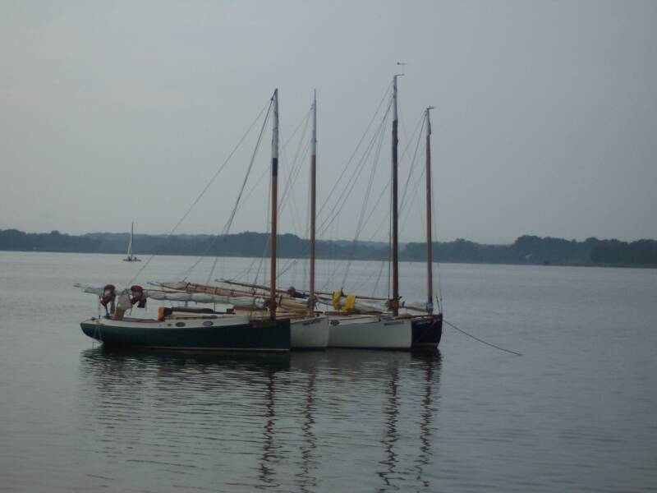
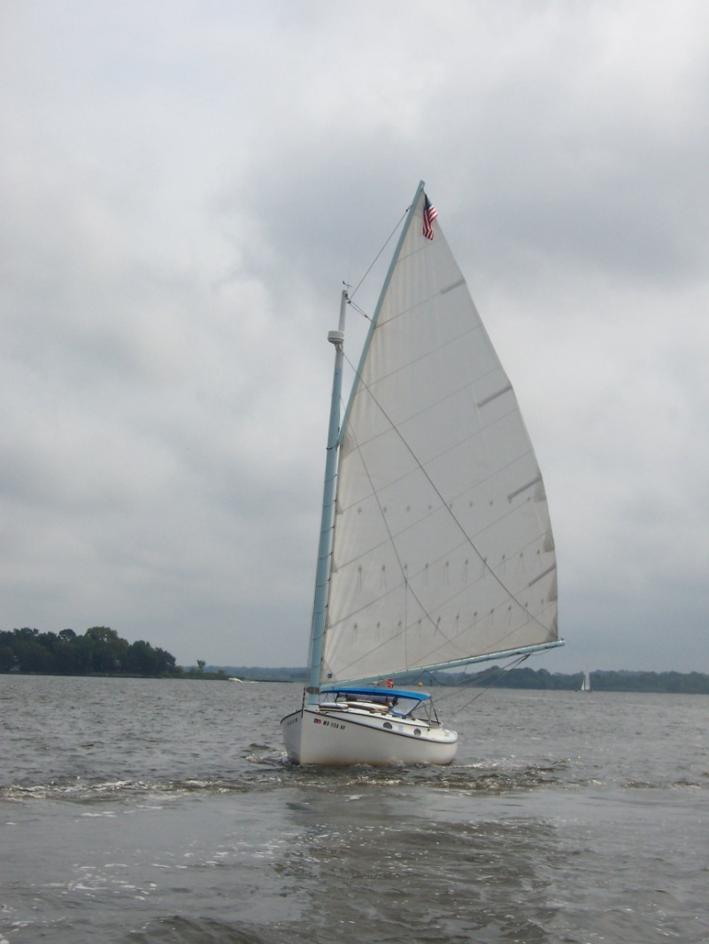
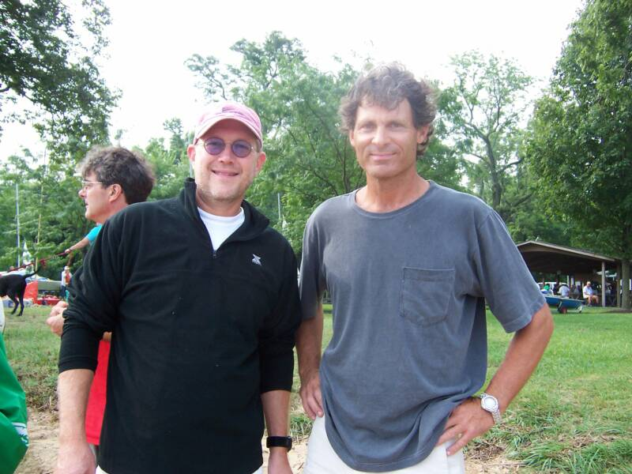

CORSICA RIVER RACE 2005
(Photos Courtesy of Cathy Downes CRYC)
