2006 Events
2006 ROUND BAY
With weather fronts subsiding, the Chesapeake Catboat Association gathered for its 2006 season kick-off event at Round Bay. Hosted by catboat emeritus members Stefan and Ann Marculewicz, a field of seven catboats of various shapes and sizes participated. Wind was from the NNW at a comfortable 10 knots average with gusts beyond that at times and the quirky nature of river sailing to provide the remaining challenge. The start and finish was off the Linstead Pier on the Severn River and include two new members in Richard Templeton who finally splashed YANKEE, a Herreshoff 18, after installing a new stainless steel centerboard and Peter Teeling with the recently purchased and first time out Marshall 18 FINE AS KIND. The skipper's meeting took place at 1 pm with a 2 pm start. All boats finished the race, and despite some alleged protests along with some evidence of different course maps, the race committee ruled on the results using the Hoover/Dunn modified CCBA handicap. The finishing order on corrected time was:

ANNA - Marshall 18
GULL - Mystic 20
PERT - Hermann 17
WANDERER - Wittholz 25
DUSTY - Marshall 18
FINE AS KIND - Marshall 18
YANKEE - Herreshoff 18

The group returned to the Linstead Pier for a cookout and potluck ashore on the community beach, joined by CCBA shore support. All were fed, with race results announced before the group broke up for the evening with some skippers needing to haul their boats and others enroute across the Severn River to lovely and secluded Mayndier Creek behind St. Helen's Island for the night. In the morning, those who stayed over in the creek had a pleasant sail down the Severn with the wind behind them before parting ways for home at the mouth of the Severn. It was a great start to sailing season.

mcc, ccba-cwp

ROUND BAY PHOTOS: Courtesy of Marc Cruder.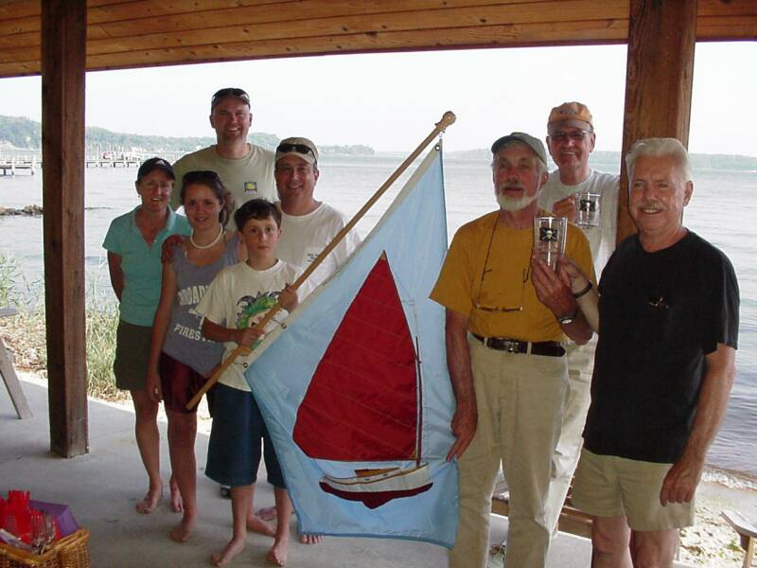
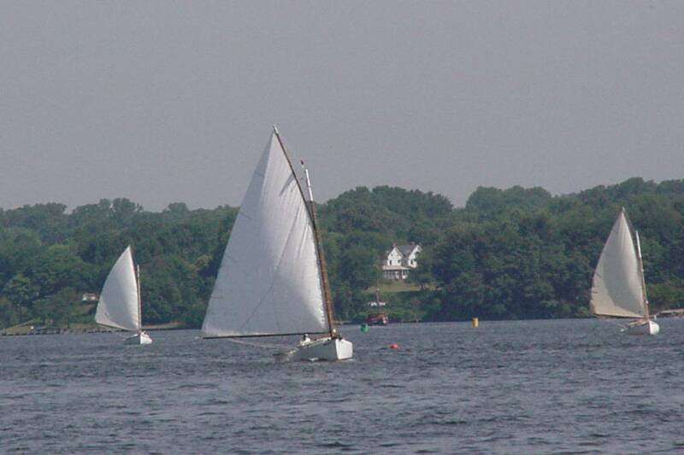
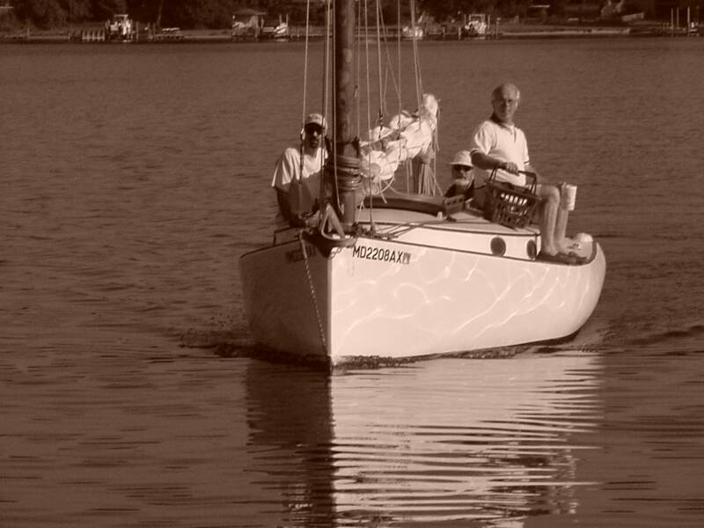
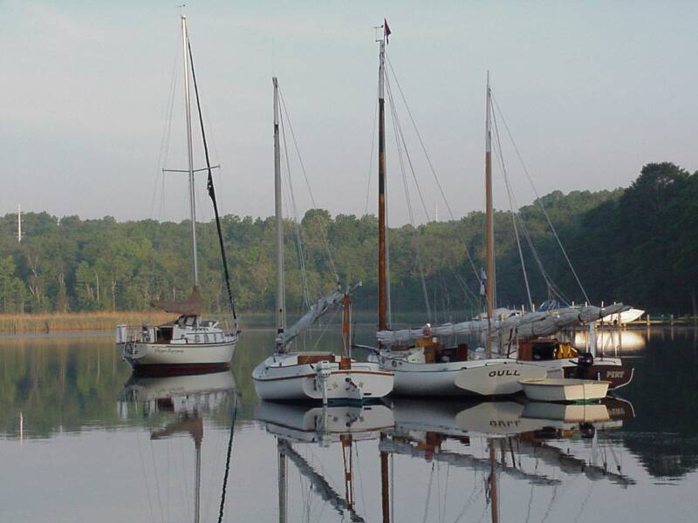
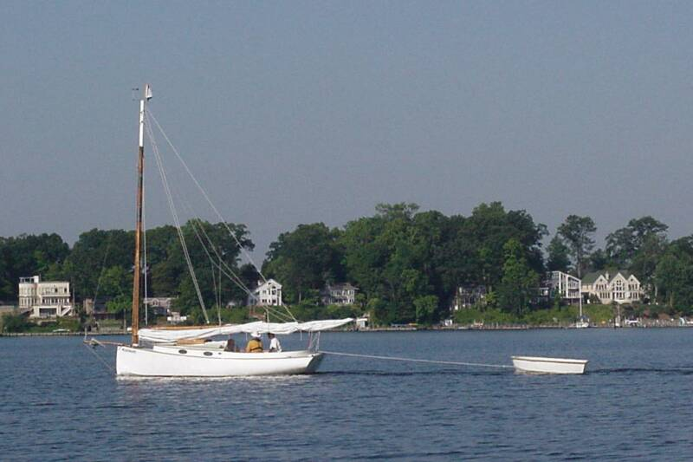
2006 PATUXENT RIVER SHOOTOUT

The Patuxent River “Shootout” held 2 July 2006, was the first race held by the CCBA south of their normal racing grounds - Annapolis to the Corsica River. Boats from the Annapolis area south to Solomons raced on a 5.5nm triangular course on the Patuxent River, just off the mouth of St. Leonard Creek. A 1430 start and favorable 10-15 knot winds moved the racers well in anticipation of a late afternoon feast, though the 92+ deg. heat and associated sun necessitated a shorter course than might have otherwise been used.

The boats were relatively close at the first upwind mark, with Dusty (Marshall 18) nipping at the heels of Caerulean (Menger 23), but Caerulean’s lead became more defined in the subsequent legs. The second mark (reset committee boat with cameras on board) - initially hard to see against the wooded backdrop, fishing boats and a slight shift in briefed location - made it a challenge for the lead boats to find. Once Butler, single-handing on Caerulean, was able to get to his binoculars below, the mark was confirmed and heading trued to the jibe mark. Caerulean finished the course in just under 63 minutes, with Dusty following in just over 68. On corrected time - using the Hoover/Dunn Portsmouth numbers, the official times were Caerulean (64.84), Scotty (66.99) and Dusty (68.12).

Returning up the busy (understatement) St. Leonard Creek – crowded with speedboats, jet skis and larger fishing boats pulling water skiers, the racers met again at the Flesner “Estate” for what we hope is an annual race, awards ceremony, and appropriately well attended feast.

Of special note:
1. The McLaughlins (Rich, Chris and their son) traveled to and from the event – 3 hours from their home in Pennsylvania - and borrowed Steve Flesner’s Marshall 15 “Scotty,” placing second!
2. Doug Oeller, spent the night before the race “camping” on his Marsh Cat 15, snug in a quiet cove close to the entrance to St Leonard Creek.
3. The Millers (3) and Doug Oeller (1) left the event before dark to head back to their launch point 1.5 hours away in Solomons, but not before a sudden thunder storm hit them with wind gusts and associated rain that exceeded 50kts. Both boats arrived home safely.

Thanks to Steve Flesner and Stefan Marculewicz – the race committee – for supplying the committee boat, mark setting, photography and higher math skills.

Note: This is the first time a Menger 23 has actually raced in a CCBA event and - to this writer’s knowledge – the first time any Menger 23 has placed – let alone raced – in a catboat race. If there were others, we’d love to know it.

The Results
Place Skipper Boat Design
1 Butler Smythe Caerulean III Menger 23
2 Rich McLaughlin Scotty Marshall 15
3 Butch Miller Dusty Marshall 18
4 Marc Cruder Wanderer Wittholtz 25
5 Jeanne Griffin Heron Marshall 22
6 Ned Sprague Scaredy Cat Marshall 18
7 Doug Oeller Comfort Marsh Cat 15

Photo Credits to Steve Flesner - THANKS!!!

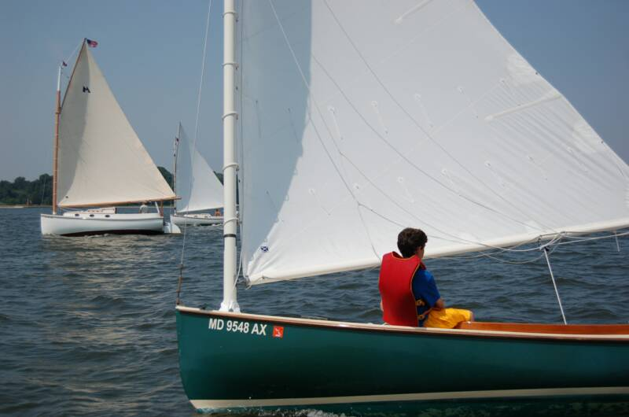

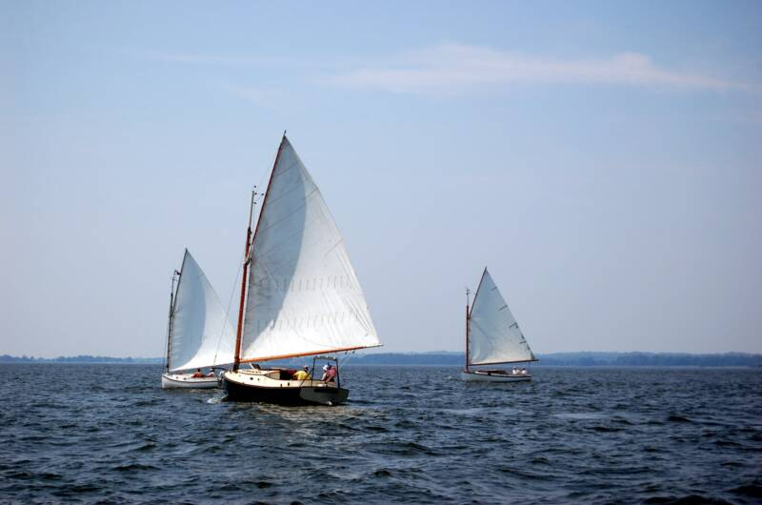

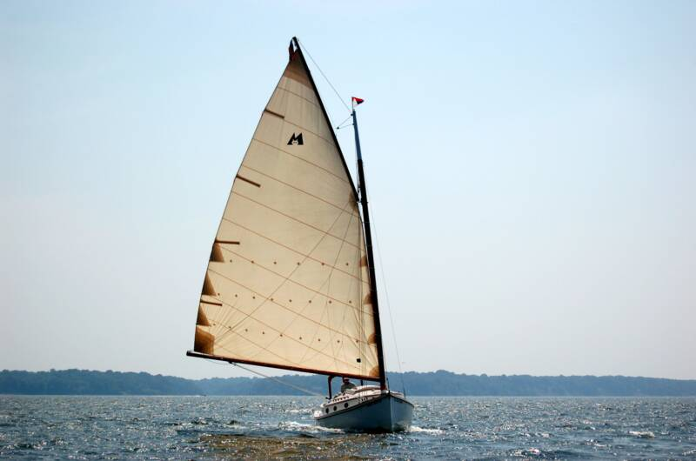

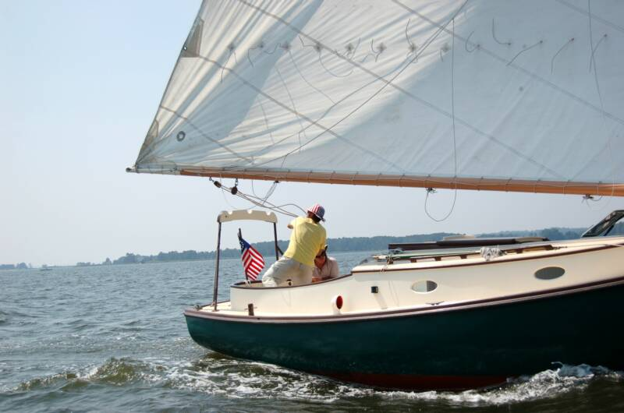

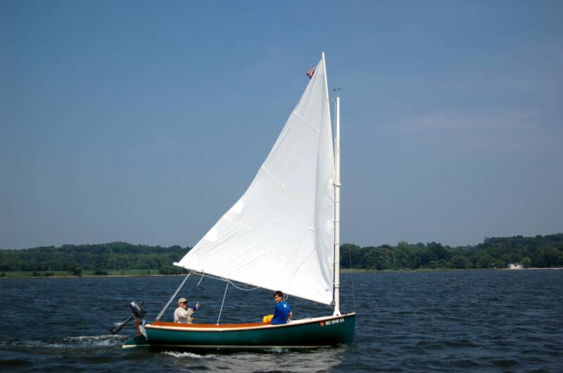

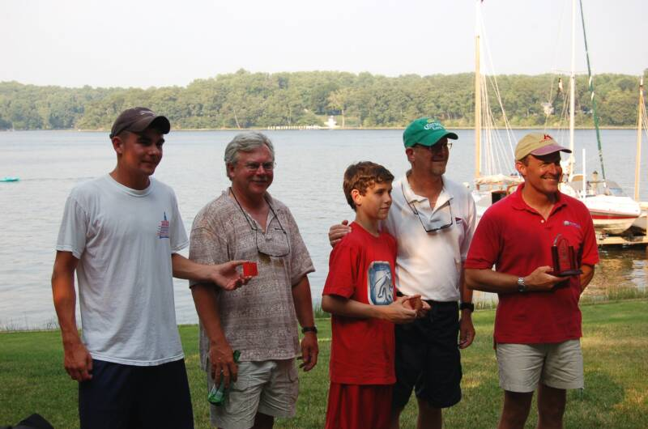
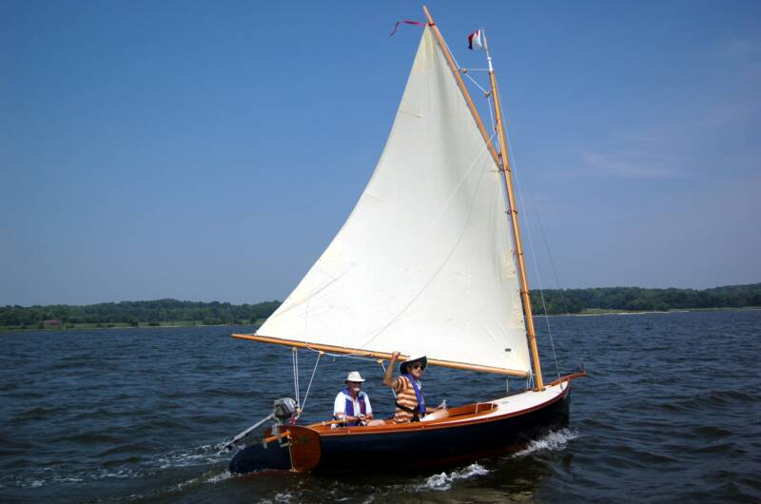

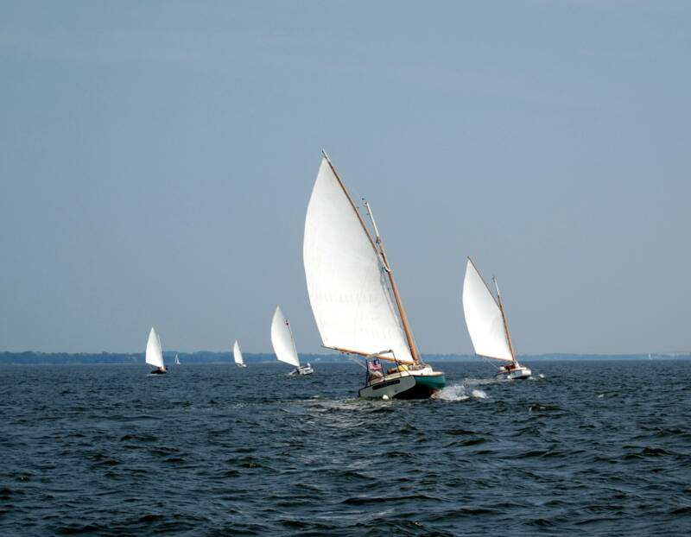
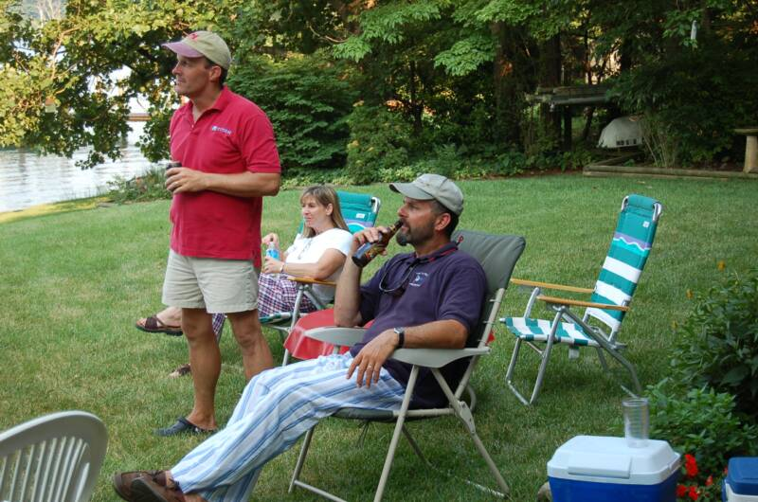

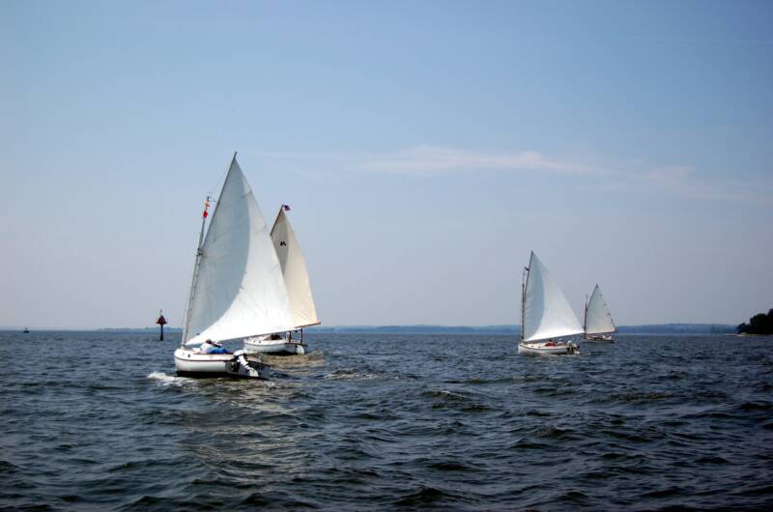

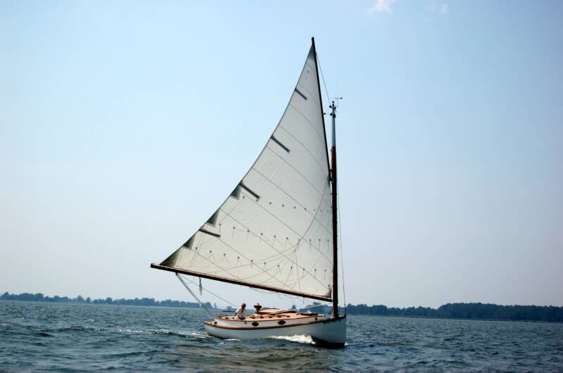
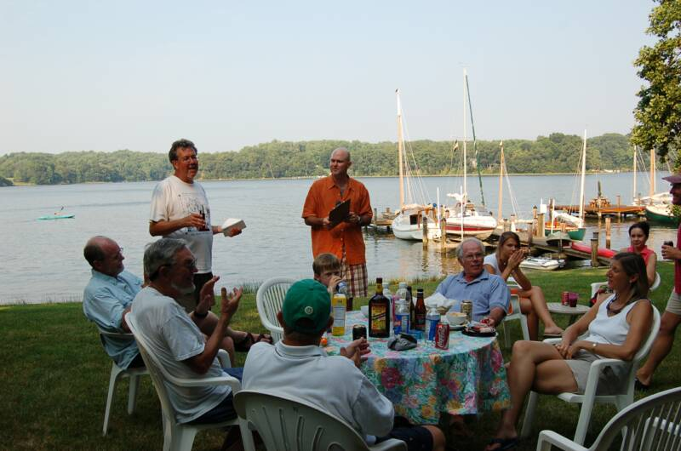

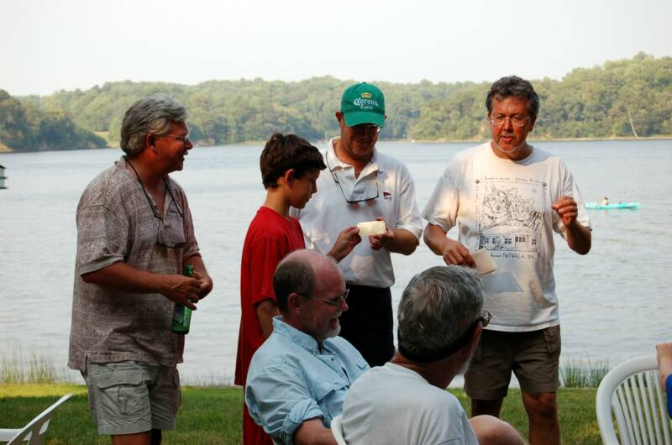
2006 Corsica River Races Summary

Corsica River
CENTERVILLE, MD – This year the Corsica River Yacht Club (CRYC) ran the 65th CRYC Race Days on July 29 and 30, and the Chesapeake Catboat Association was again represented well.

The weather was extremely hot and humid with relatively light air. Saturday we got in two races on a dying breeze and Sunday two more races were held in exceedingly light air. The turnout was good, food was great, and the river was comfortable to swim in due to the fresh water, which helped to prevent the sea nettles common in saltier bay waters.

The CRYC event is highly organized and well run, and the CRYC is hoping to move next years event next year to a new facility they are building. We would love to see more area catboaters put this race date on their schedules for next year and launching facilities are available nearby.

This years CCBA participants included Don Dunn in Granmary, Rich McLaughlin and his son in Tenacity, Mike Crawford and son in Homer, Dave Park in Pert, Butch and Denise Miller in Dusty, David Bleil and Jim Olmacher in Pussy Foot 'N, and Marc Cruder in Wanderer.

Results (based an average of the 4 races):
Place Captain Boat Design
1 Butch and Denise Miller Dusty Marshall 18
2 David Bleil and Jim Olmacher Pussy Foot ‘N Mystic 20
3 Marc Cruder Wanderer Wittholz 25
4 Dave Park Pert Hermann 17
5 Mike Crawford Homer Hermann 17
6 Don Dunn Granmary Atlantic City 21
7 Rich McLaughlin Tenacity Marshall 22
– David E. Park
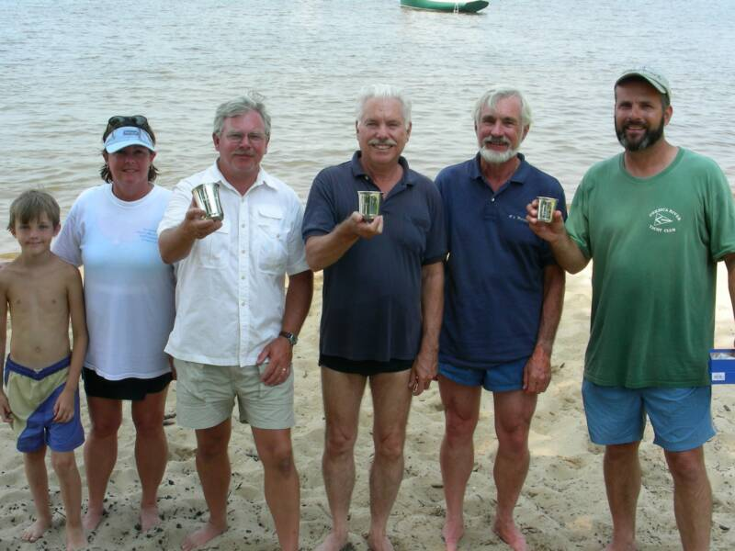
For More Photos Click Here.http://www.fototime.com/inv/06FA4CFCA76D476

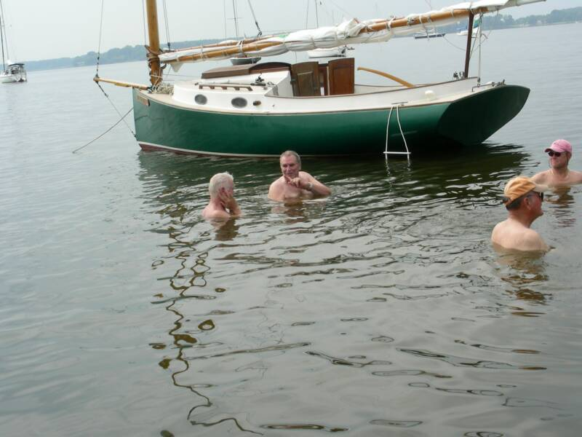
Great Whitehall Race 2006
"Mystic 20 designer & builder Peter Legnos presented the Capt. Bill Hoover Perpetual Trophy"

This year's event was hampered by weather for Saturday's planned cocktail hour and potluck dinner so formal events actually started on Sunday with the captain's meeting and race preparations at the Providence Club House located on Mill Creek in Annapolis. Race summary and events below. The Mystic 20 designer and builder Peter Legnos was on hand to present the Mystic 20 half model to the Hoover family as the Capt. Bill Hoover Perpetual Trophy. It was awarded this year to Dan Oldale and his son sailing his family's wood Beetle Cat - the first winners of the Great Whitehall Race.

Hosted by Carolyn Hoover September 2 & 3, catboats, catboat sailors and friends gathered Sunday after "Ernesto" passed by on Friday and Saturday leaving the Annapolis area covered in leaves, tree limbs and without power.

Sunday morning 6 boats participated in the traditional race around the government buoys in Whitehall Bay. Boats ranged in size from a Beetle Cat (12') to a Wittholtz 25. Conditions were difficult with a very light and spotty breeze that never exceeded 5 knots. The race committee wisely shortened course allowing the boats to finish within a reasonable time-frame.

After the race, the Capt. Bill Hoover Perpetual Trophy was presented by Pete Legnos, builder of the Mystic 20, to Carolyn Hoover in her late
husband's honor. The trophy, a beautiful half hull model of the Mystic 20, was then presented by Carolyn to Dan & Sam Oldale winners of this year's race.

Great food and drink were had by all with catboat camaraderie abounding.

The results using the CCBA Hoover/Dunn Portsmouth numbers for handicapping:
Place Skipper Boat Design
1 Dan Oldale Hornet Beetle Cat
2 Dave Bleil Gull Mystic 20
3 Dave Morrow Anna Marshall 18
4 Deborah Keir Patience Handy Cat 14
5 Marc Cruder Wanderer Wittholtz 25
6 Butch Miller Dusty Marshall 18
- Dave Morrow

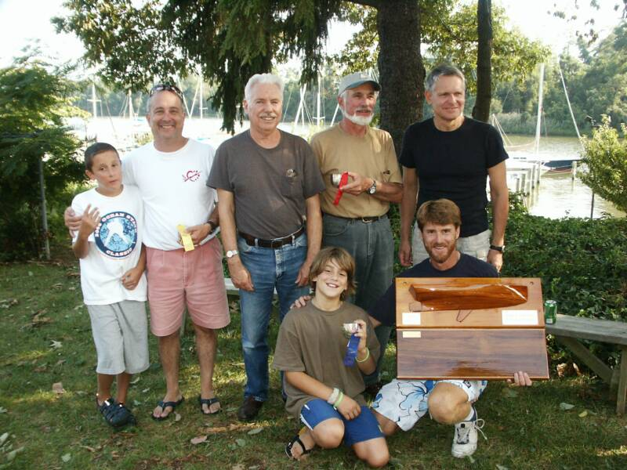

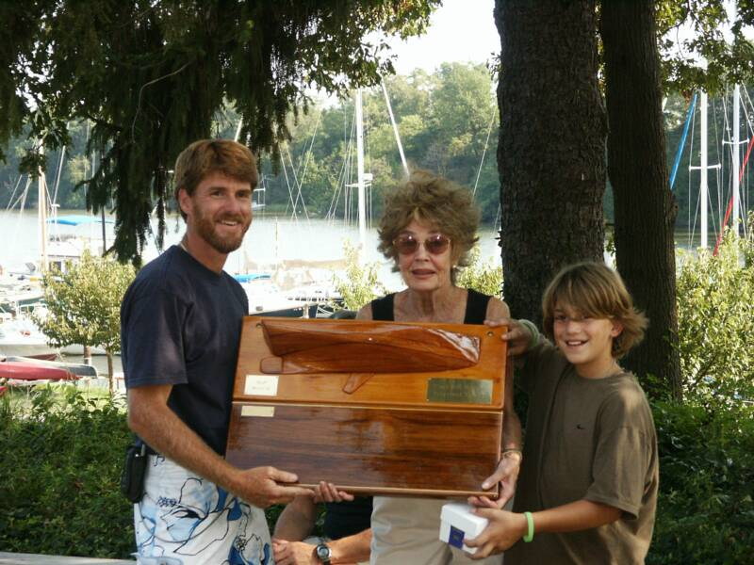
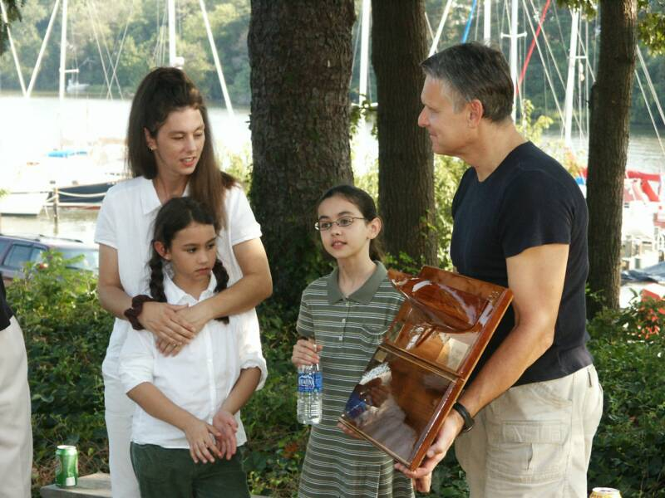

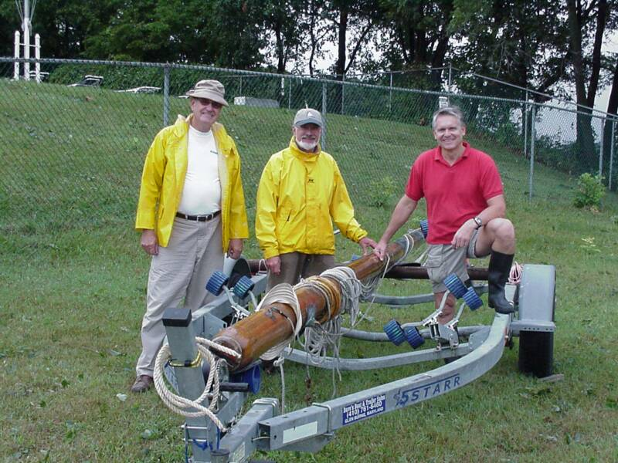
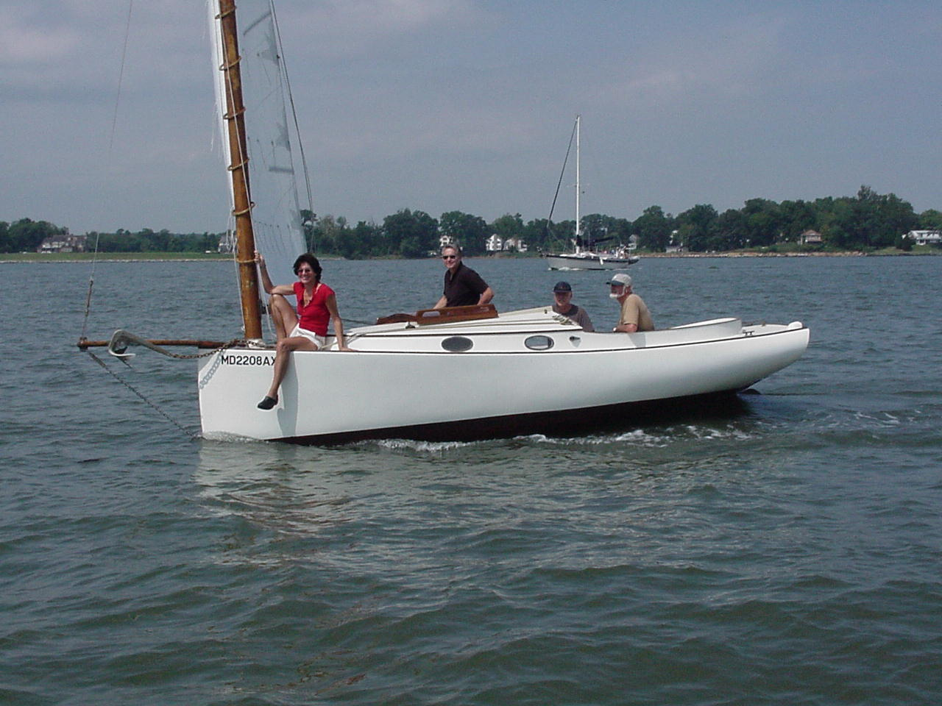

Team GULL with Jan and Peter improving trim and appearances.

The gin pole operation....or...how many catboaters does it take to put a mast in?
Photos by Marc Cruder

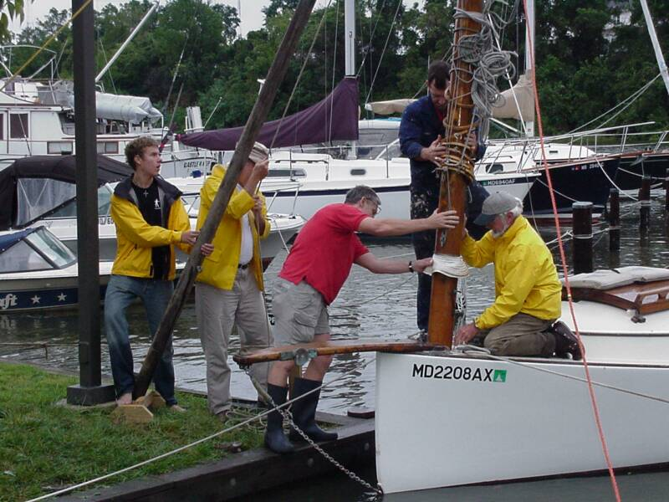
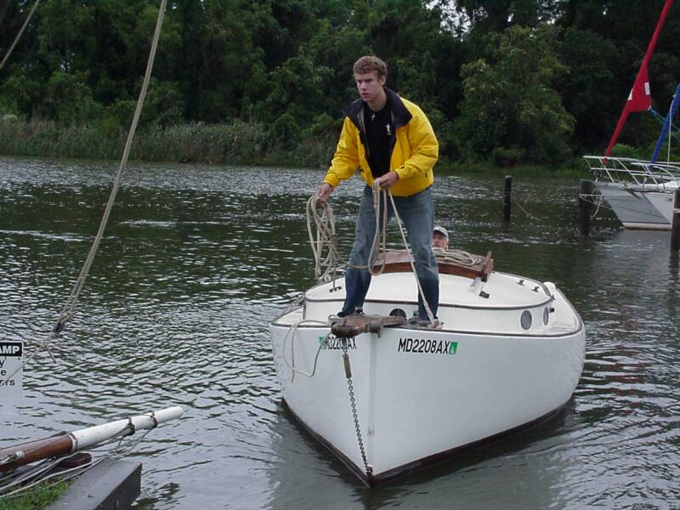

Matt shows his line throwing form

The mast operation...Daves x 2 and Peter Legnos in high fashion with his Greek Boots
Photos by Butler Smythe

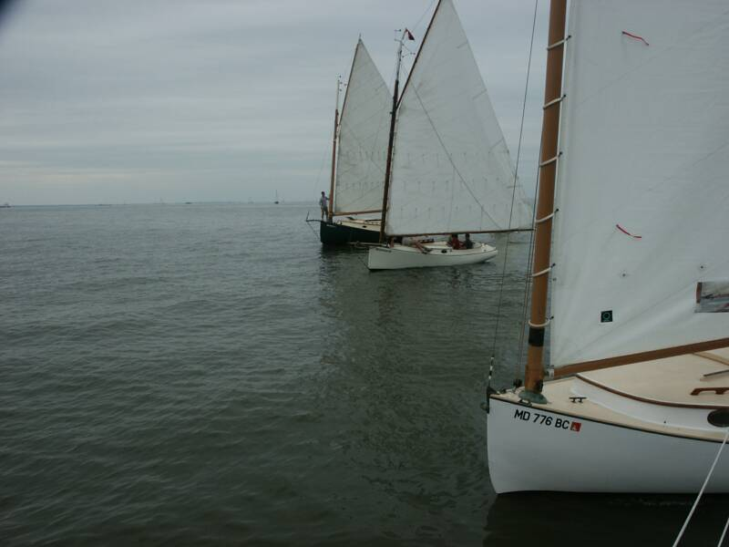
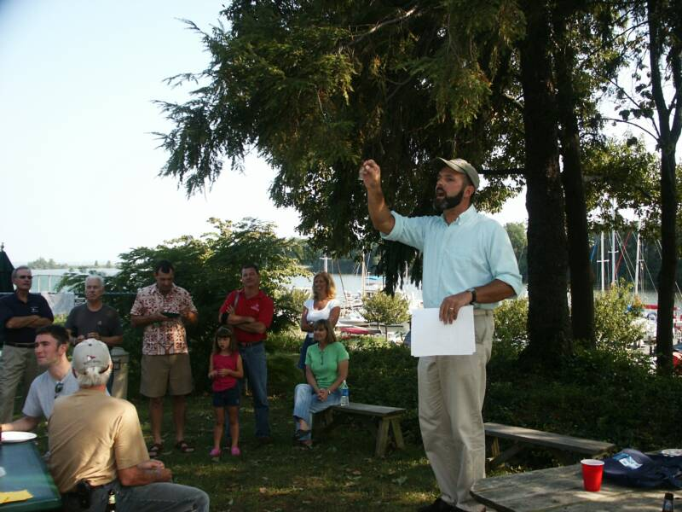

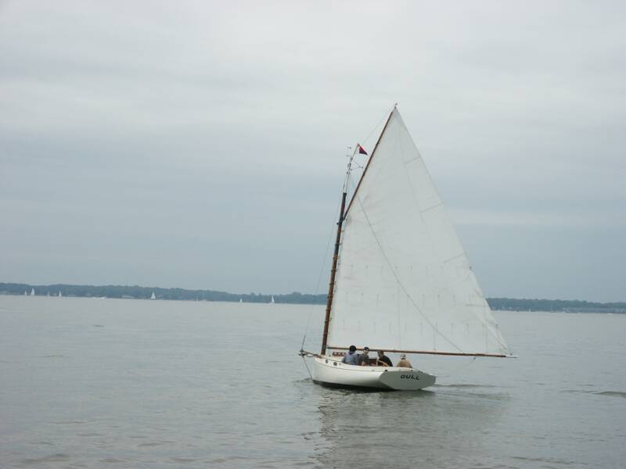
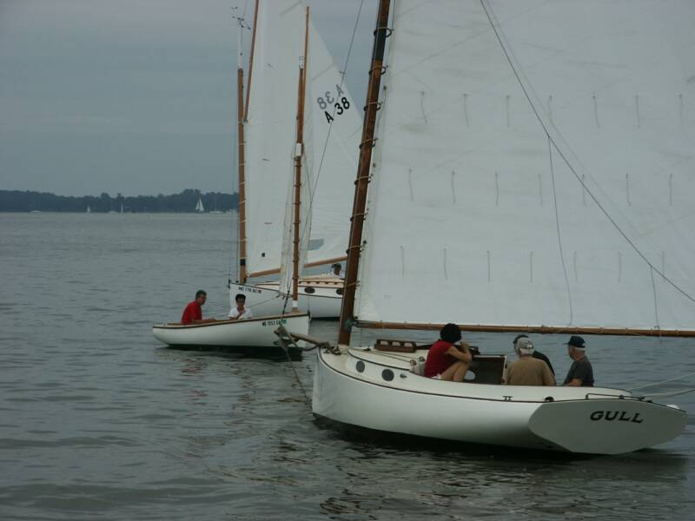

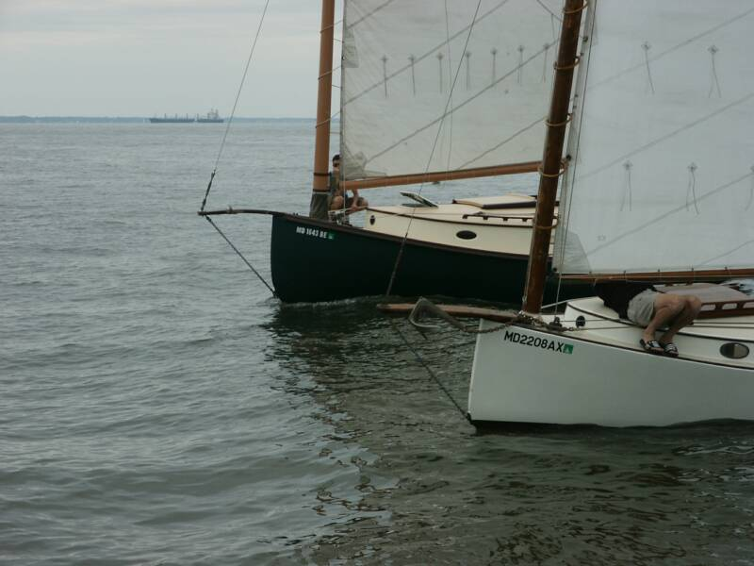
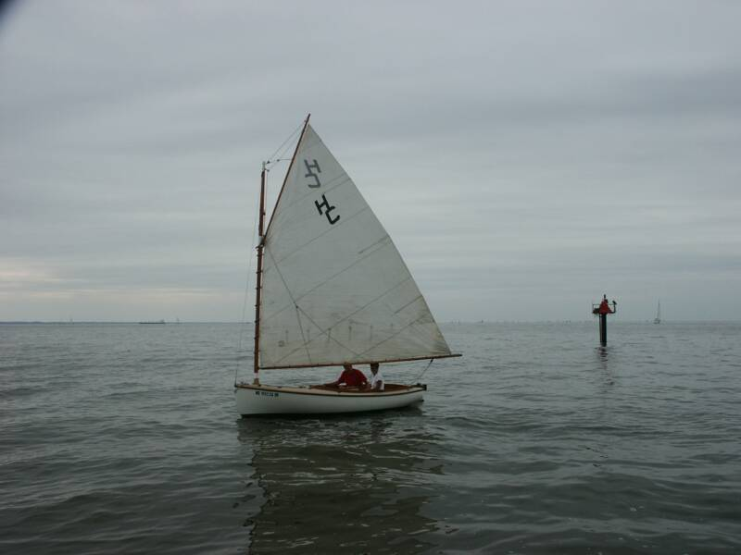

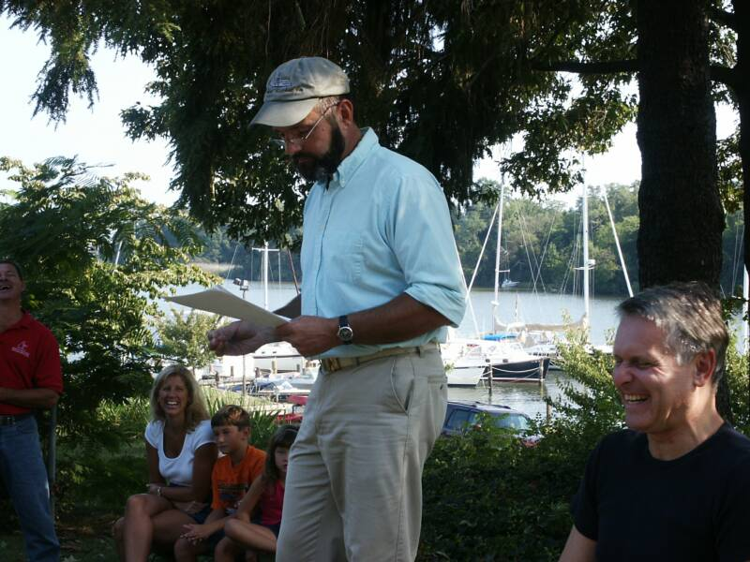

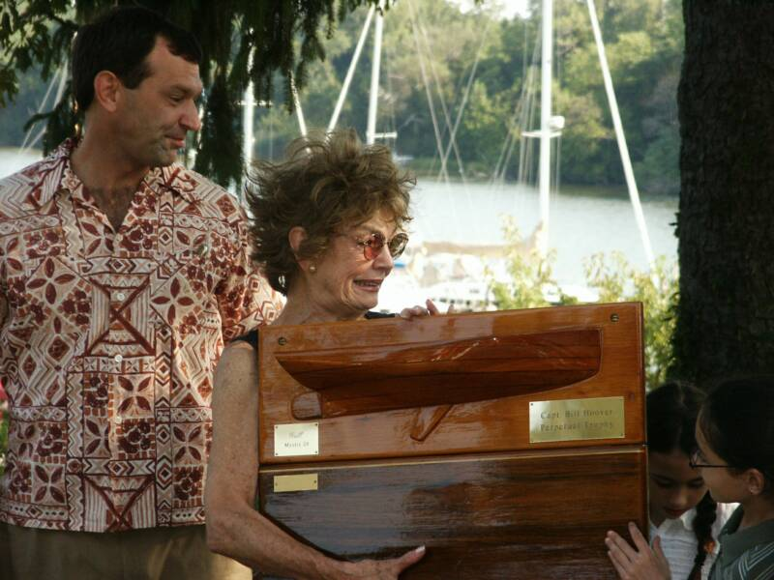

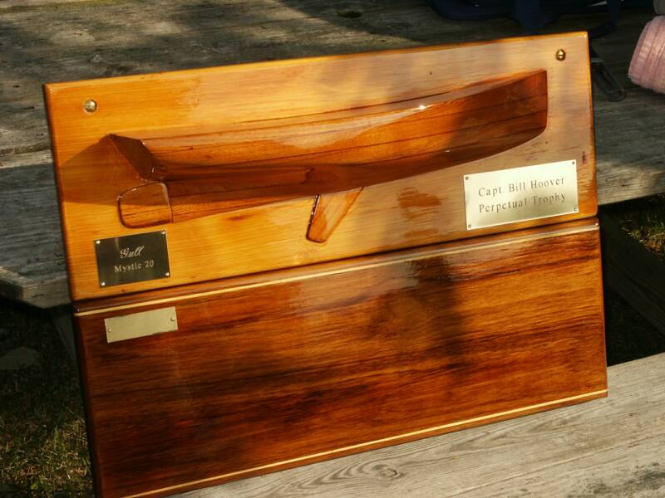

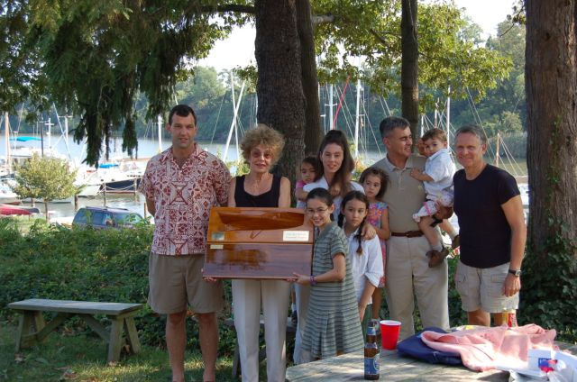
Photo by Steve Flesner

2006 Prospect Bay Catboat Regatta

The 2006 Prospect Bay Catboat Regatta (PBCR) took place on SATURDAY, SEPTEMBER 09, 2006 and was a social success - though an athletic disappointment. The tidal current was stronger than the wind for most of the race and, with a WNW breeze less (much less much of the time) than 5 knots, the course was shortened to two instead of the planned seven legs. The hardy souls that participated finished as follows:

Finish Boat/Skipper Type
1 PussyFoot’N/J. Ohmacher Mystic 20
2 Wanderer/M. Cruder Wittholtz 25
3 Pert/D. Park Hermann 17
4 Gull/D. Bleil Mystic 20+
5 Dusty/B. Miller Marshall 18
DNF Granmary/D. Dunn Atlantic City 21
DNF Winters Dream/J.Smith Marshall 18
DNS Mariah/D.Bevin Marshall 22

The renowned Hoover-Dunn Modified Portsmouth System was used to handicap this fleet of stray cats.

After lots of libation and great food at hosts Jill and Roger Compton’s place on the Eastern Shore, the unpleasantness of the day’s sailing was all but forgotten. Following the presentation of hardware for the PBCR ’06, the winner of the cumulative Chesapeake Bay Catboat Association 2006 racing season was announced. This year’s winner is Marc Cruder in Wanderer. Running a very close second was Butch Miller in Dusty. Congratulations to both!

