2008 Races & Events
2008 Annual Meeting - Severn Inn (Annapolis)
8 March 2008
The 2008 CCBA Annual Meeting was held at the Severn Inn again this year to a great crowd that brought back old members as well as a couple new ones, some of whom have chosen to enter the catboat crowd with boats like an Atlantic City 24, which we hope will join us for races and other events over the year. The meeting was officially started after a great meal at the "Inn." Marc Cruder (Commodore without papers) began the meeting and worked through the list of events for the coming CCBA season.
The first official event is the CCBA Long Cruise up to the Baltimore area, which will get the cruisers into a more populated area than in past years - but with excursions into the last remaining quiet areas in that part of the bay. A warning to cruisers was that washing of dishes in the water, as well as swimming, might not be such a good idea due to the nature of the water....
Butch Miller provided a short report on the CBA Annual Meeting in Newport, RI and it appears that the CCBA will remain represented on various CBA committees, which will keep us southerners in high vis. positions there. Steve Flesner provided a summary of the next event - the Pax River Shootout on the Patuxent River with the Corsica River Races and Great Whitehall Race to follow over the summer. Details are available on the CCBA Web site. Other events such as the Old Salt, Prospect Bay and St. Michaels Small Craft Festival were mentioned and Don Dunn provided information on the CCBA Handicap System which follows the Portsmouth Handicap system - also available on the site.
After CCBA Administrative Business discussing Dues and Newsletter with Dave Bleil; the Membership Roster with Dave Flesner; the Website and Communications with the CBA with Butler Smythe - and a Vote of Confidence for current CCBA volunteers to retain their volunteer positions - Marc moved on to awards. A door prize was presented to Ned Sprague who received a very nice Art piece donated by Alena Ortega who maintains an Art Studio in Dames Quarter on the Easter Shore, and who was there to greet and entertain us last year on our all too short visit to Larry's place. And then there was Larry. Larry Antonik was our more than gracious host last summer on the Long Cruise to the Eastern Shore and a large framed Catboat in the Marsh was presented to Larry as our thanks for his efforts. A signed photo with all 2007 cruisers was attached on the back.
Much hope for another successful sailing season!
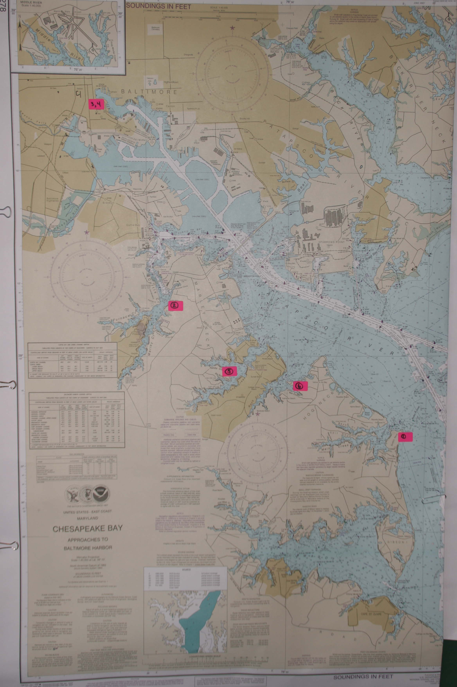
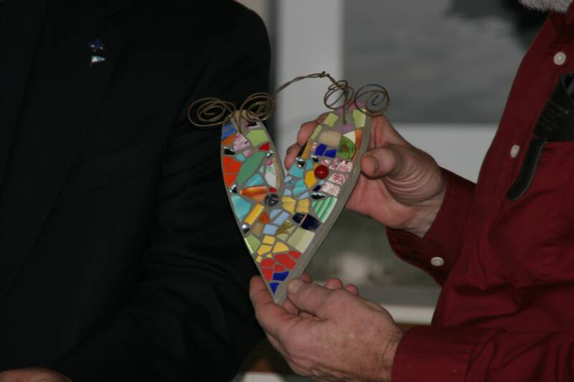
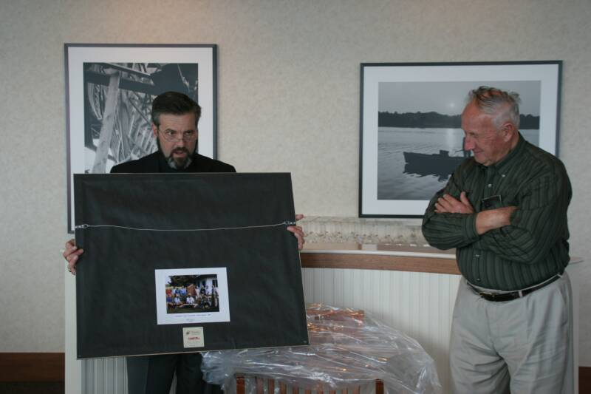
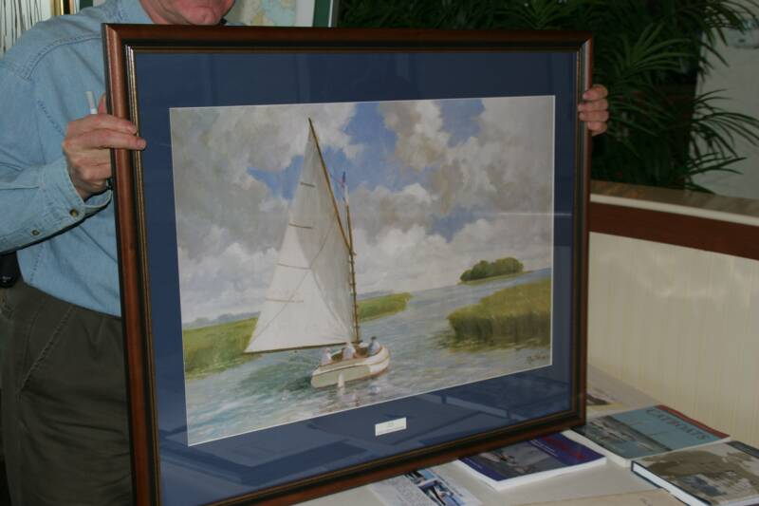
2008 Patuxent River Shootout
5 July 2008

Steve & Lois Flesner and Butler & Maria Smythe hosted the third annual Patuxent River Shootout on July 5th held at the Flesner’s place on St. Leonard Creek in Southern MD. Dave Bleil and Jim Ohlmacher aboard Gull and Butch & Denise Miller aboard Dusty arrived Friday evening after a long cruise from the Eastern Shore and were greeted with crab cakes and steaks…pays to arrive early! Catboat races requires three ingredents... people, boats and wind. Unfortunately this year we only had two of the three…no wind…not even a whisper. Seven boats were at the mark at the start when the tide took command of the event…more tide, no wind... what now? Race was called and we headed back to the Flesner’s for a rather unique approach for the awards ceremony. Leslie Dale, a local artist crafted our trophies…unfortunately the kiln didn’t cooperate and we wound up with 3 1st place plates, 2 2nd place plates and 2 3rd place plates... we had backups…what unforeseen luck! So…in the spirit that catboaters camaraderie is noted for, Steve and Marc Cruder, Commodore without portfolio, decided the awards would be given in order of arrival! Thus the explanation for the group picture and no times! Steve was kind enough to donate his award to Kent Mumford who ran the committee boat from his Nimble yawl and all other catboats were happy with their trophies even if they arrived third and it said first! Kent desecrated his trophy by adding a mizzen mast to the catboat. Awards were followed by a pot luck with North Carolina barbeque and other tasty dishes. After such a “flat” day, a nice light breeze came up and Commodore Marc joined Deborah Keir on Patience for some very pleasant…educational sailing. So you see…our “First” place arrival actually earned her “First” place amongst the trophies…she got the only sail in of the day! Dave Bleil put it succinctly when he said, “it’s not always about racing, it’s about spending the day with your catboat friends”….how true!
Arrival Order!
Deborah Keir Patience Handy Cat 14
Dave Bleil Gull Legnos 20
Butch Miller Dusty Marshall 18
Butler Smythe Caerulean III Menger 23
Ned Sprague Scardey Cat Marshall 18
Rob Dale Heron Marshall 22
Steve Flesner Scotty Marshall 15

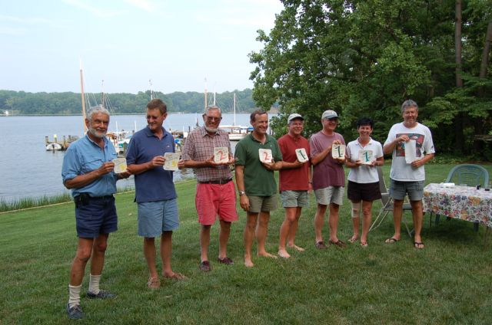
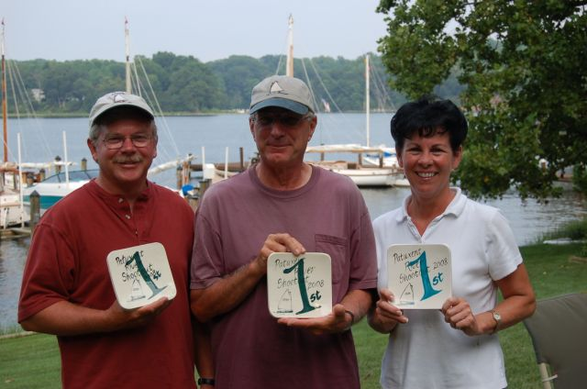
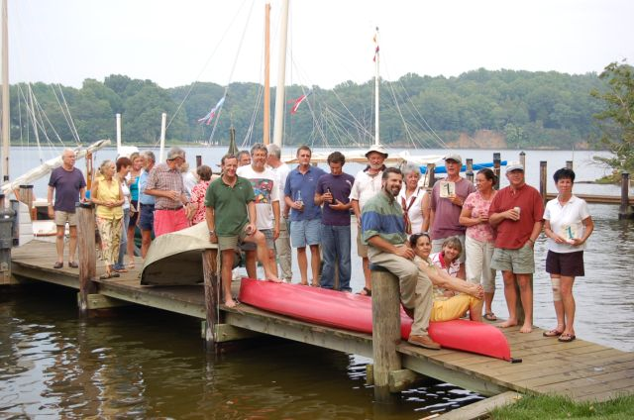
2008 Corsica River Races
26/27 July 2008
The Chesapeake Catboat Association continued its summer events with more racing and social cruising - just to get there sometimes. The most recent event was the CORSICA RIVER RACES for which our able reporter David E. Park submitted the following:
The Corsica River Races were held on 26 and 27 July at Conquest Beach Park in Centreville on Maryland ’s Eastern Shore. Winds cooperated this year and forced the catboats racing to reef at times during the four races held on Saturday, while on Sunday the winds blew a steady 10 to 12 knots that did not present that challenge. Two more races were completed that day under the more favorable conditions.
Winners based on handicap, average of 6 races were as follows:
Place Skipper Boat Make
1st Ben Heilman No Name Marshall 15
2nd Butch Miller Dusty Marshall 18
3rd David Bleil Gull Legnos 20
4th Mike Crawford Hamer Herman 17

Dinner this year was catered by the Phipps family of Kent Narrows Restaurant, who prepared an excellent meal of chicken, crab cakes and fresh vegetables. Turnout for the event was very good, with more than 80 boats participating in the event that brought together boats as diverse as catboats and catamarans. Sunday’s trip home was made exciting by an afternoon front that came through with rain and lightning but everyone returned safely to their home ports.
The CCBA has been known as "a loose concatenation of kindred spirits."... "with membership open to anyone discerning enough to recognize the unique qualities and beauty of the cat, even if they might own some other (ugh) type of boat."
2008 Great Whitehall Bay Race
31 August 2008

Out of the mist and into Providence Harbor they came – Wanderer, Gull & Caerulean. They, along with Patience, Dusty and Team Bradley’s Barnegat Bay Sneakbox came together to vie for the Capt. Bill Hoover Perpetual Trophy in the Great Whitehall Bay Catboat Race held on Labor Day weekend.
The usual suspects, David Bleil’s Gull, Marc Cruder’s Wanderer, Butch Miller’s Dusty, Butler Smythe’s Caerulean III, along with Deborah Keir’s Patience and John Bradley’s Barnegat Bay Sneakbox, arrived in Saturday’s steamy weather that ended with a brief but dry evening light show. Camp Bradley was thankful for the dry part. Sunday - race day - dawned with an azure sky and an unusual morning breeze, so the traditional Skipper’s Meeting breakfast of coffee and fresh donuts was dispatched quickly in order to get on the water before the gift of wind dissipated. But the start was delayed somewhat by the need to reset one of the newly acquired “can see ‘em for miles” marks that had wandered about 300 yds. downwind. The start on the triangular course was clean and racing was its usual challenge in the bay’s quirky winds. A wind chart would resemble iron filings dropped around a bar magnet with no south pole. The first time around went smoothly until the turn back at the start pin. Hails heard from the committee boat stating that it was ok to go through the line and not necessary to round the mark to port were heeded by Gull the first boat there, but rebuffed by the others who continued to round the mark so as not to foul. The reason for the “confused” race committee’s course change was soon discovered by Wanderer who promptly dragged across the hard bottomed shoal on the far side of the turn. It seems the pin had decided to take its gypsy brother’s lead and dragged until it anchored itself in the shallows. Both Gull and the race committee were later forgiven. Proper anchors will be club’s the next purchase. Racing was close, with a few lead changes and close crossings. Just enough wind held till the end for a fair finish to the event although Patience and the inseparable Team Bradley (captain and four crew in a 12’ boat) were stymied by their size due to the wind-blocking trees that line the small bay. Dusty crossed first followed by Gull, Caerulean III and then Wanderer. After the handicapping, Dusty placed first, Caerulean III second with Gull taking third place. Wanderer suffered from the dragging but took it in stride and offered suggestions for next year, and even though Patience and Team Bradley fell out of the running, both had a great day on the water.
Sometime during the day a shore-side comment was made about the conduct of some of the power boaters in the creek. It went something like, “If I lived here, I’d have to shoot someone.” Not long after, the sentiment was affirmed when two Hoover family members were capsized while rowing their skiff within the 6 mph zone. Fortunately, no one was hurt.
Libations and the presentation of the awards, including the Capt. Bill Hoover Perpetual Trophy, followed the race. The trophy was conceived to honor Bill for his character and contribution to the CCBA and catboating. The large plaque was built and donated to the club by Peter Legnos, and features a half-hull model of Gull, the “Legnos” Mystic 20 formerly sailed by Bill. Caroline Hoover has graciously presented the trophy for past three years.

The afternoon wrapped up with a tasteful potluck supper including Mary Dunn’s much anticipated shrimp dish. Caroline Hoover did her usual magnificent job of hosting the event at the Providence community clubhouse with the help from co-hosts Denise and Butch Miller. All who attended are grateful for a thoroughly enjoyable time. Special thanks also to Dave Park who made an 11 hr passage on Lyre from the Wye to be the able, if not always heeded race committee, and for his patience with those who doth protest.
Place Boat Skipper Make
1st Dusty Butch Miller Marshall 18
2nd Caerulean III Butler Smythe Menger 23
3rd Gull Jim Ohlmacher Legnos 20
4th Wanderer Marc Cruder Wittholtz 25

