2009 Races & Events
2009 Annual Meeting - Summary by Dave Bleil
Approximately fifty people attended this year's annual meeting of the Chesapeake Catboat Association on Saturday March 7 at the Severn Inn across from the U.S. Naval Academy. This year we had a separate room for our exhibits and the ability to conduct business without competing with the noises of the rest of the restaurant. Steve Flesner displayed a library of recommended reading for Catboat owners, as well as the exhibit of the text and photographs he had displayed at the Catboat Association meeting in Mystic, CT. The display contained photos of Maynard’s boat yard on Knapp’s Narrows and workshop on Tilghman Island, all nine of the catboats Maynard built along with detailed photos of the building of two Fenwick Williams 1 6’s, Catnipper (1 998) and Pyewacket (2008). The owner of Chessie Cat (1 980) a Fenwick Williams 21 built by Maynard, introduced himself and advised the group that the boat was now up in Southeast Harbor, ME undergoing repairs after sailing for years on the Chesapeake. Maynard used to say, “You tell those folks up in New England we build catboats down here.” Steve announced plans to donate the display to a maritime museum on the Eastern Shore. Hall Kellogg, director of the Tilghman Island Waterman's Museum was present to accept the donation as were several members of the Lowery family. Steve also thanked Dave Park, Marc Cruder and Peter Brewer for donating photos for his project.
The following schedule of events was discussed and agreed upon - others see above
- Poplar Island Restoration Tour 10 July 2009 Contact David Bleil 410-721-0375
- Sail-in & cookout on Whitemarsh Creek 11-12 July 2009 Contact: Marc Cruder 410-987-9616
Butler Smythe gave an update on the website and reminded everyone that if there are updates or changes, members should call him. He is able to post changes to the website very quickly. Remember that weather and other unpredictable factors can cause last minute changes. If changes or cancellations occur we will try to advise by email when possible but everyone should check the website http://Chesapeakecatboats.org before starting out if there is even a suspicion that the event might be altered. The website is the best place for up to the minute news of events, event changes and boats for sale. Various search engines including Google have cataloged our site so listing boats for sale on our web pages will generate worldwide exposure. Drawings were also held for prizes, including an artistically decorated trowel donated by Alane Ortega of Quarter Creek Co. Mosaics and a numbered print of Oscar Pease sailing Vanity, a scallop dredger, the last working Catboat in North America. The decorated shovel was won by John Brown and the print of Vanity was won by John Bradley and family.
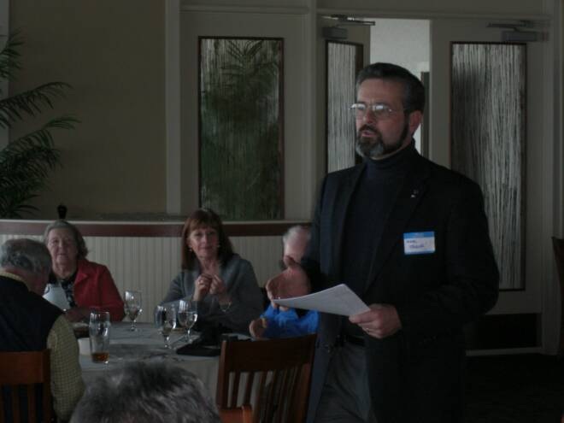
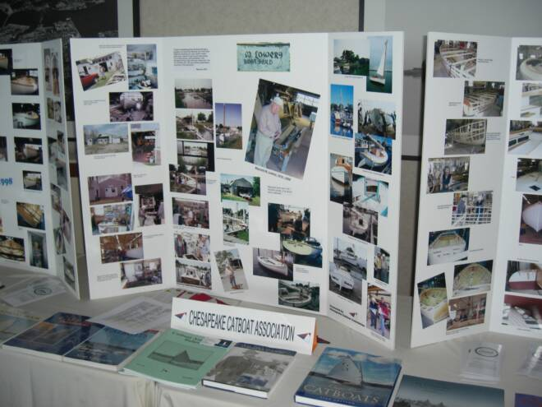
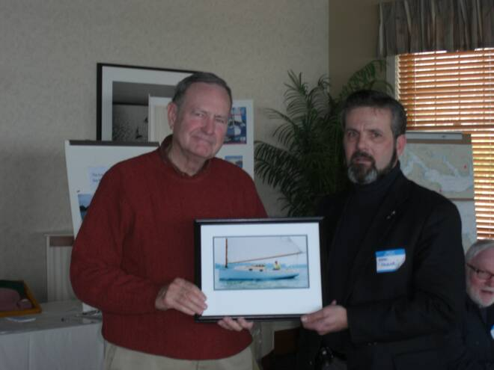
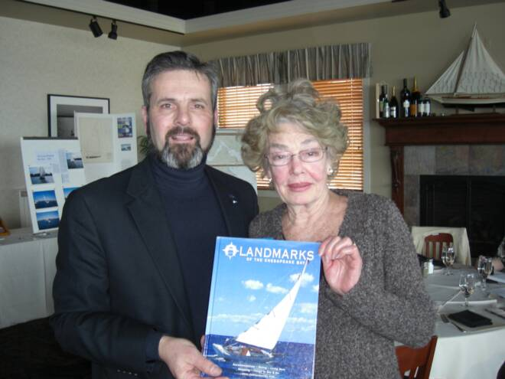
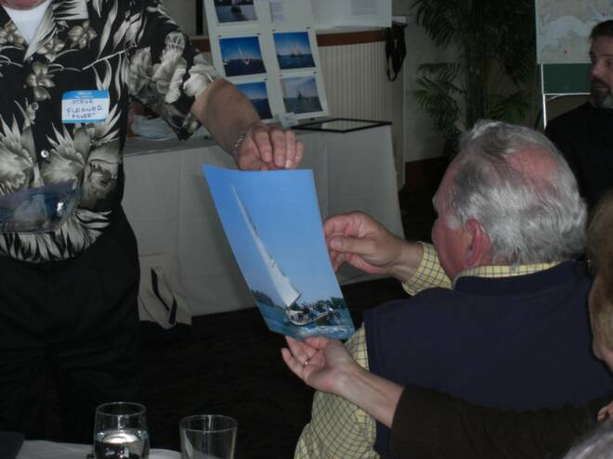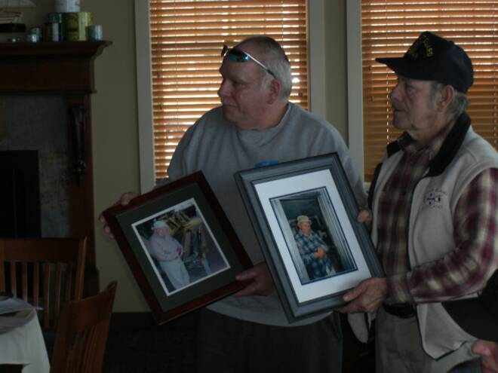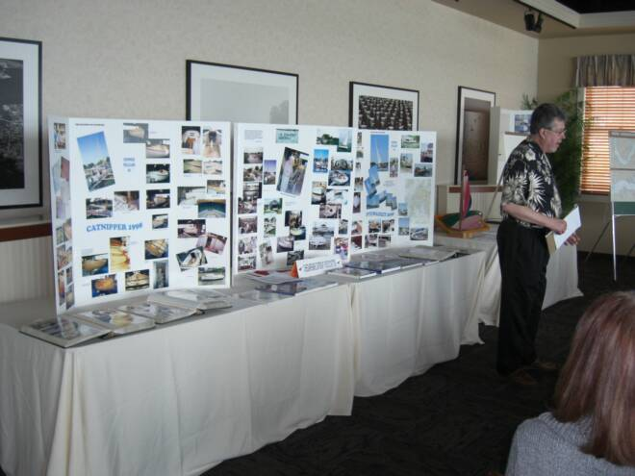

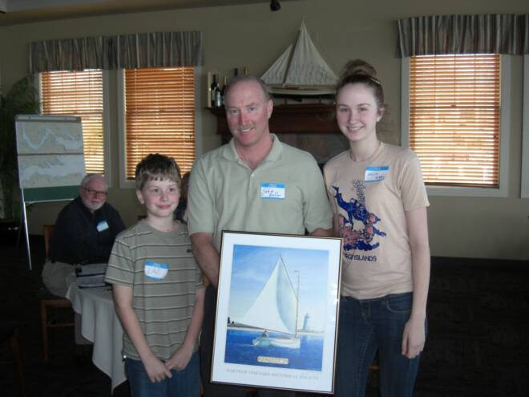
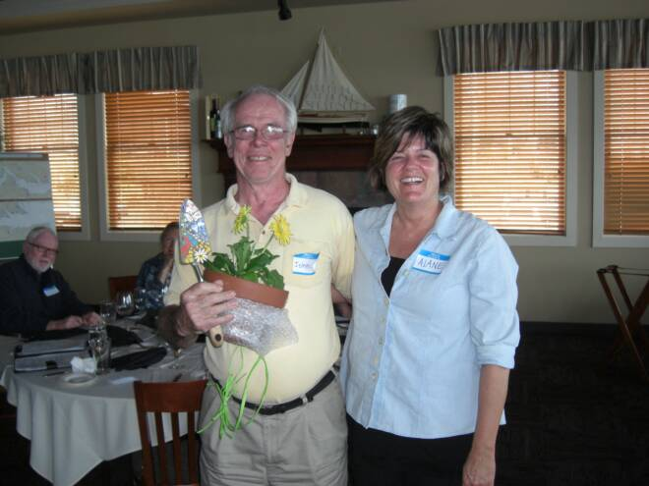

Patuxent River Shootout 2009 –
Summary by Steve Flesner

Or maybe it was the Patuxent Washout! Catboater’s gathered once again at the Flesner’s on St. Leonard Creek for a race and cookout. Gull, Wanderer and Pussy Footin’ had been prepositioned at the Flesner’s along with Tuckernuck and Scotty after the Lower Potomac Cruise the week before. Dusty (Butch & Denise Miller) arrived Friday afternoon followed on Saturday by Sun Shower, owned by Tom and Gretchen Morgan from Lynchburg, VA. Caerulean would round out the fleet. Unfortunately as Saturday dawned, the weather did its best not to cooperate. Severe thunderstorm warnings accompanied by high winds and lighting were forecast for most of the day. After a brief Captain’s meeting it was decided to postpone the race until Sunday AM, so with free time on our hands, some of us went over to Small Open Boats (SOB’s) in Port Republic. Ken Spring, the owner, was in the final stages of a restoration of a 1928 22 Square Meter racing boat known as Skeery Cruisers that was built by Abeking & Rassmussen. What a beauty! Long overhangs with a narrow pointed thin bow and a beautiful curved transom. Cast bronze fish and dolphins for cleats and a gorgeous teak deck with lots of bright work. She looked as if she could slice thru the water with no effort at all. It will soon be on a lift at a neighbor of the Flesner’s so we may get a chance to see her in action.
Catboat owners were joined by Tim & Jan Cobert, (Bay Pilot), Kent & Nancy Muntford (biologist and orchid grower), Brenda & Joe Clark, Deborah & Kenney Keir, Eric & Nina (IRS & TSA!) and Rob & Leslie Dale (South African sailors, woodworker and artist) along with the usual suspects from the cruise, Marc, Debbie & Matt Cruder, David Bleil, Jim Ohlmacher, Dave Park, and John Brown (farmer & OS). The North Carolina barbeque was a bit spicy, but it didn’t seem to slow anyone down! Good food, plenty of beer and wine and of course, catboat conversation kept the party going. Matt Cruder refused to be skunked after taking a day off from work (crew on the Woodwind in Annapolis) so he took Marc out on Scotty, despite the pouring rain with occasional sun breaks. Matt got the only sail in of the day, carrying on the Deborah Keir tradition of last year at the Shootout. Wet, but fun!
Captain and crew spent the night on their boats and arose a bit after O dark 30 to have coffee and prepare for an early race as most had to look forward to a two day cruise home. Unlike last year with no wind, the forecast called for 20 – 25+ kts with a chance for thunderstorms once again. Reefs were tucked in at the dock and the fleet headed out following the committee boat run by Steve’s neighbor, Ricky and his son Brian. Caerulean met us in the creek with a rather unsettling report of strong winds and high waves. Upon entering the Patuxent, all hell broke loose. Those who were sailing were flying almost out of control. A second or third reef would have been needed to cope with what we ran into. A squall line…read wall of water, was moving directly down the river toward the scattered cats as the committee boat attempted to anchor and began taking water over the bow…not good in a 23 ft. bow rider. Butler Smythe on Caerulean made the call with hand signals and no one asked for a second opinion! Once back in the creek, Wanderer, Gull, Pussy Footin’ and Dusty retrieved dinghies, put on foul weather gear and headed for a nasty day on the Bay. Butch Miller reported they made Slaughter Creek late in the afternoon, exhausted and hungry as few had time to eat during the crossing, especially those who were solo.
Marc Cruder reports on the crossing: After the race, it was a screaming downwind leg with “chicken jibes” to shape up for the bridge. Wind was strong and speeds high. Butler took the lead out of the creek on engine and the kept it. Last I saw of Sun Shower, it was on the southern shore headed south without sail just as the weather came through. We never saw them again but I’m sure they made it to Solomons (they did). Rounding Drum Point found us in heavy seas and strong northwest winds with a foul tide. With a reef up and engine full tilt, we found some stability on the first tack, but it was not looking good for a while. Even a catboat has limits under these conditions. I had to come off the wind so the sail would help the engine pull the boat through the seaway…and this was a day for more than just getting off the mooring engine power! We found some balance after a while and some lee on the far shore as we made long tacks up the bay until we got to the James/Taylor Island cut, where we finally came off engine and had the best sail of the day until we picked up the marks into Slaughter Creek. We had Pussy Footin’ and Dusty immediately behind us, while Gull eventually made the scene about an hour behind us in Chapel Creek. Everyone was on the hook by 6 pm with a strong north breeze in the cove all night for good sleeping…and those in the smaller boats (especially solo sailors) hit the rack early…despite it being the longest day of the year with light until about 9:30 pm. Even on Wanderer, though less harrowing, it was good to have a second person to relieve the helm on a regular basis. David Bleil on Gull described waves breaking over the bow, over the cabin and into the cockpit and his boots!
Day two has us up and out of there before 7 am. Winds were from the north, so better, and the seastate was nothing like the previous day where we were in foul weather gear all day. Wanderer and Pussy Footin’ power sailed, while Gull and Dusty powered only. As the day went on, the sea laid down and wind eased. John and I were tied up at Ponder Cove, packed up and headed home by 5 pm.
The weather got us last year and again this year. The 2009 trophies done by Rob Dale will have to be touched up for 2010 as none were given out! As Bill Hoover used to say…”we will live to sail another day.” I guess that about sums it up.
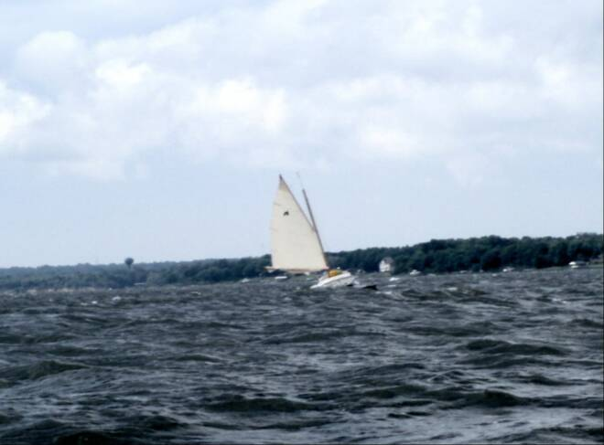
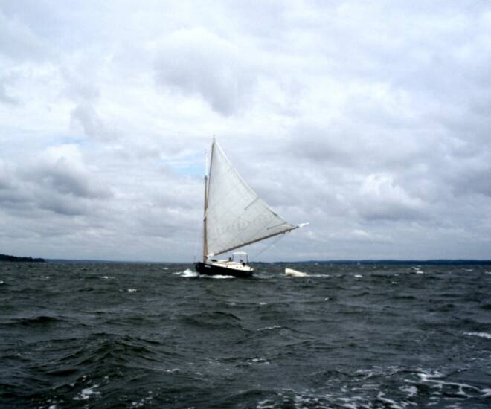
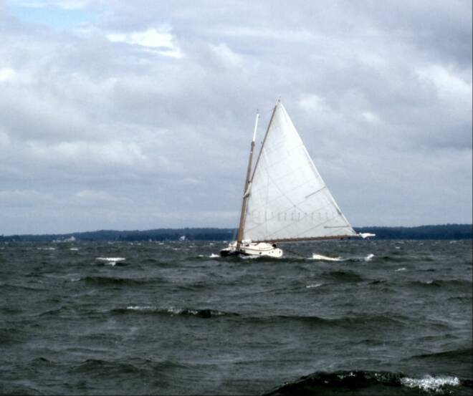
Corsica Yacht Club Races
25 & 26 July 2009
This year’s event was a combination of many type of catboats sailing and character boats, with good wind to severe conditions over the weekend.
A new attendee was Guy Beckly with wife Liz and crew Danny Marqise sailing “Patience” an 1898 Crosby from the upper Bay. She proved to be a capable sailor, despite her 111 years of age, and sporting the original low aspect main. Having sailed 65 miles to attend she was awarded the “distance” award.
As the following list shows, we had a nice variety of boats;
1st Ben Heilman Mistoffelees Marshall 15
2nd Rich McLaughlin Tenacity Marshall 22
3rd Marc Cruder Wanderer Wittholtz 25
4th Drew McMullen Kathe Beetle Cat
5th Guy Beckly Patience Crosby20
6th David Bleil Gull Legnos 20
7th Butch Miller Dusty Marshall 18
8th Mike Crawford Homer Wittholtz 17
9th John Bradley 1920 Sneakbox
10th Pete McCrary Anna Penobscot 14

Following dinner on Saturday evening, a strong front came through with high winds putting some boats aground, and fouled anchors on others. Sunday called for more heavy weather, and due to the distance
some had to travel an early departure was prudent. But as always, the CRYC did an excellent job of running the event, providing a wonderful meal, with live music, etc. My takeaway from this race, was when one of our members told
me that during the race Drew McMullen’s wife and small son were aboard, and the little boy was pulling his small toy boat behind the Beetle on a string. It speaks to the nice family atmosphere of this event. Hope to see more of you there next year!
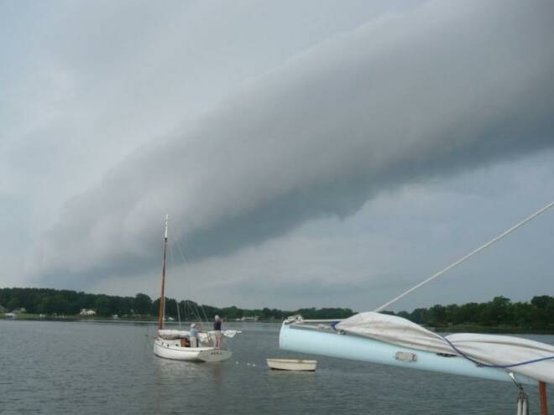

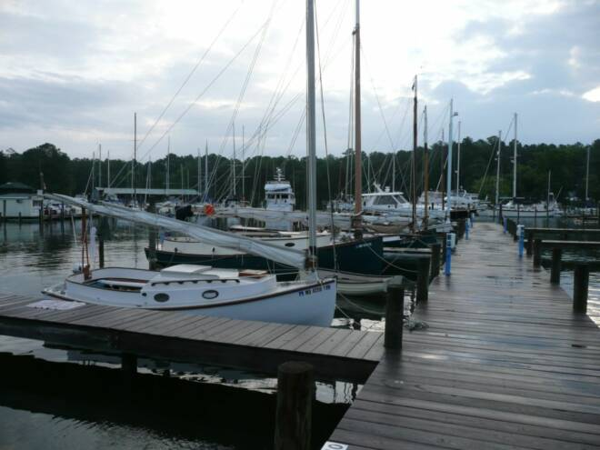

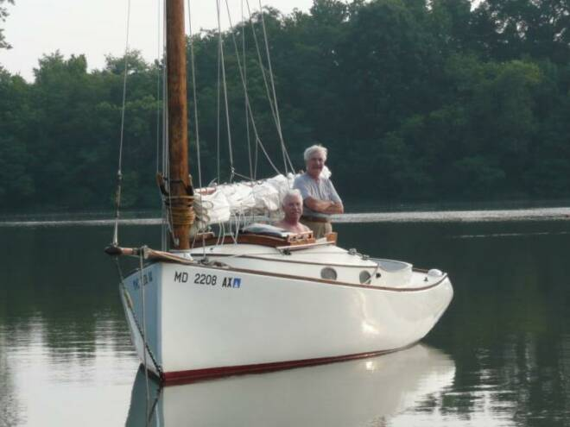
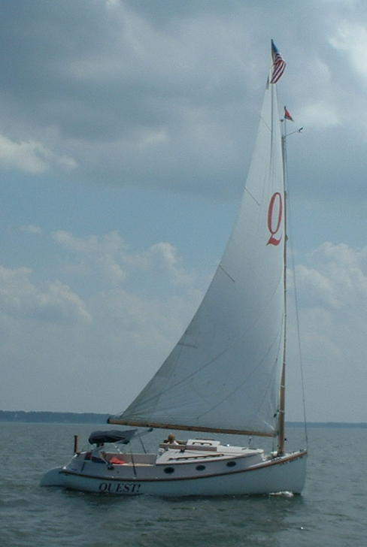
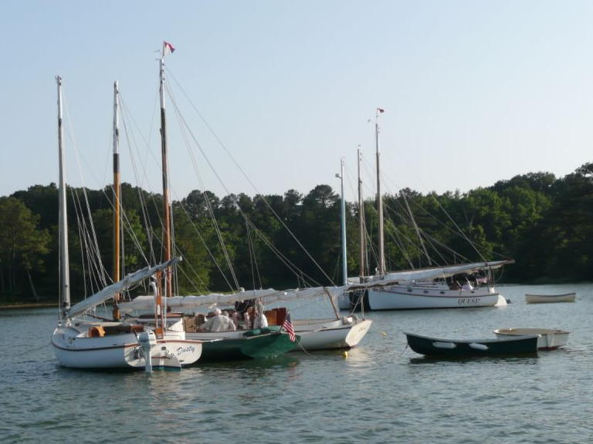
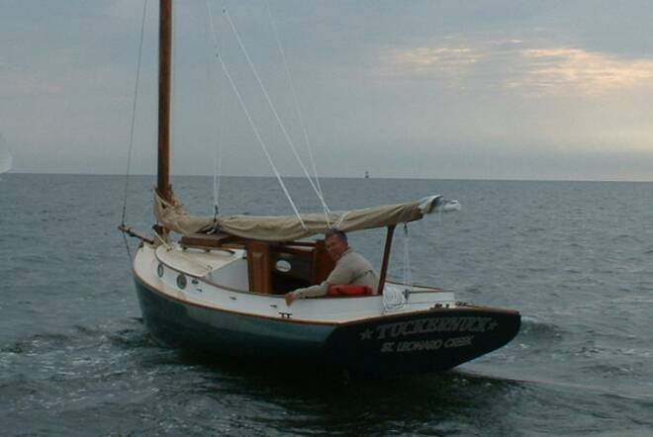

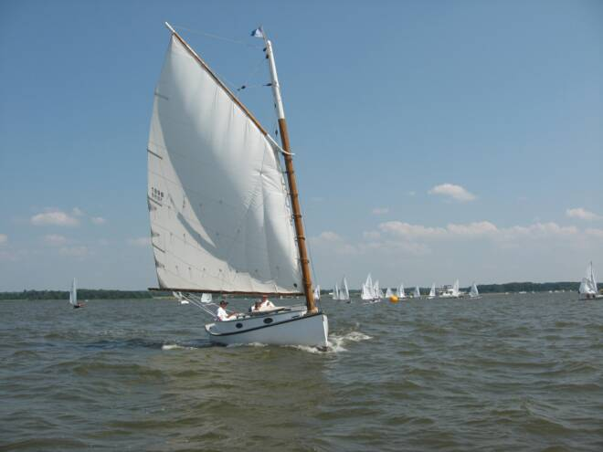
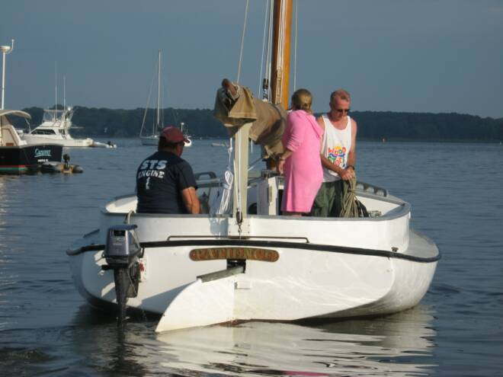
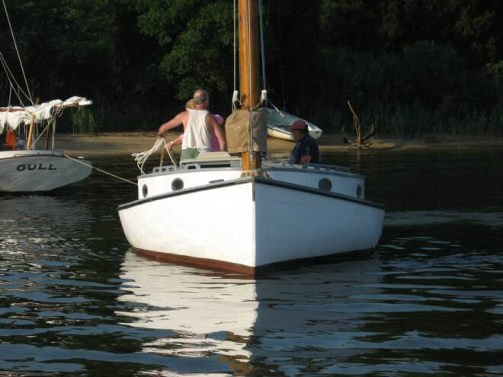
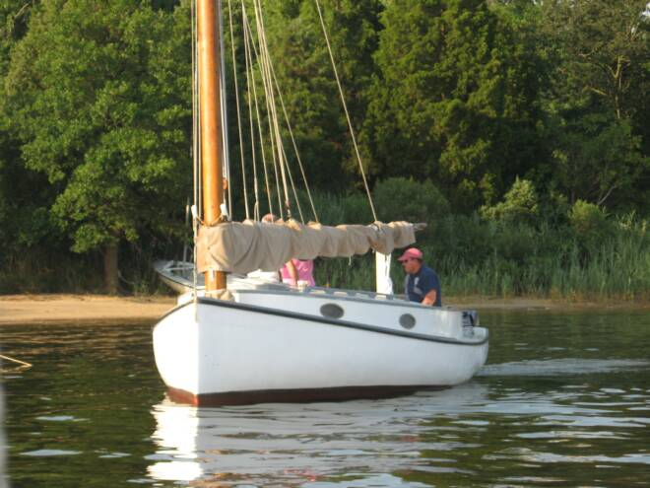
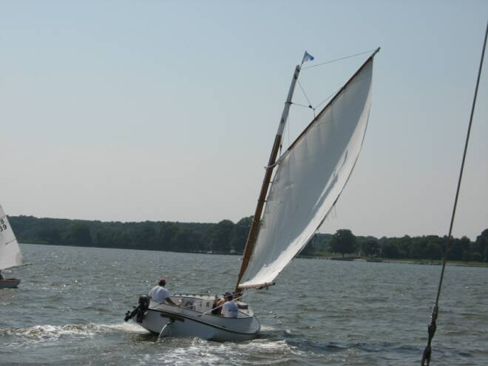
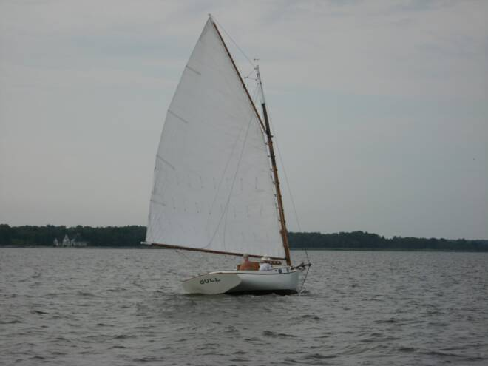
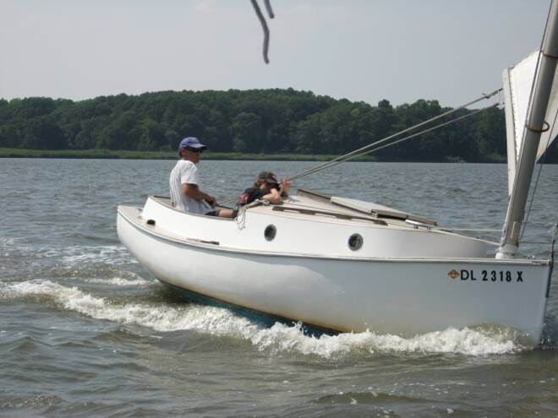
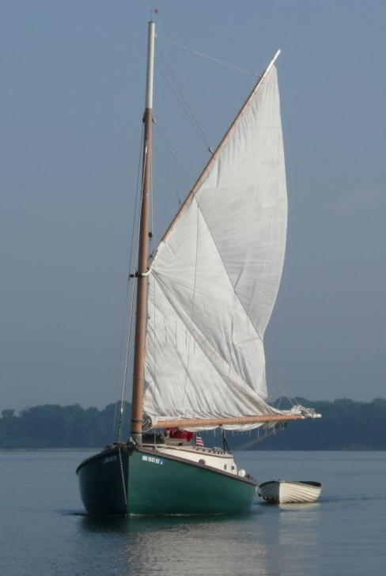
The Great Whitehall Race & Rendezvous – 2009
- Butch Miller
The year’s nineteenth running of the Great Whitehall Race proved to be one of the best in recent memory. Six boats participated in near perfect conditions - bright with the winds out of the NE around 10kts with occasional significant gusts, virtually no seas and a noticeable lack of powerboat wakes. Great conditions for our mix of cats.
Whitehall Bay was its usual challenge being a small body surrounded on three sides by a tree lined shore with a gap in the NE corner, a.k.a. “The Slot”, and a tidal current down the center. Playing the drift, headers and lifts caused by these features is an art form particular to this venue. The course layout was changed this year to a shorter more traditionally shaped triangular course allowing the option of one or more races of twice around, then up and down as the weather dictates. The race committee also managed to keep its commitment to have the marks remain in position. Although less interesting, pier dodging, groundings and sails through anchorages were mostly avoided. What would Bill think?
Peter Legnos made the trip down from Connecticut to join us again and to sail one of the local Mystic 20s against two others in a much-anticipated “Battle of the Mystics.” Unfortunately, due to weather and an errant thrust of a dipstick only Gull managed to post. Peter did manage to slide into a welcomed crew position on Gull, much to the rest of the fleet’s dismay. Hopefully, next year we’ll manage to get all three boats in the same place at the same time.
The weather allowed two well fought races having various upwind tacking schemes, a few lead changes, some mid-course “conversation” and two cats that lost their way.
The social half of the day was also a great success despite a surprise plumbing issue, which rendered the clubhouse unusable. Thanks to our intrepid co-host Caroline Hoover and the fine weather the Pot Luck was moved to the lawn and the clubhouse was never missed. The Capt. Bill Hoover Perpetual Trophy, a mounted Mystic 20 half-hull donated by Peter Legnos conceived to honor Bill’s character and his contributions to the CCBA and catboating, was presented to David Bleil for his first place finish. This was the first win for Gull at her former homeport in many years making it an even sweeter victory for David. The Pot-Luck again opened with Mary Dunn’s always anticipated shrimp dish. This year the soppers made it to everyone’s added enjoyment. It was noted that the clean-up was much easier on the grass.
An added attraction was the appearance of Chesapeake, the O’Malley’s new to them 1910 Bugeye Schooner. It seems their Marshall 22 was getting a little cramped for their changing style so they sized up to something that wields a hundred pound hook. She’s a beauty and some racers couldn’t resist stopping by for a tour on the way in from the course. She sailed down from Havre de Grace, a trip of over 40 miles as was Butler Smythe’s up from Solomons.
Of course there are many thanks to bestow. Many thanks to Caroline Hoover for her 19th hosting of the event and saving the day; to the Millers for co-hosting and to Dave Park for manning the committee boat and keeping the cats in order. Well, all but two.
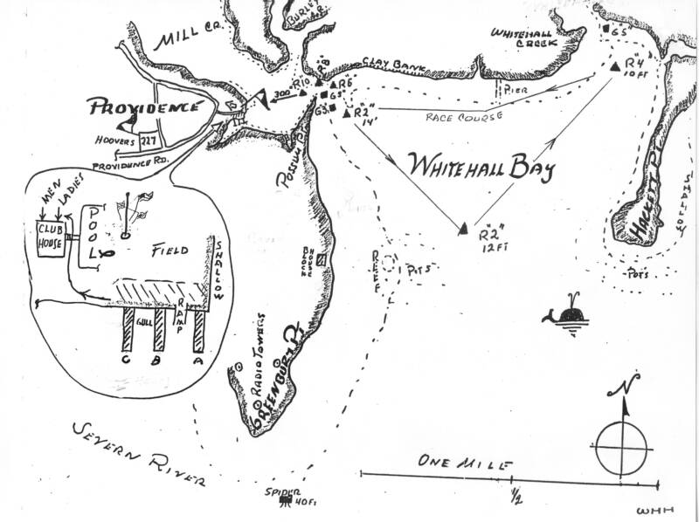
The Results:
Place Skipper Boat Design
1 David Bleil Gull Mystic 20
2 Steve Flesner Scotty Marshall 15
3 Marc Cruder Wanderer Wittholtz 25
4 Butler Smythe Caerulean III Menger 23
5 Butch Miller Dusty Marshall 18
6 Deborah Kerr Patience Handicat 14

2009 PROSPECT BAY CATBOAT REGATTA
– ROGER COMPTON
On an overcast Saturday afternoon in early September, three catboats hit the starting line for the last race of the summer of 2009. The wind was gusty and from the NNW. Between mechanical breakdowns, business trips, and parenting responsibilities, our normal seven to nine competitors failed to materialize. The good news was that everyone came away with silver.

The results were:
Place Skipper Boat Name Type Corr Time
1 D. Bleil GULL Mystic 20+21.24 m

2 S. Flesner SCOTTY Marshall 15 24.49 m

3 D. Bevin MARIAH Marshall 22 27.24 m

Following the race the competitors, their families, and non-competing members of CCBA enjoyed refreshments and fellowship at Jill and Roger Compton’s home. In addition to the trophy presentation for the 2009 PBCR, the Washington Irving “Tut” Tuttle Perpetual Trophy was presented to Dave Bleil and GULL for finishing first in the season-long series of CCBA sanctioned races in the Chesapeake Bay.

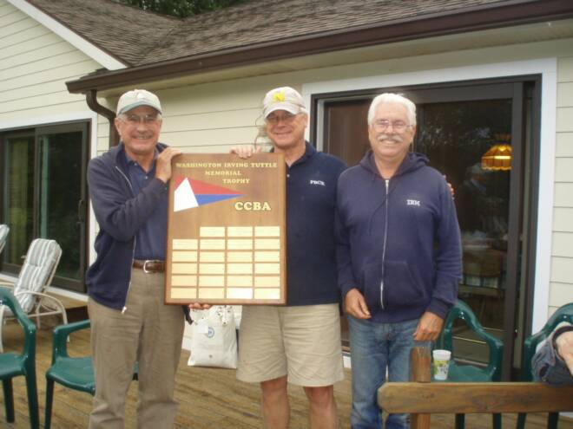

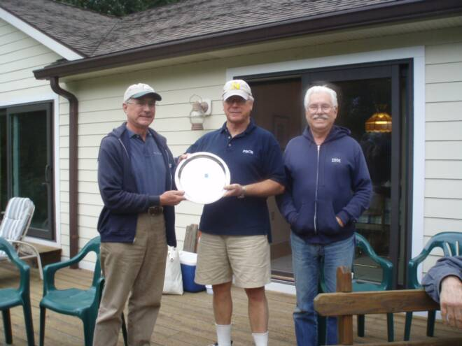1st
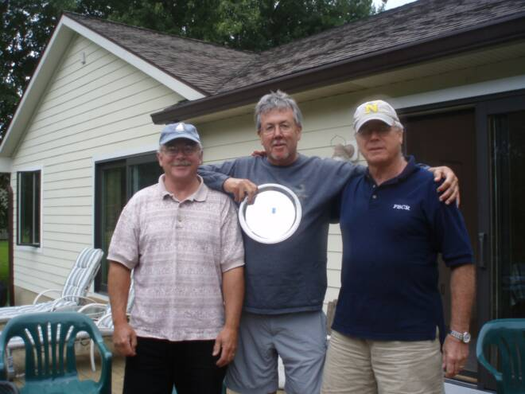2nd
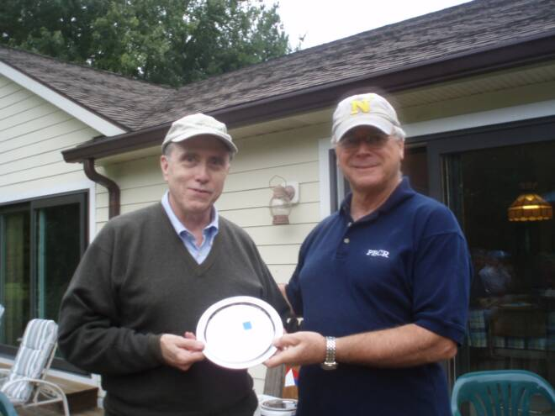3rd
