2011 Races & Events
Patuxent River Shootout 2011
By Butler Smythe

On the 3rd of July 2011 the Patuxent Shootout race committee (Butler Smythe) briefed the fleet of six catboats at the captain’s meeting held under the cool shadow of the Drum Point Lighthouse at the Calvert Marine Museum – the host again this year for the CCBA’s southern event. His request to Ken Spring on his wooden MacKenzie Cuttyhunk 26 Carole Anne (committee boat) was to make sure he anchored well and left plenty of room for racers to tack if necessary on the line. Since we had no idea what the wind would really be like, the instructions would help ensure most could tack to some degree with little to no wind. He performed that job admirably throughout the long race and did a perfect job of all his duties.

Following the meeting Butler headed out to set the one inflatable mark across the river – the rest being day marks, or in the case of the start line, a mark used by one of the local sailing clubs for starts. The long course (picked because of the wind speed) was approximately 6.5 miles - starting off the Solomons boardwalk, across the river to the Navy sailing Basin and out to a green day mark just south of Drum Point itself and return. Given the wind and tacking required, the course would take a bit over 2 hours – for some. Taking a bit longer than planned to get back across the river and for others to get in position, the start was shifted 10 minutes to allow all to hear the 15-minute sound with sails set. Though Caerulean III (Menger 23) had a perfect start, she was passed by Whiskers and Rejoice (Nonsuch 22s) before the first mark as the wind established its routine for the day of being fluky and sometimes erratic. After Shoveller rounded the first mark (winds were not helping), Ken retrieved the mark and got back to his position on the line enjoying the hot sun and bouncing wakes of passing powerboats – big and small.

The second leg was interesting as some chose to maintain a tight course on the wind while others chose to ease their course for more boat speed. Some wondered just where they were actually going. For some, the choice to try and get speed was not the right one as the day’s wind failed later that afternoon leaving the last boat fighting to cross the line. Whiskers, Rejoice and Caerulean III chose the straighter line, which then became a battle between the two Nonsuch’s, and for a short time the Menger 23.
Marc Cruder on Wanderer chose boat speed and closed on Caerulean III close to the second mark, starting a short tacking duel. They could not catch the two Nonsuch’s that had already rounded the second mark and were off on their downwind leg to the finish.
Caerulean III rounded the mark a little ahead of Wanderer, but on the last leg (downwind) pulled ahead by about 100 - 200 yards. Scotty and Shoveller who had headed off the wind did not fare as well ending up getting caught in the lighter winds that started to affected the fleet. Whiskers established a commanding lead to the finish over Rejoice and finished out of sight of Caerulean III as it cleared the red day mark off Solomons to head to the finish. Though not an official mark it was instructed that all river day marks be honored. The end of the island blocked the finish from view until clearing the day mark and gave more variety to the course as most had to jibe to make the finish line. First across the line was Whiskers followed by Rejoice and Caerulean III further behind was Wanderer was who was the next to finish. Scotty crossed and then Shoveller who was much further behind having apparently snagged a crab pot near the second mark. Ken on Carole Anne waited for Shoveller to finish after the rest were safely moored at the museum basin and sipping on beers.

While the crossing of the line and the distances involved may have appeared an easy means of accounting for actual place positions, the corrected times proved something different and the Results follow. Thanks to all for participating and the wind that wasn’t so bad this year.

The Results:
Place Skipper Boat Design
1 Marc Cruder Wanderer Wittholtz 25
2 Butch Garren Whiskers Nonsuch 22
3 Butler Smythe Caerulean III Menger 23
4 Steve Flesner Scotty Marshall 15
5 Alan Suydam Rejoice Nonsuch 22
6 Mike Crawford Shoveller Fenwick Williams 25

Following the race the racers, their crew and other participants gathered under the Drum Point Lighthouse for appetizers, great food and even two Smith Island cakes (7-layer) brought in special from the last inhabited island (accessible only by boat) in Maryland. Awards were presented and the 1st three place finishers, as well as our committee boat Capt. are depicted in the photo below.
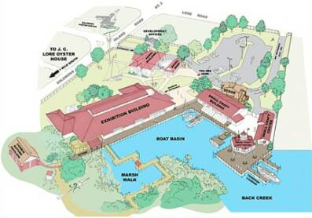
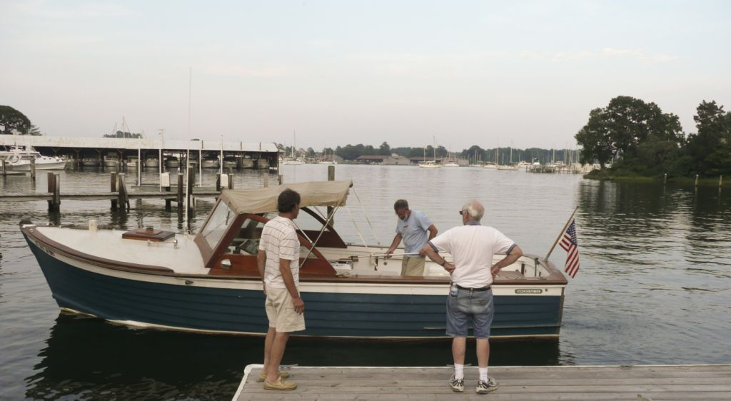
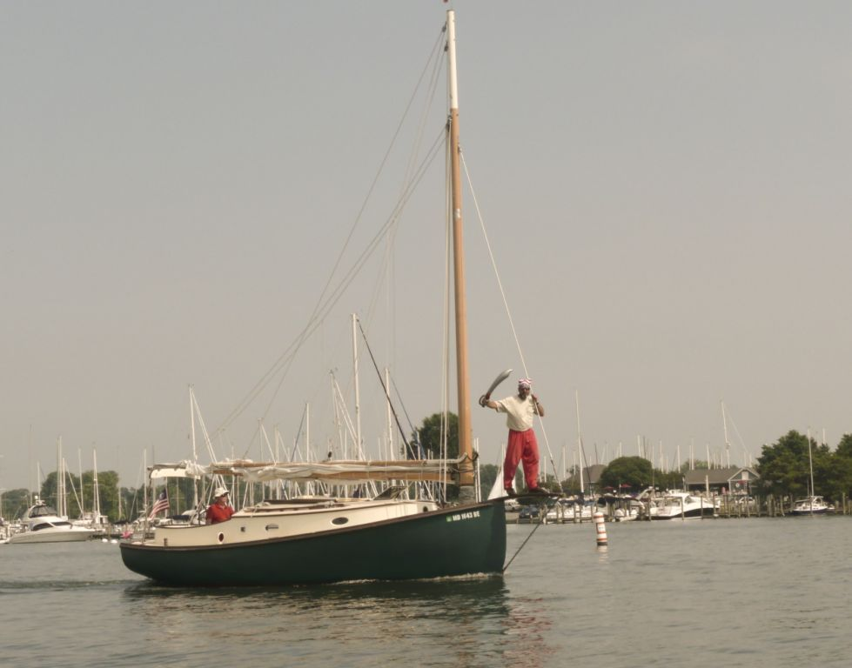
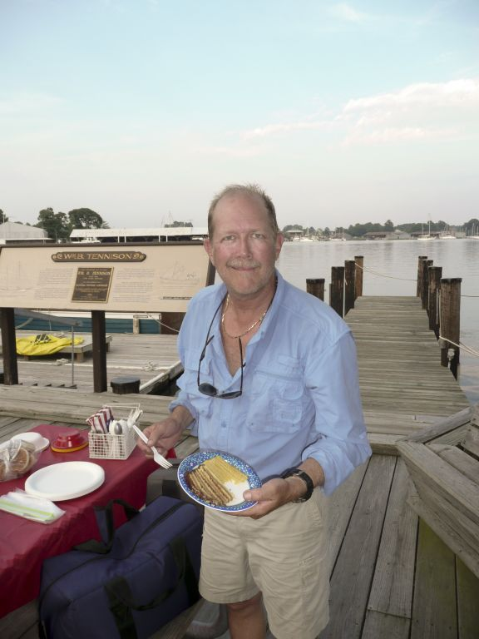
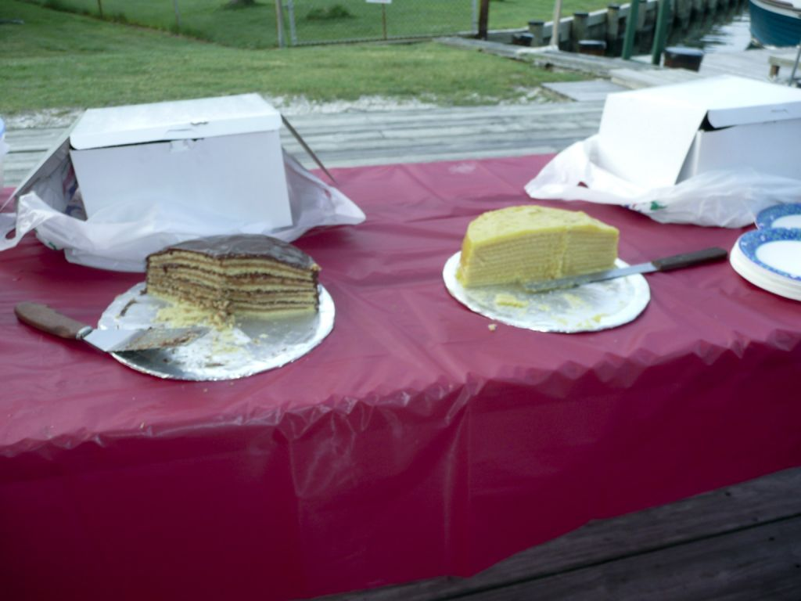

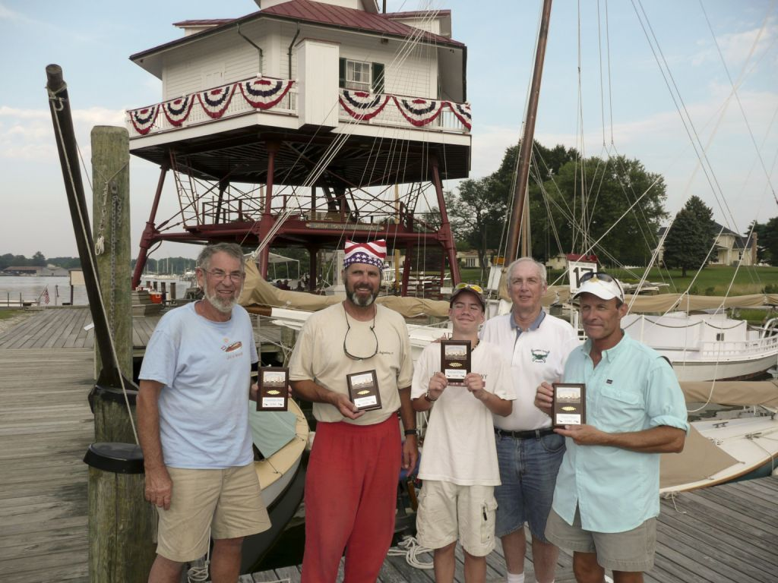
Ken Spring – Committee boat
Marc Cruder - 1st Wanderer (Wittholtz 25)
Scott Garren – Grandson of Butch Garren
Butch Garren - 2nd Whiskers (Nonsuch 22)
Butler Smythe - 3rd Caerulean III (Menger 23)
Photos by Steve Flesner
CORSICA RIVER YACHT CLUB Races
by Marc Cruder
Corsica River Yacht Club held it's 70th Annual Regatta on July 23rd and 24th, finally returning the event to their Ship Point facility directly on the Corsica River. Arguably the hottest weekend of the summer with a record temperature of 104 degrees on Friday "get to the race" day, attendance was markedly down in all classes but three catboats arrived to ensure the "ponderous" class raced. WANDERER (Wittholz 25) and crew motor sailed seven hours before heaving to at the Rock Hall Yacht Club, three miles west of the race venue on the other side of the Chester River. Reaching the end of our capabilities to regulate body temperature, we were the guests of Rich McLaughlin and Mike Crawford. Mike brought SHOVELLER (Fenwick Williams 25) around from Grays Inn Creek to be the second participant at Corsica the next day. The facilities at Rock Hall Yacht club included much appreciated air conditioned shower facilities, that started the cool down process on the way to the club facilities run by Joy, the resident bar maid, who "refreshed" us further with mandatory ice water soaked bar rags to wrap around our necks while she prepared frozen libatious concoctions to adjust our attitudes once we were hydrated again. We were later joined by CCBA members and past Rock Hall Yacht Club Commodores Don and Mary Dunn as we continued to enjoy the air-conditioned surrounds while sampling the well executed and reasonably priced fare from the kitchen. Suffice it to say seafood salad sandwiches and crab cakes went a long way to restoring our energy and getting us focused for racing the next day.
We anchored out for the night and slept on deck, getting an early start the next morning before the sun got too high. At Ship Point we were joined by CBA member Ben Heilman in MISTOFELEES (Marshall 15), being sailed this year by his grand daughter Emma and crew. So it was the battle of the 25's and the 15. We enjoyed 5-8 kt winds with no noticeable influence from the tide at the mouth of the Corsica, a usual characteristic of this regatta when held off Conquest Beach requiring local knowledge. The race committee challenged us with an interesting course of windward, leeward thru a gate of marks with optional left or right turn, then finishing to windward. The big boats dominated the first day of four races, but MISTOFELEES was onto us by the third race. She finally showed the speed Marshall 15's are known for with light winds and the highest CCBA handicap further working on her side.
Saturday evening's festivities included live blue grass music and traditional Eastern Shore cookout focused around the 4 C's...chicken, corn on the cob, cole slaw and cantaloupe. CCBA members who left their boats home to duck the heat, joined us in person for dinner including Dave Bleil and Jim Ohlmacher of GULL (Mystic 20+) as well as Denise and Butch Miller of DUSTY (Marshall 18). Although the beer truck was on the premises, GULL's crew supplied Dark and Stormies in true CCBA tradition and a good time was had by all. While the heat stayed with us, it was tapering off with each passing hour. The big cats were rafted up and another pleasant night in the cockpit with a nice breeze and no insects allowed us to rest.
Although we could have used the mid-sized cats to round out the field, it was great overall racing with clean starts and all finishing with no protests or mishaps with the other racing classes. There was one-second call of "starboard" which kept a few Comets from becoming splinters in way of WANDERER's cockpit, but all in all a good two days. Emma took her place on behalf of Corsica River Yacht Club and continued her lead on Sunday. While the big boats almost came close a few times as the wind piped up to a blistering 10 knots, it simply wasn't enough and on balance we just couldn't catch her. With MISTOFELEES taking first for both races on Sunday, their first place finish over six races was secured. WANDERER took second place honors and SHOVELLER rounded out the field in third. Not surprisingly and handicaps aside; as wind speed picks up, the heavier boats do better and as wind speed drops, the big boats slow down first.

WANDERER left from the racecourse getting a jump on the gathering thunderstorms while the rest gathered for awards. Poking in and out of weather, we shaved a half hour off our transit time home to 6.5 hours. Another great weekend on the water and well worth it on all counts. Friday night at Rock Hall Yacht Club was also a keeper.
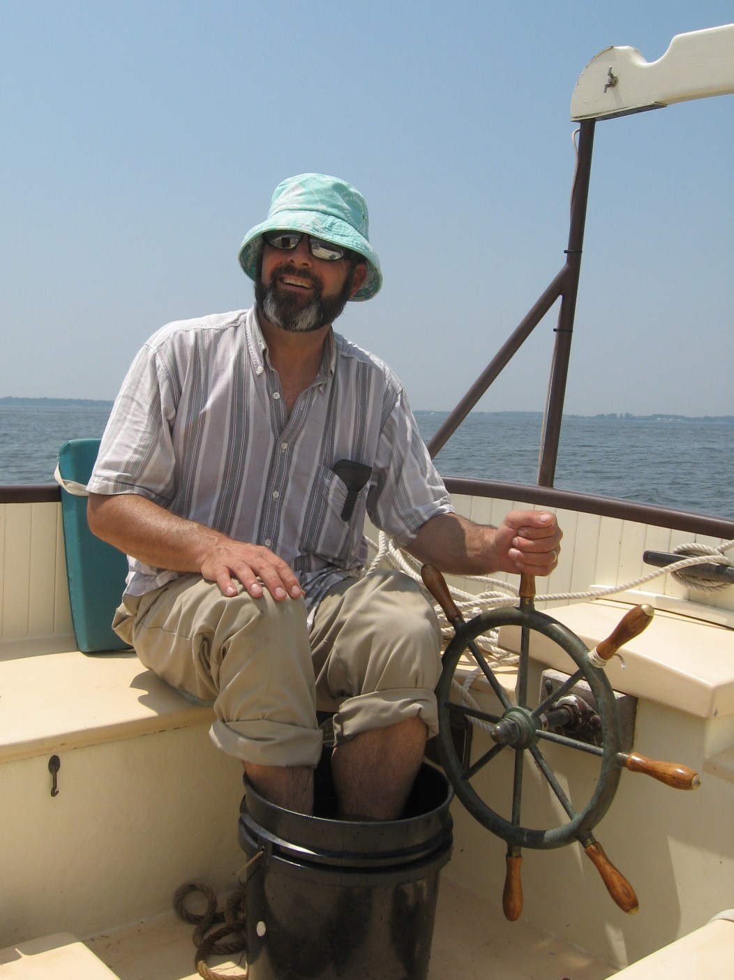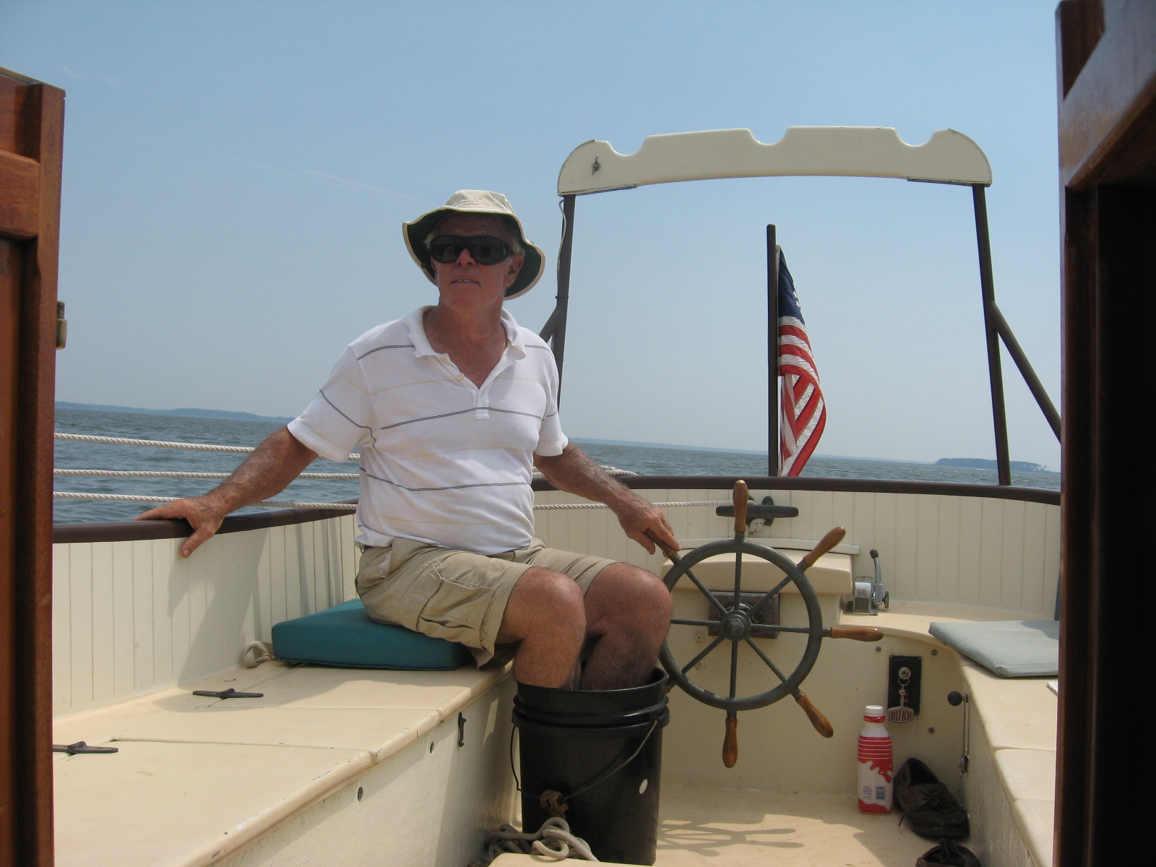

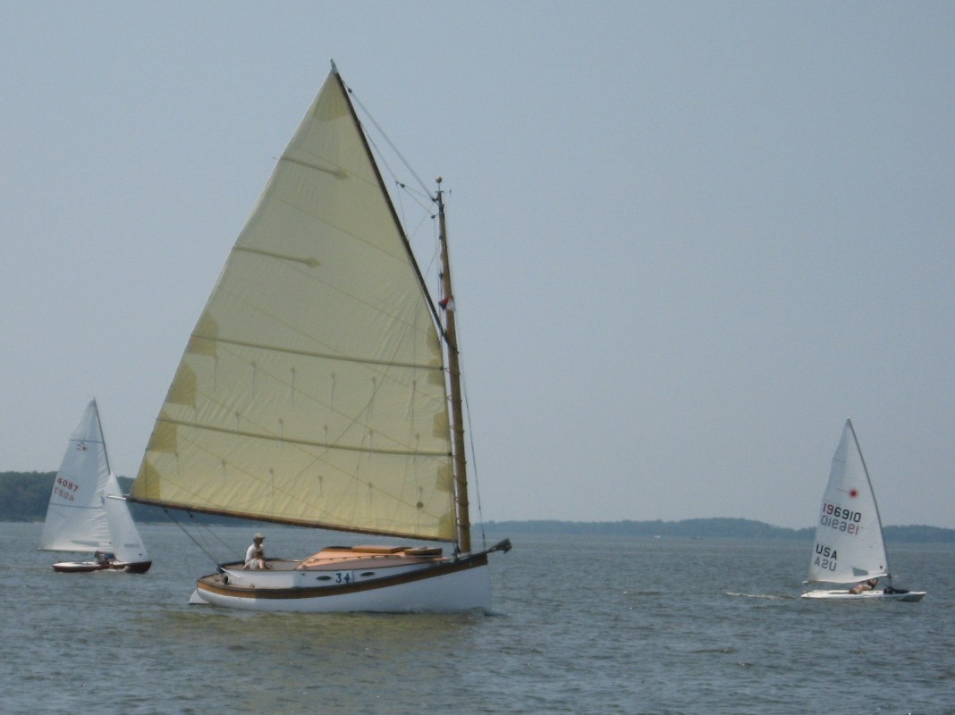
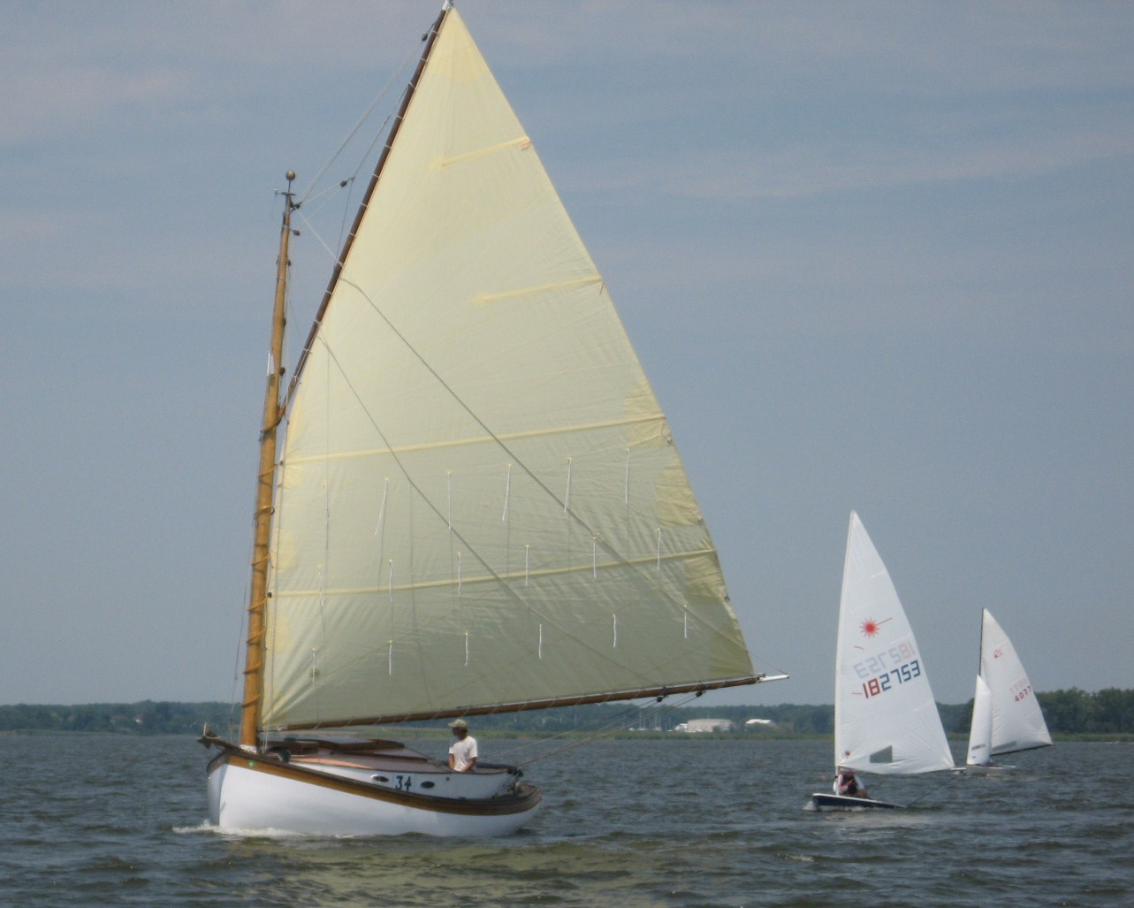
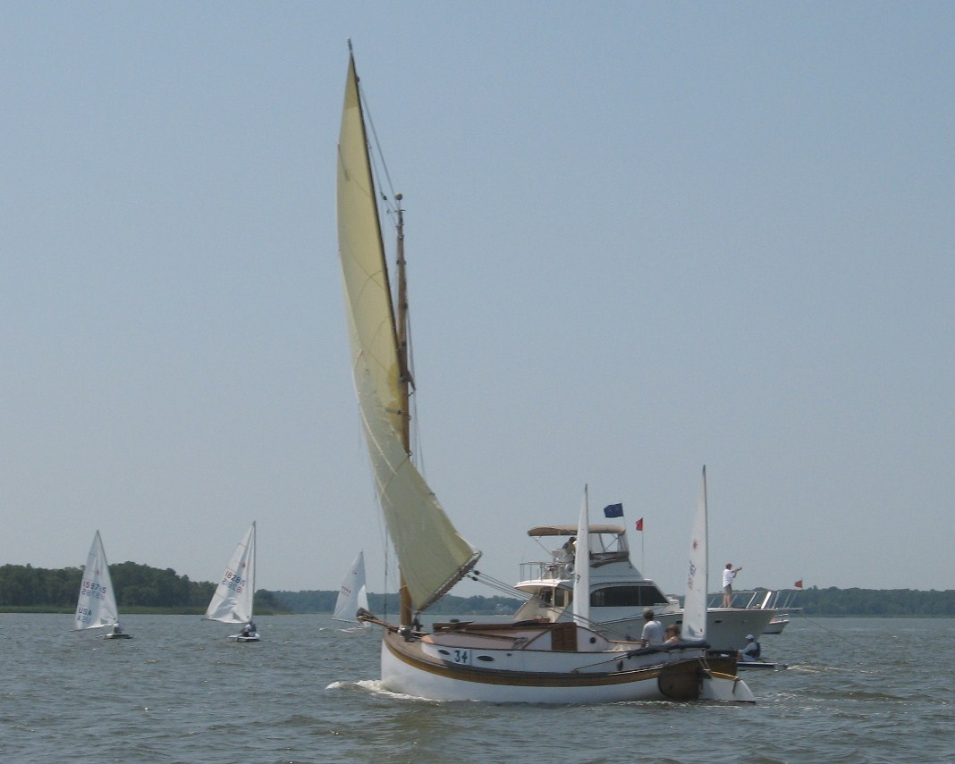
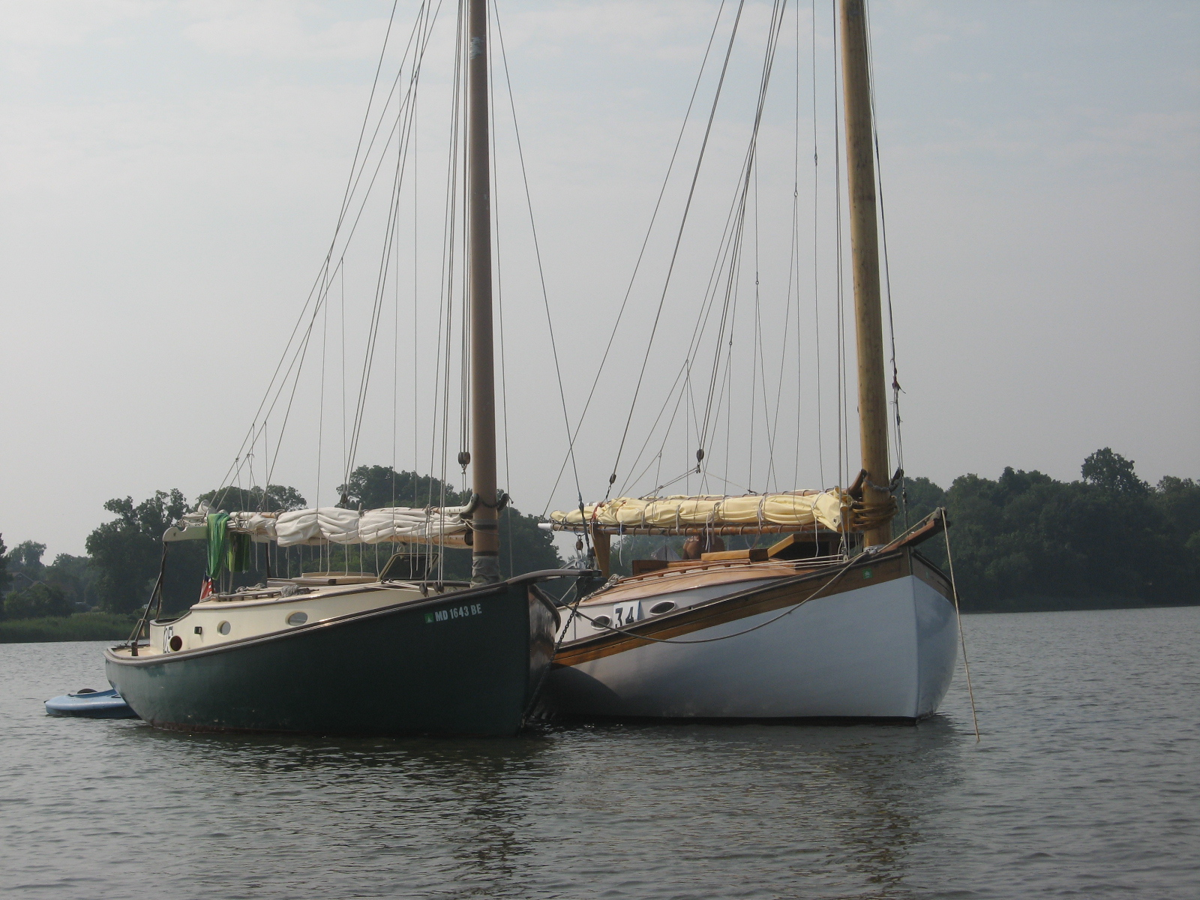
Prospect Bay Catboat Regatta 2011
By Roger H. Compton

After an almost perfect event the previous weekend with nine boats and a steady southerly breeze between ten and fifteen knots, this year’s Prospect Bay Catboat Regatta (PBCR), held on Saturday, September 10, was a big disappointment with four (of an optimistically predicted seven) boats and virtually no wind. Its events like this that make it obvious why commercial and military ships rely on mechanical power systems!

Four brave, or masochistic, catboaters crossed the starting line at 1430 in shifting and mostly non-existent wind – generally from the west (plus or minus 50 degrees). An equally misguided race committee (Roger and Jill Compton) had set a seven-leg course earlier in the day. When it became apparent that the first boat would barely round the first mark by 1530, the course was shortened to a simple windward-leeward one.

The results of the 2011 PBCR are as follow:
PLACE BOAT SKIPPER DESIGN
1 Gull J. Ohmacher Mystic 20
2 Dusty B. Miller Marshall 18
3 Wanderer M. Cruder Wittholtz 25
4 Sarah K. D. Park Herreshoff 18

The competitors and the race committee, well sunburned and ready for a shower, retired to the Compton’s dock and deck to socialize with families and fellow catboaters who had not been willing or able to participate in the afternoon’s racing excitement. Good fellowship and food were followed by the presentation of awards. As the PBCR is the last competitive event in the Chesapeake Catboat Association’s annual schedule, the association’s cumulative season trophy, the Washington Irving (“Tut”) Tuttle Memorial Trophy was awarded to the skipper with the best season-long racing record. This year, for the third time, the honor went to our Commodore-Without-Portfolio, Marc Cruder in Wanderer. Marc sailed and did well in every competitive event on our 2011 schedule. Congratulations, Marc!

Small Craft Festival St. Michaels 10-01-11
By Dave Park

This year's event began with a weather front from Canada, dropping temperatures 30 degrees overnight. Participants at the show , many campers in tents put on the usual fine show of both home built, and professional offerings. Following the show on Saturday, the following members of CCBA met at the beautiful home of Dave and Maryanne Bevan, for a jovial eat and drink.

Those attending were; Butch Miller. Roger and Jill Compton, Nancy and Dave Park, Jim Ohmacker, David Bleil, Jack Smith, Larry Antonik, Kerry and Cris O'Malley, and Martin Gardner who joined us from Venice California !

It is always a nice way to close out the Boating Season, and a great excuse to meet with our boating friends as we begin to think about pulling the boats, and beginning the winter projects we have chosen.

Our thanks go to the Dave and Maryanne Bevan for once again opening the wonderful home to us, with it's breathtaking view of St. Michaels Harbor.
Great Whitehall Bay Race 2011
by Butch Miller

The twenty-first annual Great Whitehall Bay Catboat Race & Rendezvous was held Sunday August 28, 2011 at the Providence Yacht Club in Annapolis Md. Begun by the late Capt. Bill Hoover on his home waters in Annapolis MD, this event is traditionally the CCBA’s most popular of the season. Caroline Bill’s first mate, has strived to continue the tradition by graciously hosting the event since his passing in 2005.

New to the event this year were Craig Ligibel and Jim Doherty in Mystic Wind, a Mystic 20; back from New York after many years were Roger and Jill Compton with Pussy Footin’, Mystic 20 and Dave Park brought his latest rehab project Sarah K, Herreshoff 18. Rounding out the nine-boat fleet were Caerulean III, Menger 23; Dusty, Marshall 18; Gull Mystic 20; Paws, Areys Pond 14; Sarah K. Herreshoff 18; Scotty Marshall 15 and Wanderer, Wittholz 25. Watching three Mystic 20's sail together was a rare treat.

The weather was ideal for our mix of boats with steady but fading winds 12-18kts out of the south and through the open end of the horseshoe shaped bay. Much to everyone’s delight the unusual southerly direction negated the influence that the tree lined shore has on the course. A short triangular course of twice around then up and back was set and two races were held. While there were a few position changes in the middle of the pack and many close crossings, finishing positions remained nearly identical in both races. Caerulean III again showed her speed and if memory serves stayed out in front all day, at least it felt that way. After application of the handicaps, Paws took the honors followed by Pussy Footin’, then Wanderer.

Caroline’s Mars and Tonic Bar was opened following the race setting the mood for the award ceremony where the Capt. Bill Hoover Perpetual Trophy, a mounted Mystic 20 half-hull donated by Peter Legnos, was presented to Richard Rogers and his daughter Jessica. Cups were presented to Roger and Jill Compton for second place and to Marc Cruder and John Brown for third.
Although the remnants of hurricane Irene threw us into picnic mode with the many downed wires in the Providence neighborhood, the lights came on just in time for the Pot Luck. Many sweet and savory dishes filled out the main course of Popeye’s finest. Unfortunately, the Dunn’s weren’t able to make it and Mary’s “Shrimp and Soppers” were sorely missed, and so were they.
Many thanks to Caroline Hoover putting the event together once again and for the dedication she has put forth to continue the tradition of this special event. Also, thanks to the Millers for co-hosting, including Chip for manning the committee boat.

The Results:
Place BOAT SKIPPER DESIGN
1 Paws Richard Rodgers Areys Pond 14
2 Pussy Footin' Roger Compton Mystic 20
3 Wanderer Marc Cruder Wittholz 25
4 Caerulean III Butler Smythe Menger 23
5 Gull David Bliel Mystic 20
6 Dusty Butch Miller Marshall 18
7 Mystic WInd Craig Ligebel Mystic 20
DNF Scotty Steve Flesner Marshall 15
DNF Sarah K. Dave Park Herreshoff 18

