Updated Fall
2015
Chesapeake Catboat Association

08
Fall

Cruise Summaries by Marc Cruder
Chesapeake Catboat Association (CCBA) LONG CRUISES from 2004 to 2015
Photos by Various Cruisers….

Table of Contents
CRUISING THE UPPER CHOPTANK - 2004 3
CRUISE TO HISTORIC ST. MARY’S CITY - 2005 11
CHESAPEAKE CATS TO THE SUSQUEHANNA FLATS - 2006 22
DOWN BAY CRUISE TO DAMES QUARTER - 2007 35
BALTIMORE NAUTICAL ARCHEOLOGY CRUISE - 2008 46
CCBA CRUISE POTOMAC RIVER - 2009 56
CCBA MID-WESTERN SHORE CRUISE-LITE - 2010 63
CCBA SMITH ISLAND RUN - 2011 72
RAFT UP ON THE SASSAFRAS - 2012 79
RETURN TO THE LITTLE CHOPTANK - 2013 88
CRUISE TO THE BOHEMIA BAY – C&D CANAL OR BUST– 2014 99
FREE RANGE CATBOATING ON THE CHOPTANK - 2015 108

CRUISING THE UPPER CHOPTANK - 2004
By Marc Cruder

Introduction
This year’s cruise took us beyond sailing, to include a leg under power to the upper reaches of the Choptank River. This scenic part of the river is frequented by few, much less sailboats. Typical of Maryland’s larger rivers, it was deep as far as we took it, but got narrow and winding with a healthy current as we made our way along. Before the Bay Bridge, towns along rivers like the Choptank were served by steamboats out of Baltimore that moved the produce grown by farmers along these rivers to market. Although not the head of the river, some 30 miles from the bay is the town of Denton, once a busy steamboat stop owned by the Maryland Steamboat Lines and called Joppa Wharf. The restored wharf and terminal building is home to the Old Harford Maritime Center and our cruise destination. Seven catboats with skippers from 14 to 81 years of age made the trek, and as promised, the big cat made her first Chesapeake Cruise. Weather was exceptionally good, sailing was hearty at times, the river was pristine, the swing bridge didn’t get stuck and the bugs stayed home. Here’s how it went….

Returning Cruisers
- Bill “You can’t sail against the dang current” Hoover sailing GULL - Mystic 20.
- Marc “I didn’t tell you to put your sail up” Cruder with crew John “I’m ready to go ashore Captain and just want to be sure you don’t need me when we tie up” Brown sailing WANDERER - Wittholz/Prudence 25.
- Dave “I’ll take a dark & stormy” Bleil and crew Jim “Secret nettle repelling formula on and I’m ready for a swim” Ohlmacher aboard MELVIL’S MOUSER - Herreshoff 18.
- Don “That is not precisely what I said” Dunn sailing GRANMARY - AC 21.
- Keith “M-R Ducks (Y-I-B)” Johnson sailing MIZ CHIEF - Herreshoff 18.
- Butler “I prefer to park in the valet lot” Smythe sailing CAERULEAN - Menger 23.

New “Solo” Cruisers
- Matt “Why does the cabin smell like gas” Cruder and crew Danny “I think we should sleep on deck tonight” Brown sailing SYLPH - Wittholz/Hermman 17.

Cruise Support that met us in Denton:
- Dave and Nancy Park, along with Tom and Sarah Beall brought us some unexpected fresh food and delicious deserts while explaining why their boats weren’t with us.
- Jack Smith, who usually finds the nearest boat ramp, but came for the camaraderie.

Other
- Stefan “I’m not on the cruise, but I’m on the cruise” Marculewicz who stopped by while the group refueled enroute La Trappe Creek, for a photo op aboard a catboat and to give closing arguments as to why he had to chase billable hours instead of sail with us.

Sunday, 6/20: Day One - Destination: Blackwalnut Cove – Tilghman Island
Weather: Sunny and fair with west winds @ 12 kts diminishing to calm
Well, it finally happened…the big cat was coming on the cruise. After a second winter ashore inside for more restoration work, but nevertheless, already shook down, functional and well ahead of last year’s unexpected transmission issue which left her tied to a piling in Le Compte Creek, we were ready to go. In the meantime, MUFASA, normally our Mother Ship, had transmission problems of her own and was out of commission. That made John and Danny Brown coming looking for a berth so as not to miss the cruise. A little sooner than I had planned, but because we were going to be on a river the whole time, I agreed to let Matt and Danny man SYLPH while John would be my crew. There was one stipulation. John had to be the adult supervision for the bay crossing that would get them to and from the cruise area. That being the case, they came down a day early and finished up shopping duty, while I finished putting trim pieces back into the cabin of the 25. Early Sunday morning, I saw SYLPH and its fearsome threesome off from the South River, and then headed for Cambridge by car get aboard WANDERER and set out for Blackwalnut Cove on my own. Ah, the cruise was here.

Arrived at Le Compte Creek and spent the morning loading WANDERER via dinghy… many trips, lots of boxes and no precise stowage. Luckily and unlike the 17, everything brought aboard was pretty much guaranteed to stay where it was put. This boat, with its displacement, simply does not roll around much. After ferrying everything out, I got away under power at about 1345 with LIBERTY, our “fatty knees” in tow. Once in Le Compte Bay, I set sail, moving onto and out of the Choptank. It didn’t take long to recognize a foul tide and easing wind, so I was back on the engine in short order.

Had a good visual on Tilghman Island and headed for the southern tip. Although I knew where I was going almost without charts, I had never approached Blackwalnut Cove from the east. In the vicinity of red bell buoy #12, I found a green #1 by binoculars, but it turned out to be too far north and correlated to #3 on the chart….so much for this year’s chartbook. Turning south I found the cove entrance only because CEARULEAN, a Menger 23 was anchored at the mouth. Took a close swing past the 23, but found it empty, so proceeded up the narrow channel with a reported 3.5 ft at MLW to find the rest of the raft-up. Came up around the back of the raft-up and tied up alongside SYLPH.

Having reported in by radio almost an hour before, I had some explaining to do as the group swapped lies and imbibed while I tried to justify why I couldn’t find their location. After the requisite rum and tonic, heated up some home made Chili provided frozen by Debbie and then had the boys carry out another anchor for the raft-up from WANDERER. The breeze picked up and stayed up as the sun went down, grounding our winged friends. So here we all were. SYLPH had reportedly made a fast transit across the bay in a following sea and wind. Upon my arrival, the boys were now left under their own command as John reported aboard WANDERER to take his assigned berth. Matt asked for the “Debbie Outboard” and got the intentionally unmaintained marine weed whacker cranked up to take Butler back to his 23. Things wound down as the raft-up stayed together and the group one by one retreated to their cabins.

Monday, 6/21: Day Two - Destination: Bolingbroke Creek – Choptank River
Weather: Sunny and clear with winds steady from the west @ about 12 kts and building
After a very restful, bug free and cool night, slept in until 0600 and it felt late. Between work and every other available day beating a path to Cambridge, I was used to being up much earlier. The cabin was still a mass of boxes. After breakfast and knowing we had a low mileage day, I made the supreme effort to stow the cabin into some semblance of order. The rest of the group was slowly departing as the continual sound of lawn care crews on the nearby shores became obvious. This was a sure sign civilization or at least some unnatural desire for manicured lawns, was infiltrating Tilghman Island. Although we were sad to experience evidence of the onslaught of development, we were greeted by a cove resident in a little trimaran and later his wife in a small runabout, who stopped to recall the last time we were in the cove and ask us if we needed anything. With the shallow channel, few recreational boaters even try the entrance much less sailboats of the usual type found on the Chesapeake with their fixed keel drafts.

Stowed the “Debbie Outboard,” started WANDERER’s trusty Bukh 20 and headed out. Set sail abeam the #1 green at the entrance and shaped up on a course of about 110 degrees PMC with wind and seas on the starboard quarter. John took the helm as both wind and seas picked up. WANDERER, at about 9000 lbs with a slightly cut down sail handled things without a reef, even as the whitecaps got regular. Made one tack to clear Howell Point and then followed the channel to the Route 50 bridge. About noontime, I raised MIZ CHIEF, who accounted for all boats while we brought up the rear. Just before the Route 50 bridge, turned into Gateway Marina to port for supplies.

Still trying to mark dipsticks and learn capacities, I put another 5 gallons of diesel in the tank and considered it full at 15 gallons to be prepared for minimal services up river. Powered out of Gateway and under the Route 50 bridge to size up the entrance to Bolingbroke creek. Although there was a choice around the island guarding the entrance, we picked the buoyed side. I took the helm while John manned the depth sounder (calibrated boat hook with attached lanyard). It was low water again and the chart called for 3 feet at the bar across the entrance. With our 2.5 foot draft, we proceed slowly and saw that 3 feet on the boathook, but obviously cleared with inches “under the to keel” or rather centerboard, to spare.

Investigated both legs of this pretty creek and then found the majority of the group rafted up in the larger, deeper leg. GRANMARY had found a secluded cove off the creek, while MELVIL’S MOUSER was still out exploring under sail. The raft-up was secure on CAERULEAN’s mighty Fortress anchor. Swim call was the order of the day, with no nettles to be found, followed by the requisite happy hour and then dinner. Time was spent aboard the new Menger 23, whose red cabin lights helped us retain our night vision as the sun went down. Sipping rum and pipe tobacco were out in GULL’s cockpit. I pulled out my MacArthur corncob, while Bill produced a beautiful and well broken in calabash. The wind stayed up again, promising another bug-free night. Came ahead with WANDERER to “pirouette” the raft up and set a second anchor before calling it a night. The group voted Bolingbroke to the “keeper” list.

Cruise note: This was the first full day alone for Team SYLPH. They looked absolutely beat as we came alongside and tied up to them. They were parched and sunburned with bloodshot eyes. It was a little different running the boat all day than sleeping and playing at the destinations.

Wednesday 6/22: Day Three - Destination: Choptank, MD
Weather: Warm and Sunny; winds at 12-15 kts plus from the South.
Up again after a bugless, cool and sufficiently breezy night to make sleeping a pleasure. Some rain sprinkles about 0700 chased Matt and Danny from their cockpit where they were sleeping while SYLPH was ventilating overnight from some inadvertently vented portable gas cans. GULL invited the fume filled duo for buckwheats, so they fried up some bacon to displace the gasoline fumes. Hearing no explosion or call to quarters, we assumed and were pleased to find SYLPH had sufficiently ventilated. Aboard WANDERER, John was making bacon and eggs.

Another morning to lay in due to low mileage, but the wind promised to pick up, so some of the fleet was busy putting in a reef. The group departed at a leisurely 1030 with SYLPH and MIZ CHIEF tacking out under sail, while the rest were under power with WANDERER bringing up the rear. All departed via the buoyed easterly entrance. Once outside the creek and with wind on the quarter, all catboats were sailing smartly with bones in the their teeth, making hull speed.

Rounding Jamaica Point, the wind was barreling down the river, which had narrowed and was fairly high sided. It was an alley funneling the wind all the way to our destination at the town of Choptank. The sailing got interesting fast. Most were laboring under a press of a little too much canvas, except CEARULEAN, who had put in a double reef. GULL and MELVIL’s MOUSER quickly hove to and put in another reef. With lots of foam in each catboat wake and “chicken jibes” the norm, the group tacked down river. Waterline length ruled this leg as the bigger boats slowly overhauled the fleet. It was an exciting two hours with all boats in sight, that had skippers and crews fully engaged in their task.

Choptank is at a bend in the river characterized by a shallow cove, which marks the entrance to Hunting Creek, then a three-sided bulkhead style breakwater with slips inside. The cove was originally a turning basin for steamboats that stopped at Choptank, once known as Medford’s Landing. The breakwater was clearly necessary to accommodate dockage, as there was no protection from almost any direction. After dousing sail, we checked the handheld wind indicator and were getting a steady 20 MPH with gusts noticeably higher. I think any in the group could validate those numbers as they headed inside the breakwater and tied up for a respite.

This is a small town of about a dozen farms, and reportedly a small general store. Although a State run facility with a fuel dock and heads ashore, signs were clearly posted that there was no dockmaster on duty, but a telephone number could be called if services were needed. Fuel wasn’t on everyone’s mind, but ice was, so we walked up the street and found the general store with a plugged in and running ice machine out front. The storefront was attached to a small house whose sole resident came to the door when she saw our group “pokin’ around” (Something you can’t do every place in Choptank – See Cruise Notes). Our elderly hostess was very gracious and opened the store just for us. Judging by the contents of the store, it could not be ascertained just exactly when the last time it had seen visitors. Nonetheless, the ice machine was running so we negotiated our situation, took some ice and promised to come back to pay when her daughter, the actual store owner was due back some time later in the day (See Cruise Notes again for that outcome. It was a hot day, but with the wind up, certainly tolerable.

Some were offered a ride to Preston, the nearest town with a recognizable main street from one of the local Choptank residents. So a few went riding the countryside in the back of a pickup. It was early in the afternoon, so the boys fired up the marine weed whacker to explore the adjacent cove, while some walked the road to find the entrance to Hunting Creek. CEARULEAN was at a slip, WANDERER was at the fuel dock (recently renovated with a new gas and diesel pump after Hurricane Isabel) and the rest of the cats were tied to the shoreside bulkhead as we watched the weather deteriorate. The VHF was calling for strong storms through the area that night. With the general lack of protection on the river and a wind shift with weather pending, we opted to contact the dockmaster to see what our options were, while CEARULEAN eyed a spot on the other side of the river he thought suitable. So we cast CEARULEAN off, standing by the radio for his report from outside the breakwater and for the dockmaster to acknowledge our call. There was even talk of trying to poke our way into Hunting Creek if we could make it over the bar at the entrance, but there were no takers willing to try that with the weather moving in fast.

CEARULEAN answered up first and reported good conditions across the river. Through some misunderstood communications, I was not convinced. In the meantime, the dockmaster showed up, recognized the pending storm situation and gave us the run of available slips for free. Decision made for the rest of us. CERULEAN opted to stay put on the other side of the river on the hook. Facilities were limited ashore, so freshwater showers from dockside garden hoses were the order of the day, led by GRANMARY in his zippy, fashion statement swimsuit. This sight at the end of the dock got him voted “poster child” for this year’s cruise. Congratulations Don.

The evening came on, with rain and storm clouds on and off. Happy hour ensued around the dock with boats at different locations. Entertained and chatted with some of the locals and finally settled in waiting for the big storm, but knowing we were secure.

Cruise Notes: (1) The General Store is really not open for business. When the group went back, the same women described a band of hoodlums who came and took ice without paying. Those that returned bought more ice and paid for their previous trip.
(2) As far as pokin’ around goes, there was a house under restoration or possibly demolition just up from the docks. Instead of the usual “No Trespassing” sign, plywood was nailed over the main entrance with a hand painted warning: Don’t come poking around”…the only thing missing was “And that means You!”

Wednesday, 6/23: Day Four - Destination: Joppa Wharf – Denton, MD
Weather: Overcast/Cool/Northwest winds @ 10 kts.
Well the big storm never really came as the line squall passed slightly to the north of us. As a result, the wind subsided and we finally found some mosquitoes but used repellant to keep them at bay. Because we were at a former steamboat wharf, the topic for the morning was proper whistle signals when leaving a slip. John made the morning trash run and on the way decided to “gently” wake the boys aboard SYLPH by pounding on the cabin top. With voice and tone easily heard for half a mile, the orders to the occupants were: “raise steam and report from the engine room when ready to answer all bells.” On the way back to WANDERER, he was answered with a statement of how much steam pressure was available. Satisfied that they were moving, MIZ CHIEF sounded a slip whistle at about 0700 to get everyone headed for the Dover swing bridge together. GRANMARY, our self appointed forward recon boat, was already in the lead.

With a following tide but foul wind, we made good time and arrived enmasse off buoy #55 at about 0830. Contacted the bridge tender by cell phone, who said he’d open for us in about 30 minutes. Passed that to the group and then decided to drop a hook. Unusual in my experience with catboats, the current was stronger than the wind effect, so that after I dropped the hook off the stern heading down river, the boat swung around up river position and into the wind. Current was about 2.5 kts. As luck would have it, five minutes later the bridge tender called and said he was ready and asked that we form up and start making for the bridge. The current naturally really set the danforth I put down, quickly, but we got it up in time to see GULL come up with a divining rod shaped crook on the end of his Bruce. In any case, the bridge swung and were all through by 0900.

We continued up the Choptank under power and with the tide. At about 1100, we were abeam the #62 red daymark at Tuckahoe Creek. This was supposed to be a kayaker’s dream, as there was a low fixed bridge about two miles in that stopped most traffic from going further. We needed a diversion, so I passed the word to make the turn to port and follow the creek to the fixed bridge. It was worth the side trip as we found a nice place to raft-up for swim call and lunch. The water was clean and clear and the surrounds were only lightly populated. Took some raft-up pictures. Some needed to check out the water’s edge, which from here north was populated with some form of lily-pad like plant growing out of the mud bottom.

Finished our stop, got underway under power again turning back into the Choptank at about 1230. We knew we were working against the tide by this time. Checked my cell phone to find a message from Joppa Wharf wanting to confirm our arrival, because they had a reporter and photographer from the local paper waiting on us. They also reported a Coast Guard Auxiliary boat had just come from Cambridge and did not see us. Of course we were up Tuckahoe creek. Called back and gave our position south of Watts Creek to the nearest daymark. Executive Director Carl Scheffel and his volunteers met us on the dock as some of the larger cats tied up outboard of the skipjack Flora A. Price. The rest tied up to new docks adjoining the 1883 replication of the Maryland Steamboat Company’s Denton Wharf and Terminal Building. We then got to tour the Terminal Building and exhibits inside as well as hear the “big picture” plans to continue restoration of the old waterfront and associated buildings. Although the Flora A. Price was floating, she needed work. The F.C. Lewis was fiberglassed and blocked up ashore, while the Maggie Lee (one of the few round bilge, fully framed, fore and aft planked skipjacks) was pulled partially up on a make shift railway and fast becoming one with the earth again. A volunteer confided to me that they may have “to put her to sleep.” It was a nice visit, we were allowed to tie up for the night and interviewed by the local paper, as apparently one of the first groups, and traditional sailboats at that, to recognize the efforts of the Old Harford Town Maritime Center and Museum by making it our destination. As a gesture of good will, the CCBA made a nice donation to the facility.

Finishing up with the Maritime Center, we organized to get across the river and start barbecuing. It became a combination of walking across the fixed bridge on the pedestrian walkway and dinghying across, some by oars, some by marine weed whacker. All assembled on the other side. Some escaped to town for awhile, but all made it to the cookout location, including a welcome surprise visit from the Parks and Bealls, who freshened up our culinary choices by bringing an assortment of things from fresh greens to deserts. The “no lighter necessary” charcoal actually worked and John contributed some incredibly tasty (not gamey) venison that Captain Hoover simply could not get enough of. I have to say, it was the best I had ever had without a marinade or some other way to disguise it. Jack Smith, a regular Marshall 18 trailer sailor couldn’t get away with boat this year, but came to this rendezvous spot to socialize and catch up with the group. We were very appreciative of all this shoreside support and camaraderie.

Eventually the group broke up and those who came by land disappeared as quick as they came, but not before offering rides and help to those left who needed to get back to their boats. It was a quiet time for a group of us in WANDERER’s cockpit, enjoying a nite-cap and some smooth cigars. Despite obvious swarming, there were no biting insects as the Irrigation Pump diesel played on all night, down the wharf a bit.

Cruise Notes: (1) Information on the Old Harford Town Maritme Center is at www.riverhertiage.org. They are always looking for volunteer help to keep up the skipjacks, and for a small steamboat or launch in keeping with their current theme.
(2) Even catboaters can get too much of a good thing as Matt and Dan found themselves ready for a break from each other and individually sought out their fathers for a little change of companionship and advice….how surprised and pleased the Dads were at this interesting turn of events….another positive growth experience.

Thursday, 6/24: Day Five – Suicide Bridge off Cabin Creek – Hurlock, MD
Weather: Sunny and Clear with light winds.
We were up early and underway with a slack tide at about 0700. It was simply a beautiful day on the river, even though this leg was under power. John had gone into town the night before and brought back some steamed crabs, while we were eating his venison, hotdogs and other goodies. John split what was left of the crabs with Danny, and in a throw back from his youthful days on the Old Bay Line with his father, he quietly asked permission to sit on the stern quarter and pick his crabs for breakfast. By now, as two guys that have gone to sea, we quickly honed our shipboard routine, so this was no problem. On top of that, although he was not cracking the crabs directly on the deck, this is a time when my choice of “workboat finish” was and continues to be a plus, because I knew that no matter what kind of mess John would make (and he did), it wasn’t anything his bucket on a line couldn’t take care of during his daily washdown of the deck….and there was a washdown fore and aft, every day.

So, downstream we went, just enjoying the river and an occasional piece of cold crab, while the tide started to turn around. We made the #62 red off Tuckahoe Creek at about 0900 and had the Dover swing bridge in sight when we were abeam the #58 red at about 1100. The swing bridge tender contacted me first this time, so we lined up and put all the catboats through the swing at about 1035.

Continued down river and the group immediately spread out again so the first few boats were out of sight. I can’t verify this firsthand, but I am told there was some boarding and piracy going on between SYLPH and MIZ CHIEF at close quarters. As we passed Choptank, saw them both inside the breakwater, tied to the bulkhead negotiating ice sales with one of the locals. Used the noon radio check to pass the word for swim call and lunch at the cove just south of Choptank, opposite Bow Knee Point.

This was an unexpected, fun stop and exactly what was needed to lighten things up on the backside of the trip. Six of seven boats were rafted up to WANDERER in 4.5 feet of water with a very soft bottom, when the antics started. I asked Matt if he had his wallet in his pocket. When he said no, he was summarily thrown in as the first swimmer. Danny provided the entertainment next by diving in and coming up with a head full of that soft mud. Glad it was a soft bottom and hope the mud had some medicinal value for his hair and scalp. Aside from mud, the bottom was filled with cherrystone clams. Butler began the clam diving, by piling them on a floating cushion, later transferred to John’s colorful laundry bag, where they could hang over the side and “cleanse themselves.” The final act came when I asked John why the boat with the anchor down has to wait for everyone else to leave before they do. John said there was no reason he could think of, so he went on deck and came back a minute later and said: “Problem solved.” He had untied the raft up and they were loose. Some level of disbelief and brief pandemonium ensued, particularly to MIZ CHIEF who was taking a nap at the time. This told me I shouldn’t be too literal with John, as he acts upon every command. In any case, it moved the group along.

CAERULEAN took a quick start, maintaining the lead as we tacked upwind. MELVIL’S MOUSER was tactically most efficient, while we traded tacks with GULL until I thought I could make it across his bow and didn’t, later apologizing for that move. WANDERER was able to keep her speed up and then some, but could not outpoint GULL. All (7) boats proceeded into Cabin Creek and one by one took down sails and waited for direction. Our forward recon boat, GRANMARY had been ashore and briefed by the restaurant manager, but didn’t quite remember every detail, so I spoke with the remaining staff, since the manager had left and did the easiest thing, which was to put all the boats, except one, at the T-dock. When we met with the manager later, seems there were showers available too, but they were not able to be found by the recon team, so went unmentioned.

Ever resourceful, the group found other ways to freshen up, then met “on the porch” of the Suicide Restaurant for cocktails. We were doing fine until there were some language difficulties. Captain Hoover ordered his usual, a Meyers and Tonic, which the polite server repeated as “Mars” and Tonic, to which Bill replied, No, Meyers and Tonic. This went on until we happily told the server that Bill was from out of town and ascertained that the server knew what Meyers rum was. He responded in the affirmative by pronouncing it with an exaggerated smile that forced “Mars” to become an Annapolis western shore “Meyers” to the ear of the casual observer. With that problem solved, drinks moved onto dinner and a full stomach was had by all.

It was during the after dinner coffee and seeing all the local ducks on the dock, that Keith began to school Matt and Danny in the language of “M-R DUCKS.” With their new found degrees in duckology, they set out to impress some of the local ladies out on the pier also admiring the ducks. Needless to say there were several attempted exchanges that finished more unilaterally than the boys had hoped. Apparently transient duckologist don’t impress them eastern shore girls. With that, the group was left to repair to their vessels. WANDERER took SYLPH on the hip and powered out to anchor for the night.

Friday, 6/25/03: Day Six - Destination: La Trappe Creek
Weather: Warm/overcast – Winds South/Southwest @ 10 kts.
The day started abruptly as MIZ CHIEF sounded signals on departure and woke us all up. Then there were more rumblings about not being able to sail against the current, followed by what I can only call the farmer’s perspective and demonstration on how to start engines. All these interesting and seemingly minor annoyances aside, we were underway under power at about 0930 and set sail for Jamaica Point as we cleared Cabin Creek.

Worked against the current but had steady wind and made the Route 50 bridge by 1230. Doused sail on the east side of the bridge and made a return visit to Gateway Marina for ice, fuel and to clean/stow our coolers. We were greeted on the dock by YANKEE’s skipper, who cancelled his cruise plans at the last minute, but kept his business meetings in Cambridge. We were glad to see him, missed his company but forced him into a photo opportunity aboard WANDERER so we could say he was with us. We stayed at the dock long enough to have lunch while our visitor left to bill a few hours of work but vowed to be with us for the Corsica Races. Departed Gateway at about 1415 under power, then set sail for La Trappe Creek, with SYLPH ahead of us.

We had a quick and pleasant sail to La Trappe Creek and came screaming into the first cove to starboard where we saw catboats rafted up. SYLPH and CEARULEAN were still maneuvering under sail. Made a few circles around the raft up, begging for someone to take some underway shots of us and then doused sail. We were having fun on the eve of this last night. John and I decided we play nice together in the sandbox and were in tune when it came to being underway together.

After we joined the raft-up, took a quick dip, despite a report of sea nettle sightings, then took a row with Matt and the dinghy over to the little sand spit peninsula that guarded the cove. Sitting on the beach, Matt was upbeat and certainly past the mid-cruise frustrations. I was glad. Rowed back to join the “Friends of Bill Hoover” for a “Mars & Tonic”, some cheese and triscuts. Everyone was settled down and happy after a nice day of sailing.

With a storm brewing to the north, we broke from the raft-up and took SYLPH on the hip to an anchorage further up the cove. As part of dinner we boiled some water and steamed up our Choptank Cherrystones and set the dinner table in the cockpit for four, before getting chased into the big cabin by the weather. Set the centerboard table as the back-up, but returned to the cockpit before it was all over, where we were visited by CEARULEAN, who was taking an evening constitutional in his Trinka dinghy “Relax U.” Butler had a long way to go, so would be leaving early and came to say his good-byes. With the business of the day complete and both crews content, we hit the rack, so we could get SYLPH off early with John in charge again for the bay crossing.

Saturday 6/26: Day Seven - Destination: Homeward Bound
Weather: Overcast with light drizzle and winds from the northwest.
Awakened at 0515 with Danny pounding on the hull. Everyone got up except Matthew, who through some negotiated arrangement was allowed to remain sleeping. Transferred cargo and John to get the process started. Swapped out SYLPH’s battery, which had gone flat with WANDERER’s spare, so they’d have running lights if poor visibility set in. The outboard starting sequence followed and went smoother this time, with no lectures or untoward demonstrations. SYLPH was underway under power at 0600.

WANDERER was away shortly thereafter at about 0630. Passed by the remaining group one by one, while passing up buckwheats aboard GULL. I needed to get WANDERER tied up, unloaded and be on the dock back on the western shore when SYLPH came in. So, with light winds of no consequence, I stayed on the engine for the short ride across the river to Le Compte Bay, then Creek. Conducted a full power trial enroute, to see what the 16 x 14 prop would do. Tied WANDERER to the piling and unloaded by dinghy.

Was on the dock when SYLPH came in sight about 1230, all looking no worse for the wear, but ready to come ashore. We unloaded SYLPH and parted company with John and Danny Brown….until the next adventure. Thus another cruise complete.

Epilogue
This cruise was the nicest ones we’ve had weather-wise in a few years. There was plenty of wind, mileage was right for sailing, no storm activity, no bugs and no sea nettles, which translated to frequent swim-calls, good sleeping and some fine sailing. Our run under power up the river broke the sailing rhythm while requiring some coordination, and giving us something else to think about in the way of tide, running current and a trip through the Dover swing bridge. The Old Harford Maritime Center with its Joppa Wharf Steamboat dock was an interesting destination because we got to see parts of the Choptank, including a small section of the Tuckahoe River that we would have otherwise not seen, while at the same time bringing some recognition to the hard working volunteers trying to preserve a piece of Denton’s maritime culture past. We found two creeks worthy to return to, in Bolingbroke and La Trappe Creeks. The other destinations were certainly interesting and the cherrystones out of the Choptank mud topped off the experience. Although we said this last year, I will try again and have gotten the go-ahead to plan something north on the Patapasco River, so keep an eye on our website www.chesapeakecatboats.org and we hope to see as many as can make it next year.
mcc (WANDERER)

CRUISE TO HISTORIC ST. MARY’S CITY - 2005
By Marc Cruder

Introduction
Although the Maritime Heritage Festival at St. Mary’s City was our focus, this trip south turned out to be better than just the core event. The weather was favorable, with good sailing and no extreme temperatures. Our winged friends only came out one night in seven. Participation was up, bringing catboaters and friends of catboaters from the south. The core cruisers numbered only 5, but we were up to 9 traditional catboats, 1 cat rigged sharpie and a yawl rigged Marshall 22; for a total of 11 vessels at our peak. We had member support ashore, added 2 new cruisers, while others joined us for a few days here and there to keep the mix ever changing. Swim calls were numerous, shore stops were convenient and we certainly brought a new dimension to the cruise as our catboat teens harvested the bay’s crabs and fish at every opportunity. Here’s how it went….

Returning Cruisers
- Marc “Do you have your wallet in your pocket?” Cruder sailing Wanderer -Wittholz/Prudence 25.
- Dave “On duty again” Bleil and crew Jim “The engine worked for a little while” Ohlmacher aboard Pussy Footin’ - Mystic 20.
- Don “Possession is 9/10ths of the law” Dunn sailing Granmary - AC 21.
- John “I’m the swing man, but Don Dunn has all my stuff” Brown, who was a free agent this year and crewed for 3 different captains as needed.

New Cruisers
- Rich “Start it with the fuel valve closed” McLaughlin and crew Mike “I like the sound of ratchet wrenches in the morning” Crawford aboard Tenacity - Marshall 22.
- Butch “I can’t make that 12 o’clock radio check until about 1 o’clock” Miller with crew Mark “This is no canoe trip” Garrett sailing Dusty - Marshall 18.

Cruisers that met us along the way (in order of appearance)
- Jeanne “Why must I get grease on my white capri’s every time I sit on my wheel box” Griffin with crew Steve “Don’t open pump out fittings that look like they’re under pressure and leaking” Flesner sailing Heron - Marshall 22.
- Butler “Geez, would you spend some money” Smythe on Caerulean III - Menger 23.
- Jack “Reporting in as ordered” Smith sailing Winter’s Dream - Marshall 18.
- Sid “Marlinspike Seamanship” Tiesenga and wife Gail aboard Quest - Menger 23.
- Jack “Real sailboats don’t have engines” Clayton and son aboard Egia - Bruce Kirby 18 cat-rigged Norwalk Sharpie
- Stuart “Catboats don’t have weather helm when you rig them correctly” Hopkins sailing Muskrat – Yawl rigged Marshall 22
- Matt “I’ll take the dinghy if they won’t give me my own catboat” Cruder and Mike “Gotta crab…gotta fish” McVirey, both crewing aboard Wanderer.
Cruise Support that met us at St. Mary’s City

- Bill “I brought the extra beer, now where are those catboats” Hoover and wife Carolyn, with Hobie and Sheila Bauhan.
- Denise “I just got up but I’m going back to bed” Miller, who stayed aboard Dusty overnight at St. Mary’s City.
- Maria Smythe as well as Debbie and Noelle Cruder

Wednesday, 6/15: Day One - Destination: Parsons Creek – Little Choptank River
Weather: Alternating overcast and sun; winds slightly north of west @ 10 kts
With the trip coordinated around a specific event, our start date was before school let out, so my crew could not join me until the weekend, which as it turned out was just as well. Matt lost his sailing partner Danny Brown for the season, which led to leaving Sylph ashore this year anyway. This made things easier with just one boat to prepare, although I still didn’t get in the water until less than a week from the start of the trip. Year 3 of my projected 5-year restoration had details finishing right up to the day of departure, but my schedule had allowed for a shakedown under both power and sail the previous weekend, with only provisioning required on departure day. Leaving again as I did last year from Cambridge, my transit time to the first anchorage was short so I could afford what turned out to be a later than mid-day departure.

Arrived at Le Compte Creek and loaded Wanderer from a dock instead of via dinghy like last year. This was immeasurably easier. Got underway out of Le Compte Creek at about 1400 with dinghy in tow and raised sail as soon as I was out in Le Compte Bay. By 1430, I was sailing past the #16 red day mark off Castle Haven and outbound on the Choptank River. With spotty wind, I was on and off the engine until I rounded Cook Point about 1600 and changed course to the southwest. Now under sail alone, I was headed for the Little Choptank River and moving at a steady pace.

At 1700, conducted the first radio check of the trip and raised Pussy Footin’ in company with Dusty. As I rounded the #1 day mark off Hills Point, I had them both visually ahead of me. No sign of nor sound from the two other boats expected from the Chester River. Arrived in Parsons Creek about 1830 with little or no wind from the west, so decided to give it a try. This creek (read slight indentation) offers relatively little protection, which has been cause to pass it up on several previous trips. All three boats were soon rafted up in about 5 feet of water. Pussy Footin’ a Mystic 20 with its characteristic tumblehome below the sheer, was equipped with substantially oversized fenders to accommodate rafting up and preserve what another Mystic 20 owner (Bill Hoover) calls the “fine yacht finish” (read no way to install a proper rub rail) of the vessel. Speaking of Bill Hoover; our “Commodore without portfolio” could not be with us on the cruise, but promised to come by land to St. Mary’s City. In his absence, I ensured all hands had a Myers (pronounced “Mars” on the Eastern Shore) and Tonic (with lime) in hand before we used the magic of cell phones to wish him well in a way we knew he would appreciate.

After about an hour, we broke off to our own anchors. Swim call followed by dinner preparations were the order of the day. Just as I was drying off at about 2000, I heard a call on the VHF. It was Granmary from Slaughter Creek, just about 2 miles away at Taylors Island. He reported to have John Brown aboard and be in company with Tenacity, who was having some engine problems. Both boats had come down from the Chester River together. Tenacity had a carburetor flooding problem at the end of last season that apparently still persisted. I suggested John be detailed to the Palmer P-60 as he knew best how to keep finicky gas engines running based on his experience with old farm equipment ashore. I informed that we would stay put separately for the night, but swing into Slaughter Creek in the morning to take stock of their situation.

Hearing no further traffic, settled into some dinner. The annual cruise was underway.

Thursday, 6/16: Day Two - Destination: Mill Creek – Solomons Island
Weather: Hot and sunny; Winds westerly @ 5 to 10 kts and spotty
Passed a quiet night but got rocked by a steady swell that never went away, exacerbated in the early morning by watermen working their trot lines on Slaughter Creek. After some morning coffee, all three boats were away under power to investigate Tenacity’s engine issue. Leaving last, I arrived at the bottom of Slaughter Creek to find the whole fleet outbound with John leading the pack at the helm of Granmary. The hand gesture was an unmistakable “onward and upward.” Initiated a “thumbs up” interrogatory as I passed Tenacity and got answered with a “thumbs up.” With the fleet in hand, I stopped to fill an extra 5 gallon can of diesel before continuing. By 0830, I was away from Slaughter Creek marina pier with sail set bringing up the rear. In another half hour, left the creek and was outbound on the Little Choptank River heading for James Island under power and sail. By 1000, cleared the cut between James and Taylors Islands. Continued out for another 15 minutes to the edge of the shipping channel, then turned south taking advantage of the west winds. Shut down the engine. All cats in sight ahead.

Made the 1200 radio check near the now reactivated Cove Point LNG docks. Accounted for all boats. Got a report that Granmary and Tenacity, having run at a good clip on engines to keep the fuel flooding issue under control and with a following wind, were already in Solomons in search of shoreside libation. Was asked to verify the location of Mill Creek (because there are two) and then stood by channel 72. By 1330, had rounded Little Cove Point and was working into the Patuxent River. Wind started to be steady from the leading edge of a weather front moving our way. Took advantage and closed out the day with some good sailing. By 1530 the clouds were looking dark, so doused sail just in time, got my foul weather gear on and zipped up just as the rain started. Searched out the creek in the downpour.
At 1630, Pussy Footin’ made radio contact, so I picked an anchorage just beyond the green #9 in lower Mill Creek (east of the Solomons Island bridge). As we rafted up, heard from Heron on the VHF, and guided her in by radio. CCBA members Jeanne Griffin and Steve Flesner teamed up to make part of the long cruise for the first time and came down from up river to join us. The next voice on the radio was Tenacity and did the same. Raft up complete with two boats M.I.A. Granmary, abandoning John aboard Tenacity was allegedly last seen in search of a fuel filter, while Dusty was last seen heading up river beyond Solomons Island.

Happy hour ensued with our new arrivals while John reported aboard Wanderer as crew. Jeanne fixed herself a scotch while crew Steve was assigned galley duty. The Marshall 22’s compared notes and discussed everything from unwanted grease on steering shafts to rigging comparisons. Mill Creek is heavily populated, but the houses are high off the water, so the anchorage was quiet. No weather was expected so we all stayed rafted up as we swapped stories about our boats and the day’s events. Heron, despite an earlier incident of steering shaft grease on her white yachting Capri’s (saved only by the magic of the proper spot remover carried aboard), brought a new ambiance to the raft up with cloth napkins in napkin rings and stylish wine glasses with tropical fish integrated into the stems. We knew things were moving to a whole new level as Steve and Jeanne (both married, but not to each other) needed to discuss just what would be appropriate to sleep in since it was a little warm for pajamas. So before things got any further out of control, we capped off dinner with a round of cigars aboard Wanderer but pondered how we might use our cigar bands as napkin rings for the next raft up. John was unable to reconcile being left without his clothes and stores by Granmary.

Friday 6/17: Day Three - Destination: St. Inigoes Creek – St. Mary’s River
Weather: Sunny and pleasant; winds west, then southwest, then west again and building
The raft-up proved fine, but a woman skipper in the ranks instantly raised the group’s awareness (in a good way), particularly with respect to controlling wayward behavior and executing bodily functions discreetly. Since John was now aboard, a proper breakfast was in order in the form of corned beef hash and eggs, until I realized I had forgotten the eggs. Heron came to the rescue with liquid eggs of allegedly 99% real egg parts as noted on the carton. A crew mutiny was avoided….thanks Jeanne.

We were underway under power out of Mill Creek by 0730 and clear of Solomons Island an hour later. Found one our M.I.A.’s (Granmary) waiting at the creek entrance as we made our way out into the river. Approaching the middle of the river, we sighted our second M.I.A., Dusty coming down from under the Solomon’s Island bridge. We later learned they were together in the “other” Mill Creek. Hoisted sail in the light westerly breeze to provide morning shade from the sun. By 0930 we were rounding Cedar Point headed south and by 1030, with steady wind, we were making a good 5.5 to 6.0 MPH per the GPS. A half hour later we were still sailing full and by, passing the USN bombing range off Patuxent Naval Air Station. At 1215 we were abeam Point No Point and at 1330 we rounded Point Lookout to a hard ebb at the mouth of the Potomac River while being overhauled by the Skipjack Nathan Of Dorchester, also headed for St. Mary’s City. On engine and sail to stem the tide, we miraculously found the “SM” red/green buoy marking the entrance to the St. Mary’s River at 1530.

Note: Prior navigational prowess led us to focus on a seemingly stationary green can that came more and more to look like a vessel until John exclaimed: “I’m looking into the pilothouse windows.” It was a large stubby 2-deck steel Jay Benford-esque live aboard trawler named Steel Away.

At 1545, with our course ascertained, we took a side trip for fuel up Carthegena Creek. Found no fuel, but found Caerulean sailing around trying to contact us on Channel 68 instead of 72. Also found Egia, a Norwalk Sharpie coming at us. Exchanged greetings and told him we’d see him at St. Inigoes Creek. Meanwhile, “sticked” the tank once we were flat and found I had plenty of fuel, so decided not to stop, but follow Caerulean into St. Inigoes Creek. By 1830 we were pulling into the creek to the largest raft-up of the trip. There were 10 boats and later one more. Of note, Egia, Quest and Muskrat sailed up from Virginia, while Winter’s Dream put in at Crisfield and sailed across, making one overnight stop on Smith Island. Took the required raft up photos, then held a Maritime Festival business meeting aboard Heron, centrally located in the raft up. Unveiled the intended display and answered questions about festival details including the proposed docking arrangement. All satisfied and most continued with dinner prep while some broke from the raft to their own hooks. Early start required to be dockside on time.

Saturday 6/18: Day Four - Destination: St. Mary’s City, MD
Weather: Sunny; Winds light and variable.
Another great sleeping night with no bugs and a nice breeze, although the local owl population was very audible in this lovely creek. Up early at 0600 with John provisioning our breakfast from Granmary. By 0700 we were underway under power out of the creek with the rest of the catboats following behind. Arrived at St. Mary’s City by 0745 and made our way into the available dockage. S/V Dove prominent at the little dock with good water right up to the beach. Assessing our situation, decided to rearrange the group to put the smaller vessels closest to shore because of their lesser draft. Got momentarily rocked by passing wakes while we were tying up, which caused us to run out anchors to pull the group apart and off the dock. Despite this one time distraction, what could have been major confusion actually went quite smoothly and we had 10 boats tied up in short order with some help from the museum staff.

Met with Captain Gates, who then introduced us to our administrative liaison to the museum, Janna. Put up our display and got tips from Janna on how to interpret our boats. Discussed catboats and cat rigged boats, generally educating our liaison on her charges. Now we had some time until the start of the festival, so Steve and I got directions to the College athletic facility and made our way inland to the showers, meeting Jeanne along the way. The athletic complex promised was closed, but we were invited to use showers in a nearby dorm. Steve quickly struck up a conversation with the multi-pierced, scantily clad, morning cigarette smoking coed who was outside the dorm. She directed us to the showers, both men and women’s. After getting clean we were ready for the festival.

An exhibitor’s meeting was held at about 0930. We were told: “Today is about the public; tomorrow is about us.” The schedule of events and our responsibilities were discussed, including an exhibitor pep talk to pump everyone up. The turnout on the waterfront was generally low but it was evident from talking to museum staff that they were trying to grow this event which was getting bigger each year. This was its third year. The waterfront portion was focused around the Traditional Small Craft Association, whose slogan was “small craft: build, use, share.” These were small trailerable and beachable, built by their owners traditional sailing craft of all types. There was even a Joel White designed 15 ft cold molded catboat named Obediah who was actually one of our members. The catboats took up a substantial portion of the dock space and provided a nice backdrop for the event along with the passenger-certificated skipjacks, Nathan Of Dorchester and Dee of St. Mary’s. Local Coast Guard Station St. Inigoes provided a small patrol boat for the public to access as well.

By 1300 CCBA shore support had arrived. My new crew reported aboard with all their provisions and accoutrements, so John was released back to Granmary. We had crab cakes under the big tent up the hill, followed by drinks aboard Wanderer with the Hoovers and Bauhans. Quest had children and grandchildren aboard, while Dusty got an overnight guest as Denise Miller decided to come down and see what all this catboat stuff was about and whether any women ever showed up to these things. Matt rigged our dinghy Liberty for the first time with its racing “sock” rig and successfully sailed away from the beach while his friend Mike was fully engaged catching every crab in and around the dock. By 1700 we were able to steam up half a dozen for dinner with a makeshift seasoning of salt pepper and butter. Following the crab picking ashore in the shade, we held cocktail hour in Wanderer’s cockpit at about 1800. An hour later we attended a guitar and fiddle concert under the big tent up the hill by balladeer Charlie Zahm. Teens attended and enjoyed as well. Returned for evening cigars and welcomed the museum shipwright aboard for a beer. Easy day tomorrow, so lights out at 2300.

Sunday, 6/19: Day Five – Destination: Jutland Creek off the St. Mary’s River
Weather: Sunny and Clear; winds north east @ 8 to 10 kts with weather expected
It was a quiet night at the dock. Teens slept on the cockpit seats. Got up about 0700 and made coffee, while activity was beginning on the pier. Continental breakfast set up by 0800 and in full swing. At 0915, Dove sailed for a one hour exhibitor’s cruise, with several catboaters aboard. Between trips Pussy Footin’ came along side Dove to get an ingested CCBA burgee out of a block at the top of the mast. At 1030, Dove sailed again as catboaters took their cue to depart pierside and join the sail.

Note: Quest was first away from the raft up by request. Being in the middle, it took some coordination that started easy and quiet enough, but quickly escalated to commands urgently given, lines being handled and boats moving around. Denise Miller innocently poked her head up from the companionway of Dusty in a Puxetawney Phil kind of way, took a quick look around and decided this was no place for her and quickly retreated. I couldn’t get a camera quick enough, but the look on her face was priceless.

The “free sail” lasted over an hour with plenty of photo ops available to all. Dove seemed to move along nicely considering the 17th century technology, but it really highlighted the technological progress made by the catboat design, especially going to windward, if you can imagine that. We had to remember, it was all relative.

By midday, Dove headed back to her dock and the catboats headed down the river. The 1200 radio check found all catboats visually, and Matt alongside solo in Liberty opting to sail the short leg to Jutland Creek in the dinghy. His crew Mike was dead to the world in my cabin. The weather was good, and the dinghy was fast enough so we continued down the river together, wind behind us, with Wanderer chicken-jibing every now and again to keep Liberty alongside. Mike alive at 1300 and making lunch. At 1330, cut across the flats off Kitts Point and came into group at the mouth of Smith Creek. Just as I was pacing with Muskrat in our tack up the creek, I went a tad too far, and just as Matt yelled: “Dad….Tack!”….I stuck the centerboard. Needed to raise the board and get on the engine to swing Wanderer around back into deeper water. At 1430, doused sail and approached Point Lookout Marina for fuel. Mike handled the helm like a natural while Matt came pierside for the lunch he missed. Matt was a bit sunburned and had enough, so rigged the dinghy for towing. We had ice creams all around to cool off a bit.

Headed away from the dock and made our way into Jutland Creek where the rest were rafted up. On the way to the raft up, decided to initiate our new crew, so asked Mike if he had his wallet in his pocket, the negative answer to which got him thrown overboard to Matt’s satisfaction, since I pulled that on him last year. While Mike was sorting things out in the water, rafted up with Tenacity, Heron and Winter’s Dream. It was about 1500. Granmary and Muskrat sighted on his own hooks.

Once tied up and not to leave Matt out, I tried to manhandle him over the side, but he reacted quick, hit the water, but was hanging on the toe rail. When I came to get him, he swung onto the mooring lines between boats in Indiana Jones style, which forced me to shake the line until he fell all the way into the drink. To keep him off his guard as he threatened me from the water, I jumped in on top of him with clothes on. Declared crazy by my crew, I reminded them that I was unpredictable and no matter how big Matt got, I would revert to Bill Cosby’s philosophy of “I brought you into this world, and I can take you out.” A good swim call was had by all, followed by chilled shrimp and cold beer from Tenacity’s cockpit.
The group eventually broke up to their own anchors, but not before the Marshall 22 sailors got a chance to visit on Muskrat and size up this interestingly modified vessel that had already proven its balanced sailing qualities on the trip down the river and up the creek. While the 22’s were comparing notes, the boys were off fishing in the dinghy, with only limited success…one perch. Nonetheless, he was gutted, cleaned and fried up as an appetizer. The rest of the group went into the Point Lookout Marina for dinner.

At about 2000 the group was back and we were all making preparations for an early start in the morning due to pending weather. Had a quick nite cap aboard Wanderer while Matt entertained on ukulele. The cruising guides were right. This was a beautiful creek.

Monday, 6/20/05: Day Six - Destination: St. Leonard’s Creek
Weather: Overcast with winds northeast @ 15kts.
It was a quiet anchorage. With the drop in temperature and winds increasing, everyone was in the cabin, using the cabin sole as the third bunk. No insects. By 0700, we had unrigged the dinghy, ready to tow and the engine was on to signal departure after throwing one reef in. Heron left on Jutland Creek to be retrieved later by her owner, so Steve could get home to help Lois with the onslaught on catboaters expected that evening.

With following wind, we quickly were on the sail alone headed south for Point Lookout. Taking advantage of a stable platform, the boys cooked up pancakes on this leg. At 0830, added the engine as we rounded Point Lookout to face steep, short period 4 to 6 ft rollers coming around the point which I nicknamed the “wall of death” to keep things interesting for our new crew member. All cats were in sight and watched those with sail up, douse one by one. To keep the boat stable I kept both power and sail up, maintaining a close hauled port tack due east. Wanderer moving predictably at 5 knots plus out to the #69A green can, before changing over for the long starboard tack north. Motorsailing knocks out rolling in all directions, and stabilizes the ride to a predictable, comfortable pitching-only motion. Despite the seas, which put the bowsprit into green water once, we were dry in the cockpit. Size and displacement count on days like this as we watched the smaller cats under power deal with Mother Nature. We had sun once and awhile and never saw any rain, making things as pleasant as they could be under the circumstances.

Matt and I had our traditional “10 o’clock” orange. Mike was a little under the weather in the building seas, but came on deck triumphant and happy after he evacuated the morning pancakes from his stomach. We were glad to see evidence of his strong constitution, knowing that this was a new environment for him. Proceeded steadily along, finding ourselves abeam Point No Point at 1030, and along side the USN bombing range at 1130. The 1200 radio check netted no takers as all were substantially engaged, but in sight. At 1230, came around to a port tack again just below Cedar Point. Rounded the point a half hour later with all cats ahead and Pussy Footin’ substantially astern presumably under sail only, but in sight. Eased the sail and cut the engine as we entered the Patuxent, giving Mike a chance to rig a trawling line. Trawled up and through the Route 2 bridge with no bites. Passed under the bridge at about 1430 and shook out the single reef at about 1500 as the wind continued to ease. Another half hour and enough was enough for the day. Doused sail and got on the engine, entering St. Leonard’s Creek at about 1600. By 1630, we were at the Flesner’s dock, with all boats except Pussy Footin’ tied up by 1700. Rest and relaxation, including hot showers dictated activities as a nice contrast to previous conditions on the bay. We also took this opportunity to force Mike to sharpen his dinghy rowing skills publicly, since he as unable to negotiate the dinghy alone the night before. The cruisers were a tough crowd and directed Mike’s rowing from the comfort of lawn chairs, until he rowed sufficiently to not jump the oars from the oar locks. We’re not sure Mike was a happy camper, but he certainly demonstrated increased rowing skills. By the end of the night and because he was now qualified to go off alone, he hit a magic spot and came up with 6 perch.

Meanwhile, so preoccupied was I with relaxing and rowing lessons that I forgot the 1700 radio check. Pussy Footin’ rolled in around 1830 with intermittent engine issues and reminded me he could not reach the group on VHF at 1700….duly and correctly noted. By 1900 all were settling into a great feast of hamburgers and hot dogs from the barbeque. There was also inspection of Steve’s 3 catboats, only one of which was in the water and for sale. Taking inventory, we anticipate Steve and his Mystic 20 on next year’s cruise. Some time was also spent in the garage looking at a vintage BMW and talking motorcycles. Local guests joining the festivities included newly found owners of Hermann Cat #63 and a neighbor with a yawl rigged, Nimble 30. Life was good, and spirits were still high despite the tedious slog.

Note: Received 2 cell phone messages from Winter’s Dream. He reported making one stop at Smith Island Marina and finishing the day in Crisfield, MD (where he started earlier in the week) covering over 40 miles in a day. Nice work Jack!

Tuesday 6/21: Day Seven - Destination: Slaughter Creek – Little Choptank River
Weather: Sunny and clear with winds light and variable, becoming northwest @ 10 kts
The boys were offered the floor of the screened in porch while “swing man” John Brown was offered a stateroom ashore. After cruising the yard and detecting no bugs, I opted for my own boat. The topic of the morning was Pussy Footin’s engine issues which included a bad water pump impeller that had to be changed….now. The search began for tools and parts while the rest of the group enjoyed a nice continental breakfast.

By 0815, all boats were away except Pussy Footin’ who would follow if Steve could help them find what they needed and Jim could get the impeller changed. Leaving this situation in capable hands, we powered down to Solomons Island, with Matt and I getting a lesson from Mike on how to properly clean the perch he caught the night before. At 1030, after ducking into Solomons to be sure we had everyone, we headed out. Made some adjustments to the sail lacing as we continued out of the Patuxent under power. By 1230 we were off Little Cove Point with a steady wind coming up from the southeast on a perfectly flat blue Chesapeake Bay. We were moving easily under sail alone as I adjusted our course northeast shaping up for James Island. Trawled all the way up the bay on this picture perfect day with no luck catching the big one. Even put Matt over the side as bait during an under sail only swim call where he dragged himself from the dinghy.

At 1300 we got a cell phone call that Pussy Footin’ was fixed and away with a seven hour ETA to Slaughter Creek. By 1430, we were negotiating the cut between James and Taylors Islands and by 1600 we were in Chapel Cove with the remaining catboats, each on their own hooks. Swim call ensued, but then the action started. Mike was designated Chief Cook with Matt as assistant. Chef McVirey, whose rowing lessons stuck, went fishing on his own to see if he could increase our perch inventory before settling into cooking at large. On the crab front, we were offered our pick from Steve’s crab pots and took 9, which we kept in a bucket all day with ice on top of them separated by a layer of newspaper. Tenacity had unintentionally dragged a crab pot into Chapel Cove on their first run in the week before, so the boys pulled that pot up to retrieve 3 more crabs. So we had a dozen bay crabs and 7 perch fillets by 1700 when Pussy Footin’ called. They were just clear of the James/Taylors Island cut and coming strong on the engine.

At about 1730, Dusty came boiling in under sail with his new crew aboard that had joined at the Patuxent. Things were looking good until he rounded up into the moored Tenacity. Thank God for rub rails. Cameras flew, the situation was quickly documented and Dusty was waved off from coming alongside with a series of choice words. Dinghy service was offered instead. With the action behind us, Chef Mike was in full swing by 1830 cooking up his array of local catch as appetizers for the group. Chastised by John Brown when he asked for pliers to handle the crabs, John dumped the crustaceans in Wanderer’s cockpit. Things got lively fast and thank God for “workboat finish.” There were crabs everywhere, or so it seemed. With a few borrowed items such as pots and small tables, and the water taxi service complete, the group was sampling the bay aboard Wanderer. In another hour, a portion of the group was heading into the new Taylors Island Restaurant, where the General Store had once been. Highlights of this transition included John flipping Don’s dinghy after being told how many people had done so before him and to be careful (cameras flew again). Granmary came along side for a perfectly executed “on the fly” transfer of personnel from Wanderer’s cockpit, including the now dripping wet John Brown. It was an unnecessarily bad visual for us all as Granmary pulled away and John wasted no time getting out of his wet clothes while still on deck. A very interesting last night indeed.

Wednesday 6/22/05: Day Eight – Homeward Bound
Weather: Overcast with winds from the northwest @ 10 – 15 kts.
Another quite night with no further antics from the returning diners. Up at 0600 for morning coffee. Shifted Matt off the cabin sole and left the boys sleeping. They earned it after the spectacular dinner they fixed and cleaned up after the night before. At 0700 made the rounds to all boats, spreading the message of “North to the Susquehanna’ for next year. The response was positive.

Underway under power from Chapel Cove at 0715. Raised sail at 0730, maintaining engine as well working out of Slaughter Creek. Cleared the last channel buoy at 0830 to find wind and seas on the nose. By 0930 concluded that this would not be a fun day at this pace, so changed course off Hills Point and headed for the Choptank to end where we started. With new crew only running on 2 cylinders by now, thought it was a good way to get home early and to beat some pending weather. Rounded Cook Point at about 1000 and entered the Choptank River. We were abeam the green #13 at about 1115 and rounded the red #16 off Castle Haven at about 1145. At 1200 we rounded the last buoy, the # 2 red into Le Compte Bay as the sky began to get dark. Doused sail at 1215 with light rain starting. By 1230 we were tied to the piling behind Ashmar Boatworks (the old Richardson Shed). Got gear and crew ashore by dinghy. Set a second anchor. Arrived Severna Park by 1600. Cruise complete. Crew safe and recharged on the ride home.

Epilogue
This cruise, although longer and more complicated in its execution, was a logistical success in part due to planning but largely due to the cooperation of the participants. Planning alone doesn’t make these things go this smooth unless the group makes it happen. We had that synergy this year. The increased and varied participation kept things interesting and everyone got quality group as well as alone time, while our resident “swing man” kept various crews on task. St. Mary’s was a nice treat. Not only did we meet a few new potential members, but we heard some good music and sailed with Dove. Not an ideal annual event, but we may do it again in few years if invited. There was evidence that members attending the cruise for the first time experienced the kind of positive growth with themselves and their boats that they were looking for, so we hope to see them become regulars. It was also nice to see some members we don’t usually see, because we were closer to their sailing ground. I enjoyed having Matt back on the big boat, Mike got rowing qualified in between catching and cooking what he could from the bay and we found out Liberty was quite a good sailor. The cruise solidified the theme that catboats are for sailing and not just talking about from the comfort of an armchair. So, come join us next year as we make our plans to finally turn north. Details will be on our website at www.chesapeakecatboats.org. We hope to see as many as can make it. Until then….Happy catboatin’ from the Chesapeake Bay.
mcc (Wanderer)

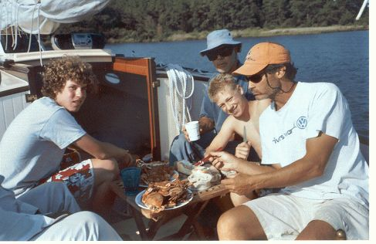
Crab Feast at in Chapel Cove
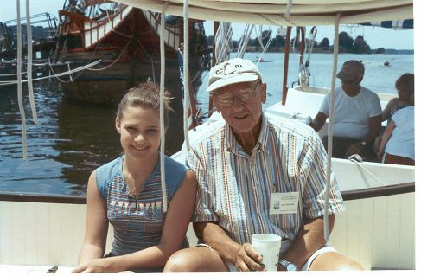
Bill Hoover & Noelle Cruder - dockside support
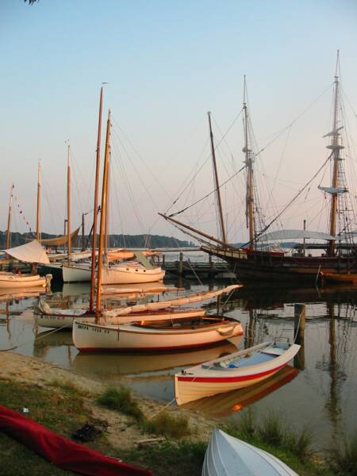
Catboats with Dove at St. Mary's City
Wanderer leaving Mill Creek
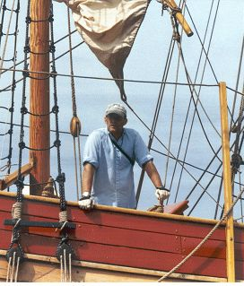
A Pirate in all of us - Butler on Dove
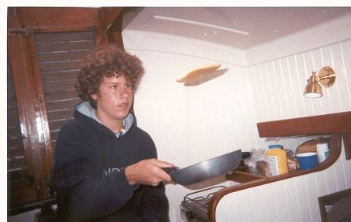
Matt and the Flying Pancake

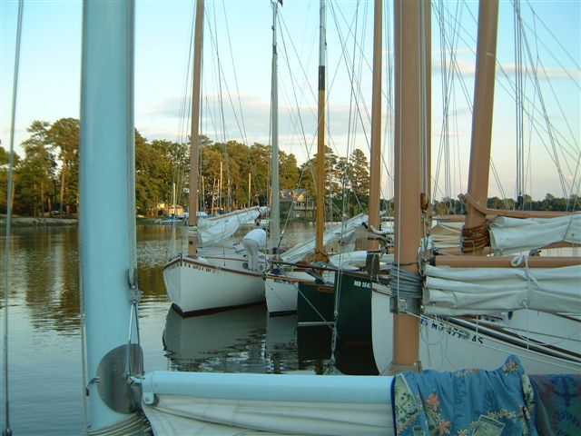
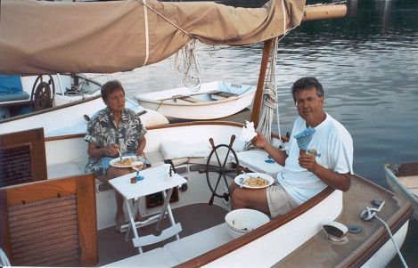
Fine dining on Heron
Jean Griffin & Steve Flesner
St. Inigoes Raft-Up
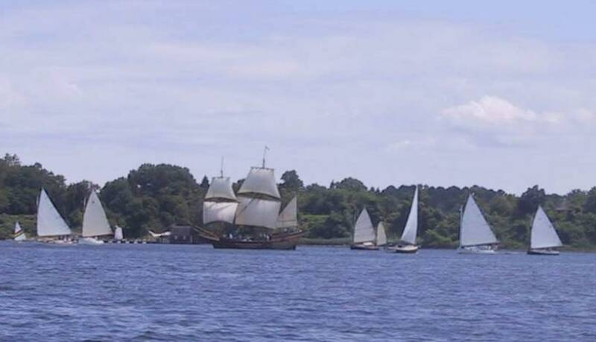

CHESAPEAKE CATS TO THE SUSQUEHANNA FLATS - 2006
By Marc Cruder

Introduction
There is considerable trepidation when one looks at the charts and contemplates the Susquehanna River, whose flats at the mouth of the river give new meaning to the word “shallow.” Nonetheless, seven fearless catboaters made the trek, surviving the tug and rock barge traffic to tell the tale. Interestingly, this cruise marked the first time non-trailer sized cats outnumbered trailer sized cats 4 to 3. We had largely fair weather, favorable tides and no insects. The two-day stop over in Havre De Grace was not as tedious as envisioned and the unexpected highlight of the trip was the sail upriver to Port Deposit and back. We had member support ashore, and were even greeted by local catboaters at Harve De Grace. Swim calls were regular with no sea nettles to be found. There was one unanticipated major breakdown, but the group put together a rescue squad and got the injured cat and its owner home in one piece. Here’s how it went….

Returning Cruisers
- Marc “Separate checks from now on” Cruder sailing Wanderer -Wittholz/Prudence 25.
- Dave “What would Capt Bill do” Bleil sailing Gull - Mystic 20.
- Don “A cup of diesel then rig the towing bridle” Dunn sailing Granmary - AC 21.
- Butch “I’d rather be under my new sun shade” Miller sailing Dusty - Marshall 18.
- Rich “That engine’s running right this year” McLaughlin and crew Mike “Rig my umbrella in the cockpit” Crawford aboard Tenacity - Marshall 22.
- Butler “I have a visual on them” Smythe sailing Caerulean III – Menger 23
- John “Very, very danger” Brown, who sailed on Granmary and bunked on Wanderer.

New Cruisers
- Dave “I tried anchoring by the stern - it’s not for me” Park sailing Pert – Hermann 17

Special Guest Catboater Emeritus at Still Pond Creek
- Bill Buchanan – builder of Pilgrim (now Wanderer) aboard Otter, a Sundowner 32 Tug.

Cruise Support at Havre De Grace
- Kerry & Chris “Are you catboaters?” O’Malley; owners of Crabbie Cat – Marshall 22
- Denise Miller as well as Debbie, Matthew and Noelle Cruder

Sunday, 6/18: Day One - Destination: Cornfield Creek – Magothy River
Weather: Sunny and warm with winds slightly southwest @ 10 kts
Although the trip waited for school to let out, this was the first time in 9 years that I did not have my crew. Matt got a summer job at West Marine, and so, for more than minimum wages ashore, I went solo. The good news is that year 4 of the projected 5 year restoration had me down to cabin details and interior painting…lots of interior painting. But with no contracted work, I launched in mid-May, participated in our first event Memorial Day weekend and was in place on the western shore, ready for the cruise.

However, as fate would have it, things were just not that simple. Several family activities required my attendance the previous night, so I had to use the morning to make my final preparations. Having already gone shopping, the food was onboard but not stowed, the gaff tongue was on the workbench for modification and the dinghy needed to be towed down to the dock. At 0800 I was packed up and headed for the boat. Upon arrival, loaded the cooler, stowed the food, installed the gaff tongue and launched the dinghy. With one final stop ashore for a cell phone charger and a bag of ice, it was done by 1130 and I was underway under power down the South River with dinghy in tow…..cruise on.

Gave the engine a good run down the river and at about 1245, raised sail, cleared Thomas Point and headed north for Sandy Point Lighthouse. Passed under the Bay Bridge about two hours later as the following wind started to slack, making the sun so oppressive, I rounded up and quickly dunked myself down the underslung rudder steps. Dripping but now cooled off, I took station back at the helm and continued on, admiring the workboat finish that was conducive to sitting in wet clothes without fuss. By 1515, the wind was back as I turned northeastward shaping up for the Magothy River. Sailed full and by into and thru Magothy Narrows. At about 1615, sighted Granmary. We decided to survey Eagle Cove, which we found full of boats, so turned back and up into Cornfield Creek, where we found plenty of water and the rest of the catboat fleet, broken into two raft-ups. Moored outboard Caerulean III, who had Dusty on his other side. Granmary moored outboard of Wanderer. Gull and Pert were left to themselves. Commenced swim call, then happy hour. Gull’s skipper swam across to join the festivities, followed by dinner. John, our swing man had brought a Chinese delight from home that fed all

We stayed rafted up, with no weather expected. Cornfield Creek, although fully populated ashore, was a pleasant spot. We particularly appreciated the many 6 mph markers, which all seemed to honor without exception.

Monday 6/19: Day Two - Destination: Still Pond Creek
Weather: Warm and sunny; Winds southwest @ 15 kts plus
It was a nice calm night with a gentle breeze. Made the morning coffee (which I was now putting in a thermos bottle to keep hot), then delivered John back to Granmary by dinghy. With the National Weather Service forecasting Small Craft Advisory, all were contemplating their level of reef. Most were single reefed. Gull, because of her extra tall rig and Caerulean III, as a prudent measure put in a double.

By 0815, the smaller cats were moving out and by 0830 all were away with Wanderer bringing up the rear. At 0915, I set sail in Sillery Bay with Granmary, Gull and Pert already beyond Magothy Narrows and out of sight. The sailing proved to be pleasant and continuous as we proceeded up the bay, with Wanderer averaging 6 mph per the GPS.
At 1045, we had Poole’s Island Light abeam and at 1145 the VHF crackled with the sound of the “Auxiliary Yacht Granmary” identifying herself and apparently dodging commercial traffic on the other side of the bay somewhere in the Tolchester Channel. There was no good reason to be all the way over there, but it was later revealed that the chart inventory was not quite what it should have been, so visual dead reckoning was the order of the day. That said, I guess you need to go where the navigation marks are. At the 1200 radio check, Caerulean III, almost hull down on the horizon with reefs shook out reported and accounted for the remainder of the fleet within his sight visually.

Continuing on in an uneventful, yet pleasant sort of way, we entered the mouth of Still Pond Creek at about 1430. This is where I had arranged to meet Wanderer’s builder, now allegedly a tug/trawler owner with his first boat since the 1972 catboat construction. While I was getting the sail down, I heard the chatter on the VHF between Caerulean III and Otter. I looked across at the south anchorage in Still Pond Creek and saw a small trawler/tug anchored by the stern. That made me get on the VHF and ask Otter to identify himself, which he did as Bill Buchanan. There was some discussion about water depth on our side of the creek, so I told him to stay put while I came to visit him. Tied up along side making a successful downwind approach. We spent about an hour looking at details aboard Wanderer, as well as looking through my photo documentation of the restoration. Bill seemed happy to see his creation again and equally happy that she had been taken care of. After exhausting everything from construction details to further modifications, weather looked like it was moving in, so a sail was out of the question. Instead, I asked for a tour of Bill’s Sundowner 32 tug. It was a maximum little ship for its size and just what I thought a 32 ft tug should be. We parted company, but agreed to exchange photos as well as take a sail some time in the future. I was glad to have made this connection and give him a chance to see what I had done, while I complimented his engineering that surely had kept the boat together all these years. I for one had been putting the hull to the test over the last four seasons and was satisfied.

With the visit over, I approached the north leg of Still Pond cove and headed for the raft-up at about 1715. As I came close, the raft was breaking up and boats were spreading themselves around the creek. Was it something I said?....no, it was the National Weather Service forecast noting a short duration but severe weather alert. This made everyone find their own hook and hunker down as the wind and rain came through right on time as predicted. Rode out the rain with a solo happy hour of Myers and Tonic with smoked oysters on triscuts bedded in cheese whiz…the original seafood appetizer of choice among our southern catboat brethren. By 1830, the weather subsided and I had Granmary along side with John cooking dinner. With the weather over, we stayed rafted up for the night as the rains came.

Tuesday 6/20: Day Three - Destination: Havre De Grace – Susquehanna River
Weather: Sunny and hot; winds south @ 5 to 10 kts
The rain continued as the front worked the area on and off all night, then into the morning. Despite the weather, I can only report that it was another largely uninhabited and quiet location. The sleeping was good and the weather did its part to ground our winged friends. Cooked breakfast and then was eventually joined by Tenacity and Caerulean III, making a morning raft-up of four. The National Weather Service was reporting another short term storm, so the opportunity was used to snap a few pictures and lay in until the weather passed.

By 1000, we were outbound under power, to find the remaining boats at the mouth of the creek. Raised Bill Buchanan on the VHF to say goodbye. He indicated he would be following along for a bit to take some pictures before leaving the group to return up the Sassafrass River. In another half hour, all catboats were under sail headed northwest. The group stayed together fairly well. The 1200 radio check found all boats in sight visually as we crossed the shipping channel between towboats headed for the C & D Canal. By 1300, we cleared Locust Point with all boats dousing sail as we shaped up for the only marked channel to Havre De Grace. The Skipjack Martha Lewis was sighted outbound with passengers. Leaving the Susquehanna Flats to starboard we arrived at the Havre De Grace municipal marina about 1400. Slips were found for all, but not before some minor skirmishes with the falling tide. When they say they is no water outside the marina docks, they apparently mean it. By 1430, all were secure, Gull had been washed down and the shore side showers were getting good use.

Debbie, Matt and Noelle arrived about 1530, so we strolled around town. There was not much to see, so it didn’t take long. Havre De Grace is one of those places where not much happened historically, but everyone seemed to go through on their way to somewhere else. The town was a mix of new condo construction and old store fronts in the midst of recreating itself for the tourist trade. We used this initial trip around town to make our dinner reservations for the group at the Tidewater Grille, then returned to the marina to organize and provide transportation for the now refreshed catboaters. By this time, Denise Miller had arrived by car, so we were figuring out transportation details when we were met by Kerry and Chris O’Malley. They own a Marshall 22 that they keep at the Tidewater Marina in town, found our itinerary on the internet and joined us for dinner. Catboat stories flew as we settled into dinner. Although somewhat overpriced and not particularly memorable food wise, the atmosphere was nice, since it was on the water and air conditioned so all were comfortable.

There was a lesson learned when dealing with catboaters around a single table and a single check. That lesson is that some were mathematically challenged. Despite this temporary speed bump, which almost had us all washing dishes, we got out of the Tidewater Grille intact. As the cruise commodore, I have instituted a new catboat cruising rule – no large group reservations ashore and separate checks from now on.
With that behind us, we headed for the boats so Kerry and Chris could get a look at the fleet, but not before our carload stopped at Bomboy’s homemade ice cream to take care of a sweet tooth or two. Back at the boats, Kerry and Chris got all they could take in boat to boat tours, starting with the Tenacity, the one Marshall 22 among us and slowly working their way through the docked fleet until dark. They came away with lots of good ideas for their cat, and of course we gently suggested they join the membership. We hope to see them again soon around the water. With the tour over and our new friends as well as shore support hitting the road, those left behind settled in for the night dockside.

Wednesday 6/21: Day Four - Destination: Up the Susquehanna to Port Deposit, MD
Weather: Warm and sunny; Winds northwest @ 5 to 8 kts.
Another restful night. The slips were more than ample and surprisingly, except for a few spiders, we found no other predators. Although the Amtrak train goes through town, it was at least two miles off and not an issue, compared to a previous and never again stay on the Northeast River. Because there was low mileage in today’s itinerary, we had a leisurely breakfast of pancakes and sausages, then discussed the planned upriver exploration. The added incentive was that locals told us sails are not normally seen above the bridges. That was enough of a challenge, so we consolidated the group to Wanderer, Caerulean III and Dusty, distributing the other crews as necessary and leaving Capt Don ashore to tend to his physical therapy (walking) incident to a recent knee replacement.

We motored out into the Susquehanna to find a pleasant breeze coming down the river and a little foul current. We established a “power-tacking” regime with Caerulean III, while Dusty decided to try out the new sun shade he had made and stay cool on this little adventure. With our strategies established, we enjoyed a nice trip upriver, noting the high wooded banks and rock ledges not unlike parts of the Hudson River and the Palisades. It certainly was different than the well known marshes of the lower Eastern Shore.

Landed at the Portside Grill in Port Deposit for lunch. Docked the catboats up nicely and were amused when a wayward powerboat had to wait to find a space at the dock….how often does that happen? Had a pleasant lunch with reasonable prices and separate checks. Took some group photos, and then walked around to find the Bainbridge Naval Reserve Center Museum closed. Walked the remainder of the two block main street to note some very interesting architecture and a few shops, before heading back down the river. No engines were necessary this time. Paused to raise comms with and let a tug and light rock barge through the bridge, headed for the rock quarry. Dropped sail and returned to our slips. All were on their own for dinner. John and I walked to the other side of town to Price’s to enjoy some large steamed crabs. It was worth the 1.5 miles each way. We returned fully fed and ready for bed with a departure first thing in the morning.

Thursday, 6/22: Day Five – Destination: Tim’s Creek off Worton Creek
Weather: Overcast, a short rain squall, then warm & sunny; Winds south @ 10 to 12 kts
Woke up to a pending morning squall followed by afternoon thundershowers in the weather forecast, which made some of the group antsy to get underway. By 0800 all were underway under power with Wanderer bringing up the rear. Turning south into the channel, I threw a reef in to deal with what we thought would be all day foul weather, while sharing the channel with an outbound tug pushing a loaded rock barge ahead. The squall came and went quickly after I set sail, leaving the engine on as well. The tug and barge passed me in the vicinity of green can #5 at the turn of the channel eastward. Continued out of the channel with all cats ahead, shook out the reef as the squall passed, shut down the engine and sailed an initial course of 150 degrees PMC.

With increasing lift as I raised the eastern shore, my course came around to 225 degrees PMC, allowing me to tack around in the vicinity of Betterton at about 0945. The next several tacks were all about an hour’s duration. The first took me out to the yellow “G” buoy marking the restricted zone off Spesutie Island, then back to Plum Point on the south side of Still Pond, then out to the white occult light buoy, which finally shaped me up for Worton Creek. Doused sail at about 1345 and motored into Worton Creek, then to starboard into Tims Creek, passing an intentionally grounded keel sloop whose owner was out cleaning the bottom while the family was having a swim call.

All the cats were making their way into Tims Creek. I threw my grappling hook over, then took Caerulean III alongside. We ran out a second anchor with the dinghy. Tenacity followed on the other side along with Granmary. The raft-up remained the group of larger cats, while the smaller boats individually anchored. Swim call was the order of the day as the skies had cleared and we had an unusually lively morning of sailing, clocking 6 kts at times. The catboats had Tims Creek all to themselves since the water depth was only 3 to 5 ft, with plenty of swinging room. News came quickly that Gull had suffered a major engine problem. Further investigation found the transmission oil a goopy white and oil coming from places it shouldn’t, although the engine was reportedly running when shut down. Plans were being discussed for some of the boats to alter their itinerary and escort Gull home. Despite this little change of plans that was developing, the rest of the group enjoyed the anchorage to catch up on reading, take naps and eventually to have happy hour aboard Tenacity. This allowed the triscut – seafood - cheese whiz appetizers as well as the fixings for a Dark & Stormy all around to be salvaged from their originally intended raft up at Still Pond that got rained out.

The big cats stayed rafted up while the smaller cats stayed on their hooks as the happy hour extended to a lite dinner followed by cigars with some weather pending.

Friday, 6/23/05: Day Six - Destination: Broad Creek on the Magothy River
Weather: Sunny, warm; west winds 5-10 kts becoming south w/scattered thunderstorms
Wind and weather greeted us overnight such that the raft up swung around crossing the two anchors we had out from the same direction and putting us a little closer to some of the smaller cats than we had been. Tenacity’s skipper gently knocked on the cabin top for a prudent second opinion. Sizing up the situation, we decided the anchors were holding despite our new position and returned to bed. Once the weather had its way, things were quiet and we could all go back to sleep.

In the morning, the group immediately made plans to accompany Gull back to Greenwood Creek. Without a favorable wind, Granmary offered to be the towing vessel, but needed to change a fuel filter first. The final decision was that those from the eastern shore, Pert and Dusty, would fall in behind the tow for support and to take over if necessary once through Kent Narrows. Tenacity had plans to spend one more night out on the eastern shore at Rock Hall. Caerulean III would stay with Wanderer and keep to the original itinerary by finishing the cruise on the Magothy River.

With the plan set, John was removed back to Granmary (with all his worldly goods), the bridle was rigged and Gull was outbound in tow by 0915 with the other smaller cats following. Caerulean III and Wanderer brought up the rear raising sail just outside Tim’s Creek outbound in Worton Creek. We tacked across to the Poole’s Island restricted zone, then back to just south of Fairlee Creek, then across again, clearing the south side of Poole’s Island on a heading that continued to move around favorably to the southwest.

At 1000, raised Granmary on the VHF to find them just clearing Tolchester Beach and doing well. By the 1200 radio check, we found ourselves on the west side of the bay in the vicinity of Hart-Miller Island and coming up on Seven Foot Knoll. Granmary informed us that they would take Gull all the way to Prospect Bay, then let the little cats take her up Greenwood Creek. With that report, continued on a southwesterly course with Caerulean III, adding the engine to successfully claw off the western shore and across the Patapsco River to Gibson Island without tacking. By 1430, we were both in the Magothy Narrows, and soon made our way to Broad Creek. We anchored the two cats in a secluded spot that probably would have been a little tight for the whole group. Broad Creek was as advertised, a high sided, tree lined creek with little activity. With all fast, we took at nettle free swim call, scrubbed our bottoms (the boat’s), and then had a quiet happy hour followed by Stouffers “skillet meals” I had been carrying around all trip. Turned in early as rain came through and stayed, with more heavy weather expected.

Saturday 6/24: Day Seven - Destination: Homeward Bound
Weather: Overcast with clouds/scattered rain/winds south @ 10 to 15 kts
The weather never came and despite the fact that we were in a high sided hurricane hole, a sufficient breeze persisted and no mosquitoes bothered us. We were up at 0600 anticipating an early start, underway by 0730 with Wanderer setting sail just beyond the anchorage. Caerulean III had a longer trek ahead so took a more direct course heading under power only. Cleared the Magothy Narrows at about 0830, steering 150 degrees PMC with south winds. By 0900, with engine added, Wanderer was under the eastern channel of the Bay Bridge. Tacking to a southwesterly heading, made it across to just below Tolley Point at about 1030, then rounded up to the southeast and made Thomas Point Light in another 15 minutes. At 1100 with favorable wind and tide, secured the engine and sailed into the South River. Another hour and it was time to douse sail just before the Route 2 Bridge. Wanderer was all fast by 1230.

With the early arrival, took the time to have lunch aboard and spend the next few hours cleaning up and stowing gear. Caerulean III reportedly made the trip back to Solomons Island banging into a head sea under power in about 11 hours. The Gull rescue squad, led by Granmary was also reported safe and sound having completed their mission without incident. I wonder if TowBoat U.S. could have done as well. Probably, but certainly not at the same price. All in all – Cruise Complete.

Epilogue
Although I missed my regular crew and had to adjust to sailing alone again, the trip as always, was ever interesting nonetheless. For a trip north, all the anchorages were surprisingly good and worth remembering. The scenery on the Susquehanna was particularly worth the trip to Port Deposit and recommended. Although the jury is still out on Gull’s little Vire engine, indications are that the casualty was not predictable and probably a function of old age. The group, as seasoned cruisers, adapted to the situation, made a plan and got the injured cat and owner home safe. A special thanks to Capt Don Dunn for taking the leadership in that crisis and executing without a hitch. The only other mishap, which involved human (blood) vs. main machinery (lube oil) vital fluids, was John’s not so complete leap from Granmary to Caerulean III at Tim’s Creek. All the First Aid kits available were brought to the scene, but ignored. As of this writing it has been reported that all wounds have healed, so John will “live to sail another day.” That said the focus of next year’s cruise will be a stop at Dames Quarter on the north side of Deale Island, which will give us access to the mighty and historic Nanticoke River for exploration. Details will be on our website at www.chesapeakecatboats.org, so keep a weather eye out. Until then….that’s the latest from the Chesapeake Bay.
mcc (Wanderer)

Photo Credits to: Butler Smythe - First section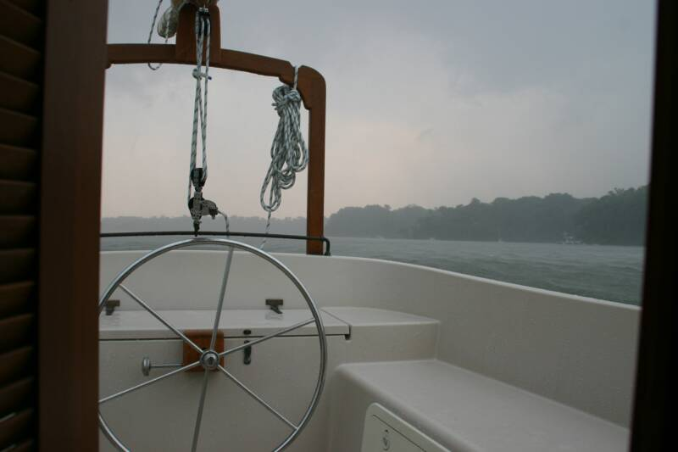

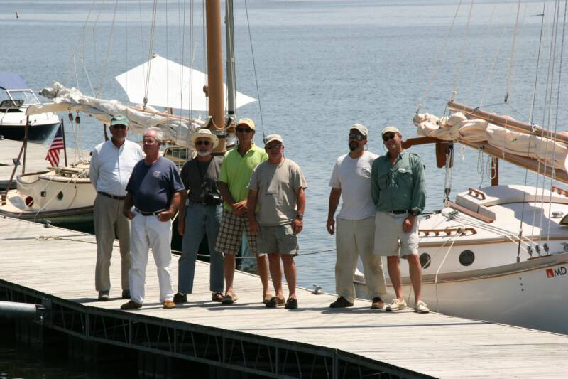

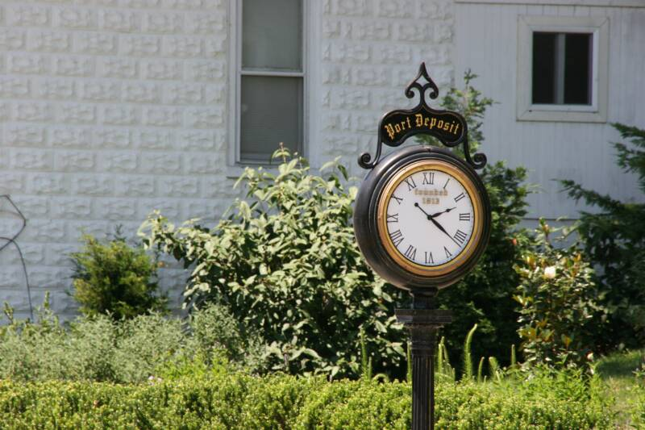
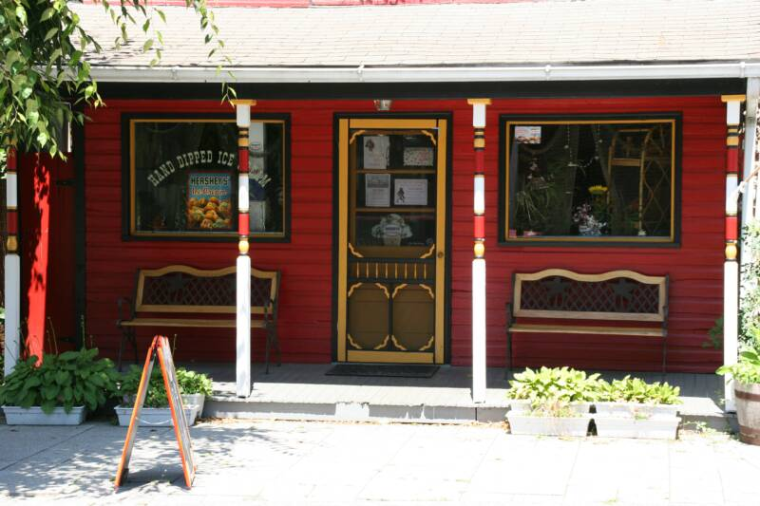
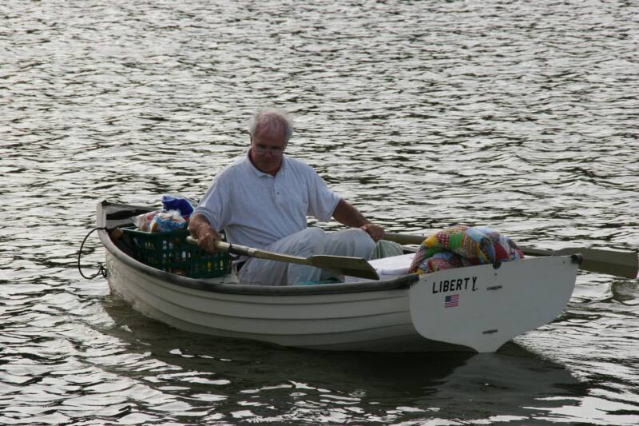
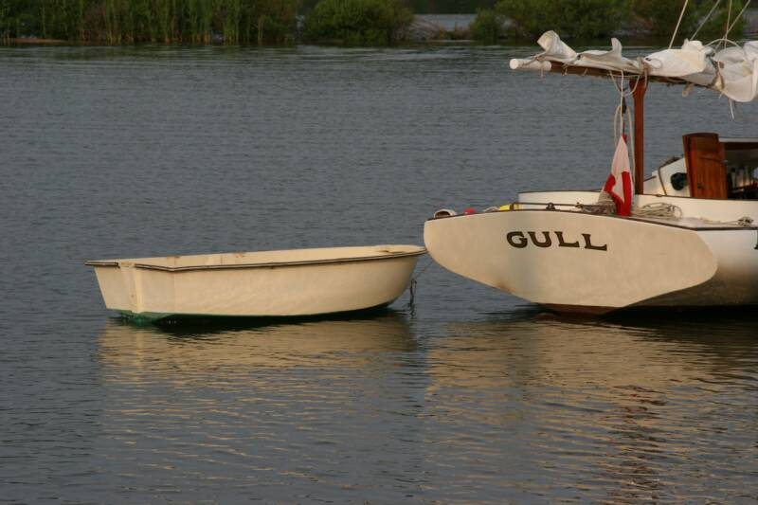
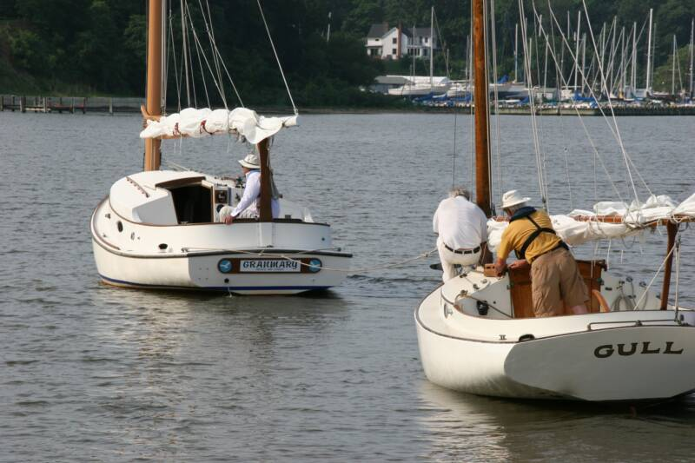
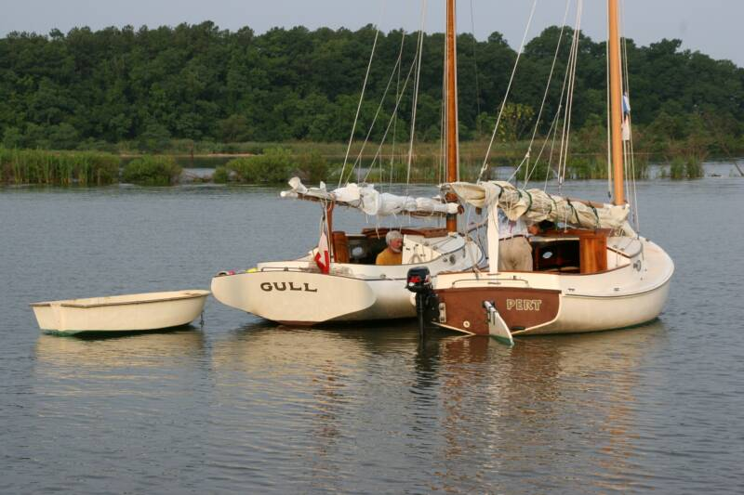
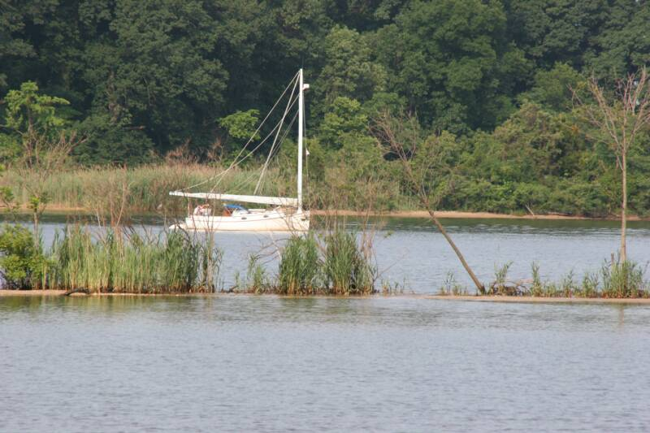
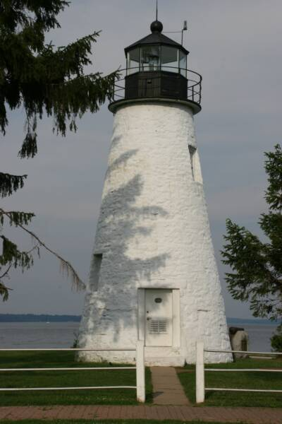
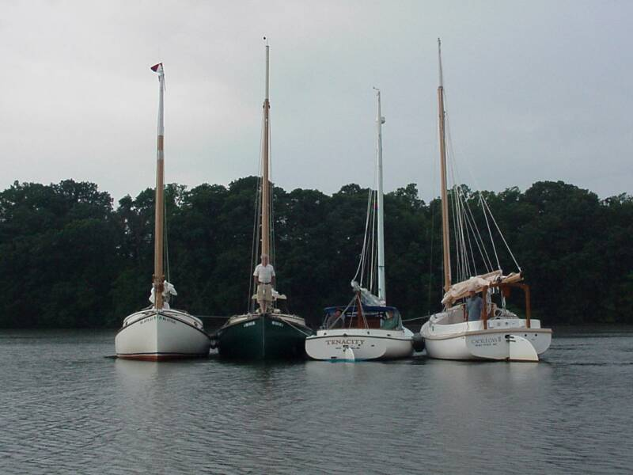

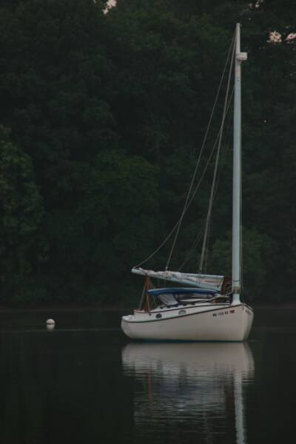

Photo Credits to: Marc Cruder - Below

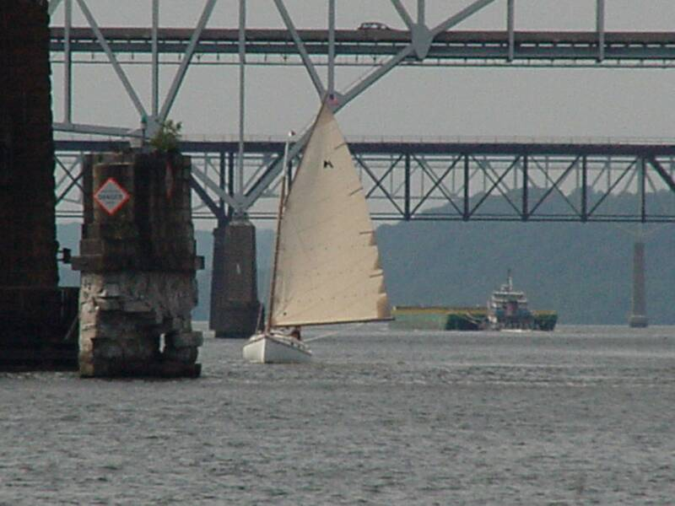

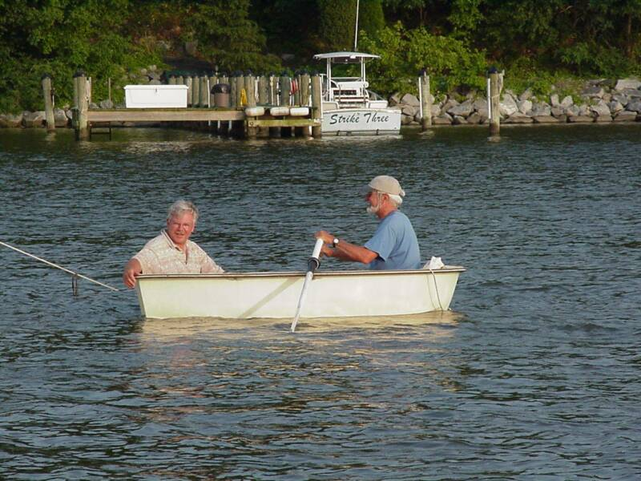

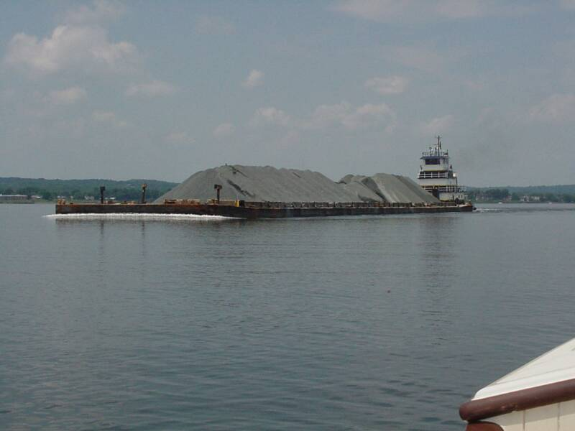

DOWN BAY CRUISE TO DAMES QUARTER - 2007
By Marc Cruder

Introduction
The right combination of weather and wind made for a very good overall and varied sailing experience. Dames Quarter couldn’t have been better as our host Larry Antonik made sure we had plenty of room to anchor and breakfast every morning. He rounded up the neighbors, treated the group to an evening run by workboat up the Wicomico River to the RED ROOST, a converted chicken coop and outstanding eatery, capped off by a local fireworks display on our way back. The run up the Nanticoke to Vienna was scenic and drew most of the group. The return trip with the current and 15 knots of wind made for interesting downwind sailing, especially when we met the inbound barge traffic. We had a record number of return cruisers, including one boat from below the Potomac, while we added 2 more at our destination. There was member support ashore, a few minor casualties along the way (that got fixed) and a great opportunity to experience a seldom visited and largely untouched part of the bay. Here’s how it went….

Returning Cruisers
- Marc “Leave the cabin doors off, it won’t rain again” Cruder sailing Wanderer -Wittholz/Prudence 25.
- Dave “Let me show you how it’s done” Bleil with crew Jim “But it looked good to me” Ohlmacher sailing Gull - Mystic 20.
- Don “About half” Dunn with crew John “Don’t leave me” Brown sailing Granmary – Atlantic City 21.
- Butler “It was me” Smythe with rookie crew Steve “He won’t let me drive” Flesner sailing Caerulean - Menger 23.
- Butch “I took 3 calls from Denise this morning” Miller sailing Dusty – Marshall 18
- Rich “Fire in the hold” McLaughlin with crew Mike “Hand me my 5 minute epoxy and the duct tape” Crawford sailing Tenacity - Marshall 22.
- Stuart “I’m not wearing my logo” Hopkins sailing Muskrat – Yawl rigged Marshall 22

Cruisers that met us along the way
- Jeanne “I’ll stay right here…I’m familiar with the Marshall 22” Griffin and Lois “I’m with you Jeanne” Flesner who both came by powerboat to the Lewis Creek raft-up.
- Jack “Careful of my new Imeron” Smith sailing Winter’s Dream - Marshall 18.

Cruise Support that met us at Dames Quarter
- Larry “How we doing…O.K.?” Antonik, our consummate host and owner of Purrrfection – Marshall 18.
- Denise “You can get the bigger boat if we get this head situation straight” Miller
- Dave “Pert is gone” Park

Sunday, 6/10: Day One - Destination: Brannock Bay – SE of Sharps Island
Weather: Overcast with temps in the 80s; winds northeast @ 5-10 kts and fading
With both my teenagers freely announcing that they had their own lives (and jobs) now, I moved this trip up to the week before school let out, since there was no family crew to be had. Year 5 of the projected 5 year restoration saw me finishing cabin details and getting the boat in the water before….that’s right before May 1st ! The only disappointment was that after the sink installation including thru-hull and plumbing, the existing water tank leaked after only about 3 gallons, and will become next winter’s project. Not deterred, I temporarily installed a bladder tank that I had laying around and so got the potable water system I wanted. That said, Wanderer was ready and shook down well ahead of time. Even most of the provisions were laid in the night before, so that the cruise would start first thing in the morning. I can’t remember when that happened last.

I was underway under power from my new location at Orme’s Bluewater Marina on the Rhode River at 0815. Bob Orme, who recently crossed the bar, was a catboat sailor of some renown locally, with his green Marshall 22 still visible under the shed. I was happy for Wanderer to be in such appropriate surroundings. Set a course of 120 degrees per magnetic compass (PMC) outbound. By 0830 I was out of the river and raised sail just east of Curtis Point and beyond the crab pots. With a favorable but light wind and heading southeast, I was abeam the green #85A by 0900 moving at about 3.5 mph per the GPS with a fair tide. Set a course of 175 degrees PMC to Sharps Island Light, steering visually for the end of Tilghman Island.

With the wind easing and deep draft traffic coming up the bay I added the engine at about 1100. By 1130 I was abeam the red #84 off Poplar Island. At 1200 the VHF crackled with the sound John Brown’s voice aboard the yacht Granmary for the 1200 radio check. He reported to be on a parallel course on the west side of Poplar Island in the Narrows. At 1230 I altered course left on sighting the #7 green south of Tilghman Island. By 1330, and abeam the mark, set a compass course of 140 degrees PMC to Brannock Bay.

At 1400 Caerulean was approaching from the south. The afternoon sun highlighted and made unmistakable her Egyptian cotton colored sail. By 1430, we were side by side checking depths (I with my 6 ft boat hook and Butler with his electronic depth sounder). The area was skinny on water, and federal navigation aids had been removed, although still noted on most charts. We worked our way in to an area with 6 to 8 ft of water and dropped the hook. While not as far in or as protected as I’d hoped, no weather was expected so we left well enough alone and had swim call. Always good to scrub a few barnacles and check the bottom paint. As we did, other catboats started to appear until we had an initial raft up of five. One boat had gone ahead to make the Patuxent River early and get a glimpse of the Captain John Smith shallop that was retracing that historic discovery voyage. Happy hour commenced with Dark and Stormies in Wanderer’s cockpit after “swing man” John reported aboard with his personal dunnage. He’d be sailing aboard Granmary and bunking aboard Wanderer. An easy first day.

Monday, 6/11: Day Two - Destination: Lewis Creek – Patuxent River
Weather: Sunny; Winds light from the west, eventually coming around to the north
Overnight, Caerulean and Dusty had stayed rafted up to Wanderer, until I was awakened by a “thump.” Found the other two boats trying to quietly unraft due to increasing winds from the unprotected west. A few hours later and as is normal on these cruises, I awoke to the sound of watermen’s boats. These were fairly quiet as they had mufflers on their exhausts. They were working trot lines and certainly in much closer to shore than we were. Had we found our way in closer, it probably would have been worse as we would have been in the middle of the trot lines. As it was, things were tolerable, if not a bit rolling due to their wake.

After eggs and proscuitto (I couldn’t find the pre-cooked bacon), we all weighed anchor at about 0900, and were underway under power. I added sail about 15 minutes later and steered a due west course for the red and green buoy set just south of Sharps Island light. At 1000 I was abeam the #6 red, and turned south to a course of about 190 degrees PMC visually lining up with James Island to port and Cove Point to starboard. Engine off.

By 1030, I added engine but kept the sail up pulling gently, providing shade while making about 3.5 mph per the GPS. I was abeam James Island for the noon radio check. All catboats reporting and in sight ahead of me in the vicinity of the Cove Point LNG docks. By 1300, the engine was no longer necessary abeam the red and white “CP” buoy with wind astern moving us at about 4.0 mph per the GPS. Abeam the LNG docks at 1400, I jibed around to a starboard tack, coming right to shape up for Drum Point.

Shortly after the jibe, an inbound tug pushing ahead was increasingly visible but miles off yet. I had been monitoring VHF channel 72 for the group that was well ahead of me when I heard: “Blow boat get the hell out of the way.” Just goes to show you, not everyone out on the bay is happy. The tug and tow had slight left bearing drift and the channel was miles wide, not to mention how far away we were from each other, so I maintained radio silence and my course, until I passed well ahead of him, then got on Channel 13 and responded with: “Thanks for the accommodation Captain” and left it at that. By 1500 I was abeam Little Cove Point, adding engine to keep speed up in the dying wind conditions. Another half hour found me off Drum Point with a favorable wind coming into the Patuxent River.

At 1630, the cell phone jingled and it was the Marshall 22 Tenacity coming down under the route 4 bridge, headed for Solomons Island and asking if I needed anything. I ordered a bag of ice. By 1700, I had negotiated the entrance to Lewis Creek and found the raft-up…swim call! At 1800, with happy hour in full swing, the Flesners arrived by powerboat with catboater Jeanne Griffin. They visited aboard Tenacity, where the “mantis” shade was rigged, while photos were taken from the dinghy, followed by dinner.

Tuesday 6/12: Day Three - Destination: Dames Qtr Creek – Dames Quarter, MD
Weather: Overcast with intermittent sun; Winds light from the north building to 15 kts.
Lewis Creek proved to be a peaceful spot, with half the boats on their own hooks and the other half rafted up. There was plenty of breeze and no winged friends. The plan however, was not to lay in, as we had some mileage ahead of us. So I cranked up the engine as the preparatory signal and weighed anchor at 0700. Made a last pass around all the boats to discuss the day’s navigation and was out of Lewis Creek within half an hour.

I soon had the sail up, shading the morning sun, with a light wind on the quarter and favorable to my outbound course. At 0800 I passed inboard of the red #6A as Dusty and Caerulean were headed into Solomons Island for fuel and crew respectively. Steve was joining Butler aboard Caerulean. Cleared Hog Point with all 6 boats in sight under sail at about 0900. The wind came up strong and steady around 0930 and all boats began to move out smartly – Tenacity, Gull and Granmary ahead with Caerulean and Dusty astern. Moving southeasterly down the bay, we were abeam the north side of Hooper Island lighthouse by 1000, passing Granmary in the process, with Capt Don running the old girl “full tilt.” Visually following the south end of Hoopers Island as it appeared we cut the corner into Hooper Strait close and well north of the Green #1 bell buoy.

Hove to in Hooper Strait to make lunch and conduct the noon radio check. All catboats in sight with Caerulean on point, having overtaken the group. Tried to contact our host at Dames Quarter, but had no cell phone signal. Having fallen behind, ran a straight course of 120 degrees PMC and was abeam Shark Fin Shoal light at about 1445, without regard to the buoy system and finding plenty of water. Tried our host again and connected. Reported: “six catboats headed your way” with an ETA of about 1700. A squall was making up and visible to starboard, but moving ahead of us (or so I thought).

Made Great Shoals light just about 1630 when the sky opened up. Kept sailing under varying wind until rounding up on Long Point. Started the engine. I was the last boat into the cove in front of Larry Antonik’s, among all the other catboats, that now numbered eight. The additions were Larry’s Marshall 18 Purrfection, Jack Smith’s freshly painted Winters Dream and Stuart Hopkins’ Muskrat. Made a flawed attempt to land at the dock due to insufficient water, so maneuvered back to a hook. Our host was on the dock as the rain subsided. The word was passed for dinner ashore at 1800. You don’t have to tell catboaters twice, and there were plenty of dinghies on hand to assist.

Larry put dinner together with some help from neighbors (and “come here’s”) Alena Ortega and Jeanne Vanlith. Food was aplenty and the company exceptional as we would learn the longer we stayed. Larry had a steady stream of interested and interesting neighbors dropping in. Although we all ended up back on our boats, facilities were open and available to the group ashore, which was greatly appreciated. Another good sailing day down and a timely arrival at our intended destination.

Wednesday 6/12: Day Four - Destination: Vienna, MD via the Nanticoke River
Weather: Overcast with some sun; Winds northeast @ 8 to 12 kts
It was another quiet night at anchor. Although we witnessed what could only be called a mosquito gauntlet between our host Larry Antonik’s pier and his house, that was not the situation out at anchor. We survived without rigging screens.

We experienced a beautiful sunrise over the marsh at about 0530, as I took the opportunity to row ashore for a shower and use of the facilities. Larry was up and on the dock moving his Marshall 18 into deeper water. Breakfast ashore was at 0800 with neighbors and the rest of the anchored catboaters attending. The homemade buffet ranged from the healthy to “it may not be that good for you, but it sure tastes great.” At 0900, we started to move toward the boats, but not before a group picture in front of Larry’ oversize catboat copper weathervane. We also took a quick tour of the shed to view everything from a Delaware Shad Skiff to several one cylinder Palmer gas engines. As I suggested to Larry he better check pockets before letting the group leave, Mike Crawford’s comment was something along the line: “It’s a good thing I don’t need any parts for my Palmer Pup at the moment.” With the tour complete we headed for the dock.

We had anchors up and were proceeding outbound when we learned Granmary was having some starting problems, so left Capt Don in the capable hands of the locals while the rest of us headed for the Nanticoke. John was crewing aboard Wanderer.

By 1000 we were under power and sail at the mouth of the Nanticoke with a total of five catboats and Stuart Hopkins Marshall 22 yawl Muskrat…but not before sighting an unusual black hulled piratesque vessel with square sails, hull up on the horizon. Not knowing what or who it was, suspecting we might be in a time warp, but seeing no cannon fire, we altered course and proceeded up river while being passed by an inbound tug pushing a tank barge ahead. Being alongside commercial traffic allowed us to pick the eastern and unbuoyed channel while the tug and barge stayed in the deeper, buoyed western channel. The transit up the river was about 5 hours and uneventful with overcast skies, so we were comfortable. Once the river narrowed up and started to bend, sails were doused and we were on engines because winds were on the nose for the most part. The “peak” power plant at Vienna was visible above the marsh for some distance, so we had a bead on our destination. The tide was fair, as we made steady progress and enjoyed the natural beauty of the river. Navigation was easy, with plenty of water and width.

As we landed at Vienna, the locals were right there with the “do’s and don’ts” as well as local information and offers of rides to whatever we needed. Vienna recently (with in the last 5 years) constructed several transient slips as well as a public sea wall. Mooring outside the slips and or to the sea wall is at no cost. Winds were still persistent out of the northeast and not easing. It was a little too active a sea state for the Marshall 18’s that were along, so they took a local tip and proceeded 2.5 miles further up river under the route 50 bridge and into Marshyhope Creek. The rest of us went into town to the Nanticoke Inn (run by Millie’s, which was across the street and being renovated). The Nanticoke Inn is the only restaurant in town and had a family atmosphere. We took advantage of crab dip, crab balls and crab cakes. The special on the menu, enjoyed by others was a gigantic slab of meatloaf, offered of course with several side dishes. After dinner we went to the only gas station in town for some ice. For planning purposes, the gas station has kerosene in addition to gasoline, but no diesel. That requires a short trip out of town, which the locals were willing to provide had we needed it. With ice in hand we walked the few blocks it took to get back to the river.

Just as we were settling in for a night cap, an old Jeep Cherokee pulled up with WBOC emblazed all over its side. It was Charlie Paparella, local feature writer and photographer out of the shore’s Salisbury TV station. I had been in touch with him before the cruise, at Larry Antonik’s urging, as the story of a group of wayward catboats was apparently newsworthy on the shore. Charlie got his camera and came aboard. Little by little, others in the group made it to Wanderer’s cockpit. Charlie interviewed any catboater willing to give him the time. He was a friendly conversationalist with great respect for our traditional little boats, so we each in turn held the microphone and answered Charlie’s questions as best we could. Once interviews were over, Charlie was apprised of our schedule, and we agreed to keep in touch the following day in case he could get the WBOC helicopter up for some underway footage or if he could meet us at Larry’s when we got in. After Charlie left, the other excitement for the night was watching an outbound towboat shape up for (crabbing sideways) and push a light barge under the route 50 bridge. We all wondered if might need to abandon ship if the tug and tow could not come around sufficiently to avoid us. Our fears were unjustified, but it got exciting for a few minutes anyway. The tide had shifted to an ebb and the wind was quieting down, so we expected a good night as the temperature was also dropping to cool things off. We had not heard from our Marshall 18’s as we thought we might on VHF, but suspected they were fine in the natural beauty of Marshyhope Creek. All to bed early for an early start in the morning to ensure we would leave on a favorable tide.

Note: Although our interaction with the locals was positive, it was initially hard to read. The line handler that met me opened with: “How are you doing?” to which I responded: “Well, we made it…that has to be worth something” … which prompted a: “Maybe to you.” Showers were then allegedly offered for $10 person; $12 if you wanted hot water. There were no takers. This was the same person that offered to take us out of town for diesel and that suggested Marshyhope Creek to the smaller boats.

Thursday, 6/14: Day Five – Destination: Dames Qtr Creek, Dames Quarter, MD
Weather: Overcast; Northeast winds @ 15 kts with a fair tide of about 2 kts
Although we were somewhat worried about being tied up to the seawall with river current, adequate spring lines and fenders made for a worry-free night with no movement, especially after the wind calmed down.

Started up the engine at 0700 to get everyone moving along. Thought we might see our Marshall 18’s but the fair tide was the determining factor although I took some time to talk with the mayor of Vienna when he hailed me from ashore. We discussed his vision for Vienna and I complimented him on the transient dock and seawall construction which made this a stop for us. We also discussed the no fee and he said he counted on transients spending their money in town, which I was happy to report we had done. By 0715, we were out in the stream setting sail and bringing up the rear (except for Marshall 18s)

About 0800, John noticed an inbound wheelhouse visible above the marsh several bends south of us. With all boats ahead and considering the towboat’s view was just the tops of our gaff peaks, thought I should get on channel 13 (bridge to bridge). As I did, I heard two captains talking to each other… “They look a little small for radios” the one said…. “I guess we’ll find out soon enough” responded the other. Just then I identified myself to the inbound towboat. Told him we could see his wheelhouse inbound above the marsh and that there were 6 sailboats headed his way with a fair tide (moving at about 8.5 mph per the GPS under sail), but that we would stay out of his way. This is all a commercial vessel wants to know…that he is seen and that you have a plan. He responded by telling me he needed to stay in the middle of the river where the water was deepest. I told him we were centerboard boats and would respect that by keeping to the sides…hoping of course that the other catboats were listening. We met the towboat Sharps Island pushing the rock barge Potomac ahead in the vicinity of the red #16 rounding the bend at Penknife Point. Got back on the GPS to thank the towboat Captain for meeting us in the widest bend in the river, to which he responded by asking us where we were going and by informing us of an outbound tug and barge coming down behind us.

By 1000, Wanderer had passed all catboats ahead jibing downwind, thanks to John’s cutting all the bends close and because waterline length matters when you are being pushed by wind astern. We were coming up on Wetipquin Creek where the river opens up to two channels again. Took a few pictures of the catboats behind us with their sails being lit up by the sun. By 1100, we were navigating again and altering course eventually hard on the wind in the vicinity of Great Shoals Light. Got passed by Caerulean and had Muskrat close substantially but not catch up due to the limited distance left. Sighted WBOC’s Charlie Paparella on Larry’s dock shooting more footage and conducting interviews with those ashore. By 1115, we were all back at anchor in Dames Quarter, so lunch aboard was the order of the day

Just when we thought we’d rest after the physical down wind trip, Tenacity, after tying up to the dock, suddenly had white smoke pouring from her cabin. A request was made for more extinguishers, but because of fast action, not needed. A close call with an electrical fire on top of the batteries caused by an extra bilge pump circuit wired directly to the battery with no fuse. Bilge pump wiring and bilge pump were removed; the battery suffered a hole in the casing on top, but was working, so temporary repairs were made and Tenacity was operational again. This small incident along with finding out that Granmary was back on line put things right with the world, so we took the rest of the afternoon to relax until our scheduled underway trip for dinner. Most of the group retreated to Alena Ortega’s art studio to view her mosaic work, followed by a short car ride to the harbors of Chance and Wenona. Everyone ashore at 1700 to assemble for the night’s festivities.

The group assembled, joined by Dave Park and Denise Miller, both of whom came by land for the night’s festivities. With lifejackets in hand the group was moved by car to the local waterman’s dock where we met Captain Ed and his wife Ginger to board their 40 year old, Cambridge built deadrise workboat. The two of them have been a married crabbing team for that same amount of time. Boarded all guests and got underway for Whitehaven, MD on the north side of the Wicomico River. The trip was interesting because we were on a wood workboat and because we got to see a piece of the other major river in this area. Upon arrival, we were picked up at the dock and driven by pick-up to the Red Roost, a converted commercial chicken coop and now very successful local restaurant. Dinner was on our host and we feasted on local seafood including clams and crabs mixed with shrimp and hush puppies, topped off with desserts like the local Smith Island Cake. Captain Ed, who sees crabs every day of his life, had the steak.

By 2000, we were back on the water and headed home as the sun went down, but not before Captain Ed checked his water depth with a boat hook (my own personal choice). In the vicinity of Long Point, we were treated to a fireworks display put on by one of Larry’s neighbors just for us. It certainly capped off the evening in a special sort of way, and had the whole boat hooping and hollerin’ including some shrill whistles from Ms. Ortega (originally from NJ…what can you expect?!). By 2100, we were back to the cars and navigated our way back to the boats in the dark without mishap. It was an exceptional day and night thanks to our host Larry Antonik. We were certainly made to feel welcome in this rarely visited part of the bay.

Friday, 6/15: Day Six - Destination: Hellen Creek off the Patuxent River
Weather: Overcast with some sun; Winds northeast @ 5 to 10kts and easing.
The wind was up overnight so our winged friends were grounded. That along with a substantial temperature drop into the 50’s made for good sleeping weather. That notwithstanding we had a long day ahead so breakfast ashore started at 0600 with an intended 0700 departure. That was the plan, but, not wanting to run out on our guest in such a hurry we lingered as we watched the WBOC helicopter overhead just about that time hoping to get some underway catboat footage. This was the first time WBOC was on time and we were not….oh well.

It was almost 0830 by the time we thanked our host, the neighbors assembled and we got out hooks up. Favorable winds had us setting sail immediately as we moved away from Dames Quarter. At 1000 we negotiated the entrance to Hooper Strait westbound as we met up again with the towboat Sharps Island pushing the now empty rock barge Potomac out of the Nanticoke and through the Hooper Strait buoy system. We were all well clear of this commercial traffic, so no radio comms were necessary. By 1100, we were abeam the Hooper Strait skeleton structure with most catboats substantially to windward. Their position forced me to make an early radio check to discuss the alternate route of navigating the Honga River. Caerulean responded with no intention of taking the inside route, so all other catboats followed his lead. At about 1230 the tide started to ebb and with the wind slacking off on approach to Hoopers Island lighthouse, all catboats were eventually on engines with a northwesterly heading for the Patuxent River.

For the rest of the afternoon we were working against the ebb with light winds on the nose but luckily no seas. Had some inbound tanker traffic coming up the bay to avoid at about 1500 and by 1600 most of us had made Cedar Point inbound up the Patuxent River. All catboats were in sight with no one stopping at Solomons Island. Made Hellen Creek at about 1800, working up to a secluded spot at the head of the creek for the final night’s raft-up. Happy hour ensued with sufficient energy to libate and snack, but not to cook. Stars of the evening included Jerry’s Spiced Rum and Dominican cigars with all making rather merry. Conversation was limited after a long day on the water but all enjoying the camaraderie and surroundings. Rookie cruiser Steve Flesner presented Wanderer with Buckwheat flour to carry on in Captain Hoover’s tradition for the making of pancakes in the morning. The thought was appreciated but the group consensus was that there would be no buckwheat pancakes until Flesner was on the cruise in his own catboat, thereby ruling on and giving incentive for seaman Flesner to get his Mystic 20 ship shape and cruise ready, instead of sitting on the trailer.

There was some minimal discussion about next year’s cruise with the Patapsco River and its creeks including Baltimore’s Inner Harbor mentioned, but time will tell. Received a call that Winters Dream had successfully hauled and made it home to Fenwick Island from Dames Quarter. With no weather expected, the group stayed rafted up for the night with exception of Gull, who was present but on her own hook.

Saturday 6/16: Day Seven - Destination: Homeward Bound
Weather: Sunny with winds light from the west
The final night was pleasant with a nice breeze. The quiet was broken only by the steady sound of a wild turkey on the shore in the woods.

Up at 0600 with John to discuss his final travel arrangements and options for a two versus three-day transit north with Capt Don. For myself, I had decided to not trek north, but instead leave Wanderer on St. Leonard’s creek in position for the Pax River Shootout in two weeks at the kind invitation of the Flesners. So I was in no hurry to go anywhere. By 0700, most had emerged from their cabins to sit and chat over a light breakfast. The surrounds looked even better after a night’s rest, so the group lingered a bit. The current cruise was recounted with renewed energy, while the call for pancakes was cancelled and replaced with some hard boiled eggs that needed to be consumed.

The group started to break up at about 0730, with all getting underway in different directions. Granmary was headed for Knapps Narrows with Tenacity and Dusty, while Caerulean, Wanderer and Gull were headed for St. Leonard’s Creek. Cleared Hellen Creek at about 0800 with reasonable west winds so raised sail for the last leg of the trip north as the rest of catboats headed south and out of the river for the Bay. Made St. Leonard’s Creek at about 0900, doused sail and powered up the creek. By 1200, was tied up, had the boat cleaned up, the dinghy ashore and all secure. Even had the time to clean up myself. Gull moved around the corner to another dock that would also position her for the next CCBA event at the end of the month. The crew of Wanderer and Gull then shifted to automobile transport provide by Steve Flesner and we made our way north, but not before stopping for lunch locally. Another cruise was history.

Epilogue
After we all split at the end of this cruise, reports continued to come in. Granmary’s crew reported in Sunday night by phone to find Capt Dunn at Grays Inn Creek and Seaman Brown eating Chinese, but not before a night on the hook somewhere off Poplar Narrows near the re-formed island and then fighting the foul tide bravely through the Kent Narrows bridge the next day. Similarly and as reported electronically by Dusty, long hours, heavy engine use and a fair tide got him and Tenacity to Prospect Bay before Tenacity continued on to the Chester River the next day.

All that said, everyone got home safe and the cruise exceeded expectations on several fronts. We had a good turnout, were treated royally in wilds of the eastern shore marsh down at Dames Quarter, including a workboat ride, dinner at the Red Roost and an impromptu fireworks show, plus simply the pleasure of our host Larry Antonik and his great property. That and cruising down the Nanticoke with following wind and tide made for some challenging full power under sail. Casualties were minor with repairs made, so that as it should be, no catboat was left behind. Our opportunity with WBOC also exceeded our expectations as Charlie Paparella put together a nice feature story that melded the uniqueness of the catboats with the varied background of their owners and then told the story of our refugee-like escape from the western shore to enjoy Father’s Day as all men should…on the water with their boats. We thank Charlie for his artistic content and respect for the group that painted a positive picture for those who may not quite understand this catboating thing. Having received a copy of the report on DVD, you can look for it soon on our website at www.chesapeakecatboats.org, where you can also stay tuned as plans develop for next year’s long cruise. Until then….It’s a wrap for cruise 2007 from the Chesapeake Bay. mcc (Wanderer)
All Photos by Butler Smythe Except as noted.
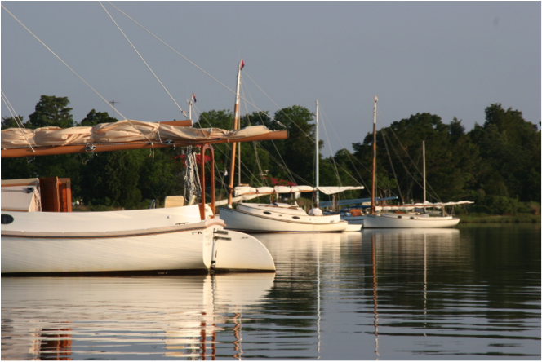

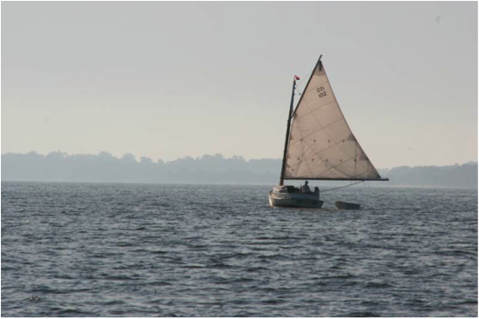

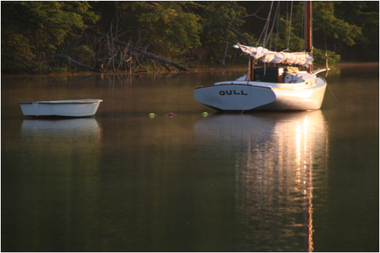

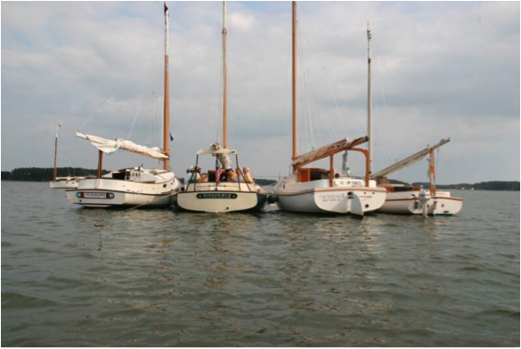

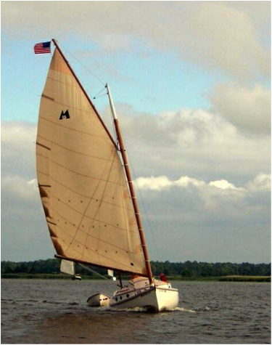
Photo By Stuart Hopkins

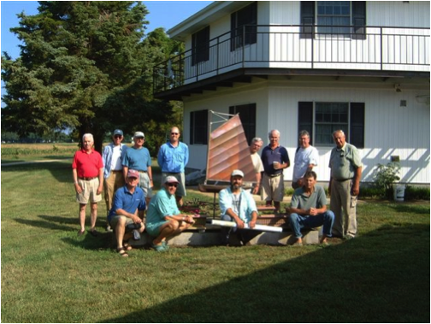
Photo By Jack Smith

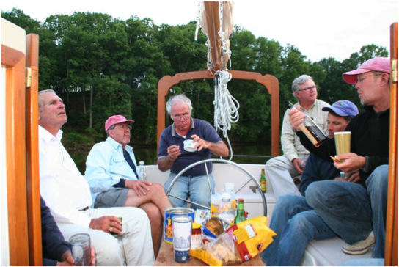
BALTIMORE NAUTICAL ARCHEOLOGY CRUISE - 2008
By Marc Cruder

Introduction: Our cruise to industrial Baltimore easily exceeded expectations and was loaded with pleasant surprises at every turn. The weather was cool and insect free. The wrecks were more accessible and plentiful than is documented. The creeks on the south side of the harbor back up to undeveloped state park land where we sighted all manner of marine wildlife including bald eagles. We found a Brewer catboat in the shadow of the Hanover Street bridge and we lived large at the Inner Harbor Marine Center, where we took advantage of downtown sights like the U.S.S. Constellation and side trips to Fells Point to sample mussels at Bertha’s. Two of us even walked up the street to Camden Yard and got free tickets to an Orioles game! On the way back we rafted up next to a pirate ship in Stoney Creek (actually the currently laid up Schooner Clipper City, but she was flying a skull and crossbones), and finished up right with dinner the last night out at Windows on the Bay. We welcomed new cruisers and retained our core group, minus a few regulars for various reasons. There was favorable wind and no casualties reported. So if you haven’t been to Baltimore lately; “Hon”…it’s time to give “Charm City” another look, and don’t forget to go see the “O’s” while you’re there. Here’s how it went….

Returning Cruisers
- Marc “Lost in the wrecks” Cruder sailing Wanderer –Wittholz/Prudence 25.
- Dave “I have a speedo now too” Bleil with crew Jim “Who authorized a second speedo?” Ohlmacher sailing Gull - Mystic 20.
- Jack “Coffee from my French press?” Smith sailing Winters Dream - Marshall 18
- Butch “We’ll meet Denise at the tapas bar” Miller sailing Dusty - Marshall 18
- Rich “The beatings will continue until morale improves” Mclaughlin with crew Mike “Breath the marine air” Crawford sailing Tenacity - Marshall 22.

New Cruisers
- Pete “Take me out to the ball game” McCrary with crew and grandson Nate “Don’t worry Grandpa, I’ll get us off the bottom” Sylvester sailing Little Mary – Cape Cod 17
- Kerry “Bugle Boy” O’Malley with crew and wife Kris “It’s all about the Persian rug and candles in the cockpit” O’Malley sailing Crabby Cat – Marshall 22.

Cruise Support that met us along the way
- Denise “I finally ate Bertha’s Mussels” Miller
- Debbie “I can always do stuffed shrimp at Windows on the Bay” Cruder

Sunday, 6/15: Day One - Destination: Bodkin Creek
Weather: Overcast with winds north/northwest @ 5-8 kts
This was the second year in all our cruising time where my busy teenagers just had other things to do besides go “catboatin” with Dad. To complete my solitude this year, John Brown, my regular crew was otherwise engaged with a personal trip to China to meet new in-laws. We were advised to stay tuned to CNN for late breaking international incidents John would surely be at the bottom of. All that said, I can assure you, it is the lap of luxury (in a catboat sort of way) to be one person on a 25 ft boat and I was more than happy to be single-handing. Wanderer spent her first winter under my ownership in the water at Orme’s Bluewater Marina, so there were no big projects save turning the gooseneck fitting over that had been upside down all these years and installing an anchor winch purchased at the CBA winter meeting. The boat had been shook down weeks before, with only a clogged thermostat housing to deal with. All that was left was a haul and the bottom, which “Chili Orme” at Bluewater accommodated the week before the cruise. He actually did a better job than I usually do, and it was nice to see the boat up on a real railway…yes railway (which will be the subject of another article, since there are few left to talk about, much less see).

With all in readiness and no one to think about but myself (thanks Deb), I departed Blue Water Marina on Bear Neck Creek off the Rhode River under power with dinghy in tow at about 0900. With the Bukh sufficiently warmed up on the transit out, I set sail at 0935 at the mouth of the Rhode and West Rivers shaping up on a course of 060 degrees per magnetic compass (PMC), splitting Thomas Point and its lighthouse heading for the Bay Bridge. With a fair tide, I was making 5.0 mph per GPS in the company of several wood workboats out crabbing including the round stern Elfie and the transom stern Patty D.

In another half hour I was crossing the mouth of the South River adding engine to stem the tide. By 1030, I was abeam Thomas Point Light and under sail again, moving at an easy 3.8 mph per GPS. At about 1130 passed the flashing green off Tolly Point adding engine again to stem the tide and wake wash of the Severn River at Annapolis. By 1250 I was under the Bay Bridge bucking a foul tide, then abeam Sandy Point Lighthouse at about 1310 followed by Baltimore Light (another caisson lighthouse) at about 1355. As the wind came up about an hour later, fell off to a port tack in the vicinity of the Craighill Channel lower entrance range, making about 4.0 mph per GPS under sail.

Rounded Bodkin Point, sailing past the green #5 into Bodkin Creek about 1600, picking up the channel marks. Continued under sail thru the #2 red where I sighted Little Mary at anchor to port and Copy Cat, her nutshell pram out for a sail. Doused sail and searched Main Creek under power, finding catboats along the way, to finally raft up in Back Creek at about 1700. We had 7 boats in the raft up once all lines were secured and anchors run. Took the requisite photos, then commenced swim call and happy hour, welcoming our newcomers Little Mary and Crabby Cat with a round of “Dark and Stormies.”

Monday, 6/16: Day Two - Destination: Curtis Creek and beyond
Weather: Sunny and warm; winds south at 5-8 kts, building to 15 kts with weather
Overnight we found Back Creek to be a good anchorage with plenty of breeze to deter our winged friends along with natural surroundings that made us stay rafted up. At 0700, I was cooking corned beef hash and eggs for breakfast while Winter’s Dream, at one end of the raft-up announced the use of a French press for his coffee and Crabby Cat, at the other end of the raft-up echoed that they had one too. Declining both offers, I was satisfied with my perk pot. I could have pulled out my stove-top Italian expresso pot, but it seemed they were having a moment. So I left well enough alone as I reviewed Little Mary’s “map” while Crabby Cat sailed off into the sunrise with bugle ablaze. The group dynamics were out of control after just one night, but it was all good. By 0900, most of the group were underway, leaving only Dusty and Winter’s Dream to enjoy the solitude.

Set sail in the main part of Bodkin Creek at 0930, turned off the engine and exited via the channel. Once out on the Patapsco, I came left to a northwesterly course headed for the Key Bridge. Tenacity was under sail ahead. We were on a nice broad reach making 5 mph plus on the GPS, hugging the south shore of the river. By 1030, I was abeam White Rocks Shoal making 5.8 mph per the GPS with a visual on Fort Carroll. Tenacity and Gull still in sight ahead. Made Fort Carroll at about 1115. Did a once around under sail, then set the lunch hook on the north side at the entrance sign labeled “Private - Keep Off - Guard Dog.” Took pictures from the dinghy, then had lunch. Aside from becoming a rookery, which was evident if you were down wind, the place looked like the “monkey city” in the movie version of Rudyard Kipling’s “Jungle Book.” It must have been cool when little John Brown played here as a kid. Too bad John wasn’t here.

At the 1200 radio check, only Winter’s Dream answered up. He reported to be sailing toward the Key Bridge with Dusty. There was no sign of Little Mary. Departed Fort Carroll at about 1230, negotiating the commercial tanker Rainbow I as I passed under the Key Bridge and left the small wreck sight at Hawkins Point for the way back. By 1330, sighted the remnants of the wall of WWI wood, U.S. Shipping Board Freighters in Curtis Bay as indicated on Chart 12281. Continuing on, I arrived at the first big wreck site just before the highway bridges to port. Dropped the hook to find Tenacity and crew kayaking thru the wrecks. Proceeded in by dinghy. There were reportedly 6 vessels, all visible with plenty of room to row around them and get up close to retrieve plank bungs and the outboard end of trunnels with wedges intact. These were available because the wrecks had been set afire. The combination of the inboard ends released from the planking and the contraction of the weathered wood allowed them to just be pulled out by hand.

Left site #1 and powered over to site #2, to starboard just before the railroad bridge. Arrived at about 1430 and can easily say there are more vessels here than documented in the references I read. I couldn’t identify the iron square rigger Conemaugh, but I did find 2 riveted fire tube boilers of different sizes in different locations. Left the wreck sight about 1515 and made my way beyond Curtis Creek to Marley Creek and finally Tanyard Cove to port where I found 3 of the other catboats. It was about 1600 as I entered the Cove and the National Weather Service was broadcasting severe weather, so we all hunkered down in our cabins, anchored separately just in time for the “line of severe thunderstorms” to roll through, after which everyone had time to dry out, libate and cook dinner. As noted in articles I read, this cove backs up to a county park. Although we had just come through industrial Curtis Creek, the east shore was completely natural, where in addition to the usual marine waterfowl, we surprisingly spent our time focused on a bald eagle in flight to and from its nest! It was just as described: “going from Baltimore’s back alley to Baltimore’s backyard,” and pleasantly not what we expected at all.

Tuesday 6/17: Day Three - Destination: Baltimore’s Inner Harbor
Weather: Sunny with winds west at 5-10 kts building to 15-20 kts with a foul tide
It was a quiet, cool night with a substantial temperature drop after the 2 hour weather event of the previous afternoon. All boats stayed on their own hooks, but I did move Wanderer out to the middle of the cove for a breeze, while Little Mary had to be urged off the end of a sand spit that appeared after the tide fell and she was aground. This was handily done by her crew, whose own weight, once removed was enough to float her.

With a low mileage day ahead, got underway at about 0815 and powered further up Marley Creek to locate Tenacity and Winter’s Dream. They were found about a half hour later just off the #7 Green to port of a small island just big enough to have house on it. Reviewed the day’s itinerary and then departed under sail. Passing Tanyard Cove again at about 0945, I was joined by Gull and Dusty coming out under sail. By 1000, we had sailed thru the open railroad swing bridge, past the Coast Guard Yard and were making our way under the highway bridges, joined by Winter’s Dream, now visible astern. Reached the end of Curtis Bay at about 1030 and sailed across Fort McHenry Channel where I sighted the NS (Nuclear Ship) Savannah*

* This U.S. flag freighter was the world’s first nuclear merchant ship prototype, built some 36 years ago and now being renovated as a floating museum ship.

Continuing on, I added the engine to stem the start of the outgoing tide as I tacked up the Ferry Bar Channel-East Section, picking up the channel to Ferry Bar and on to the Hanover Street Bridge, where we docked at Nick’s Seafood House at about 1115. Although I had stopped here in the middle of the winter to scope out the restaurant, and saw a plywood catboat on the hard, I didn’t meet the dockmaster, who, as the owner of the plywood cat, was probably quite surprised to see 6 catboats pulling up to his dock. It turns out his cat was a Brewer designed 18’ 7” glass over ply version as he proudly showed us the original construction plans that came with the boat. We traded catboat pleasantries, wished him luck with his project and then moved on to a nice seafood lunch.

Departed Nick’s at about 1330 with the weather picking up and all putting in reefs (2 for Gull) in anticipation of the downwind leg enroute the Inner Harbor. Little Mary had a crew reduction as grandson Nate took a cab out of Nick’s to move along to some other commitments. We enjoyed meeting him and having his company, but now Pete was on his own. As expected, we screamed down Ferry Bar Channel and rounded Fort McHenry with its oversized American flag flying straight out at about 1400, before turning up Northwest Channel to tack against the tide. That said, by 1615, all were tied up at the Inner Harbor Marine Center. While we arrived safely and were impressed with our new digs, Winter’s Dream ripped his 20 year old sail at one of the batten pockets. So, as most were taking advantage of a hot shower ashore, Winter’s Dream was on the horn to Marshall Marine ordering a new sail, that would arrive before our departure in two days!

After a good day of varied sailing and the use of good facilities ashore (the wall paper adorned with catboats and friendship sloops – we knew we were in the right place), took the time to relax, catch up my logs, cook dinner and take a climb up historic Federal Hill immediately behind us. Federal Hill, despite all the condos being built at its base, still commands an unobstructed view down to the Key Bridge. This vantage point puts the strategic history of the port in perspective and makes clear why the British only got as far as Fort McHenry….there was more than ample time to see them coming!

Wednesday 6/18: Day Four – Lay Day in the Inner Harbor
Weather: Cool but sunny; Small Craft Advisory - west winds @ 15 kts, gusting to 25 kts
Temperatures continued to cool down overnight and winds blew, but all were secure at the Inner Harbor. Up at 0700, made coffee and a leisurely breakfast, followed by a good cleaning fore and aft before heading into town for the day.

About 0900 left Wanderer in company with Butch Miller and Pete McCrary to tour the Sloop of War Constellation. This is a vessel you can stay on as long as like while you do a self-paced audio tour. We stayed at the end of our tour until 1200 to witness the daily scheduled cannon firing. Then Butch told us we were meeting his wife Denise at the “tapas” bar (we thought he said “topless” bar…obviously we were mistaken!). In any case, Denise had a plan and it was a good one. We boarded the water taxi and made our way to Fells Point, with the express intention of going to “Bertha’s” for their specialty …mussels. It was like going to McDonalds for Chicken McNuggets with half a dozen dipping sauces, only better, since we had “Letter of Marque” discount coupons for a free pint of beer (bitter). We had a great lunch and without knowing it, halfway through, we turned around to find Gull’s crew at the next table. They had come in after us on the next water taxi. We were so busy dippin’ our mussels that we didn’t even see them come in.

By 1530 we were back at the Inner Harbor Marine Center and just in time for a nap. After lazing around for a few hours, I was invited to some Merlot aboard Winter’s Dream. It was there that plans were hatched to walk up the street and see the O’s. After comparing notes with other transients in the marina, we confirmed the Orioles were in town. Pete McCrary and I were game, so we headed to Camden Yard about 1900 to see what we could do. Luck was with us as we ran into an off-duty Baltimore policeman trying to get rid of some “free” tickets. We didn’t have to be asked twice, and after trading I.D.’s to establish some legitimacy, we found ourselves sitting in right field upper seats (there are no bad seats at Camden Yard) enjoying sausage and peppers and drinking a beer. On top of that, it was “hat day” so we were properly outfitted as well. The O’s were playing Detroit, went into extra innings and won the game. It was a banner night, even for a catboat cruise. You just never know what can happen. This was simply another reason that staying at the Inner Harbor accessible to everything on foot was worth the extravagant $2 a foot slip fee. By 2300, it was lights out, hatches closed and sleeping bags on as the weather continued to be unseasonably cool.

Thursday, 6/19: Day Five – Destination: Stoney Creek
Weather: Cool but sunny; winds west @ 10 kts with scattered thunderstorms predicted
It was a noisy last night in the Inner Harbor, mostly from the other partying transients, but nonetheless a good night with cool temps and no bugs. Up at 0700, it was “one-eyed Egyptians” for breakfast before one last shower ashore. Made a quick stop at the fuel dock for 5 gallons of diesel, shook out my reef and settled the slip bill. Most of us were away from the dock by the time I got Wanderer out in the stream at 1045. Powered for about half an hour before setting sail in the vicinity of the Baltimore Museum of Industry. It should have been uneventful, but I managed to accidentally jibe and take out my yacht ensign, snapping the staff. I did this once before a few years back, but this time it didn’t land in the cockpit, it was over the side. So I proceeded to execute the requisite “yacht ensign overboard” drill, successfully retrieving what I needed to epoxy it back together.

By 1215, I was in Thomas Cove on the north side of the Key Bridge off Hawkins Point and at the last wreck site, supposed home to a schooner or two. Again, I found more vessels as I explored by dinghy, including two wood hulls with large four bladed propellers intact. I was joined at this site by Gull. With lunch and exploration complete by 1330, we both came out of Thomas Cove to see Dusty in the company of Winter’s Dream with new sail bent, coming hard southbound on the Patapsco. We joined them just under the Key Bridge and navigated under sail as a foursome to the entrance of Stoney Creek. As we approached the drawbridge, which had to open for us, I could not successfully get an answer from the tender on Channel 13 or 16, so I sounded a healthy “prolonged” blast then a short blast with an air horn canister. That decibel level got instant results. We saw window blinds go up on the bridge and gates go down. The bridge tender was awake! Winter’s Dream told me later that he had successfully reached the tender by radio. In any case, got thru the Route 173 bridge at about 1515, heading right into Nabbs Creek. This decision was colored by the site of the large steel schooner Clipper City, anchored with her board down and flying a skull and crossbones. So we opted to anchor just ahead of the “pirate ship.” According to the caretaker that came out to check on the vessel, it had just changed owners and was in need of renovation before the USCG would give them back their Certificate of Inspection to carry passengers again.

Happy hour and swim called ensued once the raft-up was set. We were then visited by a Coast Guardsman stationed on the Construction Tender (Buoy Boat) we saw moored at the Coast Guard Yard. He had rowed across the creek in a homemade rowboat from his liveaboard home at Hands Brothers Marina on the south side of Nabbs Creek. This prompted “Winter’s Dream” to break out his new West Marine inflatable, so those of us with dinghies all took a row across to see a marina that can only be described as “Liveaboard City” with its plethora of large wood cabin cruisers relegated to being floating homes at this stage of their lives. The most interesting find was a wood hull that started life as a Norwegian lifeboat converted to but not finished “pirate ship.”

After our diversion, everyone got down to cooking dinner, now that we were on our own again. Tenacity had business at home during our stay at the Inner Harbor, so left for a bit with the promise of rejoining us, which they did as we sighted them coming through the draw bridge at about 2000.

Friday, 6/20: Day Six - Destination: Rock Creek
Weather: Sunny and warm; Winds southwest @ 5 to 10kts.
We enjoyed a peaceful quiet night with cool sleeping weather. I was up at 0645 and decide to run with the “French Press” crowd by making coffee in my stovetop Expresso pot. In another hour, we were reviewing charts and involved in general “breakfast chat.” Although we had a short mileage day ahead, I had a commitment ashore and needed to move down to the next creek early, so I started the Bukh at about 0800.

Pulled out of the raft-up at about 0815 and used the time until the first draw lift at 0900 to explore the rest of Stoney Creek. By 0905, I was at the bridge and this time successfully raised the tender on Channel 13. His only concern was whether I was coming back, to which I replied in the negative. With that, the draw lifted and I exited Stoney Creek under power. It was only about an hour until I was tied up at the tee pier at White Rocks Marina, where I elected to take a slip since I was going ashore for a few hours. I was assigned slip 61(c) and was all fast by 1030. The sun was high, so I took advantage of a shower ashore before meeting and heading out with my better half. I was back at the boat by 1430. Debbie agreed to come back for dinner, since the marina’s restaurant “Windows on the Bay” is one of our favorites. Caught up my log and shortly after, started seeing catboats inbound arriving in the creek.

By 1700 Dusty and Winter’s Dream had rowed ashore, so we went up to the restaurant to start happy hour. Within half an hour, the rest of the group joined us and Debbie returned for dinner. After a leisurely dinner, a good time had been had by all before those anchored headed back to their boats, but not before consensus was reached to stage next year’s cruise from the Patuxent, then do the Potomac River. With business complete, I walked down the pier after saying goodbye to Debbie. It was a good time for an evening cigar.

Saturday 6/21: Day Seven - Destination: Homeward Bound
Weather: Sunny with winds from the west @ 10 kts
The final night, like those before it, continued to be cool and comfortable. With some mileage to cover, I was up at 0530 making coffee and underway outbound under power at 0615. By 0650 and abeam White Rocks Shoal, set sail and a course of 120 degrees PMC. In another ten minutes I was abeam Rocky Point with the wind astern making 3.5 mph per GPS. Jibed to a course change southeasterly. By 0805, I was abeam Green daymark #7 off Bodkin Point, making good time gently sailing with a favorable tide and the sail shading the morning sun. Had a visual on the Bay Bridge.

Abeam the Craighill Channel lower entrance range at about 0855 under sail and power to stem the turning tide. By 0945 I was passing Baltimore Light at the mouth of the Magothy River with the sail still up, but only for shade as the wind continued to ease. Continued to come right as I went under the Bay Bridge and around Greenbury Point to make an appointment at Eastport a-Rockin’ where my son and his band “Stockyard” were playing. Anchored stern to in front of McNasty’s Oyster Packing House and home of the Annapolis Maritime Museum at about 1215. Found Debbie and the band ashore and enjoyed their set. Got underway under power again at about 1330. By 1400, I was off the engine and under sail off Tolly Point heading east. Tacked around and back on the engine at about 1420 to stem the tide at the mouth of the South River. At 1600, I was off the engine and sailing briskly into the Rhode River. With favorable winds, I was tied up at Orme’s at 1630, making another cruise history.

Epilogue
As usual, emails started coming in as soon as I arrived home. Happily, all got home safe and enjoyed the cruise. Special mention goes to first time cruiser Pete McCrary, crew Nate Sylvester and their CCC-17 Little Mary. As our senior most participant (74), Pete sailed solo for the return trip, got himself to his retrieval spot, unstepped his non-hinged mast and made it home to Virginia perhaps a bit fatigued but without mishap. His “take away” from the cruise was the ability to share a new drink (a Dark and Stormy) with his wife upon safe return. Can’t do much better than that for the first time out.

For me, it was nice to go to industrial Baltimore, yet find it was more than we hoped for, with some interesting and natural respites tucked in and around the harbor. The wrecks didn’t disappoint and are worth a visit for any nautical history buffs. They certainly aren’t going anywhere soon. We found a stray catboat waiting to be refurbished, took in the best of the Inner Harbor including the O’s and Bertha’s mussels at Fells Point as well as the U.S.S. Constellation. Beyond that, there were no serious casualties; Marshal Marine could not have responded quicker with a new “off the shelf”18 sail; and we have consensus for next year’s cruise of the Potomoc….so see you then for more catboatin’ fun on the Chesapeake.
mcc (Wanderer)
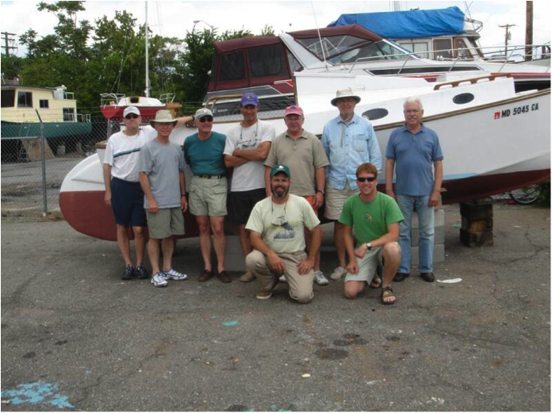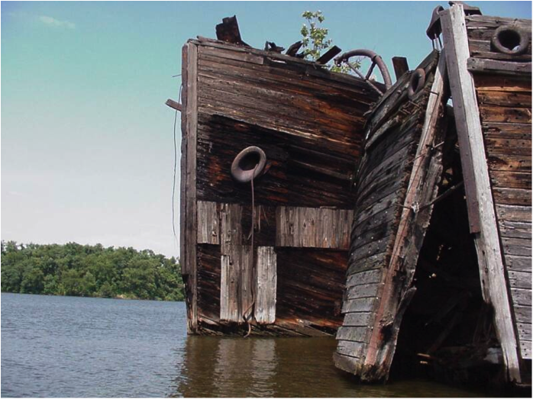
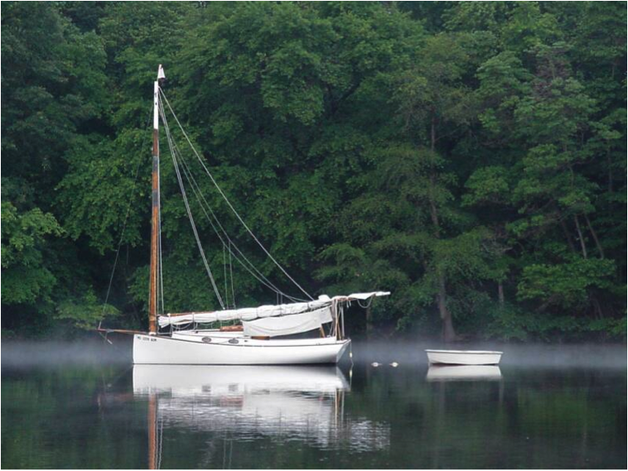
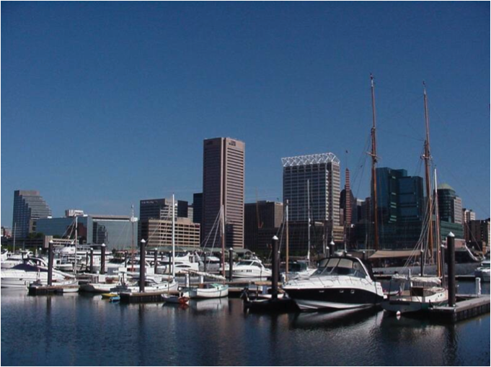
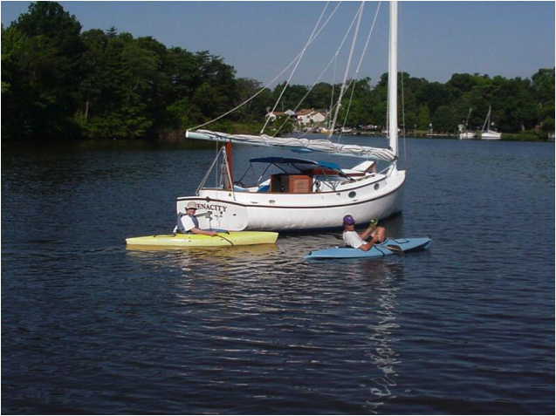
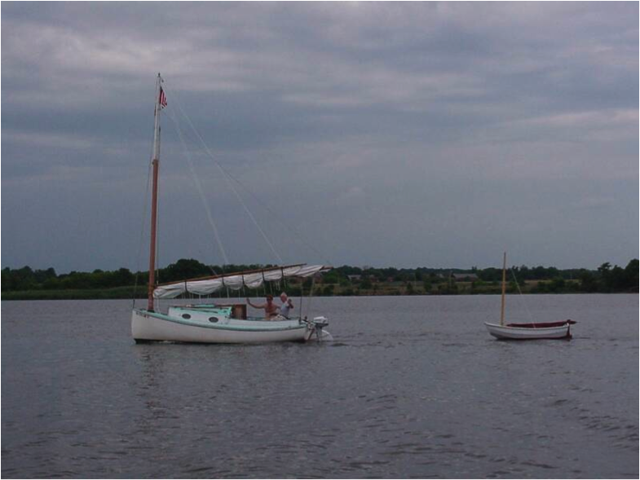

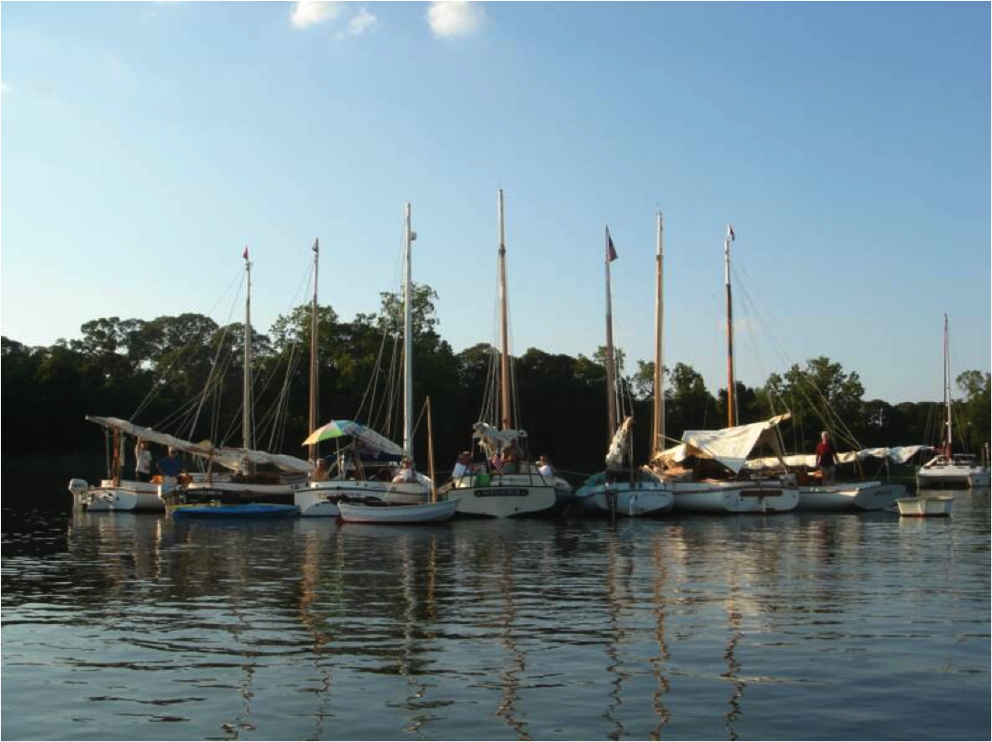
CCBA CRUISE POTOMAC RIVER - 2009
by Marc Cruder

Introduction: Venturing south early this year, got us more than we bargained for in foul weather, light winds, hot sun and longer distances on the broad lower Potomac. However, we initiated new solo cruiser Steve Flesner, who stepped up and delivered, completing his 5 year restoration of Tuckernuck, a Mystic 20 in time for the cruise. Although a broken gaff early on almost broke his spirit, he persevered, proving the condition of the original single cylinder Yanmar, while honing his skills learning a new boat. We welcomed southern cruisers we hadn’t seen in a few years, had a few drive in dinner guests and got to see some very nice natural surroundings in the creeks of the Potomac. Swing-man John Brown was back and split his time between training aboard Tuckernuck and recuperating aboard Wanderer. Finally, “mother nature” and sanity altered our last night out to a more than pleasant stop at St. Jerome’s Creek. Grab your charts - Here’s how it went….

Returning Cruisers
- Marc “Everybody down and get a line on the dock” Cruder with part-time crew John “I’m the next Don Dunn” Brown sailing Wanderer –Wittholz/Prudence 25.
- David “Have you checked the weather - the squall will be thru around 8” Bleil with crew Jim “The place is frickin’ empty” Ohlmacher sailing Gull - Mystic 20.
- Butch “Bring it over to the shop” Miller sailing Dusty - Marshall 18
- Rich “I know you’re busy, but I have a question” Mclaughlin with crew Mike “Nimble in the dinghy” Crawford sailing Tenacity - Marshall 22.
- Dave “Just polishing my bright work” Park sailing Pussy Footin’ – Mystic 20

New Cruisers
- Steve “No More Excuses” Flesner with part-time crew John “There is a Porta-Pot on this vessel, isn’t there captain?” sailing Tuckernuck – Mystic 20.

Cruisers we met along the way
- Stuart “G-flex to the rescue” Hopkins sailing Muskrat – Yawl rigged Marshall 22
- Sid “Bubba light rigged” and wife Gail “I’m the only thing he hasn’t gotten rid of after all these years” Tiesenga sailing Quest – Menger 23

Cruise Support along the way
- Pete “I’m meeting a high school classmate – she’s not my wife” McCrary
- Matt “You’ve got weather coming your way” Cruder
- Butler “Pax River gaff fleet escort boat” Smythe sailing Caerulean – Menger 23

Saturday, 6/06: Pre-cruise staging
Arrived at St. Leonard’s Creek with swing-man John Brown to board and make final preparations aboard Wanderer. I moved the boat here the previous weekend instead of add two more days on each side of the cruise. Tuckernuck, Gull, Tenacity, Pussyfootin’ and later Dusty were present and accounted for to complete the initial flotilla. Although we were all moved onto our boats, Steve Flesner hosted burgers on the grille, finalized Tuckernuck’s provisioning and got the grass cut (with a little catboat help) before we all called it an early night. As this would be the first long cruise for both Tuckernuck and her owner, swing-man Brown was detailed to Tuckernuck during the day to provide moral and physical support while retaining a berth aboard Wanderer for recharging at night.

Sunday, 6/07: Day One - Destination: Smith Creek
Weather: Sunny and fair with light south winds, increasing thru the day to 12 kts
We had a first leg of over 35 miles, and needed to catch the fair tide so all were up at about 0600 to a light breakfast ashore of coffee, bagels and yogurt. At the last minute, Grandma Grace (my wife Deb’s mother) made a batch of raisin scones that I brought up from the boat to round out the fare. They were a big hit and almost gone at their first appearance. After thanking our hosts, the group was away at about 0710, including Tuckernuck finally, after 5 years on the hard. There were photo opportunities aplenty as we powered down the creek for the Patuxent River with Wanderer bringing up the rear.

Raised sail once on the Patuxent with all catboats in sight ahead but keeping close tabs on Tuckernuck as captain and crew were getting acquainted. Initial indications were good when I saw Tuckernuck’s sail go up and I could take a few pictures. The wind was light so we were all under power as we headed southeast towards the bay with our sails acting as perfect shades against the rising sun. By 0910, we were abeam the Drum Point flashing red with Tenacity and Dusty ahead and the 3 Mystic 20s astern after a stop at Solomon’s Island. Came off the engine at about 0935 to give the Mystic 20s and particularly Tuckernuck, a chance to catch up. We were steering a course of about 130 degrees PMC (per magnetic compass) with a light following west wind exiting the river.

At 1000, rounded the remnants of Cedar Point Lighthouse on the south side of the Patuxent, moving at about 3 kts per GPS under power and sail again, with no sea state but a foul tide that would by with us all day. By 1130 we were passing inside and abeam the USN aerial bombing targets with a freshening south and slightly east wind moving us along at about 4 kts per GPS on a magnetic compass course due south toward Point No Point Lighthouse. Conducted the noon radio check with all in sight and on radio except for Tenacity, obviously somewhere well ahead of us. By 1300 and still under power and sail hauled in tight on the gallows but pulling, Wanderer was unnaturally but comfortably tacking between 140 degrees and 200 degrees PMC, moving at about 4.5 kts per GPS against south winds now up to about 12 kts.

At 1430, we rounded Point Lookout by “chicken jibe” as the wind continued to freshen and I was alone on the big boat. The new course was about 340 degrees PMC, with Pussyfootin’ nearest astern. We were both on a run now and off the engine moving briskly. In another hour, we found the #2 red marking the entrance to Smith and Jutland Creeks at Calvert Bay. The chart indicated shallow water outside the buoy line and as I shaped up for it, I decided I wasn’t up to the two jibes it would take to sail Wanderer thru alone with full sail up in a following wind and sea that were now showing sustained whitecaps. Discretion being the better part of valor, I added the engine and dropped sail, navigating the buoy line under power. Rounded the #6 red off Wynne at 1600 entering Smith Creek, then navigated to anchor in about 9 feet of water a half hour later, rafting up to long lost (at least for most of the day), Tenacity.

The anchorage was easy to find to port. Muskrat, the yawl rigged Marshall 22 was not to be missed, nor was the sky blue of Tenacity’s spars. That said, the boats kept rolling in with some taking advantage of fuel and ice at Point Lookout Marina just north of Smith Creek. The boats set up in two raft ups in something of a small boat/big boat split with Dusty, Pussyfootin’ and Gull in one raft while Tenacity and Wanderer were eventually joined by Quest. Last but not least after a fuel stop for 1 gallon of diesel were Capt Brown and his charge Seaman Flesner in Tuckernuck, who survived the first day to raft up with the big boys. The usual swim call, then happy hour ensued aboard Quest at the invitation of Sid and Gail Tiesenga with requisite dinghy photo ops.

Note: All was well until I found part of my gaff tongue on the deck. Further inspection indicated the rest of it was up in place at the front of the gaff jaws. This was a replacement piece that had been on the boat at least 3 seasons, but alas a lamination (perhaps in the wrong direction) with a starved glue line. I was looking for a solution or might have to sail without it…more to follow.

Monday, 6/08: Day Two - Destination: Canoe Neck Creek – St. Clements Bay
Weather: Sunny & Fair with winds light from the south increasing to 5 kts
Smith Creek was a nice spot with undeveloped and natural surrounds. There was a light breeze all night so we were not bothered by insects. The raft-ups stayed intact overnight. In the morning, I rowed over to the small boat raft-up to find that Dusty had some 5-minute epoxy suitable for my gaff tongue repair. Back on Wanderer and after breakfast, Muskrat came by and had the latest from the Gudgeon Brothers - G-Flex epoxy. Quest offered up small stuff to wrap the repair as a clamp and the die was cast. I worked the repair while Capt Brown drilled Seaman Flesner and Tuckernuck around the anchorage.

After the repair was set and curing, indications were that the Mystic 20 practice session was finishing up, so we were underway under power at about 1030. Bringing up the rear again but with milder conditions than when we came in, I cut the outboard channel short, rounding up on the fish trap in Calvert Bay at about 1130 to be swarmed by all manner of biting flies and no-see-ums. It was a crazy “bugs a plenty” situation from out of nowhere.

Conducted the noon radio check with a visual on all boats ahead, while having comms with Tuckernuck and Tenacity. At 1415 I was abeam Piney Point under sail and power on a course of 310 degrees PMC making about 3 kts per GPS. Checked the epoxy repair to the gaff tongue out in the cockpit sun and found it set up and ready for reinstallation. By 1500, I was abeam the Ragged Point spider buoy to port, with Quest astern and Tuckernuck on the starboard beam. At 1630, I came up on the red/green “HI” buoy on the south side of St. Clements Island and shaped up for St. Clements Bay.

Sailed into the first cove to starboard in Canoe Neck Creek behind Quest and Dusty . Dropped sail and anchor, then took Tuckernuck on the port side to find they broke their gaff, and Tenacity on the starboard side. We immediately had to mitigate the situation by consoling and cajoling Steve with Dark and Stormies, promising we’d all look at the problem and put our heads together on it….later. Capt Brown, now over the worst of the day and duly fortified, provided dinghy taxi service for Quest. Wanderer entertained all comers with Gosling’s and Ginger Beer as the cockpit filled up in every direction.

Note: Steve was understandably frustrated at losing half his propulsion and even ceremoniously put the sail cover on to indicate he was done. But after soundly criticizing a prior repair that Steve did not make, we talked him out of packing it in, although we couldn’t talk him into a temporary repair.

Tuesday 6/09: Day Three - Destination: Colonial Beach, VA
Weather: Overcast with a line of storms initially – winds south at 5 kts
With low mileage to our next stop and some questionable weather gathering, we were in no rush to move out early. That said, some had other plans and we would loose our southern members to other commitments. Muskrat was off and away at 0700 just before the national weather service came across the VHF with a severe weather alert. For those still anchored, the weather alert manifest itself as a large horizontal “roll” cloud with brief, subsequent showers and lightning.

Once the weather rolled through I reinstalled the repaired gaff tongue, but not before loosing a stainless 3/8 inch nut over the side. A galvanized nut was found among several holding the steering wheel shaft carrier bearing, so the installation was complete. Aside from Muskrat’s G-flex epoxy, Dusty came through with the cordless drill and 3/8 inch bit to chase the hole through the tongue to remove excess epoxy. So it was truly a group effort and I learned what I should have in an onboard repair kit.

With my gaff repaired and the weather clearing, boats were getting underway. Quest was the next boat out of the creek at 0900 and headed south, with the others close behind. Tuckernuck opted to stay with us under power alone, so received Captain Brown aboard for the day. Wanderer was away under power at about 0915 and abeam the #7 green in Dukehharts Channel on the north side of St. Clements Island by about 1015. Set sail at 1030 with a light wind from the south on a course of 280 degrees PMC moving at about 2.5 kts per GPS. By 1100, I was abeam the #14A red nun off St. Catherine Island and moving only slightly faster at about 3.0 kts per GPS.
Made the noon radio check with our contingent back down to 5 boats, all in sight ahead. Dusty answered up, while Tenacity was sighted exploring the southern shore of the river, presumably looking for the entrance to Popes Creek; the sight of the George Washington Birthplace National Monument. The wind continued to be light from astern with no seaway. Although the boat was moving, there was wind across the deck and the sun was high, which moved me to walk down the rudder for a quick dip at about 1330. Thank God for rudder steps. The casino on the peninsula that is Colonial Beach was more than evident ahead. In another half hour, dropped sail in the vicinity of the red #4 at the entrance to Monroe Creek on the south side of Colonial Beach, VA. By 1430 we were all tied up in the transient slip area of Colonial Beach Yacht Center, only to find the marina and the Blue Heron Pub closed…the first miscalculation of the trip. The ice truck was making a regular delivery, so we negotiated a few bags from the driver. The marina owner lived just a mile down the road, quickly found out we were there and came to introduce himself. He explained that since everyone else closes on Mondays, he closes on Tuesdays, but recommended the Happy Clam at the north end of Monroe Creek. We then confirmed the combination to the showers agreeing to settle up in the morning. CCBA member Pete McCrary arrived by car and wisely chose to drive to dinner.

So, with the Happy Clam on the agenda, all agreed to be aboard Wanderer at 1730 for a catboat ferry ride to dinner. Made phone contact with my son Matt, who had the day off from deckhand duties aboard the Woodwind Schooners of Annapolis and was also driving down to meet us for dinner. Confirmed he was enroute. We did not check the weather before leaving the dock. How much trouble could you get into on a creek only going about a mile in bright sunshine?…apparently more than you’d think. We left the dock under power only and shortly noticed a quickly darkening and I mean darkening like black, sky making up ahead of us. Just about the time that I realized we wouldn’t make it all the way to the restaurant, Dusty remarked; “Can’t this thing go any faster?” Well, more speed or not, I had a decision to make and quick. I saw an open slip with 4 pilings a few docks ahead of the Happy Clam and decided that was the new destination. Luckily I had rigged mooring lines at every cleat before we left, so all that was left was the last command of: “Everybody down so I can see….when we hit the slip, get lines on the dock!” Just then, the wind hit that 10 inch diameter mast and we were setting down and away from the dock in an instant. I only had one shot at it and threw the rudder hard left while kicking the BUKH 20 for all it was worth overcoming the force on the mast just long enough for the all catboat crew to get lines on the dock and pilings in every direction. An impressive display of seamanship that I’d have been pressed to do alone. Now the rain was coming down in buckets, but we were secure. Some crew ran ahead and got permission from the dock owner to tie up and use his yard as an easement to the Happy Clam. Lived to sail another day.

We had a nice dinner with full crew, slightly wet down but not defeated. Matt showed up within 10 minutes asking if I had gotten his phone message about weather coming our way. He struggled over the high and windy 2-lane Route 301 bridge and experienced the storm ahead of us. Of course I was in no position to answer electronic devices jingling in the cabin. Nonetheless all were safe. We enjoyed local seafood while lightning flashed and rain continued outside. With a few cars available, some chose alternate return transportation. The rest embarked aboard Wanderer at about 2030, huddled in the cabin hoping for the best. The rain had stopped and the only thing I had to worry about was finding the daymarks in the dark and navigating around the crab pot fields. Gave a short aviation style safety briefing for the return trip to ensure everyone knew bunk cushions could be used as life jackets in the event of a water landing. With vigilant lookouts John Brown and David Bleil on deck, we were moored back at Colonial Beach Yacht Center at 2130 after ensuring “tray tables were in the upright and locked position” prior to the docking maneuver. It was nothing like the previous one.

Took Matt aboard for the night, relocating swing-man Brown to a berth aboard Dusty. The other cats were moored alongside; not in slips, so there was some unexpected outcome from the storm, which called for mooring adjustments, but all finally settled down. That was enough for one night. Thank you Mother Nature – Lights out.

Wednesday 6/10: Day Four - Destination: Nomini Creek – South side of the Potomac
Weather: Sunny with winds from the south at 5 kts
The weather settled down and it was an uneventful night at the dock. Glad to spend a little time with Matt who had not been aboard for an overnight in quite awhile. We laid in to wait for the marina to open. With good weather forecast for the day, Tuckernuck decided to go solo continuing the trip under power, now that every day would only bring him closer to home. So having been displaced again, Captain Brown reported back aboard Wanderer and immediately got busy cooking up chorizo and eggs for three. I was glad to have him back. We would keep an eye on Tuckernuck from a distance while John might get a chance to recuperate from his day in the sun on the Mystic 20.

We squared up with the marina at $1.50 a foot. Some waited on the gas dock attendant. Matt killed some time rowing the dinghy around, then we walked around the boatyard to inventory what was on the hard, finding at least one old Mathews flush deck cruiser that was in nice shape for its age. Finally, Matt handled my dock lines and then took off down the road by car. It was 1000 when we got away from the dock. Set sail shortly after to keep John shaded from the morning sun that we were headed into. Within an hour we were off the engine and enjoyed a nice southeasterly sail on a course of about 160 degrees PMC, moving at about 3.5 kts per GPS. .

By 1300 we were abeam Mt. Airy, VA with Currioman Bay in sight. At 1415 we were abeam the PRV6B Marker off Hollis Marsh. In another half hour, we added engine to stem the tide as we came up on the #2 red at the bottom of Nomini Bay, picking up the channel to Nomini Creek. By 1600, after navigating local watermen working the creek, we were anchored off Mount Holly at the bottom of Nomini Creek. Dusty and Tuckernuck rafted up along side while Gull’s crew joined the happy hour aboard Wanderer after a requisite swim call. Tenacity found a good spot up at the top of Nomini Creek and stayed there for the night. Everyone to their own hooks for the night. Tuckernuck completed a solo day without incident and stayed alongside.

Thursday, 6/11: Day Five – Destination: Port Kinsale on the West Yeocomico River
Weather: Overcast; with winds from the southeast at 5-10 kts
There was a nice breeze in the creek so we started sleeping on deck until rain later drove us back into the cabin. Despite the weather, which came and went, it was a quiet night on the hook. Got underway in the morning under power at about 0830, watching the watermen work and surprised at how quiet they were. As is usually the case on the Chesapeake, the ways of the local watermen are regional. In this case, the workboats on Nomini Creek where consistent in their use of technology, with transoms modified to accept modern 4 stroke outboards. Honda was the engine of choice. The result is we were not awakened as we have been in some creeks at very early hours by straight exhaust V-8 auto engines. It was interesting and not the result of gentrification on the creek as there was no modern development of note. Seems it may just have been for efficiency.

In about an hour, we were out of the creek with no sign of Tenacity as we passed the green #5 behind White Point where they had anchored. Off Kincopisco Point we set sail on a course of 060 degrees PMC and came off the engine as we traversed the width of the river. At 1115 we crossed bows with Dusty, then tacked around to a course of 150 degrees PMC and back on the engine to stem the tide headed for Sandy Point on the south shore. We tacked around again at 1145 to 100 degrees PMC with a good visual on Piney Point and moving at about 3.5 kts per GPS. In another hour, we tacked one more time shaping up on a course of 160 degrees PMC for the Yecomico River, with Dusty astern. The predicted scattered thunderstorms looked like they were making up in the western sky and we hoped we might beat the weather to the dock, but it was not to be. At about 1430 in the vicinity of the #2 flashing red off Lynch Point at the mouth of the Yecomico we were hit by a passing squall. Since we had time to watch it coming, John and I were already in foul weather gear with a good compass heading to the #3 green, our next intended mark in the river before visibility due to rain, went to zero. We were under power, but also full sail, so it got interesting for a little bit. The quick wind increase churned up the shallow water off the point and of course backed around so we had no choice but to follow the wind, since the sail was up. We sailed almost in a full circle over the course of the 10 minutes it took the squall to pass, while were taking rainwater into the cockpit sufficient to require one of us to bail since, of course, the water was pooling where the drain wasn’t, since we were healed. Just as we thought we had things under control, visibility came back up enough for John to say: “Well, there’s the beach,” to which I responded: “That’s not good, steer away from that.” In the end, the squall passed as if nothing had happened, the sun came up and it was hot again. John remarked: “My, wasn’t that refreshing” and “the boat pulled us through again.” We took the opportunity to douse sail and noted everyone else was docked except for us and Dusty, who was now cutting Lynch Point close to get into the river. By 1600, we were in a slip at Port Kinsale Marina with the rest of the catboats. Most were in before the squall. Tenacity and crew watched from the bar, and Tuckernuck, under power alone, bare-knuckled it abeam the last buoy before the marina when he lost visibility. So everyone had some fun.

We found the showers, got cleaned up and met for happy hour at the Moorings Restaurant at about 1730. Stuart and Dee Hopkins (Muskrat) drove in to join us for dinner with proof of having battled the “roll cloud” of 2 days earlier. Stuart produced a picture of the roll cloud and a shot of his GPS showing a speed of 7.1 kts in his Marshall 22 cat yawl. Quite impressive. The menu and its execution were not to be faulted and all left pleased. Some of the group re-formed in Wanderer’s cockpit to explore a nightcap with Sailor Dave or at Kentucky Tavern. Another good day.

Friday, 6/12: Day Six - Destination: St. Jerome Creek instead of Smith Point
Weather: Clearing with winds from the southwest, moving around to the north
Up and making coffee at 0700 after a somewhat muggy night in the marina. Fuel, ice and dockage fees were paid off followed by a captain’s meeting on the dock. Considering the predicted winds and the distance down the Little Wicomico on the south side of the mouth of the Potomac, consensus was to take advantage of the southwest winds and turn the corner on Point Lookout to duck into St. Jerome Creek, which is the only inlet on the bay between the Potomac and the Patuxent Rivers. There were no negative votes, this being the down side of the trip and the group collectively getting “channel fever.”

With a plan in place, we were underway at about 0900 and I was making a second pot of coffee so we could enjoy the donuts John brought along. By 1000, we had raised sail and were moving nicely with the wind astern with all catboats ahead making for Point Lookout. At 1100, we jibed around to intercept Tuckernuck who seemed to be heading a little too far south. On the 1200 radio check we got a positive status on Tuckernuck, so decided to track him visually as we came up hard on the wind about 1230, rounding Point Lookout and moving up the western shore at about 4.5 kts per GPS. Tenacity was already up at Point No Point and reported he had a good course and was continuing on instead of stopping. Wished he and his crew safe home and then got down to navigating into St. Jerome Creek. This is a tricky creek with a switchback entrance between 2 sandy and shallow spits of beach. Some years back, I tried it under sail in Sylph, my Hermann 17, but had too much foul tide running thru the opening and had to resort to the outboard. This time, wind was ample but not heavy and tide was fair, so I decided to give it a shot under sail. We sailed the buoy line, dropped sail and put out a stern hook without engine. Sometimes things just work, and you can never practice enough without the engine.

Everyone found their hook, while we took Tuckernuck alongside. The decision was good one. We were settled by 1400, the weather was perfect and swim call was the best of the trip. St. Jerome Creek has a sandy bottom, so even the water color is uncharacteristically tropical in appearance. With a nice wind in the creek and sun, but not scorching, the atmosphere and conditions were right for a leisurely afternoon of recharging and recreating. A suitable happy hour ensued as we added Dusty alongside. John decided to cook up some type of port tenderloin surprise as he extolled the benefits of cooking by “reduction.” There was plenty all around, none of it helping any of us reduce. Dinner was topped off by local entertainment as we watched what we thought was a controlled burn become an uncontrolled fire. Tuckernuck called it in to 911, specifying location in the creek. That almost immediately got the local fire siren going, but then we listened to the fire trucks drive around to the south side of the creek, until they were just looking across the water at the fire. Needless to say, the structure burned as we watched by binoculars. The north side of St. Jerome Creek is now speckled with new, large second homes, unoccupied during this event. We did all we could do, the fire burned down and out…no thanks to the local fire department. You win some and you lose some I guess. Enough fun for one day. Everyone was ready for the final leg back to the Patuxent River.

Saturday 6/13: Day Seven - Destination: Homeward Bound/St. Leonard’s Creek
Weather: Overcast with north winds at 5 – 10 kts

Up at 0600 with a no nonsense breakfast of coffee and hard boiled eggs compliments of Tuckernuck. Added some diesel to Tuckernuck’s fuel stingy once cylinder Yamnar and then got the group underway under power by 0700. Navigated the channel out and set sail off Point No Point at about 0730, retaining the engine to stem the ebb. Our course was due east at a speed of about 4.0 kts per GPS with all catboats ahead under sail. Tuckernuck took station crawling under power up close to the western shore where he was easily visible. After an hour, tacked around to a course of 330 degrees PMC and increased throttle to give us another half knot of speed. A little after 1000, we tacked around to our due east heading again, off the first of two domes prominent and visible between Point No Point and Cedar Point on the south side of the Patuxent River. At 1155, we were up fighting a strong ebb at the mouth of the river, taking several tacks to clear Cedar Point. On the 1200 radio check, had comms with Gull, Tuckernuck and the Patuxent River welcoming committee catboat Caerulean.

Tacked around into the Patuxent at about 1225 and off the engine, sailing at a good 4.0 kts per GPS. Sighted our charge Tuckernuck officially in the river. Although we should have stayed with him, it was too late, we were headed for the barn now, but kept the radio on just in case. At 1300 the wind died and we were still fighting the last of the tide. Kept the sail up for shade and came back on the engine. Passed under the Route 2/4 bridge and around Point Patience at 1400. By 1430, the sail was down and we were headed for St. Leonard’s Creek with Gull and Tuckernuck visible astern. We turned into St. Leonard’s Creek at 1500 and were tied up at 1530.

We had plenty to do to clean up the boats as Tuckernuck came around the last bend an hour later. After a successful docking maneuver, we cleaned up and took a minute to congratulate Steve Flesner on his first long cruise complete, despite the adversity of a broken gaff. He was presented, or more correctly “re-gifted” a bag of exotic buckwheat pancake mix, reminiscent of another infamous Mystic 20 sailor, Captain Bill Hoover, marking Steve’s and his Mystic 20’s accomplishment. He is expected to have everyone aboard for breakfast on next year’s long cruise.
The remaining group left their boats in anticipation of the Pax River Shootout the following weekend and emptied the Flesner driveway of extra cars. Cruise Complete.

Epilogue
Although a bit more arduous and complicated due to pre-staging than most of our cruises, we succeeded in getting on the Potomac the first night, where we joined our more southerly located members. On average, weather was good but hot due to consistently low wind speeds that were made up for on more than one occasion by line squalls, lightning shows or just plain downpour including a rare “roll cloud” sighting. That said, everyone handled conditions without further weather induced mishap and we all agreed that we now had some appreciation for the lower Potomac River.

On the upside, except for Tuckernuck’s gaff giving way just behind the jaws due to a less then well executed previous repair not made by the owner, and my broken but repaired gaff tongue thanks to a better prepared member who always carries epoxy onboard, all the other boats ran flawlessly. We spent a good deal of time powering under sail to provide ourselves shade, work against foul tides in light wind while certainly giving the auxiliaries a work out. We congratulated Steve Flesner for making Tuckernuck “swim” again and look forward to her return under sail but enjoyed watching Steve gain confidence and perspective on what it takes to complete a long cruise with this group.

A special thanks to our southern members for making the effort to intercept our path and join in some catboat camaraderie, as well as to the Flesner’s for hosting the pre and post-staging that enabled our success. I expect a low-impact cruise next year in the mid-Chesapeake focused on several of the rivers on the western shore. Keep an eye on our website at www.chesapeakecatboats.org, as plans develop. With another successful cruise down, look for us again in 2010 on the Chesapeake Bay.
mcc (Wanderer)

CCBA MID-WESTERN SHORE CRUISE-LITE - 2010
Shoveller Arrives... and Survives
By Marc Cruder and David Bleil

The vision for this year’s cruise was two-fold. First we were looking for cooler weather after last year’s scorcher, so intentionally started the cruise earlier than we ever have; Memorial Day Weekend. Second, we were looking for a low mileage local event that would offset last year’s longer and more challenging trek to the Potomac. As everyone across the country knows, the weather has been unusually warm to say the least. For the Chesapeake, we experienced what is usually “only the month of August” weather from mid-May on. So, brisk and refreshing things weren’t, but we did have some wind and even for those who opted to make the cruise somewhat disjointed (or short), enjoy some good local sailing. We also sighted a few stray cats and were joined by other CCBA kindred spirits shoreside. Of note was Mike Crawford’s recent purchase of Shoveller, a strip-planked Fenwick Williams 25 originally built for CBA luminary Max Fife. This was her inaugural cruise on the Chesapeake. Here’s how it went….

Returning Cruisers
- Marc “I have been volumetrically surpassed” Cruder with crew John “This is a significant part of my life…but I have a few issues” Brown sailing Wanderer –Wittholz/Prudence 25.
- David “One hand for you, one hand for the ship…or else” Bleil with crew Jim “I’ve only had the dory out once this season” Ohlmacher sailing Gull - Mystic 20.
- Butch “I have standards and I’m not about to change them now” with crew Denise “Men are all the same” Miller sailing Dusty - Marshall 18
- Mike “I’m a happy guy with my big wood catboat” Crawford with crew Rich “I’ve been demoted to Mate” Mclaughlin sailing Shoveller - Fenwick Williams 25.
- Butler “Diver Dan E.C.M.O…No pooping allowed” Smythe sailing Caerulean - Menger 23.
- Jack “I’m a lot late…but I have my own shade” Smith sailing Winters Dream - Marshall 18.

Cruisers that joined us along the way
- Kerry and Kris “We really don’t have anyone else to play with and kind of like you guys anyway” O’Malley with canine crew Grommet sailing Chesapeake - Bugeye Yacht
- Chip and Erik Miller managed each to join Dusty at different spots along the route.

Cruise Support that met us at Skipper’s Pier
- Steve “I shall return…maybe!?” Flesner who only prepped a Marshall 15 this season.
- Various others met the group for dinner including Deborah and Kenny Kerr; Denise Miller and new members Butch & Karen Garren along with Alan and Nan Suydam as well as conscripted Paradise Marina Dockmaster and owner of Hesper, Steve Verry. Other Catboats Sighted

- Viola – Menger 19 on the Magothy River
- Hesper – Marshall 22 moored at Paradise Marine – Rockhold Creek
- Herreshoff Eagle – moored at Sherman’s Marina – Rockhold Creek

Sunday 5/30: Day One - Destination: Ponder Cove Sail In - White Marsh Creek
Scheduling the first night as a “sail in” to the community docks at Ponder Cove made my preparation somewhat different and easier than getting underway, although Wanderer had to be ready to go regardless. This was not a big feat since she was in the water again over the winter due to an unscheduled parting of the tiller arms on my Edson worm and roller gear at the end of last season. Aside from the steering gear overhaul (a whole diatribe of its own), other prep was just continuing maintenance, so the engine and rig had been shook down and the prop freed of winter barnacles by running the boat into a local shallow cove where I was able to stand up behind it…putty knife in hand.

Both kids were busy with their lives so I was happily cruising without them. My home from college for the summer son, Matthew was living at the Cove House, but working full time on the Woodwind Schooners in Annapolis. His contribution was to make sure the house was clean enough for transient shower users. He accomplished this by closing all extra doors and marking them “Employees Only.” Nonetheless, the shower was clean and useable. My daughter Noelle would be graduating High School during cruise week and certainly had better things to do than hang out with dear old Dad, but she did manage to stop by for a hot dog with her boyfriend, a self-proclaimed “competitive sailor” in the local Annapolis sailing scene. Various catboats and others started trickling in during the afternoon, so Debbie had plenty of help with the usual support functions of a CCBA event. Normally, the first night out is something of a food sharing event, if we get past “happy hour.” This was billed as a “cook what you brought” event, so only entailed ensuring adequate dockage, cleaning barbecue pits, lighting fires, throwing a few tablecloths around and lining up enough paper plates and other sundries. We even managed to raise an American Flag and have a moment of silence for our veterans, it being Memorial Day Weekend and all.

It was an interesting gathering and only the second time I used the community facilities. The first time, weather largely precluded catboats from arriving by water. This time, we launched one, had the pleasure of the O’Malley’s bugeye yacht Chesapeake anchored out in the creek not far from the schooner rigged skipjack yacht Fortune, and officially took notice of a CCBA adopted Shoveller, originally owned by Max Fife and made famous or infamous more recently when past CBA president Tom Maddigan retraced the voyage of “The Boy, Me and the Cat” in her from New England to Florida via the intracoastal waterway. Mike Crawford, who spent more than a few years with Homer, a very original (down to the Palmer “Pup” one cylinder) gaff rigged Hermann 17 was ready to move up in a big way and recently purchased Shoveller from Richard Ronzoni on Long Island, then sailed her down to the Chesapeake Bay. CCBA is honored to have a catboat of such pedigree and CBA history in its ranks. Mike is the man for the job and we have committed him to his role in continuing Shoveller’s cruising career on the waters of the Chesapeake Bay.

Fires were lit, the flag was flown, boats were docked or moored, the libation flowed and a good time was had by all without disturbing or involving local law enforcement.

Monday 5/31: Day Two - Destination: Forked Creek – Magothy River
The festivities wound down and although there was some friendly interaction with a local jet ski operator about his wake, things went smoothly. We did discover after the “smoking lamp” was lit, more than cigars were ignited when a black powder cannonade was fired somewhere in the vicinity of Shoveller. Thinking fireworks, teenagers and wood boats, I quickly made my way over to the other dock only to have a heart to heart with Shoveller and crew, who were found to be at the source of the munitions drill. Beyond that, it was a quiet and somewhat breezeless but bearable night at the dock.

Not pressed for time, breakfast was a slow individual boat to boat thing, the serenity of which was broken at about 0900 by Chesapeake getting underway to the strains of the signature O’Malley bugle…last heard outbound from Bodkin Creek aboard their Marshall 22 Crabby Cat. Obviously the bugle was not sold with the catboat. With Chesapeake calling us out, the group was shortly underway and followed. John Brown, my crew, had made it down the night before with Mei but elected to spend a last night ashore in comfort before returning bright and early. With short distances on the agenda, I elected to leave the dinghy ashore and we got underway unceremoniously about 0915 bringing up the rear with all catboats ahead.

By 0945, we were at the mouth of the Rhode River and had set sail as well as a course north up the bay, retaining the engine to assist negotiating the field of crab pots outside the channel. At 1000, we dropped off the engine and decided to check our speed only to find the hand held GPS inop….obviously not pre-cruise checked. The display had been slowly fading so this was its final death throw. In the vicinity of Thomas Point light off the mouth of the South River, we heard an unexpected and sharp bang. The centerboard pendant had let go, but a quick check indicated the bilges were dry. The board on this boat is large piece of ¼ inch stainless steel…think heavy. My only concern was the structural integrity of the centerboard pin and anything the board swinging fully down and coming to the end of its stroke might do. We were intact. One negative about being in the water for the winter was putting off a pendant repair from the previous season. I remember looking at the cable before the start of the cruise and thinking it would last another season. It had started to show chafing….it did not last. With board fully down, we continued off the wind toward the bay bridge, but knew we had to do something.
Despite this little trist with the centerboard pendant, we were off Tolly Point and gaining on the catboat fleet. The order at that moment in time was: Marshall 18s x 2; the Mystic 20; the Menger 23; the Fenwick Williams 25 and finally my Wittholz 25.

The 1200 radio check just north of Whitehall Bay found Winters Dream clearing the bay bridge with Caerulean ahead broad on the port bow and Shoveller astern, but all catboats in sight. At 1330 we jibed around Sandy Point Lighthouse, still heading more downwind than not, but with the centerboard “humming” at higher hull speeds. Continued another hour into the Magothy River before turning up to starboard in hopes of finding a place near Dobbins Island to beach and reattach the centerboard pendant. This being the height of the Memorial Day weekend, there were simply too many boats already taking up space in the shallow beachable areas, so we doused sail and powered back around Dobbins Island to pick up the #9 green into Forked Creek.

By 1515, we were rafted up between Shoveller and Caerulean, both anchored, with Winters Dream outboard. The alternate raft-up was Dusty and Gull anchored further up the creek. Swim call commenced to give all a chance to cool off. Took the cursory raft-up photos for the record, then assessed the pendant problem below the waterline. With the board all the way down, the pendant attachment point was accessible…Caerulean, aka Diver Dan, ECMO, USN (Retired) to the rescue. Dropped ¼ inch double braided nylon thru the trunk from inside the cabin with a weight on it. Diver Dan ascertained the line location underwater and made the final dive to accomplish the needed connection. Onboard, the line was reeved onto the winch and board control regained.

With repairs behind us, happy hour commenced at 1700 as we were boarded by Dusty, Gull and crew. Dark ‘n Stormies and clams bedded in Cheese Wiz on triscuits were the order of the day. To escape the sun, we luxuriated in Shoveller’s ample cockpit under a low bimini designed to be used under sail. It was a little like sitting in a chopped-top ’51 Mercury, but it did the job. Now getting a closer look at Shoveller, she was indeed a quality constructed vessel and so the recipient of many toasts to her continued service under her new owner’s competent stewardship. The CCBA membership present unanimously adopted the vessel without any of the responsibility, although we pledged to do what we could if called upon.

Dinner ensued. Aboard Wanderer it was “shrimp heads ala Mei,” with cigars to finish. Eventually oil lamps including the anchor light were lit and we retired on deck.

Tuesday 6/01: Day Three - Destination: Crab Creek – South River
Enjoyed a wonderful bug free and breezy night on deck. Up sometime between 0730 and 0800 greeting the day with coffee and Little Debbie pecan swirlies. We were unrafted and underway under power by 0845. The smaller cats headed up the river a little further for ice and fuel. The weather was predicting thundershowers and winds gusting to 25 mph, so tied in a single reef as we headed out. In another half hour we were underway under sail in company with Caerulean and Shoveller. Cleared Magothy Narrows at 0930 with Caerulean and Shoveller astern. Winds were out of the Southwest as we sailed without other wake or seastate and in the shade of the mainsail. By 1030, the wind eased in the vicinity of Sandy Point lighthouse as the big cats shook out their reefs. The small cats were visible exiting the narrows. At 1200, numerous tacks and the right wind (despite the foul tide) put Wanderer under the bay bridge first with all cats visible astern. Handed the wheel over to John to make lunch. The wind was up and Wanderer was moving out.

At 1330, shifted the watch and was handed the vessel going astern in windless conditions with a squall making up in the western sky over Annapolis! We were off Tolly Point in the Ship Anchorage headed south for Thomas Point hoping we would avoid said squall, which appeared to be moving north. By 1415 the weather was continuing to make up to the west and included the South River. We doused sail at about 1430, donned foul weather gear, then got hit by thunderstorms and lightning as visibility went to zero. Thomas Point Lighthouse eventually came up as visibility resumed. Shoveller and Gull visible ahead, Caerulean abeam with Dusty astern. Winters Dream nowhere to be seen. As the weather continued to clear, Winters Dream sighted and all under power up the South River heading for clearing and sunny skies.

Navigated into Crab Creek about 1530. The area was marked by large homes on high and heavily wooded ground. Interestingly, not all homes on the water had piers so there were many mooring balls in the creek. We found a nice spot near wooded cliffs. By 1630 we were rafted up with Happy Hour happening simultaneously in multiple cockpits. Each to his own for dinner, with skillet chicken and pasta aboard Wanderer. As a result of the weather event, Shoveller reported finding the further extent of soft deck, laid and underlying, as plans for dinner were overtaken by close up wood inspection. With no further weather expected, the big boats stayed rafted up, including Winters Dream.

Wednesday 6/02: Day Four - Destination: Indian Landing - Severn River
Woke up to John’s latest shoreside crisis, necessitating his returning home with me for a cruise break. My excuse was a daughter graduating high school. With John, it is best to use a version of the military’s “Don’t Ask – Don’t Tell” policy, because the less I know sometimes, the better! After making a plan of action, I set John to cooking volumes of sausage, bacon and his version of loose eggs for breakfast. Invited Shoveller aboard for breakfast to mitigate and shore up any perceived buyer’s remorse over the soft deck situation. “Deck Fund” donation boxes were suggested for installation port and starboard in the cockpit. Beyond that, consensus was that this situation was small potatoes and now at the top of the winter worklist with a bullet. A fitting project of which she is worthy.

Moving right along, the group was cleaned up and underway at about 0830, with a variety of agendas. Some were in search of ice and others were headed for the Severn River. Wanderer arrived at the mouth of the South River at about 0930 and continued under power due to light winds. Heading south, John and I navigated the crab pot field and turned the corner into the Rhode River at about 1030 headed for Ponder Cove on White Marsh Creek. We were moored and secure by noon with tentative plans to get underway again on Friday morning.

(Editorial Note 1: The following is an edited version of events provided by Gull)
Due to excellent explicit sailing directions the remaining five boats reached the upper extremities of the Severn. After investigating the two small islands noted in the sailing directions the early arrivals decided to anchor in the spectator section of the local water ski circuit. We arrived early enough for plenty of time to row the dinghies or kayaks to and around the islands, one of which had a log cabin prominently posted for no trespassing. The other island proved to be a popular rest stop for large canines. Dusty had a crew change at a local yacht club which allowed him to take each of his sons on the cruise but not at the same time. Erik was aboard for this leg. Dusty showed himself a master at logistics. Everybody got transferred to and from the boat without a hitch.

Thursday 6/03: Day Five – Destination: Rockhold Creek – Herring Bay
The next day was a long day and most boats opted for an early start. The wind was brisk and on the nose which made for some exciting tacking duels. Around Holland Point Gull tied in one reef which managed to delay us just enough to put us in the cross hairs of the next afternoon thunder storm. Dropped the sail and pulled on the oilskins but this time not before the rain started. When visibility improved again we made straight for the entrance to Rockhold Harbor and our first and only night in a marina. We were guided in to the proper slips by the owner of the shiniest, most elegant Marshall 22 not in a showroom, Hesper. The Paradise Marina is a work in progress but finished enough to accommodate those wanting showers (all of us), ice and a place to recharge portable electronics (only two plugs, stand in line). It was the perfect place to bail out, dry out, clean up and go out to eat. Skippers Pier, a regional landmark, is identified by a large
Parrot statue which is reported to be one of the few items to survive Hurricane Isabel. We filled three reserved tables, supplementing the cruisers with other members who had driven in. The food was excellent, the service attentive and the bar well stocked. It is definitely a place worthy of a second visit and easily accessible by car so it probably will be. The thunder storms were still out and about during our dinner but left us early enough to pass a quiet night. No reveille the next morning but a parade of charter fishing boats provided a wake-up call.

Friday 6/04: Day Six - Destination: Smith Creek - West River
Not having far to go for the last day we waited around to pay our dockage fee. The owner never materialized so Caerulean collected for all, made change and deposited the dockage fees in the padlocked ice locker. We certainly paid with cold cash. A short run up to West River got us to Smith Creek early in the afternoon. Some of the other creeks and boat yards of the area were explored before setting up two rafts again. Shoveller and Winters Dream hung off Caerulean's shiny titanium anchor. Gull and Dusty were further in the cove hanging on Gull's mud shovel. In the midst of swim call, Caerulean's anchor pulled loose and the big boats began bearing down on the other two with remarkable speed. Frenzied activity and fending off caused the mobile raft to slide by with millimeters to spare. Whereupon Caerulean started engine and headed straight back for us again. Once the still rafted boats had steerage they were again able to squeeze by with no collisions and resume their former position, this time adding Shoveller's anchor to the holding tackle. Dark and Stormies in Shoveller's spacious cockpit soothed frazzled nerves and all was well again.

(Editorial Note 2: There is of course a VERY different perspective on the “drifting raft event” from Caerulean’s owner, who was allegedly clear on the other side of the creek rowing in his dinghy when he saw the raft drifting apparently before anyone else. As reported, he did made it back aboard, aborting the “drifting raft” by directing it with power and resetting the Fortress anchor in deeper and less debris ridden bottom)

That evening a fireworks display over Galesville was answered by Shoveller's ordnance. The Commodore always seems to miss the most exciting parts. We never saw him again for the rest of the cruise. Maybe he did know something he wasn't telling us.

(Editorial Note 3: The something referred to was that the weather did not change substantially from the time of Wanderer and crew’s departure from the cruise. It continued to be hot, humid and windless with thunderstorms mixed in just for fun. Both John and I decided it was not worth a run down to join the group Friday night just to enjoy a “sweat-fest.” We shamelessly remained in cooler surroundings and let our imaginations only wonder what the group was up to.)

Saturday 6/05: Day Seven - Destination: Homeward Bound
As best I can tell in absence of evidence to the contrary, all catboats returned safely home.

(Editorial Note 4: Since I was already home, I went to Chesapeake Rigging to borrow a nicro-press tool to secure a new stainless centerboard pendant. The manager suggested doing something for his crew by stocking the refrigerator as an appropriate rental fee. It cost me a case of beer, but I made the fix. Feels much better than the ¼ inch nylon!)

There was some evidence of catboats lingering on the western shore as I spied Shoveller early Sunday morning, just getting underway from a slip in Spa Creek. Later reports indicated Shoveller had a steering casualty in blustery southwest winds off Hail Point, but because the previous owner had a back-up steering provision in place Capt Crawford and Mate Mclaughlin navigated her home otherwise intact.

Epilogue
Despite the fact that Wanderer did not finish the cruise, by all accounts the post mortem by email appeared good. Those in the group got to see some interesting places in the central Chesapeake that they usually pass to and from other local CCBA events. Sometimes, you never take the time to see what is right in your backyard that others travel miles to experience. That said, we found more creeks worth a second visit that we had not been in before. While the weather was not optimal, short mileage legs made the heat and light wind at times tolerable. Alternately, Paradise Marina and Skipper’s Pier lived up to expectations and provided the venue for shore support.

A high point for all of us was the chance to spend some up close and personal time with Shoveller. While the new owner was kind enough to listen to all would problem-solvers, at the end of the day, it is a wonderful example of the breed and we are more than happy to have been witness to her inaugural cruise on the Chesapeake. As has been said before, Mike Crawford is the man for the job and we are all confident that he will bring his woodworking talents to bear in only the most positive way that will be a credit to himself and his commitment to Shoveller as she begins another chapter of her long and illustrious career here with us on the Chesapeake. We welcome her and are committed to her continued success….may she swim well in these waters!

Finally, the little discussion there has been about next year’s cruise continues to revolve around Shoveller. When you get some displacement under you, you want to take it places. That said, the suggestion, largely from the big wood boat is that an island exploration is in order. My response with the support of the membership is that we add a day or two to the cruise for 2011 and make Smith Island our destination. Until then, stay tuned for details on our website at www.chesapeakecatboats.org. Fair winds my catboat friends.
mcc (Wanderer)
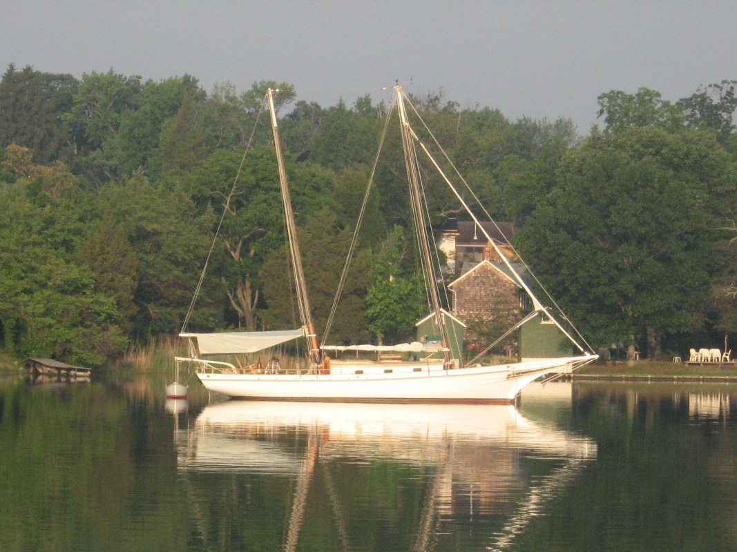
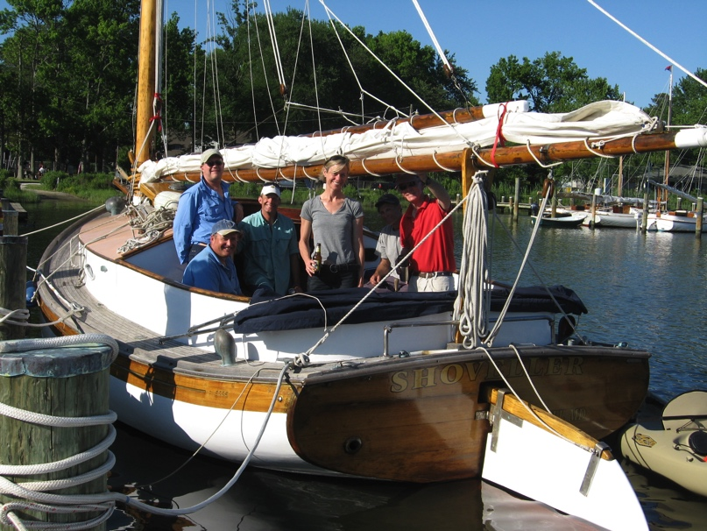
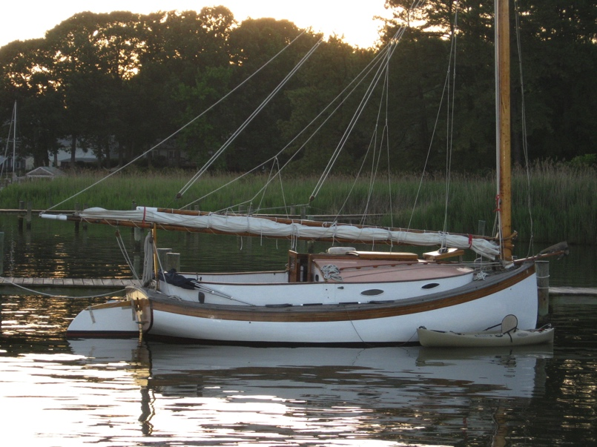
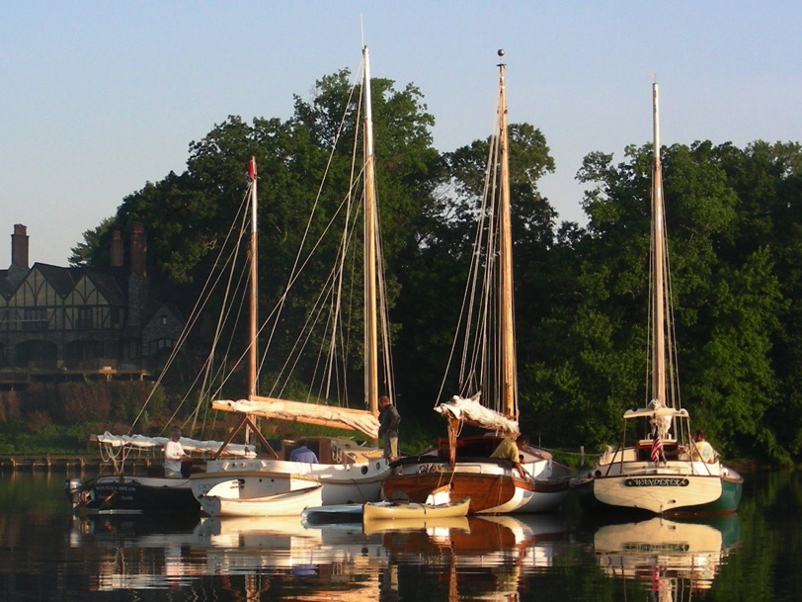
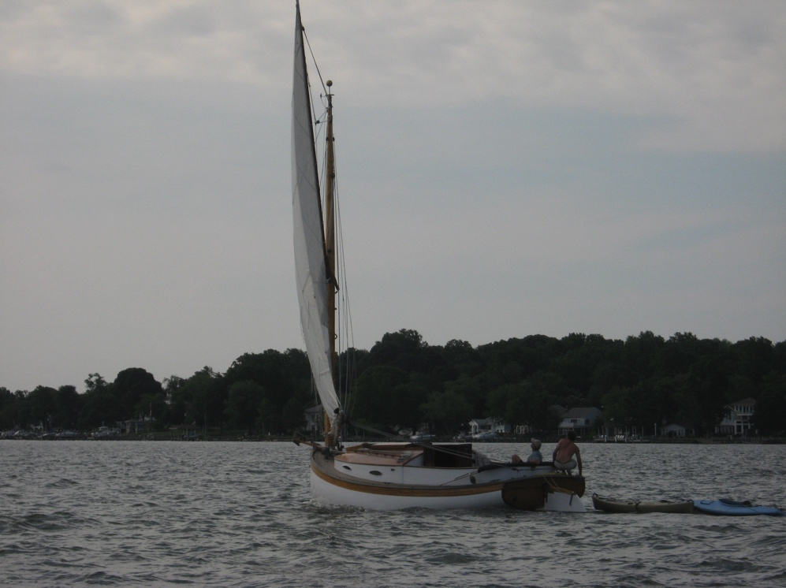
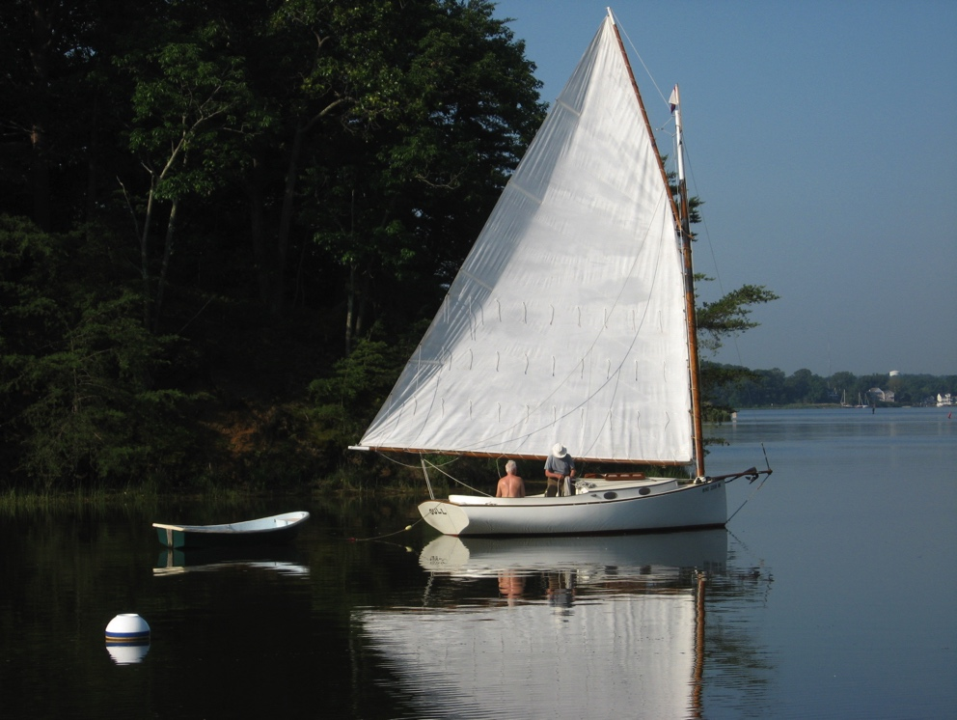
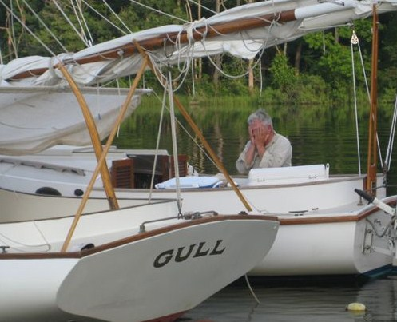
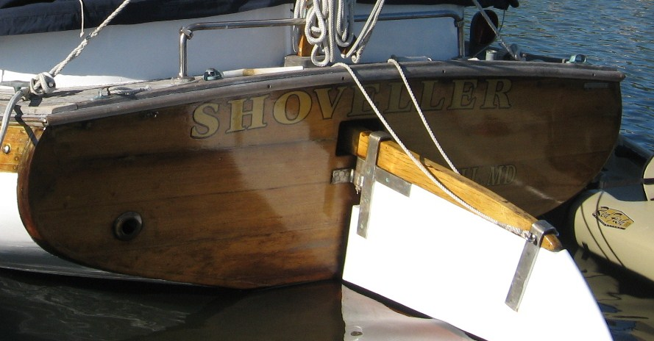

CCBA SMITH ISLAND RUN - 2011
“Down to the Last Maryland Offshore Chesapeake Island”
By Marc Cruder

Introduction
This year’s island theme cruise to the last inhabited offshore island in the Maryland Chesapeake drew good weather, good wind, favorable tides and a record number of boats. In addition to the core group of traditional cats we also had a contingent of Nonsuch 22s, a home-built pocket cruiser and a sailing skiff. Of particular note was the addition of another big cat in wood with Martin Gardner’s Planet, a Dana Story built Wittholz Prudence 25. We experienced the untouched natural beauty of the eastern shore along the creeks of the sparsely populated Honga River, enjoyed the luxury of Somers Cove Marina (with swimming pool) in Crisfield before descending on the most hospitable and uniquely pleasant residents of all three communities on Smith Island, before finishing off our cruise at the hands of our host Larry Antonik and the locals at Luckies Last Chance who surely showed us how to enjoy every iteration of oysters and crabs. Here’s how it went….

Returning Cruisers
- Marc “Ranger Gord” Cruder with crew John “These boats don’t point well with a reef” Brown sailing Wanderer - Wittholz/Prudence 25 (glass).
- David “Unexpectedly Solo” Bleil without crew Jim “Take me back to the dock, I can’t stay” Ohlmacher sailing Gull - Mystic 20.
- Butch “Roger Dodger” Miller sailing Dusty - Marshall 18
- Mike “I got everything I wanted in a sail” Crawford and son Tristin “Those Smith Island girls are creeping on me” Crawford with crew Rich “This is the way we do it on Shoveller” Mclaughlin sailing Shoveller - Fenwick Williams 25.
- Butler “Let me help you with your dock lines” Smythe sailing Caerulean - Menger 23.
- Jack “My aerated wine is at its peak” Smith sailing Winters Dream - Marshall 18.
- Pete “I might have to pack it in” McCrary sailing Tattoo - Chesapeake Light Craft PocketShip 15.
- Bill “Watch out for the eel grass” Bell sailing Bobbin - Marshall 22.

New Cruisers
- Martin “Just because it’s illegal doesn’t necessarily mean it’s bad” Gardner sailing Planet – Wittholz/Prudence 25 (wood).

Cruisers that joined us along the way
- Alan “Steaks all around” Suydam with veteran cruiser crew Steve I’m under a lot of pressure here” Flesner sailing Rejoice – Nonsuch 22 (inboard).
- Butch “Can someone come get me” Garren with grandson Scott “I’m ROTC material” Garren sailing Whiskers – Nonsuch 22 (outboard).
- Peter “I can make it to Smith Island if you guys can” Alexander with crew Larry “I prefer to stand” Antonik sailing a Dudley Dix sailing skiff.
Cruise Support that met us ashore

Deborah and Kenny Keir joined us for dinner at Luckies in Dames Quarter.

Sunday 6/12: Day One - Destination: Brooks Creek – Little Choptank River
This year’s preparation went smoothly for Wanderer including an alternator rebuild, an impeller change, but more importantly a haul on the Orme railway at Blue Water Marina. Some will remember Bob Orme who crossed the bar a few years ago, as a devout catboat sailor and early member of the CCBA. His marina on Bear Neck Creek continues under the management of his sons Bob Jr, (Big Brother) and Chili (the middle brother). Little brother John, is still an active waterman, so not engaged in the family business. I was glad to spend some time with them and they seemed happy to have a catboat up on the railway. The local slip holders also seemed interested. During my brief stay, I got every comment from: “what kind of boat is that…I like it” to “Gee, we didn’t know the railway still worked.” That said, Chili got ‘er hauled, Lil’ Chil (Chili’s adult son), got the bottom paint on while I attended to all the other maintenance from touch up to rigging. The most time consuming job (which I did over the winter), was re-painting the name board. In the end, there were no surprises, the job got done and I was splashed in time for the cruise.

My family crew, Matt and Noelle are now both in college and with intent (mine), living close to the poverty line, so busy working summers with no time for catboats. This left John Brown, my defacto crew for the last few years as the next order of business. John surfaced like he always does after the winter, but in recent years only after returning from what has become an annual pilgrimage (since he married Mei), to China. When he called to confirm his bunk on Wanderer, I had to tell him that although there was a berth, I had arranged for him to crew for a member who just bought Bobbin, a Marshall 22 and expressed an interest in some onboard oversight at the beginning of the cruise. He would be coming out of the West River, so, I said we’d meet at the red day mark at the mouth of the Rhode River to make the personnel transfer. John takes these challenges in stride and as long as he has a clean bunk aboard Wanderer to return to at night, does not complain, despite the fact that he is not as “nimble” in the dinghy as he used to be…but then who is anymore. So with that in mind, we were underway under power from Ponder Cove with dinghy in tow at about 0800.

On the run out, I realized I was minus my tool box. Arriving at the #2 red, Bobbin was nowhere to be seen, so I set John adrift in the dinghy after calling Bobbin by cell phone to let him know what he was looking for. It was about 0845 when I went back for the tools with John floating merrily at the mouth of the Rhode River. It was 1000 by the time I cleared the #2 red day mark outbound again, but I had a visual on Bobbin under sail ahead with dinghy, cutting across the shallows off Curtis Point. Wind was light from the southeast, so I stayed on the engine as I raised sail, caught up and was along side by 1130.

Leaving John aboard Bobbin, I continued under engine and sail across the shipping lanes tacking down on Sharps Island lighthouse to the #7 flashing green, then between the red & green “wreck” buoy and the #6 flashing red. By 1440, the wind was up with whitecaps showing there to be about 15 kts, so came off the engine passing the green #1 at 1540, the #3 green at 1605 and the #5 green around the bottom of Ragged Island into the Little Choptank River. Sighted other catboats and with sufficient but easing breeze, I continued into Brooks Creek under sail and was anchored by 1730. There were seven boats in the anchorage area including Shoveller, Dusty, Gull, Planet, and Tattoo with Bobbin coming in behind Wanderer. Swim call ensued followed by happy hour aboard Shoveller.

Monday 6/13: Day Two - Destination: Fox Creek – Honga River
The wind came up and the bugs were grounded as a strong northwest wind gathered throughout the night. The group was largely individually anchored because of the weather and all slept good in the security of an adequate lee. Up at 0600, I rowed the anchorage advising at least a one reef day and further noting that the anchorage would remain Fox Creek off the Honga River. Those with more than 35 ft of vertical mast were best served going around the bottom of Hooper Island. As the wind was coming up and staying up, intrepid Pete McCrary in his Chesapeake Light Craft Pocket Ship decided he might head back to the Patuxent River, then home instead of endangering himself on the bay for the rest of the week. His decision would turn out to be a good one. Others informed that they were heading across to Slaughter Creek for some supplies before continuing on.

Bobbin decided he needed John for another day, so let them depart together as I waited to bring up the rear, but not before watching Planet sail off the hook. Followed behind under power with one reef tied in. Got the sail up around 0920 and was immediately hit by big rollers and high wind as we cleared the lee of the cove. Then things got interesting. Planet lost her main sheet out of the cockpit but it stopped at the first block on the boom. We had VHF comms and Planet informed after retrieving the bitter end of the mainsheet that perhaps a second reef was in order. While the boats were both Wittholz 25s, Wanderer is more an estranged sister-vessel with slightly less sail due to her lighter weight in composite, so was holding her own under her one reef in these conditions. Besides it was probably the worst place to throw that second reef in.

Keeping an eye astern on Planet, I continued on thru the James Island Cut finding the need to depower all the more acute considering the likelihood of a following sea and wind all day. So ducking behind what little lee James Island could provide, I threw in a second reef. That was a good move as I got organized again waiting for Planet so we could continue down the bay together. After watching Planet’s first time with us skipper in action, I was no longer concerned about their survival for the rest of the cruise.

South we went, crossing Barren Island Gap at about 1215, before turning east for the fixed bridge on the north side of Hooper Island. Maintained sail under and cleared the bridge at 1330. Continued into the Honga River, sailing by the lee from the green #1 to the flashing green #5 off Bentley Point, then around the red #2 at the bottom of Windmill Point on Asquith Island to the green #1 off Paul Point, turning into Fox Creek. As expected, although we had come around north into the creek, there was no high ground so not much protection, but we did find a reasonable lee in the northwest corner of the creek in about four feet of water. Rafted up the whole group on a hook forward and a hook aft from the big boats to declare swim call and happy hour.

Tuesday 6/14: Day Three - Destination: Crisfield, MD – Somers Cove Marina
It was a pleasant evening with just enough lee to maintain the raft up. Gull provided the morning entertainment close aboard while raising sail “on the run” to be the first underway and under sail. Things aboard Wanderer were moving at a slower pace as John, now back aboard full time, cooked up chorizo and eggs for breakfast. The raft up began breaking up around 0900 after most shook out at least one reef expecting lighter winds.

Headed south out of Fox Creek proceeding along the outside route down the west side of Bloodsworth Island while some took Hooper Strait directly into Tangier Sound and then south. The outside route in the bay eventually had us working against heavy beam and quartering seas with associated parametric rolling. This required taking a strain on the windward topping lift to mitigate any boom end dipping. The wind was a steady 15 knots and the boat was moving at 5.5 kts to hull speed of about 6.5 kts.

About 1030 we were abeam Holland Island (no longer with house) and the red “WRZ” buoy. Sighted Nonsuch 22s approaching with haste from the east. At 1200 we were in the vicinity of Holland Island Bar Light with all catboats in sight except Gull and Dusty who had taken the inside route. Continued into Kedges Strait around Solomons Lump and made for Jane’s Island Light. All continuing to sail hard and at hull speed. As we rounded up to make the channel into Crisfield, saw Bobbin lose her main sheet and accidentally jibe…but recover. Rounded up and doused sail standing by for Bobbin to get under control and make way in the proper direction. Eventually all boats arrived into the Little Annemessex River intact and in Crisfield Harbor by 1400.

Somers Cove Marina appeared ready for the group with elaborate docking procedures that included red shirted dockhands, slip numbers shouted from the end of the pier and ECMO line handling orchestration. Once we were settled, CCBA member and host from the high ground on Dames Quarter, Larry Antonik was there to greet all, along with Pete Alexander and his Dudley Dix designed sailing skiff.

Everyone successfully checked in with marina manager Suzanne Ford, who had all the group’s paperwork in order and was genuinely glad to see us. We were glad to be there after a swift day of battling the elements. The facilities were excellent with the opportunity for hot showers followed by suitable chlorinating in the pool followed by happy hour aboard Planet to compare Wittholz 25 notes. Moved on to dinner at the marina’s suggestion to The Cove since it was a short walk from the docks. We enjoyed some good camaraderie with a couple we met that sailed in on an Allied Seawind Ketch. We knew the history of that boat’s design (first production fiberglass boat to be sailed around the world circa 1962….and they knew what catboats were). We didn’t need much else in common to enjoy our time together.
Note: Lots has changed in Crisfield in the 15 years since I last visited. The crab capitol of the eastern shore has been all but obliterated by the credit and housing bubble burst with subsequent impact on the restaurant situation. There are empty high rise condos at the end of main street, businesses like the old marine hardware store that have gone out of business with the place generally looking like a ghost town. On the food side, we cannot recommend The Cove because there was no crab in the Cream of Crab soup and the Crab Cakes were all filler and marginal at best.

Lit the smoking lamp back aboard the boats to ponder Crisfield’s plight, but agreed that the service and facilities at Somers Cove Marina were the highlight of the visit. We all wished we were staying longer so we could sit around the pool some more.

Wednesday 6/15: Day Four - Destination: Ewell - Smith Island, MD
Another surprisingly refreshing night with a nice breeze, topped off with a short downpour. Nothing fatal. Decided to walk up to main street and go to legendary Gordon’s for breakfast. This is where the local watermen converge and have their coffee. The scene is similar to any local McDonalds, but a little rougher around the edges in a Chesapeake Bay kind of way. We engaged some of the locals sitting outside. We told them we were just blow boat guys passing thru, to which one responded: “Anybody with a blow boat don’t belong here no way anyhow.” We agreed with him and took that as our cue to go in now and sample the fair….egg, steakum and cheese on a hamburger roll, slightly greased for a couple of bucks. There you go. Despite what the welcome sounds like, the locals are blow boat friendly and you can always depend on the watermen in their deadrise boats to do the right thing when you are out there maneuvering under sail. They won’t cross your bow or wake you; something their recreational powerboat brothers could take a lesson from. On the way out, I made a comment to the owner about how the place hasn’t changed in 15 years. He cavalierly responded: “Yeah we almost put a new floor in the back room, but it ain’t broke thru yet.” Again, there you go.

Lazed around town, visited the local little museum and planned a noon departure for Smith Island, just 8 miles sea buoy to sea buoy back west across the bay.

Underway outbound as planned setting sail about 1215 on a course of 240 degrees PMC (per magnetic compass). In the vicinity of the green #1, shook out the single reef. About 1330 tacked back on a course due north, snagging a crab pot in the process between the skeg and the rudder. It didn’t stop us, just slowed us a little until we cleared it to continue sailing. Hit the flashing green #1 about 1400, dousing sail to power up the channel to Big Thorofare and to the main community of Ewell. Fought a strong current for over an hour under power to find all boats present moored at the Smith Island Marina. Since I had only read the cruising guides, I wasn’t sure what we’d find. As it turned out, we found a woman named Pauli under the Smith Island Marina sign with enough shallow water slips that were just right for this crew. The marina consisted of a bed and breakfast that was not currently operating, complemented by a small outbuilding with a beach décor sitting room as the precursor to shower and toilet facilities. That was all we needed. Captain Steve (Pauli’s husband) had passenger carrying fishing boat, but was working off the island. We would meet him during our stay. Pauli is not a native islander, but came to work at the bed and breakfast; eventually marrying Steve in an all-island attending ceremony. Pauli, an artist advertises a business doing boat portraits.

Once tied up, she advised me she had a telephone call for me in the house from one of our group. Looking around we were missing Whiskers, one of the Nonsuch 22s. He was at the channel entrance with an inop outboard that had not been charging. Some outboards still need juice for the electronic ignition even to be started by hand. So he was stuck. With no facilities on the island, I recommended he sail with the wind back to Crisfield while it was still light with the water tower more than prominent. There he could get his engine situation diagnosed. We had some discussion and he thought sailing back to Solomons with favorable wind in the morning might be better. Last advice was to anchor well outside the Channel because there was still likely to be local boat traffic overnight.

Returned to the boat to make dinner while some others negotiated soft shell crabs from the locals. Bobbin’s skipper was joined by his wife and they were off to one of the local bed & breakfast establishments on the island. We were visited well after dinner by Pastor Rick just as the bugs were coming out. He’s the resident Methodist Minister on the island carrying on in the tradition of Joshua Thomas, the “Parson of the Islands.” We had a nice non- denominational chat. Because we thought it was a “dry” island, we did not offer him a drink, but found out later from the locals that Pastor Rick likes his wine. Who knew? Eventually said good night to our spiritual guest and rigged the bug nets for the night.

Thursday 6/16: Day Five – Destination: Exploration Smith Island, MD
We survived the night as the temperature stayed cool and the nets worked. There were no bugs in the cabin and we slept well. This was our “lay-in” day on Smith Island, so made coffee while John cooked breakfast again to use up some eggs and the last of the Chorizo. There was only one other community on the island connected by road, so a few of us walked to Rhodes Point, ending up in Marsh’s boatyard. Took photos of various indigenous wood crab scrapes and deadrise boats. Asked one of the locals working on a boat if he was winning or losing. He said: “Neither, just trying to get done…you know…you can put roses on top of fecal matter (he used a different but familiar colloquialism) but underneath, it’s still fecal matter.” Yet again…there you go.

Made our way back to the boats and conferred, with unanimous agreement that we needed to take a crabcake cruise to Tylerton, the third community on the island, but only accessible by boat. For volume and choice of the proper boat as catboat ambassador for the fleet, Capt Mike Crawford allowed us all to pile into Shoveller. With that decision made, had time to walk around Ewell, visit the Methodist Church as well we as the post office so John could mail a postcard. Also took in some of the real estate for sale, although it was rumored one of the catboaters stumbled upon the local real estate agent…she was kind enough to give him the grand tour by golf cart. And another younger catboater was seen being followed in his gold cart by a couple of the local teenage girls in their golf cart…what happens on Smith Island, stays on Smith Island. Before leaving Ewell, we came up with enough people to commit to dinner at Ruke’s…6 pm sharp!

At the appointed time, we loaded Shoveller’s cockpit with the whole group of almost a dozen hungry crab cake seekers. Got underway for Tylerton after being initially redirected by a local waterman who indicated “small water” to us visually in our original direction of transit. We turned around, eventually docking at Tylerton. Planet’s skipper had called ahead to the Drum Point Market for “crabcakes all around,” so they were ready for us…kind of…in their own way. It was a general store and eatery purported to have the best crabcakes on the island. They took a little while, but were big as softballs and tasty. Different areas of the bay make different crabakes. In the northern bay we are used to backfin crab meat in our crabcakes. These were good but not made that way. Talking to the women who took our orders, we asked how she got here. She said she married a Smith Island man was not claim a local. Besides she said: “Nobody comes here to live… they come here to die.” With that, we thanked her for the crab cakes and said goodbye to the locals sitting around in a circle of chairs (where the pot belly stove must have been originally). They were a pleasant and friendly group that knew about our boats and were interested in our travels. I particularly enjoyed their parting comment, which could only come from islanders in the middle the bay: “See you on the bay someday.”

We walked the village, which was in better repair than Ewell owing to The Chesapeake Bay Foundation having an outpost there. Their monetary influence was evident including the small sea wall erected by the Army Corp of Engineers on the island’s windward side. While I’m sure it was stabilizing the island’s shape, it certainly looked like no match for the flooding Mother Nature could bring on with even the slightest bit of weather. In any case, most of the houses were jacked up and everyone was trying hold what they had. With that, we rounded up the crew and made the return trip to Ewell by Shoveller.

Returning to the boats, we napped, got cleaned up, enjoyed cocktails in the cockpit, then made our way to Ruke’s. Got talked into local Soft shell crabs and found them very good. Also had homemade vegetables and Smith Island Cake; traditionally 10 layers of very thin yellow cake with chocolate icing in between as well as on the top and sides. We were done. Began discussing our morning exit strategy and next year’s cruise.

Friday 6/17: Day Six - Destination: Dames Quarter, MD
Survived the night moored at Smith Island Marina with all catboaters signing the guest book before departing under power by 0730. Navigationally the group split for this next leg to Dames Quarter with half exiting back down and out the west side of the island to Crisfield then thru Janes Island State Park via the Dougherty Canal and Big Annemessex River. The other half exited the west side of the island and simply went north in Tangier Sound. Bobbin elected to get started home to ensure he still had a job on Monday.

By 0800 we were under sail with engine outbound and making our easting down Big Thorofare. Cleared the channel by 0830 headed for Crisfield. Made a side trip to Sea Mark Marine in Crisfield to look at a fiberglass bugeye-rigged centerboarder that was salty but certainly in need of more work than any of us could imagine. It did have some nice period hardware and unique castings. (Later research revealed it was a Kenner Privateer 35) By 1030, we were powering northeast in the Dougherty Canal. We passed docks, a launching ramp and camp grounds with campers sitting by the edge of the canal in the shade of big pines watching us go by. Looked like a nice place to visit for awhile. One of our group in fact, transited under sail, and got an unintended closer look.

We cleared the canal by 1130, setting a course northwest for Deal Island. At the noon radio check just south of Little Deal Island, had visuals on Caerulean, Planet and Gull ahead with Dusty astern. Winter’s Dream was hauling at Crisfield, so we expected to see him on the trailer at Dames Quarter. Arrived Dames Quarter about 1430 with all boats anchored in the little cove behind the spit in front of CCBA member Larry Antonik’s. Swim call ensued with orders to be ashore by 1700 ready for dinner.

Within the appointed time, we were all assembled inside Larry’s place. Tristen and I were making use of the pool table until heading out for dinner at Luckies in Chance, Md. Luckies is a local establishment, described as not fancy, but with good food. We found it was certainly a local place suited to its surroundings. Typical of many establishments in small rural and remote areas, it is a meeting place that serves multiple purposes. It is the community’s general store, with a bar at the other end and a kitchen with a full local menu. However, Larry had them alter the menu to bring out their finest, family style to include: Oyster Pizza, Single fried oysters, Oysters Rockefeller, Buckram crab and soft shell crabs as well as desert and beverages. While the favorite could be argued, everything was good. Aside from all the oyster dishes done right, the buckram crab is something few of us had tried…just a tad crispier than a softshell…and the crabcakes were the best of the trip including those on Smith Island.

The food kept coming until we just had to say “uncle.” Larry topped off the night by taking us for a tour of the local boatyard to view the derelict deadrise fleet on the hard slowing returning to nature as well as the progress on the local restoration of the Skipjack IDA MAY. Aside from the historic fleet, the yard was under new management poised to raise the status of its nautical residents and associated clientele.

Just as it was getting dark we made our way back to Larry’s dock and worked out the dinghy logistics until we got everyone where they wanted to go. Then we battened down the hatches ….or tried to…as the insects of the marsh came after us.

Saturday 6/18: Day Seven - Destination: Homeward Bound…almost
We survived the night, but just barely. The mosquitoes gave us a run for our money and won the day; so much so that John suggested we make coffee underway outbound. With that in mind, and although there was a promise of some skipjack sailing, Wanderer was underway under power from what we affectionately called “Bug Flats” with the coffee a brewing by 0630.
In another hour, we met a Vane Brothers tug pushing a tank barge ahead inbound for the Nanticoke River and by 0800 we were passing Sharkfin Shoal, shaping up for Hooper Strait. In half an hour we were due south of Bishop’s Point and by 0900 abeam Hooper Strait Light before coming right to 310 degrees PMC. Raised sail and set up power sailing on a port tack headed for Cedar Point on the south side of the Patuxent River. Our plan was to make it back to St. Leonard Creek to stage Wanderer for our next race over 4th of July, instead of sail all the way home.

By noon we were abeam Hooper Island Lighthouse and made Cedar Point by 1330. In another hour we were at the red #6A at Solomons where we altered course left to 280 degrees PMC making for Lewis Creek. Found our way into Lewis Creek and anchored by 1530 for swim call, happy hour then dinner. Received a report that Bobbin was in the Choptank River headed for Dunn Cove and on schedule to be back on the West River by Sunday. Rejoice checked in to say they made it home and that the dock was clear for Wanderer. We were ready for a bug free night.

Sunday 6/19: Day Eight - Destination: Docked St. Leonard Creek
It was a nice cool night and good for sleeping with no bugs. The weather however, turned overnight and began a cycle of intermittent rain that continued throughout the morning on what was Father’s Day. John whipped up the last of his sausage and eggs before we departed under power at about 0900. It was an easy but wet run up the river until we were docked at the Flesner’s by 1100. Debbie was there to pick us up and we were back home by 1230. Another cruise was officially history.

Epilogue
Reports continued to come in, with the first being that Captain Stoney had a medical emergency so nobody went skipjack sailing on Saturday morning; so we didn’t miss anything high tailing it out of “Bug Flats.” Caerulean made it back to Solomons on Saturday, as did Rejoice but not before grounding on the spit in front of Larry’s place. Tattoo had made it home on Monday night with the help of someone named “y-tee,” and Winter’s Dream left for home on the trailer from Larry’s in Dames Quarter.

Finally, next year’s cruise was discussed with some marginal consensus focused around the mighty Sassafras River to the north, but there was also discussion about the CBA 2012 Mystic Sail-In. The Sail-In has the possibility of working for the smaller trailerable boats in our fleet, but may be too impractical for the larger Chesapeake Cats. In any event, the verdict is still out and no doubt there will be more discussion. Until then and as always, stay tuned for details on our website at www.chesapeakecatboats.org. In the meantime, as the boys sitting around at the Drum Point Market in Tylerton on Smith Island would say….”Nice talking to you…See you around the Bay someday.”
mcc (Wanderer)

RAFT UP ON THE SASSAFRAS - 2012
By Marc Cruder
Introduction
As always, these cruises are ever interesting. This year we punctuated that by having some former catboaters along who were no longer in catboats. We did hit a little weather, which changed plans to varying degrees for different parts of our little flotilla, but all survived to sail another day. We missed our window for bugeye sailing but will chase that opportunity another time. The wind was kind and ample in most cases. Several were plagued by unscheduled maintenance, but temp repairs were made and most sailed on. All in all, another good cruise, although we have to do something about our raft-up anchoring process, despite the fact we like moving about as a “7-wide.” Here’s how it went….
Returning Cruisers
- Marc “Anybody got muffler tape” Cruder with crew Steve “Keep the vicodin coming” Flesner sailing Wanderer: Wittholz 25 (Glass)
- Dave “I can’t receive a radio call, but I’d be happy to receive a cell phone call” Bleil with crew Jim “I think my Chesapeake Bay Spyce cologne is overwhelming the rum” Ohlmacher sailing Gull: Mystic 20.
- Dave I’ll just anchor away from the raft-up” Park sailing Sarah K: Herreshoff 18
- Butch “Natty-Bo emergency fix-it man” Miller sailing Dusty: Marshall 18
- Mike “Marine supplies afloat” Crawford with crew Tristin “The love boat” Crawford sailing Shoveller: Fenwick Williams 25
- Rich “I’m back baby” Mclaughlin sailing Tenacity: Marshall 22
- Jack “I told you they were turning blocks” Smith sailing Winter’s Dream: Marshall 18
- Martin “Patron of the arts” Gardner sailing Planet: Wittholz 25 (Wood)
- Bill Who supplies the fender…you or me?” Bell sailing Bobbin: Marshall 22
New Cruisers
- Craig “Here today…gone tomorrow” Ligibel with delivery Captain “My Marshall 15 is in Florida” crew sailing Mystic Wind: Mystic 20.
Non-Catboat Cruisers
- John “It’s my ship and I’ll do as I damned well please” Brown with crew Butch “More power to the electronics Captain” Garren sailing Traveler: Atkins Ketch
- Kerry “If you friend me, you can see the PowerPoint” and Kris “Don’t be silly, this is what boating is all about” O’Malley sailing Chesapeake: Dickerson Bugeye
- Pete “Side curtains rigged” McCrary sailing Tattoo: CLC PocketShip 14

Sunday, 6/10: Destination: Swan Creek, MD
Continuing to treat Wanderer like a farm implement, I had no big winter projects and so no delays getting ready for the cruise. The work list just keeps getting a little longer as I liken keeping the boat up to painting a bridge. I’m ready to start over again and keep telling myself that will happen as soon as the kids are out of college. The good news is that one of two did graduate this year and has a job. So I am getting closer. That said, we moved our 4th of July event to Memorial Day Weekend this year, which made for a good shakedown to southern Maryland and the Patuxent River well before the cruise. So all I needed to do was fuel up and ensure all systems were still functioning. My regular crew, John Brown actually bought a boat again and so our Roving Ambassador Steve Flesner volunteered to crew and provision the boat. It was simply an offer I could not refuse.
Steve stopped up the day before and we had Wanderer stowed in no time, so he could get one last night ashore. The next morning he was on the dock bright and early, so I launched him in the dinghy, while I got away from the slip and had him back aboard, dinghy in tow for a 0855 recorded departure. Cruise 2012 was on.
By 0915, we were well outbound in the Rhode River and had sighted John Brown’s Atkin Ketch Traveler anchored in Rhode River Cove. Hard to miss a gaff rigged ketch with a main topmast! Made radio contact to confirm our sighting and came close aboard to render honors….hand salute! We continued out of the Rhode with Traveler astern as we rounded the duck blind at the mouth of the river about 0930. Bobbin was sighted coming out of the West River, so we slowed to allow closure. The trio proceeded northbound; catboats via the crab pot field and keel boats in the channel.
At 1000, raised sail to supplement the engine and provide some shade from the morning sun. By 1100 we were off Tolly Point, just south of Annapolis, where we sat scanning the horizon for another catboat and cruise first timer, Mystic Wind. After half an hour with negative sightings or response on the radio, we continued north.
At 1200, we were “all stop” at the Bay Bridge, where the Coast Guard was enforcing a security zone from end to end because of the scheduled “Bay Bridge Swim.” Although aware of the swim, I didn’t think the whole width of the bay would be blocked off. It actually wasn’t, but our timing was bad. The swimmers were moving left to right and the western span had already been closed. Traveler was drifting in the middle, because the 74 foot topmast would not clear the 58 ft. eastern span, but Wanderer’s 30 ft. mast would make it. I approached the eastern span just as the Coast Guard closed it and confronted us. The conversation went like this:
Coast Guard: Sir, the waterway is closed west of caisson #20
Wanderer: How do you know what the caisson numbers are?
Coast Guard: Ask someone
Wanderer: Who do I ask?
Coast Guard: The boat that will stop you.
At that point I had to fight young testosterone with the “I’m a retired Coastie” card, which I rarely draw. The answer then was that the caissons were numbered. A quick look thru the binoculars confirmed this and I thanked our regulatory friends.
With new found knowledge, we transited the Bay Bridge in the vicinity of caisson #20. Then at about 1300, Steve was at the helm faced with the next Coast Guard challenge, which was (now that the swimmers had passed) the Coast Guard buoy tender Oak. By virtue of it’s gross tonnage and speed, Steve decided to take his stern…good decision.
By 1330 we were abeam the green #95 and set a course of 050 degrees per magnetic compass (PMC) for Swan Creek. In another half hour, we were abeam Love Point at the north end of Kent Island, shaping up for the water tower at Gratitude. By 1600, we were in Swan Creek and sounding by boat hook for Traveler, in need of 6 ft. at low tide. Finding a suitable spot, Traveler set an anchor. Then things got interesting. I went into a seat locker to get out some mooring lines only to find exhaust coming up at me and the engine compartment covered with soot. A closer look indicated a crack in the corrugated metal exhaust line. Since it was not an extreme emergency, we made a quick round of the rest of the catboat fleet anchored further up the creek in shallow water before coming back down to raft up to Traveler. Happy hour was upon us and repairs could wait.
With that, I returned to make the rounds by dinghy to see who was actually among us, took requisite photos, had a quick swim and then a dark and stormy. As boats continued to roll in, some of the non-trailer size boats joined Traveler while the rest relaxed on their own hooks. In total, there were 9 catboats and a ketch in Swan Creek that night.
Monday, 6/10: Destination: Sassafras River below Route 213
All up early making breakfast. Before boat repairs, Traveler suspected his alternator was failing so gave him a solar panel to start charging his batteries while troubleshooting continued. In the interim, Dusty provided some magic “stick to itself” tape allegedly good to 500 degrees F. Decided to wrap the breached corrugated dry pipe followed by a steel corned beef hash can from breakfast, split and installed with hose clamps compliments of Shoveller. Op test satisfactory – we were gas tight again.
Catboats started out of the creek about 0730 with all out by 0830 and Traveler still not aground…yet. Cleared Swan Point in another hour on sail and engine heading north in light to no wind. About 1030 started tacking to alternately get shade as the wind was coming up from the north. The 1200 radio check found us 2 miles south of Fairlee Creek with Traveler, Tenacity, Shoveller and Dusty in sight. Exhaust repair holding.
By 1300 we were abeam Fairlee Creek and by 1430, Still Pond. At 1530 we were abeam Howell Point on the south side of the Sassafras as we turned into the river against a foul tide. Skies were dark to the north and west. Tenacity and Shoveller were ahead and by their heading and motion experiencing a confused wind and sea state different from the south side of the river which made them both douse sail.
Added 5 gallons of fuel to the tank, cranked the Bukh up full, kept the sail up and stayed to the south shore. Two tacks put us well into the river. The third tack brought us to the flashing red #2 about 5 miles in. Doused sail, donned foul weather gear as a light rain began. Rounding the green #5, sighted the group including the bugeye Chesapeake, obvious in her size and character. Made a visit by dinghy, which prompted crew Tristin to swim over from Shoveller, then Dusty to tie up alongside with crew from Gull and Sarah K. Before I knew it, an impromptu happy hour had established itself aboard Chesapeake while absolutely interrupting the Captain and Mate’s dinner. We were assured the situation was fine by our most gracious hosts, the O’Malley’s. We were even given a thorough history lesson on the bugeye but with rain in the forecast, our bugeye boutique cruise with catboat crew for the next morning was cancelled.
Cruise Notes: Lost Bobbin, who when last seen the night before looked like he had forgotten to use sun block, so retreated home well sun burned. We also could not account for Mystic Wind, but suspected they were lounging ashore in Georgetown somewhere instead of huddled in the cabin of a Mystic 20 in the rain.
Tuesday 6/11 Destination: Sassafras River @ Swantown Creek
Woke up to light rain with a forecast of more on and off. As the bugeye boutique cruise was cancelled, all were laying in. That didn’t mean there was not action in an around Chesapeake. Mate Kris O’Malley took her first “open water” swim of the season while Capt Kerry O’Malley prepared to get underway. He had a pressing engagement down bay and now without catboat commitments, was anxious to get ahead of the weather.
Took the dinghy to borrow three eggs from Capt Brown so my crew could make “Eggs Florentine.” The result was an excellent brunch aboard Wanderer. After brunch, made a round of the fleet by dinghy to reiterate the day’s plan. Then returned to catch up one some reading for the rest of the morning while it rained.
Weighed anchor about noon as the weather took a break. Proceeded upriver under power with the temporary exhaust patch still holding. Within an hour, passed the Granary (originally an intended stop) noting no signs of life, so tied up to the Georgetown Marina fuel dock for diesel and ice. About 1330, the group assembled to power under the bascule bridge that had opened for us, each to their own exploring. All proceeded past Gregg Neck boatyard at Swantown Creek on a high tide noting a six ft. depth almost everywhere in the center of the creek. In another two hours, a raft up was in progress around Traveler on the north side of Gregg Point. Called Planet on the VHF, but found him in “nap time.” He promised to call back around 1700. Meanwhile, happy hour was gaining momentum, despite the early hour…cheeses, sausages, salami, pepperoni; all with a dark and stormy if you please, under the “chop top” bimini aboard Shoveller as a light rain fell.
About 1600, we were approached by a local in a Boston Whaler who informed us we were anchored where there would only be four feet at low water. He further advised that the channel was only six feet because the local buy boat Nellie plowed the mud on the bottom periodically to keep the place navigable. That said, we thanked him and although most of us would be fine, we were rafted up to a keel boat, so a move was in our future…near future. Although warned, amid the reverie and while thinking about our options, the raft up of seven boats all on Traveler’s anchor, began to drag. The group sprang to action: Capt Brown took charge on the foredeck of Traveler; Capt Crawford took Traveler’s helm; Mate Tristin assumed Shoveller’s helm while Wanderer at the other end of the raft up was designated “auxiliary engine.”
With the raft-up manned and ready, the lone anchor was freed and the “7-wide” proceeded down river to a point south of Gregg Neck boatyard in 11 feet of water. Traveler and Wanderer dropped hooks at each end of the raft up. At 1700, Planet came up loud and clear on channel 72: “I had this dream I was on a cruise…but now they’re all gone.” Responded that we were now outside his zip code due to an anchor drag, but that he was welcome to join us.
By 1800, Sarah K, Gull and Planet temporarily joined the raft-up. Wanderer and crew took their turn below with dry clothes and a nap; emerging again in an hour to prepare chili for dinner with salad. More rain erupted as the meal was consumed. Enjoyed a cigar and called it an early night.
Wednesday, 6/12: Destination: Sassafras below Rt 213 – Georgetown Yacht Basin
Woke up to sunshine and a fresh breeze with no reason to disturb a good sleep. So laid in, had coffee in the cockpit with Traveler, Tattoo and Winter’s Dream. Then decided to cook spam to have with hard boiled eggs; sharing my breakfast delicacies with Shoveller’s crew Tristin while his Captain reported a little morning “pain on the brain.” Cooked up the rest of the spam and finished it with Tristin before putting him on dinghy bail out duty to take my crew around for photographic documentation. The day’s plan was loose and without time constraints as we only had to get back down thru the bridge and take a slip. Departure was scheduled for about noon.
Traveler went visiting aboard Tenacity to further discuss the charms of oriental women, only to find Tenacity’s bilge full of gasoline from a carburetor float bowl overflow. Traveler and Dusty began carb diagnostics. Traveler extricated himself from the situation while Dusty took control. In the interim, the raft-up was dragging again as Traveler’s danforth proved itself useless, but was backed up by Shoveller’s plow. The situation called for a group “round turn.” Reduced the raft-up by ordering Tenacity and Dusty out on their own to continue repairs and for the safety of the rest of us…after all the boats are largely plastic, making potential fire not a good thing. Removed Winter’s Dream from the raft-up and came ahead on engines to reset hooks. Wanderer, Traveler and Shoveller standing by for a final report on Tenacity. Planet joined the raft up, Tattoo “cut loose” while Sarah K, Gull and Winter’s Dream headed down river for the bridge.
Witnessed engine operations on Tenacity with Dusty reporting that the engine was now running steady. Tenacity headed home with recommendations for a new carb and clean fuel after a fuel tank clean out. With Tenacity ready for sea, the remaining raft broke up at about 1400, heading for the bridge opening en masse. Successfully transited and immediately met a friend of Winter’s Dream with a Herreshoff 18 launch sporting plenty of inboard engine (as judged by his wake) and a fine audible display of triple air horns nicely tuned. We continued on to settle in at Georgetown Marina, with all boats snug in their slips by 1600. Cocktails followed in Wanderer’s cockpit, before being overwhelmed by Chesapeake Spyce cologne, bought at the marina ship’s store and proudly donned by Gull’s crew. Finished up the impromptu happy hour to experience the shore facilities before dinner at the Kitty Knight House.
Enjoyed an adequate dinner with only average food and service at best, but had a nice view of the basin as we were accommodated nicely inside with air conditioning. Had a leisurely stroll back down to the boat, lazed awhile in the cockpit before calling it a night.
Thursday, 6/14: Destination – Fairlee Creek – Upper Eastern Shore
It was a quiet night at the slips. Woke up early, knowing Traveler would be game for the one mile walk to Twiney’s for breakfast while the rest slept. Twiney’s was everything we thought it might be as a breakfast spot of the locals. Ran into shipwright John Swain (builder of Sultana) and then enjoyed creamed beef on toast after the waitress straightened Traveler out on the meaning of “one meat.” Then there was the local jogger who everyone stops to watch as she jogs by every day at the same time. We were there for that, but perhaps it is a story for another time. In any case breakfast was good.
Came back to the marina about 0745 to find Mystic Wind had come and gone with only some minimum contact via Gull. Re-provisioned with ice, visited the marina store to buy and replace the “miracle tape” that was holding my exhaust together and found another good deck mop. By the time I returned to the boat, the group was leaving in drips and drabs. Traveler was “rigged for fast sailing.”
Departed at 0945 with crew at Wanderer’s helm to experience a leg of river navigation under sail and active instruction to ensure intuitive reactions of the helmsman were consistent and correct. Followed Shoveller out of the Sassafras and was abeam Howell Point by 1145. Sighted Traveler with a spread of canvas set including jib, staysail, gaff main and mizzen…everything but the gaff topsail! Planet and Dusty sighted astern.
Proceeded down the eastern shore, making the red 2F at Fairlee Creek by 1430. Doused sail to motor the narrow but marked, switchback entrance. Anchored just inside and across from the Tiki Bar and beach along with the other catboats. Had a leisurely swim call, drinks and a nap before Wanderer’s crew fired up the Magna Grill. Chef Steve coordinated a fine collection of steak and potatoes and even performed his own version of “the fishes and loaves” from the bible to accommodate dinner guests from Shoveller and Planet. As the good book says: “All were satisfied.”
Just as dinner wound down, a medium sized powerboat anchored fairly close by…lights on, kids screaming, a/c overboard going. Planet moved off to his own hook, while Wanderer repositioned further up into the shallower water. Some just don’t get it.
Cruise Note: Next time stay away from the navigable entrance where you may be subject to late night drive by anchoring and get thee to the other end of the creek!
Friday, 6/15: Destination: Lake Ogleton – South Side of the Severn River
Up early to find Traveler gone, others beginning to stir and my crew still asleep. Made dinghy rounds to find Shoveller’s crew canoodling on the foredeck of a Hunter sloop nearby with his girlfriend Hanna. All the rest going home except Dusty, who was sailing to Baltimore to see the Tall Ships. Returned to Wanderer to have breakfast bars and finish my coffee. Planet would join us at Lake Ogleton.
Departed Fairlee Creek about 0900 setting sail with Shoveller. Set a course of 220 degrees PMC once out on the bay. Overtaken by a Vane Brothers tug pushing the Double Skin 50 ahead. Made comms on Channel 13 and stayed out of his way. Under the Bay Bridge by 1230, exchanging radio comms with Planet. Doused sail and entered Lake Ogleton at 1330. Anchored near Planet about 1400. Took a nap.
Got up about two hours later, refreshed with a little swim call before moving into happy hour. Planet’s skipper swam over to join Wanderer and crew for the “staysail schooner” discussion as the Woodwind schooners out of Annapolis were on a regular schedule of sailing to and from the bay with passengers under sail. Let Planet row back to freshen up for dinner as we prepared Jambalaya with kielbasa complimented by fresh avocado, tomatoes and spring onions. Saw Planet off by dinghy after dinner but not before affixing Wanderer’s main sheet to the transom as a retrieval device. Finished the wine.
Cruise Notes: Of course this was Annapolis and we were unusual enough as well as anchored by the stern making us fair game for a local sailor who confronted us both outbound and again up return:
Sloop: Doesn’t the anchor go at the bow?
Catboats: We thought only powerboats had windshields.
Sloop: Are those friendship sloops?
Catboats: No, catboats.
Sloop: New Jersey catboats?
Catboats: No, Cape Cod catboats.
Sloop: Why doesn’t he have numbers?
Catboats: He’s documented.
Sloop: You going to anchor by the stern all night?
Catboats: Doesn’t everybody
And so it ended as he disappeared to wherever he came from in the creek….thank God.
Saturday 6/16: Destination: Homeward Bound
We enjoyed a pleasant sleeping night as the winds pulled around to the east. Without fuss, we were underway under power at 0700 leaving Planet in the anchorage. Once at Tolly Point, we set sail heading south ahead of a nice northeast wind, which had us abeam Thomas Point light by 0830 and at the entrance to the Rhode River by 0930.
Sailed into the Rhode, tacking the river to Bear Neck Creek, but not before hitting the shoal on the south side of flashing green #7….up board, engine on, all clear, engine off. Two more tacks and we doused sail. Powered to White Marsh Creek and tied up to the Ponder Cove docks by 1030. Finished with engines.
Epilogue
Another cruise down and nice to return to the Sassafras. Despite necessary powering the first two days, Wanderer only used five gallons of diesel over the trip. We still don’t know if the bugeye Chesapeake actually sails (although I’ve seen pictures), but we had a gracious hosting to our impromptu group boarding of the vessel when we encountered her at anchor on the Sassafras. Traveler does sail although there were some unsubstantiated reports of limber rigging before all was said and done. Apparently it doesn’t rain in Florida, as we lost Mystic Wind and crew early on, as we did Bobbin, who got fried in the sun the first day. The Sassafras is always worth the trip, especially the area above the route 213 bridge. Would pass up the Kitty Knight House next time, but Georgetown Marina was a comfortable respite and Twiney’s…well Twiney’s was…Twiney’s!

Although next year’s destination never quite came up, I’ve got an invite to a creek we haven’t been in on the Little Choptank with dinner ashore that just might fit the bill for 2013. See you next time and keep posted on www.chesapeakecatboats.org.
mcc (Wanderer)

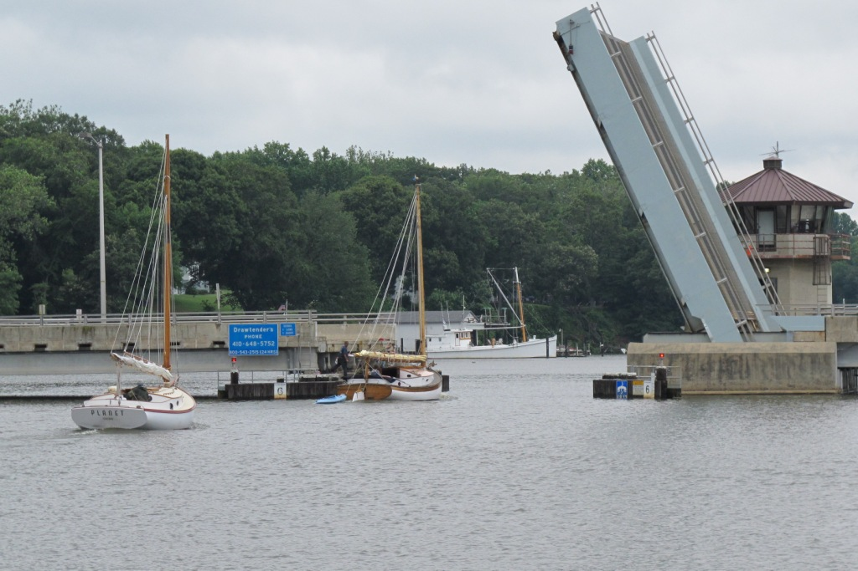
Cats through the Route 213

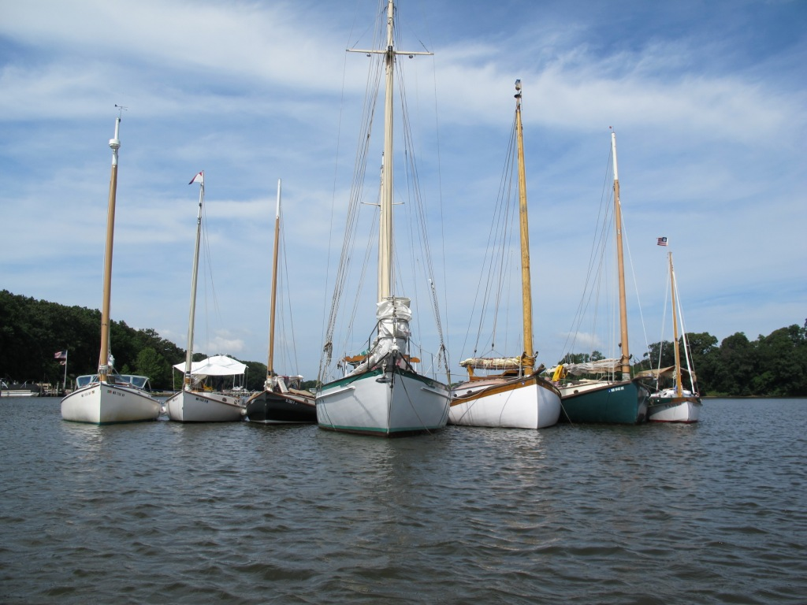CCBA 7-Wide Raft on the Sassafras
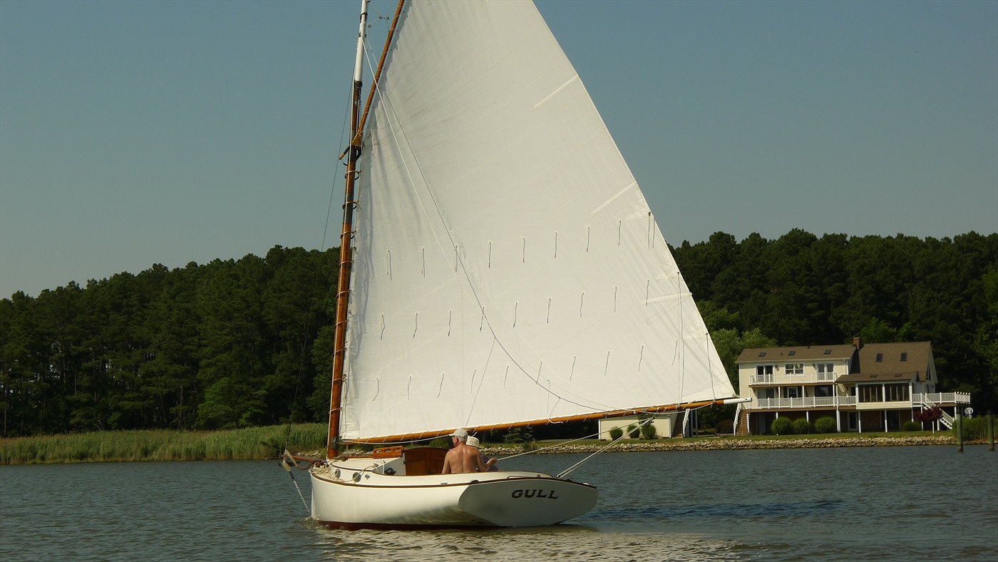
Gull Easing out of Swan Creek

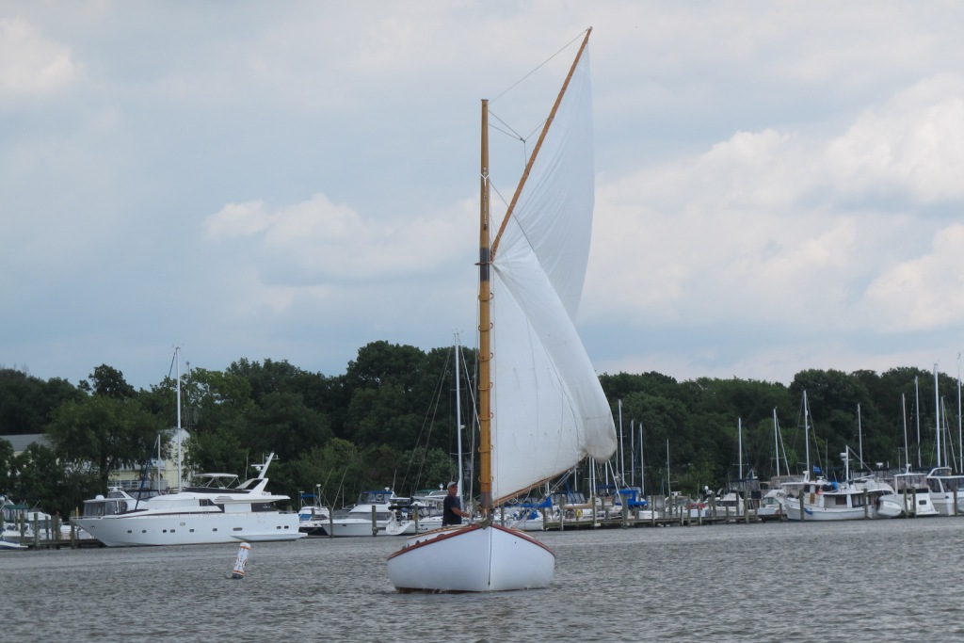
Planet Dousing Sail on Fairlee Creek
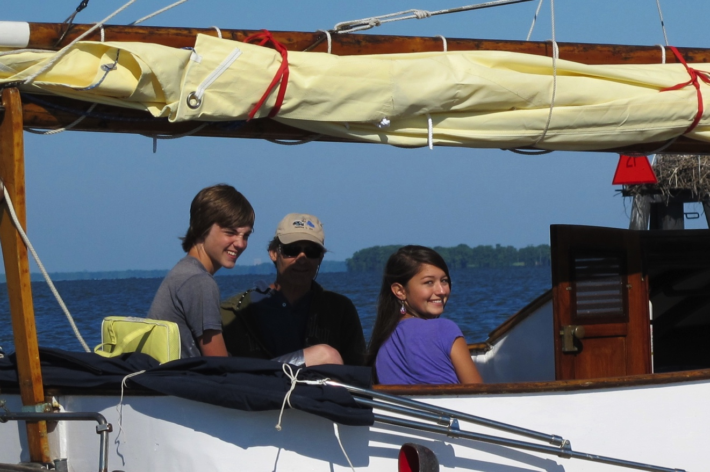
The Love Cat(Boat)

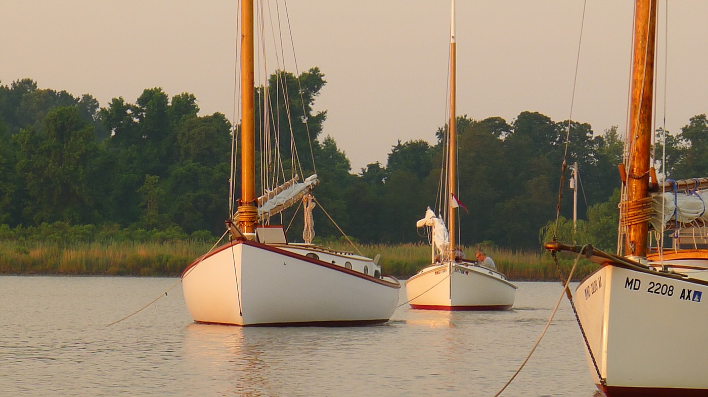
Cats at anchor in Swan Creek

RETURN TO THE LITTLE CHOPTANK - 2013
By Marc Cruder

Introduction
After last year’s trek north and continuing a theme of revisiting favorite spots, we returned to the Little Choptank River on the Eastern Shore. Cruised last in 1997, it was time to take up the remaining unexplored creeks. We only had one day of rain and otherwise fair weather with sufficient wind to sail between our low mileage stops the rest of week. The cruise included a chlorinated swim ashore, a visit to an old but changed haunt, discovery of a new one as well as a visit ashore with friends. There were no mechanical issues and only one minor anchor drag that did not involve the group. Several dinghies got rigged for sailing and of course there was fishing including “the one that got caught…but got away.” All in all it was a good time. Here’s how it went….
Returning Cruisers
- Marc “Just a salaried employee” Cruder with crew John “Daddy Warbucks, except for one thing, everything else I do is legal” Brown sailing Wanderer: Wittholz 25 (Glass)
- Dave “Just another case of biological ignorance” Bleil with crew Jim “Smile for the camera” Ohlmacher sailing Gull: Mystic 20.
- Butch “Just stoppin’ for a sandwich and a Dale’s” Miller sailing Dusty: Marshall 18
- Mike “Bad Dad, no beer, too many jellies” Crawford with crew Tristan “You know I make music” Crawford sailing Shoveller: Fenwick Williams 25
- Rich “Off kayaking and fishing” Mclaughlin sailing Tenacity: Marshall 22
- Jack “But I thought it was your dinghy” Smith sailing Winter’s Dream: Marshall 18
- Martin “Would you have Campari?” Gardner sailing Planet: Wittholz 25 (Wood)
Non-Catboat Cruisers
- Pete “Please refer to my float plan” McCrary sailing Tattoo: CLC PocketShip 15

Shore Support
- Craig “On a kitchen pass but have rum” Ligibel, who joined us at Slaughter Creek.
Sunday, 6/16: Destination: Phillips Creek
After the 2012 season started off with a leaking exhaust, Wanderer needed attention. It started with fabrication of a non-standard length of metallic flexible hose for the dry exhaust, followed by changing a few fittings that “should” have been galvanized in the raw water exhaust. Then I moved on to the water pump by replacing the cam in the existing Johnson pump and locating a spare new pump with ball bearings; not an inexpensive proposition on a 37 year old Bukh…but now I am set for awhile. I also pulled the ignition switch because of unreliable connection to the gauge panel, to find it a spring-loaded affair held captive by crimps in the pot metal casing, one of which needed to be re-crimped. With reliability improved on several fronts, I finished by cleaning all the soot from the engine compartment and finally painting the underside of the engine box cover, which still had its original laminating epoxy finish.
Thinking I was done, a section of cabin “eyebrow” disintegrated in my hand one day. I make a rule of working on the boat only up to the first event, which was the Pax River Shoot-out, Memorial Day weekend, but the best I could do was surgically remove the bad wood and wait to consider a repair. After a successful shakedown to lower Maryland, I found a piece of wood, discovered the value of a block plane and finished it off with the usual epoxy/paint coatings. Mr. Brown, who was having problems of his own aboard Traveler, the wood Atkins topsail ketch purchased the previous year, was available after Steve Flesner talked his way off my boat, thinking he could crew on one of our Nonsuch cats, who as it turned out, did not make the cruise. So, done and ready!
We decided on an early start with tide foul and winds light but somewhat useful from the southwest. Last line was 0645 as we proceeded under power, dinghy in tow, enjoying oatmeal raisin cookies and Kona coffee Mr. Brown brought aboard courtesy of a recent trip to Hawaii. Outbound on the Rhode River, looking past Curtis Point we could see Coaches Island down the bay. By 0800, we cleared Curtis Point, setting a southeast by south course of approximately 170 degrees magnetic, with sail set and engine on to stem the tide. Our practice considers the onboard GPS an emergency device not necessary with good visibility and land on both sides. Our speed was about 5 kts. Coaches Island would be a prominent fixture to port until ship traffic would alter our plans.
At 0900, the car carrier Liberty Promise was upbound, coming right to pick up the ship channel, while closing on our bow. Mr. Brown tacked over, out of the way and later tacked back to our southeast by south course. First potential danger avoided.
From there, we moved right along. By 0940 we were abeam the “Poplar Island Gas Buoy;” (now the Red 84), the southern tip of Tilghman Island (Black Walnut Point) at 1115; Sharps Island Light at 1130 and the #7 green at the bottom of Choptank Channel at 1145. About 1230 we came around to a port tack as we approached Trippe Bay and with a favorable tide, shut the engine down. In another 15 minutes we sighted our first catboat astern; it was Dusty. At 1430 we came back to a starboard tack to clear Mills Point, shaping up for the #1 green day mark at the entrance to the Little Choptank River.
Continued on into the Little Choptank, following green day marks around, ending with the lighted #13 and up into Phillips Creek. Sighted Winter’s Dream, Shoveller, Tenacity, Planet and Tattoo anchored just south of Cherry Island. Doused sail and continued past Cherry Island with Dusty into the suggested anchorage finding 6 ft. of water and a very natural (uninhabited), protected spot. With weather expected, went back to inform the group we would be up around the corner. They slowly migrated to the anchorage north and east of Cherry Island. Shoveller rafted up to Wanderer; the Marshall 18 crews came over as did Tattoo’s skipper. Gull arrived about 1900, amidst a mild happy hour in progress. Within an hour, all retreated to their own boats as a short but heavy downpour came through. Shoveller stayed alongside as we enjoyed Mei’s beef and green peppers with the Crawford’s on the cockpit table aboard Wanderer.
Once dinner was complete, each retired to their own hooks. There were 7 catboats and a Chesapeake Light Craft Pocket Ship anchored with plenty of room in the creek.
Monday, 6/17: Destination: Slaughter Creek
More weather simply did not come. Our little nook of Phillips creek turned out more protected than needed as the temperature was up with no breeze but luckily, no bugs. Just before sun up, a local waterman started running a trot line, but his boat was decidedly quieter than we were used to, as it was an outboard. With the disturbance minimal, we all slept in as the temperature finally came down and the breeze came up. Breakfast was a simple affair focused on things that would spoil over time, so we had milk over shredded wheat with fresh blueberries and of course John’s oatmeal raisin cookies with coffee.
After breakfast, it was time for the first cabin clean-up of the cruise as we enjoyed the natural surroundings. Within view were fish breaking the water, some egrets and even a bald eagle. The fleet laid in sufficiently to make time for the dinghies to rig up and get sailing: a fatty knees, a vintage fiberglass “seal” by Atlantic Laminates and Tattoo’s nutshell pram rigged with Tattoo’s new mizzen. Just as the regatta was winding down, Mr. Brown decided it was time to steam some shellfish he had brought back in a borrowed kayak. Steamed with butter for dipping, they were fresh and right off the bottom of a fairly remote and clean estuary. It was a nice lunch.
With only 7 miles to our next stop, I fired up the Bukh to signal departure about 1330. Catboats slowly filtered out of the creek as we sailed southwesterly for Slaughter Creek. At the entrance buoys, we motored down the creek since the wind was on the nose. All catboats were secure in slips by 1630. Found Craig Ligibel on the dock with a bottle of rum and some cheese…but instead of a leisurely happy hour, most were pressed to get showered, take a dip in the pool and freshen up for dinner. It was South Dorchester County on a Monday. We needed to be at the Island Grille before the kitchen closed at 7:30 pm. Luckily, Robert Bromwell, the marina manager, called ahead and provided supplemental transportation (the marina station wagon) to ensure we got there for a meal.
The Island Grille is the old Taylor’s Island General Store, but renovated a few years back. Some of the old charm remained but it was just not the same old place we remembered. The food was reasonable, the prices had gone up, no sherry was available for the cream of crab soup, but we met Jamie “kiss my glass” our waitress and former Taylor’s Island U.S. Post Master/Mistress. She took good care of the group and did not even flinch when we asked for separate checks. A good time was had by all.
Returned to Slaughter Creek Marina, thanked Craig for making the trip down from Annapolis, then had a night cap aboard Shoveller. Liberally applied some kid’s “Off” that I had on the boat, to find that it surprisingly worked to keep us bug free.
Tuesday 6/18: Destination: Fishing Creek
The local watermen berthed at Slaughter Creek Marina were right on time starting their work day between 4 and 5 am. Laid in until about 7 am before making coffee. By 8 am, John was at the stove making sausage and eggs, all complimented with a V8.
The prediction was for hazy skies and multiple showers on the way, so we had to start thinking about moving out…but we weren’t thinking too hard. Started by topping up the fuel tank and refilling my 5 gallon can. In addition to diesel, Slaughter Creek Marina had “no-ethanol” gasoline. Checked out with Robert, including a cursory internal examination of the skipjack Lady Katy based on previous discussion. The skipjack allegedly had major wood renovation/restoration “a couple three years ago.” A quick look around showed evidence of structural rebuild including chine logs, bottom and side planks as well as decks. It was in the right condition to be considered for Coast Guard Certification.
While I was off inspecting, Tenacity was in at the gas dock to complete fueling, Planet was topping up and Tattoo was going making plans based on the unsettled weather to retrieve, get trailered and head home. So the group was departing a boat at a time. Wanderer departed in company with Traveler and Winter’s Dream about 1030.
Came out of the marina and finding a favorable wind, turned south into it to set sail, only to find a dinghy adrift and her owner fully engaged in sail setting to the point of losing situational awareness of the dinghy. Mr. Brown and I retrieved the runaway dinghy and just waited for Jack (Winter’s Dream) to fully grasp the situation. He got his sail set, lifted the outboard as the last thing to do, then looked around for the next thing to handle. He looked at us (with two dinghies), then back at his stern quarters port and starboard… when the “ah ha” moment struck him. It was worth the wait. Jack quickly came alongside to retrieve his dinghy and we all sailed out of Slaughter Creek with the wind at our backs.
At the #5 green, Wanderer continued north instead of following the channel to port. With local workboats all over the place, there had to be good water…and there was. We continued this heading, maintaining about a mile’s distance off Susquehanna Neck and past Woolford Neck as we picked up the main channel day marks again.
By noon, weather was approaching from the starboard quarter while I was having lunch. Shoveller and Winter’s Dream were ahead, with Planet astern. About 1230 the rain started, with the wind picking up just short of the #11 green. Doused sail, “battened down the hatches,” determined the next three compass courses into Fishing Creek before our visibility went to zero (remember the GPS is only an emergency device)…..090 to the #2 red; 180 to the #3 green and 140 to the #4 red. A lightning crack close enough to not hear the subsequent thunder, got our attention and adrenalin flowing. Luckily, there were no smoking masts or casualties to report. The other catboats were dousing sail in different directions when last seen and as the weather hit. We began motoring on our first magnetic heading. The #2 red rose out of the fog two points off the starboard bow with visibility rapidly improving as the squall passed. Winter’s Dream and Planet were under power astern. Shoveller had made it in ahead of us, before the weather.
We anchored as planned on the south side of Cherry Point; each to their own hook. The sun came out, which allowed me to restow the sail and finally remove the battens for ease of quick weather related evolutions. In the midst of the weather event, John had stayed on the wheel, so now finally had a chance to make his lunch. We were all secure about 1330 after a mere 9 mile transit. The weather provided the requisite excitement.
Shoveller’s crew came over to rig Liberty (the fatty knees) for sailing and got a few tacks in just as dark clouds and rain approached for another round about 1430. Made up the sock sail around the little carbon fiber mast, sent Tristan back to Shoveller in his kayak and retreated to the cabin. The rain continued under bright skies for over 3 hours! We were sufficiently napped by the time it was all over about 1800.
Winter’s Dream rallied the anchorage, ferrying troops to Wanderer for happy hour, while providing white wine, cheese and crackers. We discussed the morning’s squall and strategies to cope. Tristan pumped out Liberty. A Compac 19 with a full cockpit made it out from a local residence for a sunset sail as the skies cleared. It was a night sky full of stars with temperatures and a breeze perfect for good sleeping with proper bedding. Finished the night with the “salaried employee” discussion from Mr. Brown.
Wednesday, 6/19: Destination: Gary Creek
A little after 4 am, the anchorage was rocked on the beam by a wake from a local waterman; two passes before setting one end of a trot line. While alerted to the trot line lays on Fishing Creek, I thought the intended anchorage sufficiently out of the way….apparently not. There was no conflict or even words exchanged. The watermen just had to establish themselves, and we really were sufficiently out of the way. Things settled down after that. Another indication of changing times was that the boats had mufflers, so we were hard to disturb and slept in as they went about their business. When we finally did get up, it was pancakes and sausages for breakfast.
Called Tom Howell, our next host. We agreed to be on Gary creek by 3pm. The plan was to truck everyone over to Tom’s place for a cook-out. With the destination set, rigged Liberty and made the rounds under sail to pass the word, then gave the dinghy over to Tristan so he could continue the sail that got interrupted by the rain.
He completed his sail and all slowly got underway in different directions; some to Church Creek and some to explore the rest of Fishing Creek. We opted for the latter, motoring to the head of the creek, then sailing back out as Mr. Brown again challenged the placement of navigational aids by not keeping to the marked channel. No groundings were reported.
Came around Town Point and northeast up the Little Choptank dousing sail to power up Gary Creek. Found our docks/anchorage with Tom and Judy Howell on the pier. In two cars we moved all over the Howell log cabin. While the food was in prep, Tom took us for a tour of the boatshop; formerly run by local boatbuilder Jim Richardson, Judy’s father. There is always something in progress, so we viewed several sailboats, one powerboat being modified into an open crabber and a wood tug hull that I, at one time considered finishing before I found Wanderer.
Back at the house, we found burgers (both regular and venison) as well as dogs ready to be cooked, plus sides prepared. All engaged in quality conversation as the eating and drinking progressed, including Tom breaking out some Dickel bourbon for sipping. Appropriate for this audience, Tom produced a journal from the 1920’s that his father had written, where we traced a cruise in a catboat he had at that time on Long Island, New York. As the festivities wound down, we made an ice run, replaced Tom’s bourbon and filled up his gas tank. After strawberry shortcake for dessert, got everyone back to the boats. We were certainly fortunate to have had the pleasure of our visit with the Howell’s.
Had a nightcap in the cockpit with the group back at the boats. Half at the dock and half on the hook. Bugs attending, but defeated once again by kid’s “Off.” The temperature eventually came down and breeze came up. Another night of good sleeping.
Thursday, 6/20: Destination: Madison Bay
Slept well and until almost 8 am. Only one waterman working the creek and again, with a muffler. Had a late breakfast of corned beef hash, onions, bacon and eggs. Invited Dusty for breakfast. At the same time, Gull and crew away with Liberty to the head of Gary Creek at Lloyd to view the restored windmill, part of the Dorchester County Parks System. In the interim we were joined by Shoveller and Planet. Upon Liberty’s return oarlock maintenance was in order. Stainless wire from Dusty’s toolbox did the trick.
Cleaned up/stowed the boat and then started the engine enroute Madison Bay. Winter’s Dream left early and would be hauling at Madison, so they would know we were on the way with six boats. Clearing Gary Creek, we had a favorable wind and set sail southwest down the Little Choptank. Tenacity took the lead and kept it. Planet overtook Wanderer and kept that position. Wanderer in last with Miss Kitty orchestrating the group into slips. She took our boat names and stats, saying she’d be back for the money……$1 per foot.
The group wasted no time making it to the air conditioned confines of McCray’s Castaways, where we had Bud on tap in chilled mugs for $2 a pop. For another $0.25, we found out Lisa was the owner and a native of “Baltimore…Hon.” We perused the menu and weren’t going anywhere fast. Eventually we all took our turn using the facilities (shower shoes required), so were ready to try the local fare.
All freshened up, dinner including crab dip pizza, boiled rockfish with stewed tomatoes and green beans. Soft shells were also available. The sign said “Eastern Shore Home Cooking” and it was right. Good food, plenty of it, for a good price. Just as we were winding down, Miss Kitty showed up, gave everyone a squeeze (especially Tristan), made change and collected her dock fees. She was a local from a waterman family that had built their own wood workboats, and were now in the second and third generation working the bay and repairing in fiberglass. We finished up dinner and discussed our breakfast options with Lisa, since they were not open for breakfast. They were now. We agreed we’d be there at 9 am.
Walked thru the ½ mile that is Madison, including a graveyard dating to the 1600s and waterfront property with docks and a crab shedding operation for $795K. Retired for the night. Kid’s “Off” in place.
Friday, 6/21: Destination: Brooks Creek
Good sleeping once the initial mosquito onslaught subsided. Slept in until the scheduled breakfast at 9am. Lisa was ready for us and made up a family style pile of scrambled eggs, bacon sausage, eggs, toast and coffee all for a very reasonable fixed price per head. We were even able to stock up on ice before we bid our goodbyes.
Got underway leaving Wanderer in Mr. Brown’s capable hands with Tristan as crew, so I could sail Planet, the wood Wittholz 25. Under light winds, we left at 1030. It was a treat to be at the helm as we tacked all the way. Although starting out well, in the end, we were beat to the anchorage by Wanderer, Tenacity and Shoveller. Mr. Brown is so competitive when left to his own devices…and in my boat! In any case, celebrated our passage with Campari and soda on the rocks. A very nice sail in a very nice wood catboat.
Happy hour already in swing aboard Shoveller. Retired aboard Wanderer until woke up for more provisions. Piled all but the kitchen sink into Shoveller’s cockpit for extended happy hour….cheese, chips, nacho cheese sauce, salsa, salami, pepperoni, triscuts, while all were instructed by Capt Crawford to “breath the marine air.” Later joined by Dusty, Gull and finally Planet with additional provisions that obviated making dinner. Biologist Bleil explained the bay’s water movement to Mr. Brown, who has been pondering it his whole life and can now rest easy. Tristan played his Ukulele and we had an annotated reading of a Centerville newspaper article recounting the successful Del Marva circumnavigation of the catboat Patience. The group chatted on until just before sunset, when each retired to their own boats, at least one of which was aground on the low tide.
Saturday 6/22: Destination: Homeward Bound
Good sleeping except for the full moon, which made me reverse my position in the bunk to keep the direct moonlight out of my face. Mr. Brown was up at first light, spurred on by departure of Tenacity and Shoveller. So made coffee and got underway under power at 6am. Set sail at the first opportunity in a light southerly breeze not strong enough to push us alone. Finished the milk with more shredded wheat as we made steady progress north.
By 0830 we were abeam Sharps Island Light and in another hour the #80A red buoy on a course of 345 degrees magnetic with the recreational fishing fleet to port. Continued until we came left shaping up for the Rhode/West River entrance. The wind was favorable coming into the Rhode, so we finally came off the engine until we doused sail at Bear Neck Creek. Powered to White Marsh Creek and were tied up to the Ponder Cove docks by 1330. Cruise 2013 complete.
Epilogue
It is always worth a trip to the Little Choptank and this was no exception. It is one of the least inhabited parts of the bay and aside from the mosquitoes reminding you that you are in the lowland, it is a wonderful sailing ground. We gave the dinghy fleet a chance to sail, sampled the chlorine in the swimming pool at Slaughter Creek Marina and dined at the Island Grille on Taylor’s Island. We had close encounters of the waterman kind and learned to navigate active trot lines. Tom and Judy Howell were the best of gracious hosts and treated us to everything from bourbon to old catboat journals to projects in the boat shop. Madison Bay turned out to be a nice surprise as we found Miss Kitty ready for whatever we threw at her. Although you can’t depend on open transient slips, there were enough for us this time. Jamie at McCray’s Castaways kept us going on Bud drafts in chilled mugs, soft shell crabs and even crab dip pizza....all for a reasonable price. She even came in the next morning to make breakfast just for us. Facilities at the “campground” worked for $1 per foot and we were able to get ice. On our last night in Brooks Creek we were educated on everything from “biological ignorance” to different species of bamboo, to the how the tide (or wave) works on the Chesapeake....between the educational experience, good sailing and camaraderie….who could ask for more?
Next year’s destination was briefly discussed with interest in the Wye/Miles River on the low impact side and the Pocomoke River on the more adventurous side. We also discussed staging catboats further down bay for exploration of the more southern rivers in the future. So stay tuned and we’ll keep you posted on www.chesapeakecatboats.org.
mcc (Wanderer)
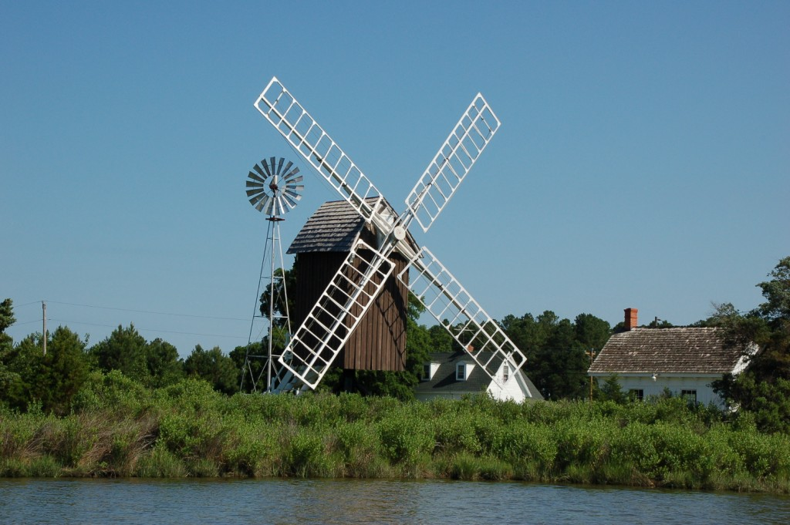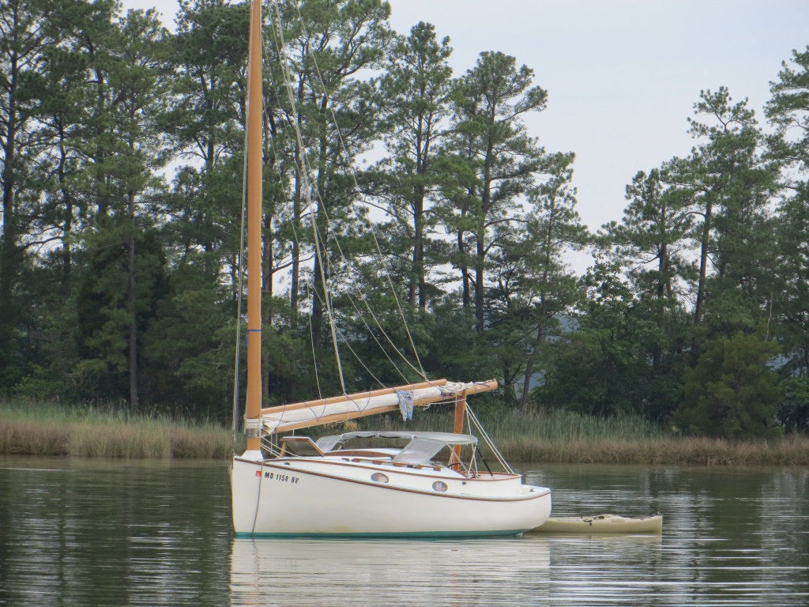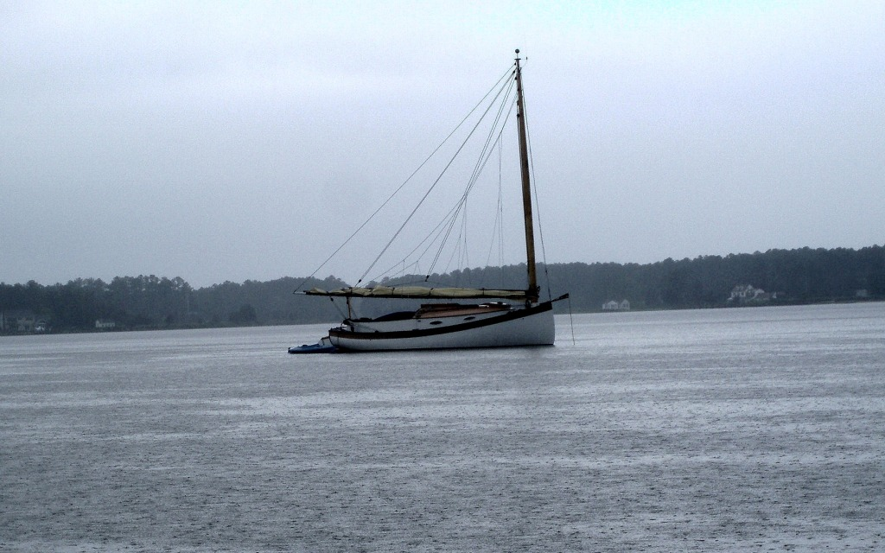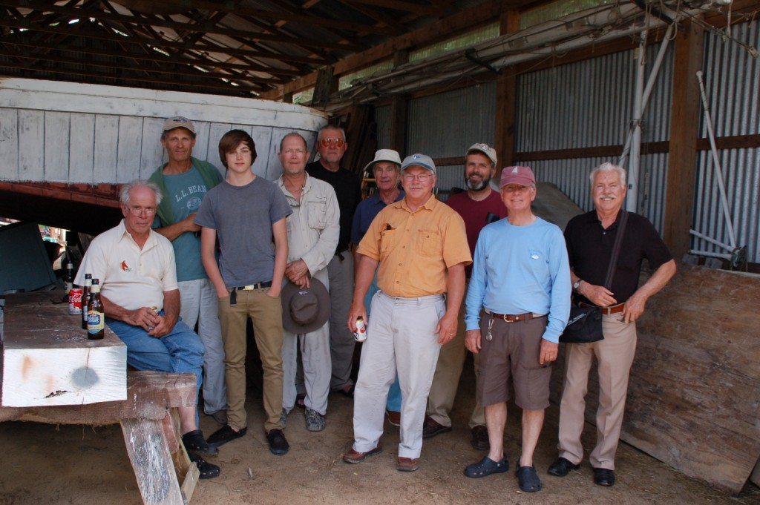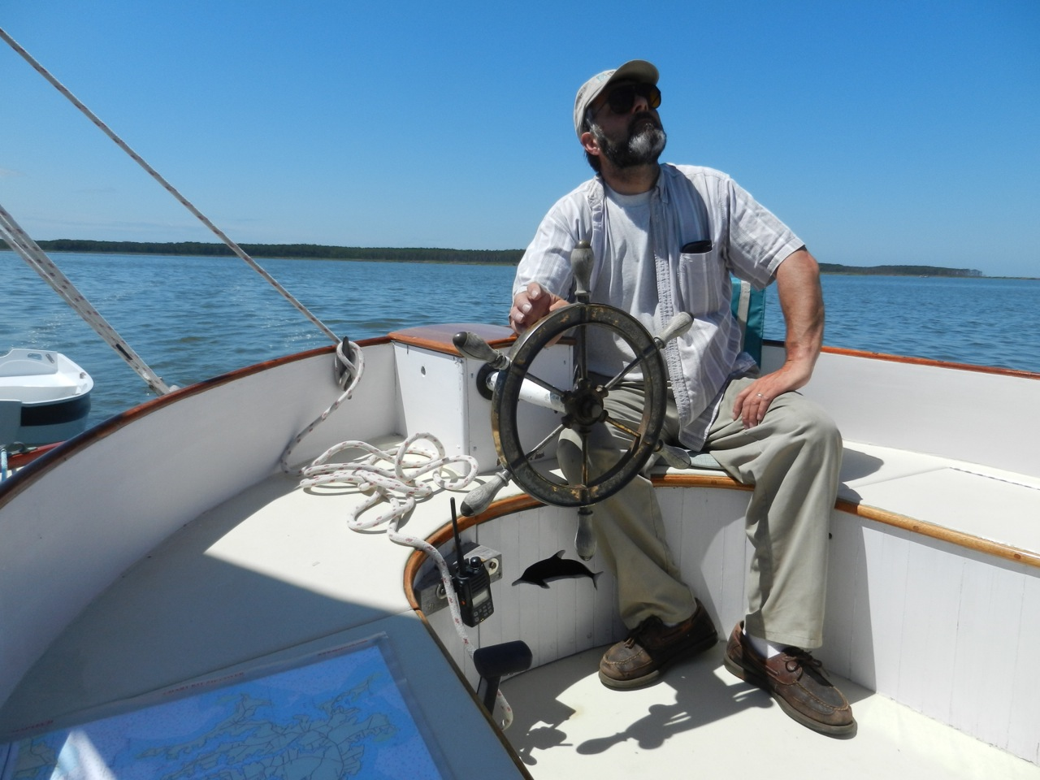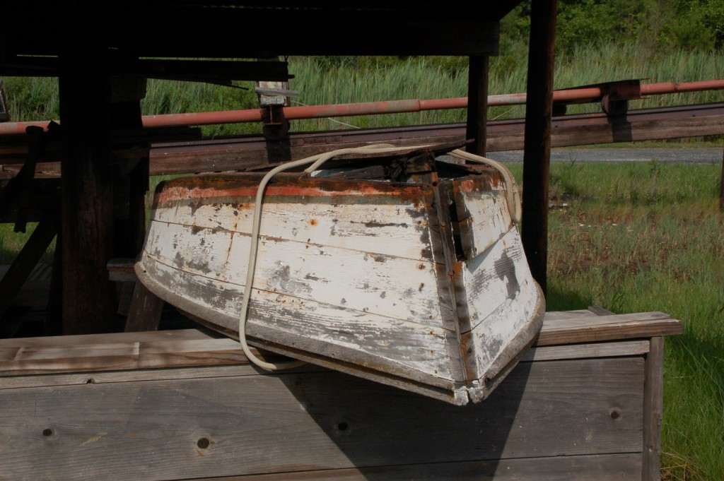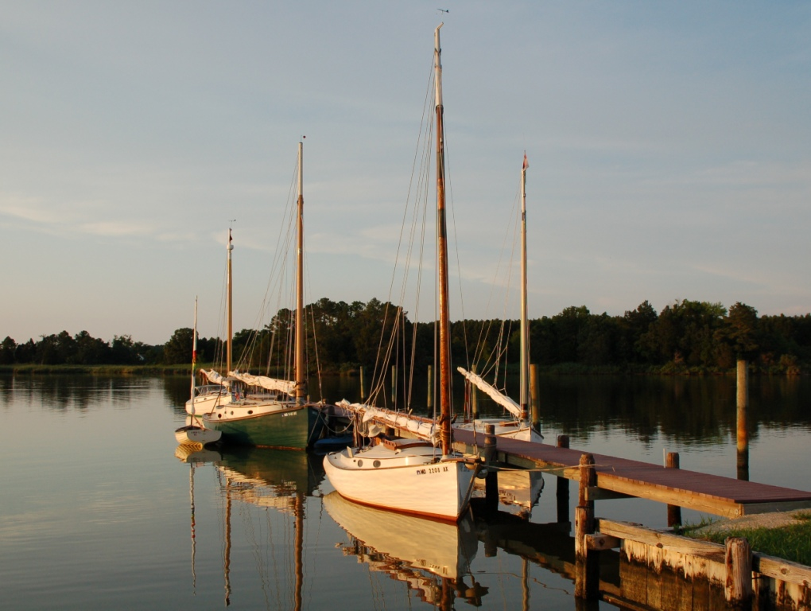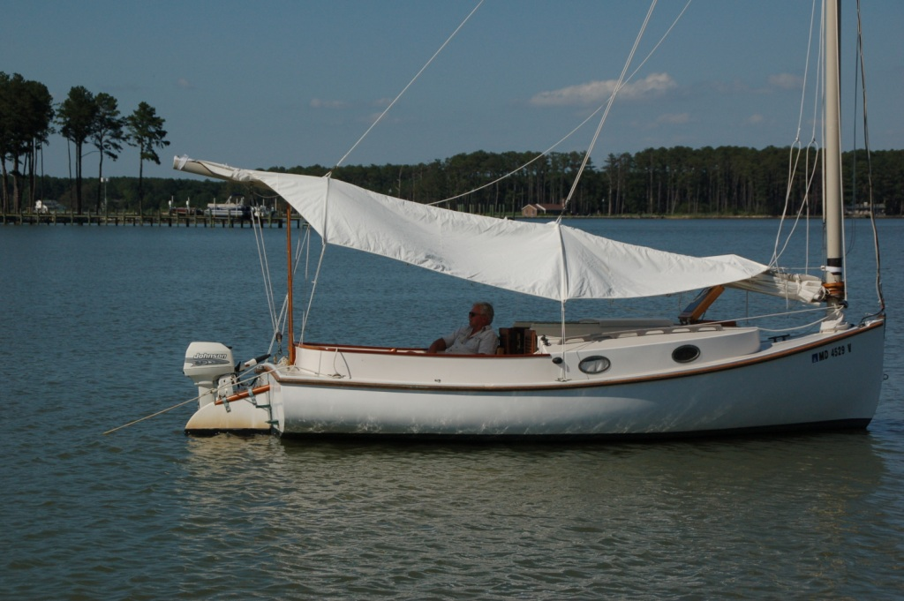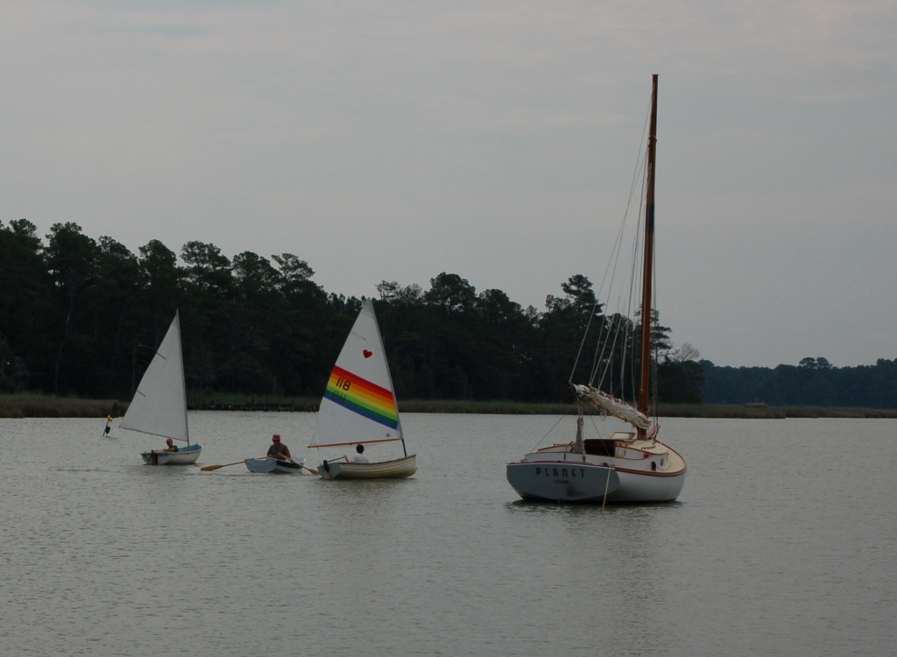

CRUISE TO THE BOHEMIA BAY – C&D CANAL OR BUST– 2014
By Marc Cruder

After last year’s cruise to the unspoiled natural environment of the Little Choptank, we headed north to more populated surrounds enroute Chesapeake City on the Chesapeake and Delaware Canal. The weather was hotter than usual, with some extreme weather that kept everyone on their game and reminded the non-believers about “global warming” while we all used our engines a little more than anticipated. That said, we returned to some good anchorages, had some good raft –ups, got in and out of the canal on the tide and enjoyed some rest and relaxation at a quality marina thanks to member Guy Beckley. All anchors held and a good time was had by all Here’s how it went….

Returning Cruisers
- Marc “I’m having protocol issues” Cruder with crew John “Selective situational awareness” Brown sailing Wanderer: Wittholz 25 (Glass)
- Butch “I’ll be behind you somewhere” Miller sailing Dusty: Marshall 18
- Martin “I could argue I left it as I found it…broken!” Gardner sailing Planet: Wittholz 25
- Dave “Where’s Olmacher when you need him” Park sailing Sarah K: Herreshoff 18
- Craig “You didn’t think we’d make it, did you?” Ligabel with Crew Jim “We’re only here until it rains” Doherty sailing Mystic Wind: Mystic 20
- Jack “Any suggestions Commodore?” Smith sailing Winter’s Dream: Marshall 18
- Mike “No salt in this marine air” Crawford with crew Tristan “Messenger and media control” Crawford sailing Shoveller: Fenwick Williams 25
- Rich “Does that sail cover ever come off?” Mclaughlin sailing Tenacity: Marshall 22
- Dave “I had medical issues…but passed them” Bleil with crew Jim “Our perfect cruise attendance record is intact” Ohlmacher sailing Gull: Mystic 20.
New Cruisers
Paul “We don’t fish….we buy fish” with crew Dominic “Dad, I’m fishing anyway” Cammaroto sailing Bubbly: Marshall 18
Guy “Absolutely…but I’m out of it” Beckley with crew Bob “It’s the only one that was a workboat” Jones sailing Patience: Crosby 20
Greg “It’s a family affair…but not quite Beach Haven” Taylor with wife, son and son’s girlfriend all on Shorebird: Marshall 18
Non-Catboat Cruisers
- Tim “I think this is the 3 foot spot” Gallogly sailing Violet Jessup: Folkboat (glass)
- Pete “Something doesn’t seem quite right” McCrary sailing Encore: Compac Eclipse

Other
- Merryheart….brand new Marshall 22, John & Nancy Henderson joined us at Swan Creek.
Sunday, 6/15: Destination: Bodkin Creek, Patapsco River
Wanderer was successfully shook down during the trip to the Pax River Shootout, so was generally ready to go, but still sporting its original sail, now coming into its 42nd season. Over the winter I had Jenkins Sails make one, so for the cruise it was bent on after shouldered eyebolts were installed to accommodate fair leads for the main clew and peak outhauls. I also discovered that a temporary repair was necessary to the laminated bowsprit in addition to finishing the installation of the dinghy’s long awaited rub rail. Wood and epoxy rejuvenated the bowsprit to my satisfaction, while the dinghy rub rail was finished with tan three-strand polypropylene from Ace Hardware. A quick shake down with the new sail and we were good to go. Repairs to Traveler, John Brown’s Atkins ketch were far from complete, so he joined me after Steve “Rover” Flesner had canine troubles at home.
So, the first surprise departure morning was that my son Matthew’s car was blocking the gate needed to get the dinghy out. The car was there, but Matt wasn’t…luckily the keys were in the house after I called and woke him out of a sound sleep, wherever he was. His only comment was: “Sorry…but Happy Father’s Day.” With access, the dinghy made it to the water, Wanderer got stowed and was ready when Mei dropped Mr. Brown and all his gear off.
We were underway under power out of White Marsh Creek about 0700. Proceeded out to Bear Neck Creek with an appropriate wave from Laurie Orme as we passed Blue Water Marina, exiting onto the Rhode River. No wind and a foul current put us on the engine from the start with the sail set only for shade. With Coaches Island visible (it seems to always be) to the southeast, we set our coarse northeasterly and had Thomas Point Lighthouse close aboard to starboard by 0900. Continued until shallow water and crab pots forced us to tack just north of Matapeake on Kent Island at the northernmost boundary of the Annapolis anchorage. Set a starboard tack, but the wind died away, so sheeted the main down and made for the center span of the Bay Bridge, still bucking a foul tide.
At 1230, we passed under the twin span, making up for Baltimore Light. As we moved up along Gibson Island, the wind came up to the south, which allowed us to back off on the engine and run dead downwind with the sail taking over. About 1500, we ran past the Craighill Channel range lights, sighting two gaff sails ahead and Planet out in the shipping channel to starboard as we picked up the green daymarks and buoys into Bodkin Creek. The Sunday afternoon crowd was in full swing, from “go-fast” boats to towed tubers, including a large powerboat on the wrong side of the channel aground. They were all trying to get home, but made the navigation easy for us in some respects.
When last here in 2008, the lead catboat found a place in Back Creek because Main Creek was too crowded. This time, we passed up Back Creek to starboard, doused sail and proceeded up Main Creek under power for a better look. We were joined astern by Sarah K and Dusty, the previously seen two gaff sails. Proceeded past the Cruising Guide’s recommended anchorage between Goose and Jubb Coves, noting the south side was all houses and docks. Continued up the creek but did not see any better spots. On the way back out, the north side between Goose and Jubb Coves was all bulrushes and looked inviting. Had Mr. Brown take Wanderer in between a duck blind and what was left of a marine railway, while I sounded the bottom with the boat hook. Six feet of water all around on a rising tide by then, so we dropped a hook.
The other catboats starting coming in to their own hooks as the weekend crowd thinned. Planet was sighted with a red-hulled folkboat named Violet Jessup, who was under sail, quickly found a shallow spot and stuck. Mr. Brown and I had only just sat down with our Myers and Tonic (in honor of past CCBA Commodore without portfolio – Bill Hoover), so we contemplated the situation as Planet came to the rescue and pulled Violet Jessup off with no help from us. Although we were chastised, we claimed to be back up as all looked in hand from our vantage point. We were to later find out an engine malfunction aboard Violet Jessup was responsible for sailing into the anchorage.
With the show over, we were approached by a gentleman in a whaler named “J.C.” asking for Craig Ligabel, a not yet sighted but expected CCBA cruise participant. J.C. said he was with the “Spinsheet” (a local sailor’s monthly) staff, so we asked him to tie off and brought him aboard to join the happy hour. Craig and crew in Mystic Wind arrived within the hour as did Bubbly and crew. Cocktails proceeded aboard Wanderer as Mr. Brown, without Chinese delights from Mei’s kitchen this year, was boiling corned beef and cabbage. There were six cats and a folkboat in the anchorage. CCBA cruise on.
Monday, 6/16: Destination: Stillpond Creek, Still Pond MD
Quiet night with tolerable bug population. Decided on a light breakfast of cereal while the milk was still fresh. About 0800, made the rounds of the anchorage by dinghy to ascertain all informed on the plan for the day and to answer questions. Found Planet assisting with the Violet Jessup engine problem, suspected to be fuel starvation. Luckily, there was a marina at Graveyard Point, so it was decided Violet Jessup would be assisted there for further diagnosis. Made a close-up exam of the marine railway, retrieved an oak stool intact from the shallows and came back to find Mr. Brown had reason to lean on the yacht ensign flagstaff….crack! A little duct tape temporarily and we were underway under power by 1000 outbound from Main Creek to the bay.
Set sail with engine on in a light southerly breeze with a northeasterly course to Still Pond, making about 3 knots. South end of Poole’s Island to port at 1300 and clear Poole’s Island at 1415. Arrived on the south side of Still Pond at about 1615 to find catboats anchored and having swim call. Additions to the fleet included Tenacity and Shoveller. Took a quick dip over the side to find a nice sandy bottom ideal for cleaning the prop, then reminded the group that the 1898 Crosby cat Patience should be waiting for us in the creek.
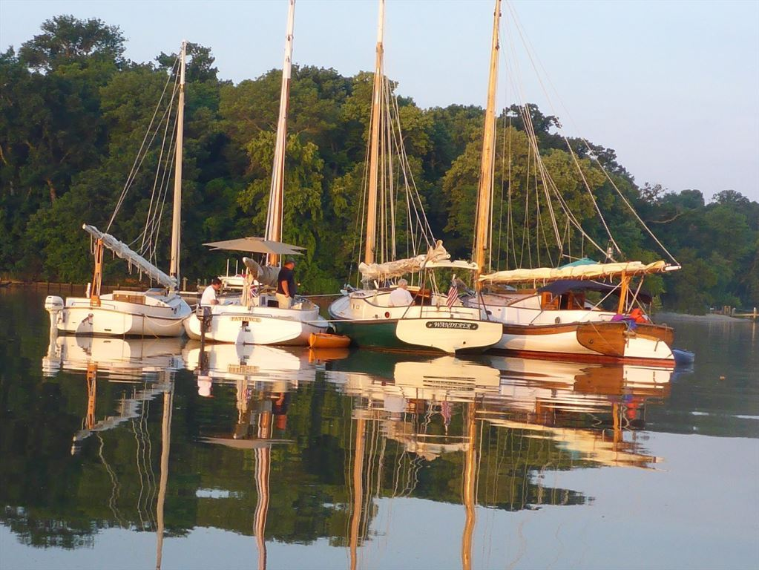
Still Pond stern to

Negotiated the entrance to Still Pond Creek, sniffing the bottom as we went. Entered the creek to find Patience. Also found Shorebird, a Marshall 18 from New Jersey with a crew of four aboard. Was invited to raft up with Patience, so made up port side to; then took Shoveller alongside. Dusty eventually made up to the other side of Patience, so took the opportunity to take requisite raft-up photos. The rest of the catboat fleet had anchored individually before descending on Wanderer’s cockpit. Happy hour with Dark and Stormies flowed as appropriate snacks were brought aboard and shared wholesale. Dinner was cancelled as the sea stories and other tales took over. The night finished with a great display of diving expertise from Capt Greg as he swam back to Shorebird and the pleasure of New Orleans finest cigars courtesy of Patience were enjoyed. Weather was expected, but never materialized. Patience was a secure moor with two anchors down and holding. All was well and we were up to ten catboats.
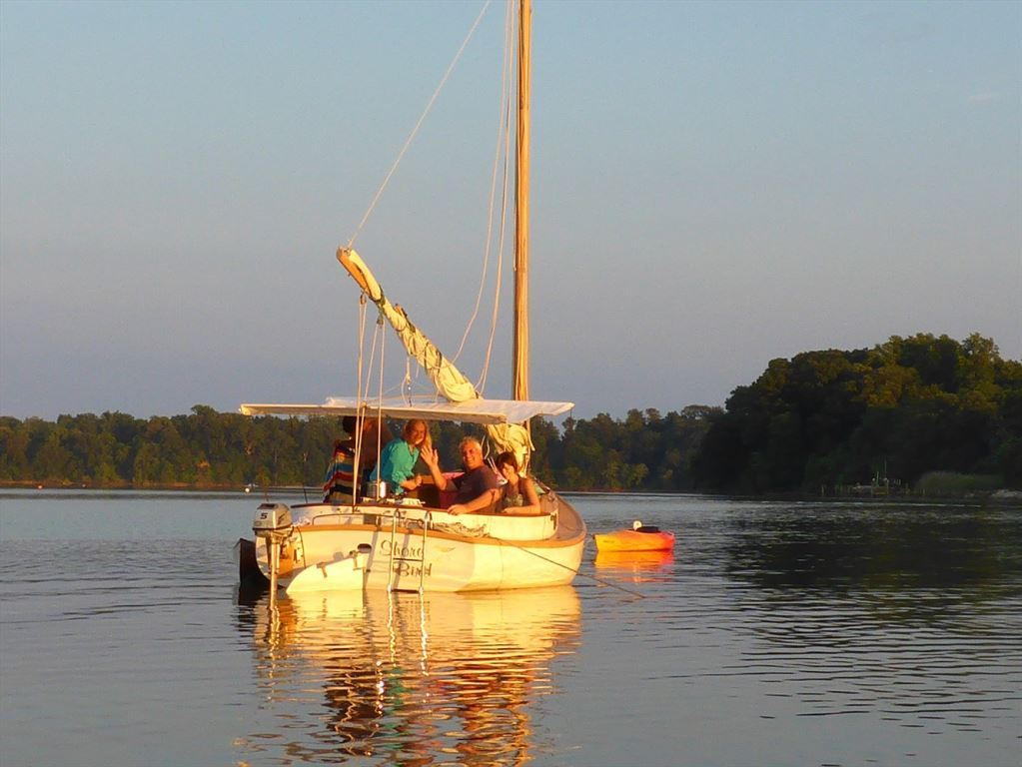
Shore Bird with crew…all 4 of them!

Tuesday 6/18: Destination: Chesapeake City in the Chesapeake & Delaware Canal
Up at 0600 making coffee. Patience rigged the Coleman camp stove and shared steak and eggs, while “green eggs and ham” were being prepared aboard Shoveller. Broke the raft-up at 0730 headed outbound and north. Winds light from the south, so we were on engine but with a fair tide. All cats ahead and behind with sails up. Mystic Wind heading home. As we headed north, sighted a Nonsuch 26 and Winter’s Dream, a CCBA trailer sailor who had launched on and came out of the Bohemia River.
We were abeam Turkey Point by 1030 and doused sail in the vicinity of the lower range tower at about 1130. Running with the tide and no commercial traffic in sight we were docked at the floating public dock in Chesapeake City at 1230. We were joined by Encore, a Compac Eclipse owned by former catboat sailor Pete McCrary, who had launched on the Elk River.

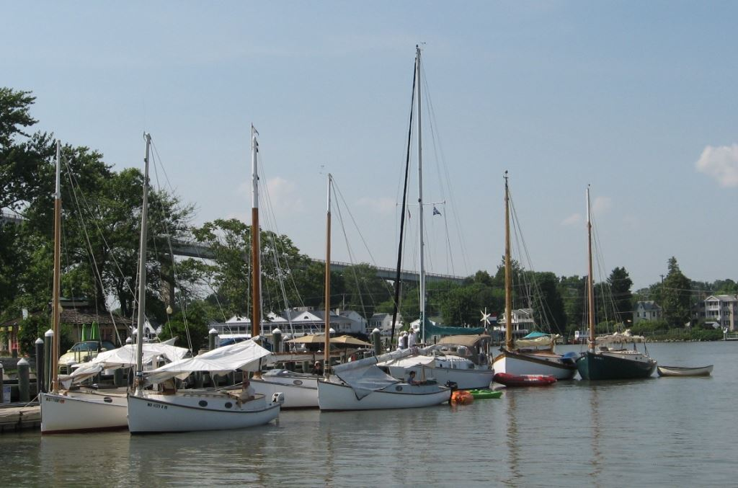
Cats at the canal.
Took a little time to find shade ashore at the bandstand rigged near the dock, before retiring to the Taproom for lunch with Mr. Brown, the crew of Shoveller, Tenacity and Eclipse. Air conditioning, beer and crabs started the afternoon right. Continued later in the afternoon over to the Chesapeake Inn “Tiki Bar” where we found Winter’s Dream and a few more catboaters taking in the sights. I was joined by Matt, who after blocking my access to the dinghy a few days earlier, drove up for dinner. We decided to revisit the “Hole in the Wall” at the Bayard House. Dinner was reasonably good, but the service was so bad that overall the experience was a disappointment compared to previous visits. At least the A/C was working and the view from the glass-enclosed deck was nice, but we can only recommend it with caution and hope they get their management and staffing worked out. The Chesapeake Inn, by comparison seemed to be the place to be.

Wednesday, 6/18: Destination: Bohemia Bay Yacht Harbour – Bohemia River
This was the first hot, buggy night requiring the use of my battery-operated fan. About 0400, we were all substantially rocked by wake from the first tug and barge heading for the Chesapeake and verifying that the current direction had changed. From then on, everyone was a little antsy to get moving, so we were underway under power in the stream with the ebb at 0700. Patience and Bubbly were ahead with all other catboats astern. In the vicinity of the lower range, set sail. Tacked repeatedly in front of the Bohemia waiting to see Eclipse. Finally sighted him as he made a hard left at the red #10 buoy, but then a hard right continuing west. I would find out later, as if it wasn’t obvious enough, that he had a change in plans. Continued sailing into Bohemia Bay Yacht Harbour. Saw catboats tied up two deep ahead of the gas dock. Sailed in close enough just to report that I was staying out to sail the river. John and I took Wanderer down to the Route 213 bridge under sail, then into the mouth of Scotchman Creek, noting an Atlantic City 24 up on the hard in shrink-wrap. Without the name visible, there was no identifying it. Locals would tell us it’s been up and covered for a few years now. Set Wanderer up tacking out of the Bohemia. Got the boat moving well, but I had talked the sail maker into shorter battens, so was having trouble making the leech stand up in light wind. Decided I needed longer battens back.

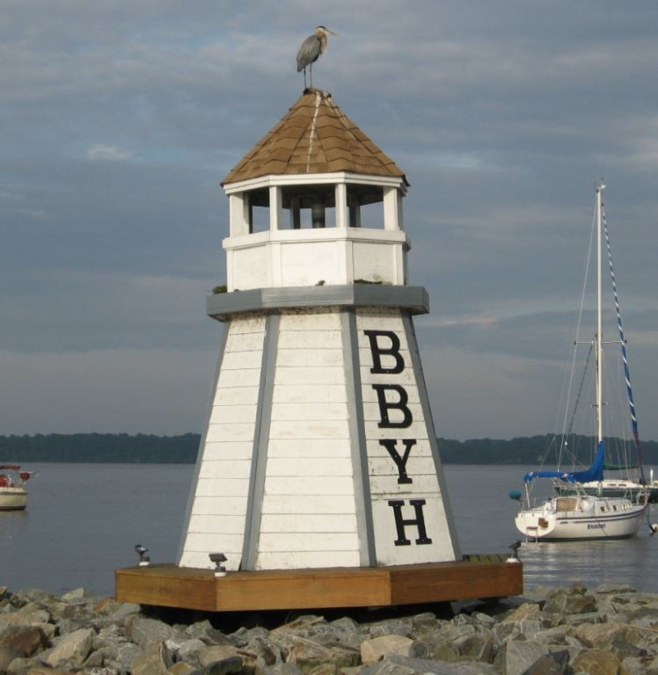
Bohemia Bay Yacht Harbour mark

Arrived back at Bohemia Bay Yacht Harbour and was assigned a berth outboard of Planet. Visited the store, settled up on the slip fee, showered in the cleanest facilities we’ve ever been in that were also air conditioned, then hit the salt water pool….totally relaxing. Emerged from the pool to confirm a rumor of catboat racing that night. Although the local boats would be racing out in front of the Yacht Harbour, racing was the last thing on the minds of the catboaters. So although well intentioned, we begged out. Perhaps that was a good decision as the local boats tangled it up during the start, with a collision that resulted in a J-boat dropping a mast. Better them than us. There was some passing discussion about a heavy line of thundershowers that night, but it didn’t seem to generate any interest.
Everyone was on their own for dinner. John and I settled into some homemade white chili, brought along frozen. The rest of the group organized some “I” talian take out and retreated to the second floor marina lounge in the A/C. Eventually joined the group after dinner to catch up the log. This was the first discussion of perhaps splitting up the next 30-mile leg into two, instead of staying a second day. Sometimes you need to let the cats herd themselves. All I knew was I was not leaving and would enjoy another day poolside. I also enjoy some downtime mid-cruise to tidy up the cabin, clean out the icebox and make any little repairs needed.
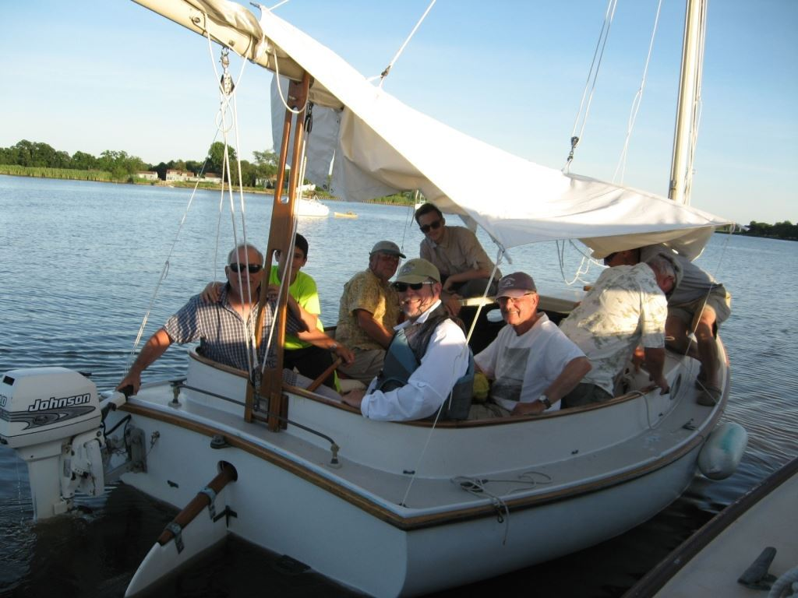
Dusty Taxi!
After catching up the log, all moved to bed down with most opting for the A/C of the lounge. I went back to Wanderer and set up in the cockpit, figuring when the rain came, I would just retreat to the cabin. The rain started about 0030 and the wind came up violently in two distinct waves of weather. It came up whistling, then was calmed by rain, only to come up whistling again, while all the while building fetch. That brought most back to their boats, with lines being doubled up between boats and to the dock, since most were breasted out, two deep and extra fenders were rigged. We got Planet’s dinghy out of the water, while mine banged relentlessly against the outboard stern quarter until I rigged it tight with a fender in between. Glad I had installed the new rub rail though. The wind was on the nose and no doubt we were rocking. The radio reported 40 mph. My biggest worry was Planet and Wanderer parting from the dock together and wondering if lashed together with two engines we’d be able to maneuver. I doubted it, but luckily taking up the slack and doubling up lines kept us together. The only thing behind us was rock riprap…not good
Walked the dock to find all tending their boats. Winter’s Dream was being cleverly fended off manually with a paddle. Rode the “line of thunderstorms” out until things settled out at 0200. No further weather, one cushion retrieved and no damage we could see.
Thursday, 6/19: Destination: Bohemia Bay Lay Day
In the aftermath of the “line of thunderstorms” all rub rails without metal quarter or half-round, showed evidence of the fight. The group dynamic continued to take hold as I stayed behind to do boat maintenance and cook breakfast, while the rest took advantage of Patience leaving his Suburban behind, making it convenient for a breakfast run of their own. Meanwhile Patience and crew came down and were going to sail the river. They looked for some catboat camaraderie but there was none to be found…and I had already done the river. By the time I made up the stern tube packing gland a few flats, sorted out the cabin and ice box, they were back from breakfast and everyone was leaving to split the next leg in two, stopping back at Still Pond Creek on the way to Swan Creek. So while Patience sailed down to the Route 213 bridge, the group sailed in the opposite direction out of the river…you just can’t herd cats.

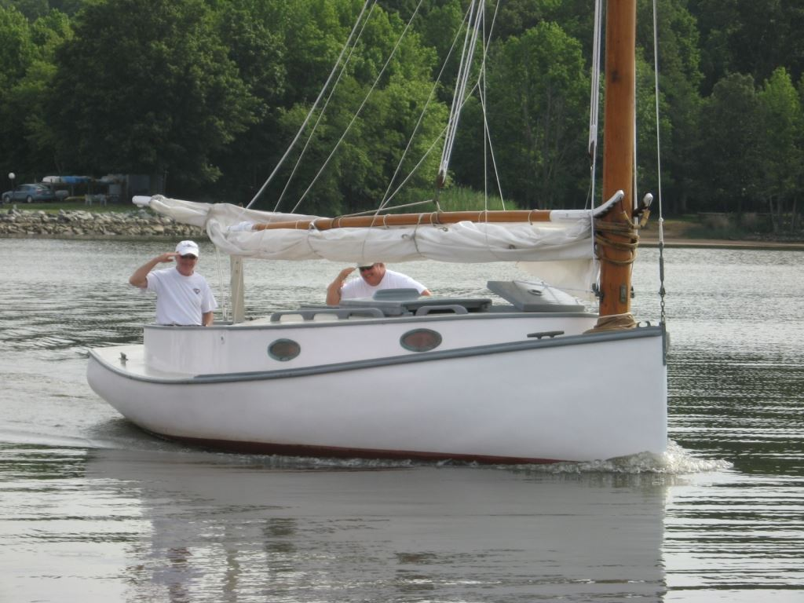
Patience – 1898 H. Crosby 20
There was nothing to be done. Some made excuses about small fuel tanks and mileage; some said nothing at all. In the words of Capt Jack Sparrow, when abandoned by his crew: “…they done what was right by them…they held to the code…” Patience came back in and I assured him it was nothing he had said. Unphased by this turn of events Capt Beckley immediately offered a dinner rendezvous ashore that night to which I graciously accepted. Had the opportunity to move Wanderer to a slip inside the marina, then continued at a leisurely pace to ready the boat for the next day. Re-iced and re-fueled, then swam in the salt water pool. Read all the magazines I had brought while sitting by the pool and finished with another shower for good measure. John continued to rest and recover in the air-conditioned climate control of the second deck lounge.
At 1800, we were picked up by Guy, Biz and Dan for a night out in northern Chesapeake City…hold on to your hats. We ended up at the Channel Inn at Schafer’s on the north side of the canal. Nice setting overlooking the water, a reasonable meal including some oysters allegedly soaked for the requisite time in the local waters for them to able to be called “Chincoteague” oysters. We were not convinced, but they slid down easily. We finished on the way back to the boat at “The Real McCoy” where soft serve and “jimmies” were the order of the day. No complaints from this crew as we were dropped back off at the marina. I made for the boat while John made for the A/C.

Friday, 6/20: Destination: Swan Creek
No storms or weather overnight, a little lacking in wind, but comfortable. Up at 0600 to find Guy and Dan on the dock to see us off. Spent a little time talking Saabs, trunnel lathes and diesels before shoving off at 0700. By 0730, the deck was swabbed, the sail was up and were headed south with a favorable tide making 5-6kts.
By 0830, we had Turkey Point abeam; by 0945 we were on the south side of the Sassafras River; and by 1045 we were in the middle of the entrance to Worton Creek. Continued down the eastern shore, shifting the watch at the red #18 just below Tolchester Beach at about 1330. Rounded Swan Point Bar at about 1530, sighting what looked to be a brand new Marshall 22 under power coming out of Gratitude. Merryheart hailing from Chestertown was on the transom. Acknowledged each other then continued in to anchor in Swan Creek at 1530, finding the rest of the cruising catboat fleet. Myers and Tonic to end the cruise just as we had started it.
About 1630, Merryheart came back into the anchorage with a message from Tenacity (how nice of Rich to send a personal messenger); who had anchored in solitude at the mouth of the creek. The message was: “Would anyone like to join Tenacity ashore for dinner.” I was also informed he was getting no response from Wanderer despite the fact the radio was never turned off. (I may have to consider a mast antenna, which I have never been in favor of). Capt Crawford aboard Shoveller quickly raised Tenacity to inform that no decision could possibly be made until happy hour took place. So began Tenacity’s first lesson at herding the cats. Instead of dinner early, Tenacity picked up his hook and joined the group, while Merryheart dropped a hook to enjoy the creek full of catboats.
Note: I’m sure we looked like a rag-tag group by now, and Merryheart seemed to know their mind, so I didn’t invite them alongside as the group seemed to be moving in a direction. As luck would have it, the direction got out of control fast. My apologies to Merryheart.
Just about that time, Gull, who at the last minute could not make the cruise, was sighted coming up the creek. Knowing the effort they made to squeak in at the end of the cruise, my first responsibility was to get them alongside. That opened the happy hour floodgates….kayaks were launched from Shoveller, Tenacity and Bubbly; while simultaneously the Planet dinghy got underway. Before we knew it, the cockpit was full of catboaters and snacks as the rum flowed. Eventually, Dusty came alongside as the designated taxi for the group and with much fanfare and commotion, emptied Wanderer’s cockpit. This was around 1900, a far cry from Tenacity’s well-intentioned thoughts of an early dinner.
Note: It’s all in the approach. With this group, Tenacity just needed to power up to the middle of the anchorage and announce that he was leaving in 15 minutes for a restaurant ashore if anyone was interested….but live and learn.
I can only wonder what they were thinking aboard Merryheart, who shortly thereafter, picked up their hook and left. Perhaps there is no worthy explanation… sometimes things are just “catboat spontaneous.” This was one of those times.
John and I finished up the evening with the contents of “Guy’s Grenade” before camping out in the cockpit at about 2145. I’m told the group returned by catboat with similar commotion, but I heard nothing and was out cold. No injuries were reported.
Saturday 6/22: Destination: Homeward Bound
We were off the deck at 0330 as light rain came through, but sleep continued easily thanks to a light breeze and no bugs. Up at 0600 to see boats moving….Sarah K and Bubbly outbound within an hour. Wanderer weighed anchor at 0730, passing through the fleet and collecting ideas for next year’s cruise itinerary. The short list was a sail everywhere lower Choptank River cruise, or stage south and voyage to Snow Hill on the Pocomoke River. Plenty to think about.
Out of the creek by 0800 under sail and power. Passed Love Point about 0930 and under the Bay Bridge twin span in another hour. Light rain starting as we maintained about 4 kts heading southwest. Made the Rhode/West River entrance about 1230 and were safely tied up in White Marsh Creek about 1315. Another cruise down.
Epilogue
Well, it wasn’t what we thought on many fronts. We certainly saw more hot windless weather than usual and used more fuel. Wanderer probably went through 15 gallons of diesel. That’s a lot. Regardless, we did have good attendance, made it in and out of the Chesapeake and Delaware Canal without incident, found a great respite at Bohemia Bay Yacht Harbour and did in fact get some limited but good sailing in. A hearty thanks to Capt Beckley for all his support….did I mention the “Cherry Garcia” ice cream pops?
On the other hand, we met new catboaters, some from out of town; had our share of camaraderie and did have some nice swim calls. The “line of thunderstorms” only served to keep everyone respectful of the weather while not tussling the group too hard. There were no catboat casualties, we brought another “catboat kid” into the fold with Domenic Cammaroto and got to spend some time swapping lies with Patience and crew.
Caerulean’s plans changed at the last minute, so we’re sorry to not have had Butler on one last cruise for a few days, but we wish him well with his transit by sea from the Chesapeake Bay to Maine and hope he will stay in touch as he moves to well deserved retirement up north.
In the end, it was another good week on the water, and how bad can that be? So stay tuned for next year’s adventure on www.chesapeakecatboats.org once we figure out how to work the website now that Butler is gone!

FREE RANGE CATBOATING ON THE CHOPTANK - 2015
By Marc Cruder

Having hit the C & D Canal last year, we headed south to the Choptank River. With a good turnout including some new boats and faces, we made for creeks largely on the north side of the river that we had never been to. The weather was again hotter than it should be and the creeks so inviting that the cruise went “free range” early…meaning some made their own itinerary. We did a lot of sailing, used only a few gallons of fuel, while it’s a good bet most can now identify and locate Choptank Light (because we sailed past it no less than four times). Our stops at St. Michaels and Suicide Bridge went well, followed by a brisk challenge hard on the wind to Oxford, where one of our members treated the group to a nice gathering at his home in the shade of Campbell’s Boatyard. Some well-intentioned catboaters didn’t start because of engine problems and others didn’t finish reportedly due to the same…or was it the conjugal visits…but that’s another story. Here’s how it went….
Returning Cruisers
- Marc “Where is my breakfast” Cruder with crew Steve “You look hot” Flesner sailing Wanderer: Wittholz 25 (Glass)
- Dave “We made it again” Bleil with crew Jim “Do I really have to put my speedo back on” Ohlmacher sailing Gull: Mystic 20.
- Butch “I’m on the side of the road and I deserve to be there…you silly” Miller sailing Cathy: Americat 22
- Jack “A little 151 from Bermuda” Smith sailing Winter’s Dream: Marshall 18
- Mike “I’m liking that clothespin scarf in the mast” Crawford with crew Rich “Fresh oysters” McLaughlin sailing Shoveller: Fenwick Williams 25
- Martin “It’s a lovely cove for a nap” Gardner sailing Planet: Wittholz 25 (Wood)
- Paul “Gooseneck casualty” Cammaroto with crew Dominic “I’m rowing this year” Cammaroto sailing Bubbly: Marshall 18 (with newly built Norwegian Pram)
Drive-By Cruiser
Craig “Camera ready” Ligabel sailing Mystic Wind (with dinghy): Mystic 20

New Cruisers
Roy “On again – off again” Henwood with crew Duncan “I only drink neat…but I think this needs a mixer” White sailing Liberty: Marshall 18
Phil “Catboat Ironman” Livingston sailing Patriot: Marshall 18

Other
John “The Perkins is still perking” Brown with crew Don “That doesn’t mean anything” Allen sailing Traveler: Atkins Ketch
Kerry “Alright, I’ll put the sails up, but I’ll leave the engine on” O’Malley with crew Kristine “I’ll take that Dark & Stormy now” O’Malley sailing Chesapeake: Dickerson Bugeye Yacht

Sunday, 6/14: Destination: Harris Creek
Wanderer finally spent some time on the hard inside this winter, which was long overdue after 5 years. Even a fiberglass boats needs work regularly. So the short story was new bowsprit, bobstay, cabin eyebrow (laminated in place this time), prop with a little less pitch, rig down, mast painted, eye bolts, running rigging and halyard blocks with roller bearings. Rub and toe rails got paint as did the hull (one part polyurethane by brush). There was also a cap for the boom end and a new mounting block for the stern light as well as a new nicro-press eye on the centerboard pendant. Needless to say, I will be looking to shorten my maintenance intervals. The upshot was that I was not launched until after Memorial Day Weekend, so missed our first event. Not a regular occurrence for me, but it happens from time to time. This year was one of those times.
I took a slip on the Eastern Shore where I launched for two weeks before the cruise, which gave me enough time to rig and sea trial. So I was ready to go when my intrepid (think Gilligan and the Skipper) but aging crew, Steve Flesner, found me. John Brown, my usual crew had been singlehandedly supporting the local economy of southern Maryland, so his Atkin Ketch Traveler was finally ready this year and occupied him completely. Steve and I did our shopping the day before departure, headed for the boat, loaded all stores, then relaxed at the Cambridge Diner for local crab cakes, homemade coleslaw and pudding (rice and bread). Had a Myers and Tonic nightcap back at the boat, then slept on deck until there were some sprinkles under the newly renovated bright lights of Ferry Point Marina and background noise of cars on Route 50. We survived.
We were up at 0600 to an overcast and muggy day. Took a quick trip into town for breakfast at Dunkin Donuts, then got ourselves out of the slip with dinghy, retrieved all dock lines, then made up to the gas dock for final ice provisioning. Given the forecast, we would be using a lot of ice on this cruise!
Underway under power flying the yacht ensign at 0830. Removed the sail cover and set sail at 0930 on a westerly heading with almost no wind, but a fair tide still ebbing. At 1030, started to tack to clear Hambrooks Bar. By 1130, the tide had turned and we were on engine sheeted in making 3.5 kts per GPS. We were abeam Choptank Light by 1230 and sighted Planet coming out of the Tred Avon River. By 1500 we were at the mouth of Harris Creek and on a run no longer requiring the engine. Navigated the buoys up and beyond Dun Cove to the combination red/green. Planet went left to a nice little cove but I was still not seeing catboats, so raised Traveler on the VHF to find him reportedly “up in the mud with all the catboats.” Something of an exaggeration since Traveler has a six ft. draft, but nonetheless, as we continued on masts became visible in the next creek including Chesapeake, our wayward bugeye yacht sailed by a former Marshall 22 couple. All were on their own hooks, so I rafted up to Traveler. Swim call and happy hour ensued, followed by Chinese “frutti di mare” aboard Traveler. With at least six catboats, a ketch and a bugeye, it was “Cruise On” for 2015. Two more catboats would make their way in before dark.

Monday, 6/15: Destination: La Trappe Creek
It cooled down after a brief rainsquall and we enjoyed a nice breeze all night hanging on Traveler’s big plow anchor. Up at about 0600 to coffee, cereal and fresh milk. Made the rounds of the anchorage by dinghy, mostly to ensure newcomers were tuned into the itinerary and prepared. Planet and Winters Dream liked the spot and informed they were staying put. All others departed on or about 0830 variously under power and or sail. Got Wanderer underway and to the mouth of Harris Creek by 1100. Of note, we did see Chesapeake with sails up, but as with most of the group, on engine due to light winds. Some sailing is better than no sailing. By 1300 we were off the engine on a course of 140 degrees PMC shaping up for Choptank Light, making 4.0 kts per GPS.
Made the entrance to La Trappe Creek about 1400. Continued under sail in company with Marshall 18 Liberty almost to Trappe Landing. Another Marshall 18, Patriot darted out from a side creek under sail to make it a threesome. Although the sail up the creek was fairly easy as the creek is buoyed throughout, the trip out was on the wind tacking. It was lively because of the tree-lined creek and so a little gusty at times. It felt like some serious dinghy racing, but we were in bigger boats. Got lucky making a few marks by rounding up and letting the 25’s momentum get us by. I was trying to stay in the channel while the 18s were able to take a little more liberty (pun intended) with the waterway due to their lesser draft requirements. Had a great sail back down to the designated anchorage. Patriot, like Liberty turned out to be another long time CCBA member finally turning out for a cruise. These two Marshall 18’s were not dock fixtures and their owners showed their stuff as we put our cats through their paces tacking in reasonably close quarters. Patriot’s invite for the group on Friday in Oxford was still on the table, so I confirmed our interest on behalf of the group.
Sailed into the anchorage, dropped sail and rafted up to Traveler. For swim call, decided to make my way over to Cathy, Butch Miller’s newly purchased Americat. Other swimmers (Gull and crew) joined the group inspection. Cathy was piled with stores for the cruise, but was obviously an original and clean example. Butch, moving up from a Marshall 18 was happy with headroom and enclosed head for his better half. We could only approve.
Completing swim call back at Wanderer, we were visited by a wood deadrise owned by “Mercedes Mike” who was a regular visitor to the shed where Wanderer spent the winter. Mike has several vintage Mercedes and would come with a different car every time I saw him. Nonetheless he promised to track us down and brought presents (several bags of ice), which were gladly received while his girlfriend, took catboat photos. Mike also reported seeing Chesapeake and Shoveller at the Cambridge Municipal Marina across the river…the cruise had officially gone “free range.”
Mercedes Mike and his nice little deadrise departed as happy hour erupted. We were boarded by Bubbly, Cathy, Liberty and Traveler. Happy hour ensued and ensued and then ensued some more. No cooking tonight…too many snacks, but lots of good company and catching up. Retired about 2200 to a cool breeze and lightning in the eastern sky.

Tuesday 6/16: Destination: Broad Creek
Up at 0600 making coffee. Breakfast bars only this morning as the crew seemed to have a sensitive stomach reacting after the previous evenings “snacks.” Underway at 0715 because we doubled back east to Ferry Point Marina for ice. Landed at Ferry Point at about 0815 and off again at 0900, meeting Gull on one whistle inbound. Came out to the main channel, set sail with engine on a course of about 300 degrees PMC. Abeam Choptank Light again at about 1100 moving at 4.0 kts. Entered Broad Creek at about 1300. Came left at the #9 green following Cathy further up into the creek. Eventually sighted Traveler anchored on the south side of the creek at about 1400. The location was Edgar Cove in about 9 ft. of water. Swim call was immediate, followed by a nap…because it was early. Liberty left to pursue an anchorage closer to St. Michaels as they had their better halves set up in a bed and breakfast, with a conjugal visit in mind!
After the requisite rest, a count of the anchorage showed the group had grown to include Shoveller, Patriot and on the horizon (our horizon) an unaccounted for Mystic 20 that could only be Mystic Wind towing his signature dinghy with Maryland State flag. The group social hour began in earnest with Wanderer and Cathy rafted up each to a side of Traveler. Shoveller reported out on the quality of the Cambridge Municipal Marina, while this was the first night Patriot would stay with us. Mystic Wind supplied Patriot’s transport to the raft up and his own martini libation along with bell peppers and hot sauce. Mystic Wind made the trek from the western shore solo and only staying for the night, but not before properly documenting the situation with photos as only he can take. We were glad to add him to the mix. Things broke up before going too far and I was able to heat up some homemade white chili brought along frozen.

Wednesday, 6/17: Destination: St. Michaels via San Domingo Cove
Slept in until 0700. After coffee, we enjoyed dry Eggs Florentine. The crew claimed to not have the knack of the alcohol stove. How could he? This was day three and only the first time he had cooked! Then the fun started. Bubbly had a gooseneck casualty and needed an assist from “Butch Marine.” While they were sorting through nuts bolts and washers, I did a little maintenance by replacing the teak single becket block on the main sheet with one of the boat’s original handmade PVC blocks (rebuilt of course). In the end, parts were found and Bubbly back in commission.
Underway under sail finally at a leisurely 1000 with Cathy, Shoveller and Bubbly for the mere 5-mile transit designed to get us in position to storm St. Michaels by day. Negotiated the three parts of Hambleton Island (not as easy as it looks, even with buoys), making our way up San Domingo creek. Passed Traveler anchored in a cove to port just before the final turn in the creek. It was low tide, but we found room for all to have dinghy access. Ashore we found Towne Creek Restaurant, where they gladly accommodated our party of 10. Had a nice crab cake as a late lunch, then off to Justine’s for pistachio ice cream. Walking back to the dinghy, we met “Conjugal Don” and his wife on the porch of a B&B. Apparently Liberty’s outboard had issues and was ashore with a local shade tree mechanic without a timeline. We wished him luck, then made our way to the seawall, rowed out to Wanderer rafted up to Shoveller, then powered back down the creek to raft up to Traveler just in time for a nap.
It was about 1730 when I came to and happy hour had commenced. This turned into another unstoppable event where the snacks kept coming since everyone had had a proper lunch. No dinner again tonight. Shoveller went in search of more breeze in the vicinity of Hambleton Island, while I stayed behind to finish a bottle of Sailor Jerry’s with “Butch Marine.” Bedded down as it cooled down…good sleeping.

Note: Rowed past a few deadrise boats docked next to the dinghy access. The watermen were on about people needing to stay away from their crab pots in a voice loud enough for all to hear. So I confronted the loudest one with: “So Capt, where do we need to be so we’re out of your way?”…he responded: “Where ya from?” I said: “I get it…we’re good.”

Thursday, 6/18: Suicide Bridge on Cabin Creek
Awoke at 0130 to find Gull’s skipper fiddling with our dinghies and Gull’s anchor rode in the middle of it all. Waited to see what the intrepid skipper would do on his own, then made it to the deck to suggest he ease out his anchor line. Once eased, the entanglement subsided, so the further suggestion was to weigh anchor and reset a farther distance away from the Wanderer/Traveler swinging raft-up. The sound of Gull’s diesel broke the night silence and it was done. With that, returned to my bunk. Shortly thereafter some wind and rain came up…timing is everything.
Up at 0600 for a quick morning coffee, then cranked up the Buhk at 0700. Winters Dream continuing on the “free range” plan was staying put in this nice anchorage while the rest of us were trekking west across the Choptank to Cabin Creek. Underway under power behind Traveler outbound with overcast skies and light rain. The other cats followed suit.
After negotiating all parts of Hambleton Island again, we found ourselves at the mouth of Broad Creek at about 0815. Set sail retaining the engine against the foul tide on a course of 130 degrees PMC shaping up for…you guessed it…Choptank Light, which we were abeam of by 0945. Continuing, we were abeam Howell Point at 1100 and back in Ferry Point Marina in company with Cathy for ice, fuel, a quick shower and lunch relaxing in an Adirondack chair on the little sand beach adjacent to the marina.
We were underway again at 1345, setting sail with a favorable tide and under the Route 50 Bridge in another 15 minutes enroute Suicide Bride Restaurant for an 1800 dinner with a projected party of 15-20. Enroute, I realized as we passed Warwick Creek that I had misinformed Traveler on our destination. I only caught my mistake by actually referring back to the printed itinerary I created. Traveler’s skipper is not much on anything but last minute verbal direction, which in this case was somewhat misguided.
In any case, made Cabin Creek at about 1600. Found Bubbly, Gull and Patriot at the mouth of the creek engaged in a swim call. Continued into the creek to find Traveler anchored to port, so rafted up and dinghied in to speak with manager of Suicide Bridge Restaurant. Catboats were welcome to tie up to the tee-head. The group was welcomed to the bar and lounge upstairs by Camilia and Holley (The bush sisters). Guests included Dave Park, Mom and Dad Livingston, the Howells and Mark Adams. Absent without leave were Shoveller and Winter’s Dream. The rain poured as we enjoyed drinks and dinner dispersed around the lounge. Nightcap of “Old Crow” aboard Traveler once the weather cleared.

Friday, 6/19: Destination: Oxford on the Tred Avon
Traveler aground about 0200 in “a good 5 ft.” as the locals would say, but unfortunately drawing “a firm 6 ft.” John’s electronics actually showed 5.3 ft. We were up at 0600 for only a quick coffee due to the mileage ahead of us and underway by 0645 after a quick visit from Patriot. Traveler was afloat again and followed us out.
Powered to the mouth of Cabin Creek, then set sail with engine off making for the Route 50 Bridge. Nice sailing until thru the bridge to have wind and seas on the nose. Set sail close hauled with the engine on to maintain our head. Caught up to Patriot after he ducked into La Trappe Creek to “almost put in a reef.” We were seeing a steady 15 plus kts of wind, coupled with a tide change counter to the wind. So began the slog in the short steep chop….feeling for the outboard boats, but enjoying the confidence of displacement under our feet. I remember staying to Steve once Wanderer was in her stride…. “To appreciate a big catboat…you need to get out in some good wind where you can feel the power and stability of the boat”…hard to beat a big cat doing what they do best. It was a great sail.
Passing Choptank Light yet again enroute the Tred Avon River, we were met by the errant Shoveller as the Tred Avon River “welcome catboat.” Now with escort, we made the entrance to the harbor at Oxford by 1300. Doused sail, powered in and found Campbell’s Town Creek Boatyard. We also found Winters Dream here in a slip near Patriot and were able to squeeze Wanderer into a 12 ft. wide slip. Settled in and made lunch.
Most of the others were in full on “free range” mode in search of suitable berths. Cathy later joined us at Campbell’s Town Creek. The group headed for Cutts & Case.
Having been there in the past, I stayed behind to enjoy a leisurely shower, cool off and catch up my log. As the afternoon went on, the group assembled at Phil Livingston’s new home, backed right up to Campbell’s Town Creek. We immediately got a tour of his new “boat shed” designed for the Marshall 18 with trailer. Apparently local ordinances don’t allow a garage, but certainly a boat shed, given the nature of this nautical community. With the shed inspection complete, we retired to air conditioning inside while treated to a spread of sandwiches, potato salad, coleslaw, watermelon, cookies, etc. The “Patriot” theme extended into the house, including the display of a colonial era naval uniform.
While very appreciative of our host, most were visually and physically drained by the day’s sail against the elements. That said, all who left Cabin Creek made it to Oxford and our host Phil Livingston was crowned “catboat ironman” for his solo transit without putting a reef in his capably sailed Marshall 18. Applause all around as the rest of the group pleaded “No Contest.” Not bad for his first outing with this eclectic group. Well done Phil!
Things wound down quickly from there as those of us residing just on the other side of the property line, retired to Adirondack chairs in the shade near the docks. There we witnessed a Coast Guard boarding team bringing a boater back to the dock, who apparently had no fire extinguisher. The Coasties were then eyeing my dinghy as their next conquest, but nothing came of that exchange when questioned. Skippers from Winters Dream and Cathy as well as Wanderer’s crew enjoyed the rest of the evening chatting it up and finally retiring about 2230. We had done some hard sailing and had 14 sailing souls reassembled at Phil’s plus two of Bubbly’s friends. It had been a good catboatin’ day.

Saturday 6/20: Destination: Homeward Bound
It was a tolerable night with a light breeze and no bugs. Up at 0600 for coffee and to finish the cereal with still fresh milk. Underway early after a short discussion with Entrepreneur Jack Smith. It was something about a “Significant Life Event” business…aka “Bucket List Catboat Adventures” where we would offer berths on this one week cruise of ours so more people could have a significant life event. My crew, Steve’s significant life event for the morning was getting into the dinghy and making out to where I could pick him up. Phil came down to see us off as we motored outbound.
Our only hiccup was running through a clump of sea grass at the mouth of the Tred Avon, that temporarily loaded up the prop. A quick slow down, stop, reverse, then ahead and we were clear. Turned on the flashing green at Benoni Point at 0800, shaping up for Knapps Narrows on a course of 300 degrees PMC. Picked up the channel (RRR from both ends) at about 0930. It was overcast; there was no wind, so we were on engine. Cleared Knapps Narrows at 1000, setting a course north for Bloody Point Lighthouse. We were clear Popular Island and abeam the lighthouse by 1145. Set a final course of 320 degrees PMC for the Rhode River, making 4.0 kts per GPS. We were tied up at Ponder Cove by 1500.

Epilogue
Another good cruise down with some more favorite creeks added to the record. Attendance stayed up and despite going “free range” early, it was nice to meet some long time and very capable CCBA members with fully found vessels who simply had not made the cruise before. While there was one mechanical failure, “Butch Marine” came thru again with sufficient stock to put Chief Cammaroto back on track enough to prove his repair during the upwind slog to Oxford. We were also happy to see Domenic add rowing to his resume while getting good use out of the father/son project pram.
The Goslings 151 was a hit, with sorry to say, none left to spare by the end of the week. The watermen have started to embrace water cooled exhausts and even quieter outboard engines in an effort to clear their work space of traditional inboard engine boxes. For us, that meant being able to sleep through the morning setting and working of trotlines…another indication of a kinder gentler world.
The cruise would not have been complete without our traveling marketing and media mogul in his Mystic 20 and little wood dinghy complete with the Maryland state flag proudly flying. Craig, not much of a stay for the week kind of guy definitely went above and beyond to sail over 20 miles each way just to have a few martinis and take a few photos. See his work at http://albums.phanfare.com/isolated/MTnIYzCL/1/6936369
In the end, we could have done worse than another week on the water catboating on the Choptank. Now that Wanderer has had enough work to put her right for awhile, I have promised an adventure next year to the Pocomoke River, so keep a weather eye on the website at www.chesapeakecatboats.org, now that the Commodore with Portfolio has added that skill to his resume. See you around the Bay sometime.

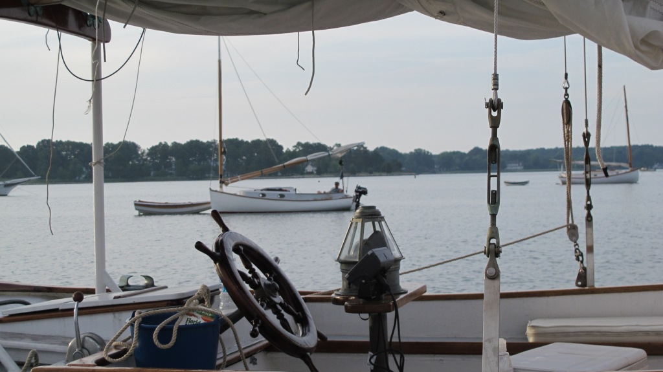
Catboats in Harris Creek via Traveler
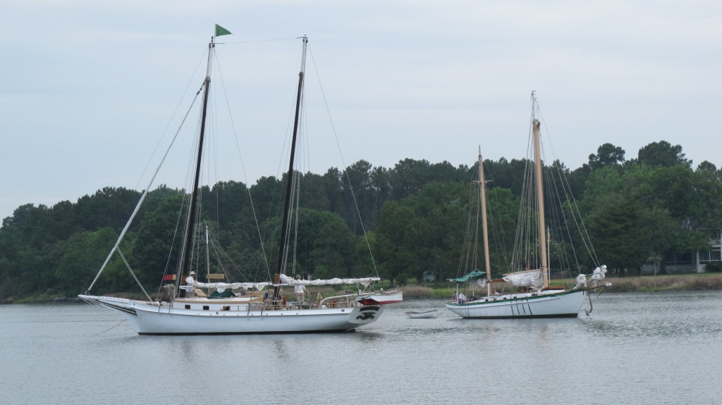
The Non-Catboat Fleet – Chesapeake and Traveler

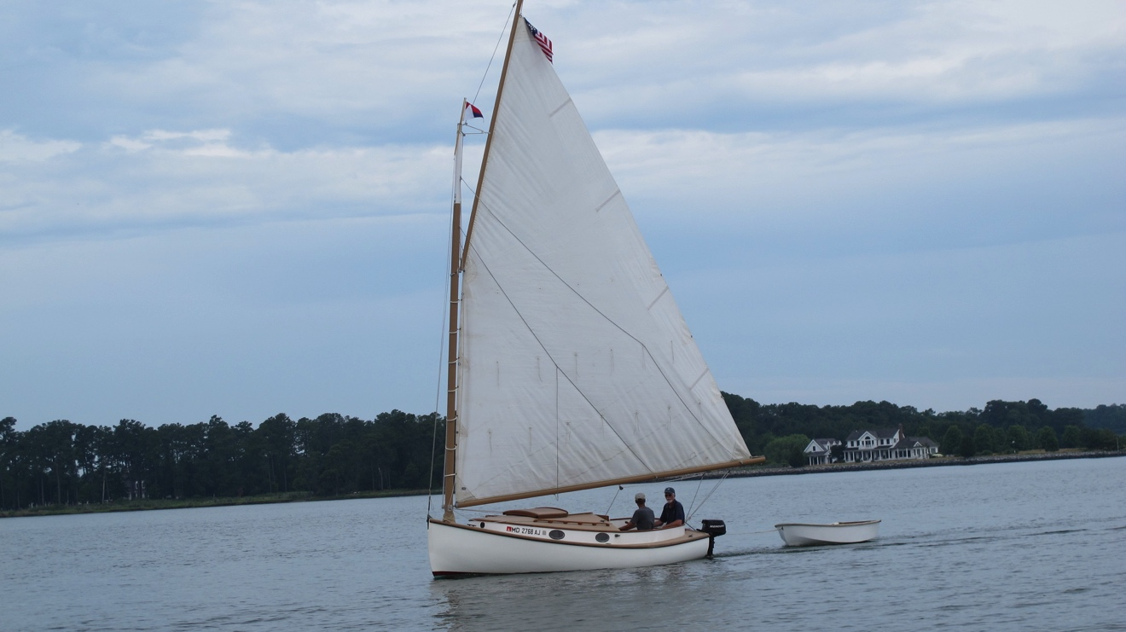
Liberty enroute La Trappe Creek
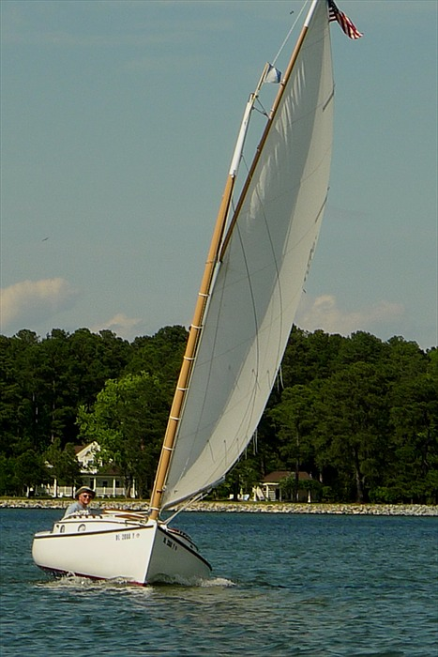
Patriot on Latrappe Creek

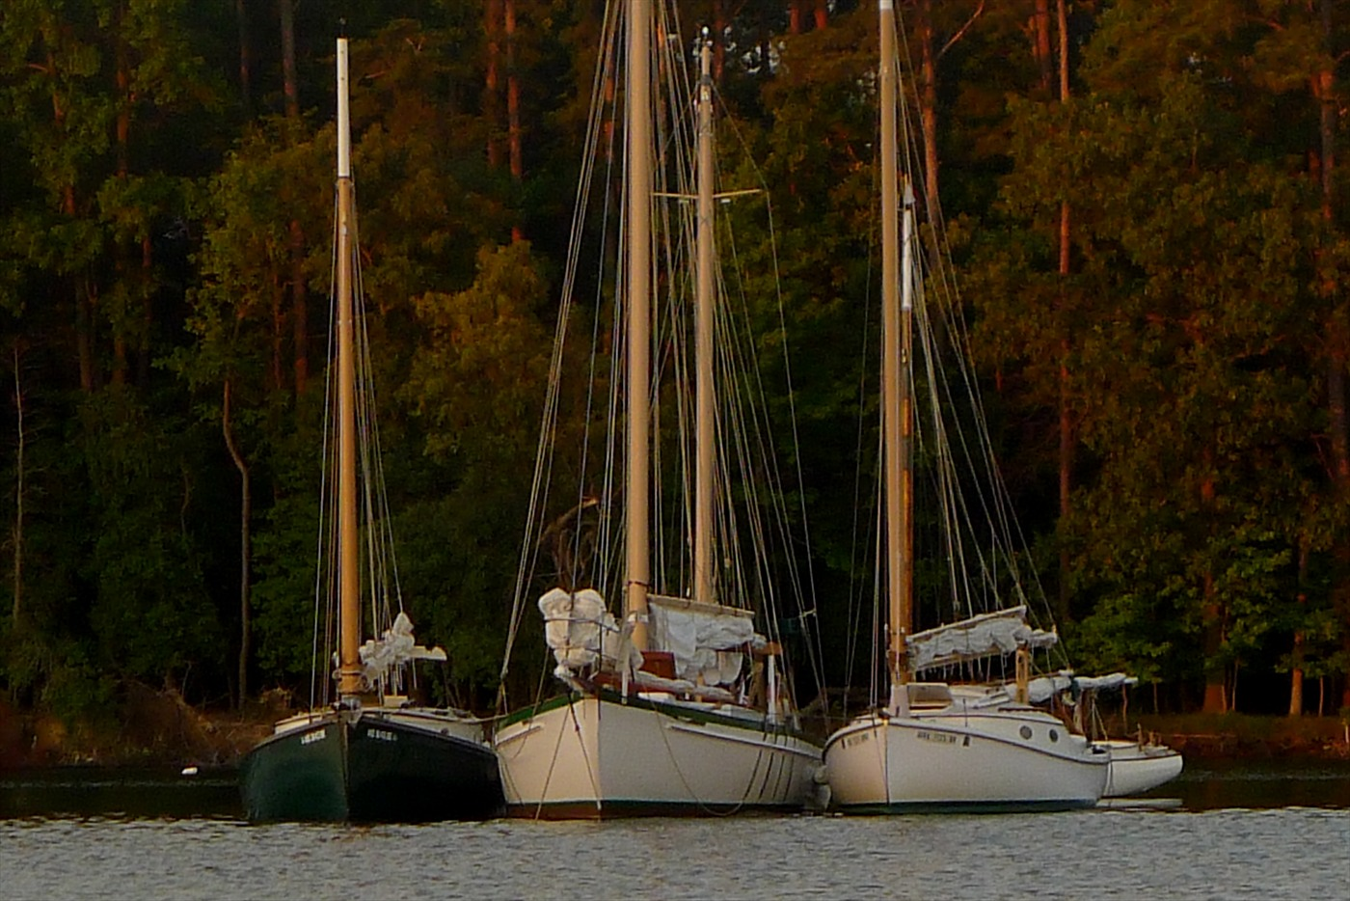
Broad Creek raftup with Americat 22 Cathy

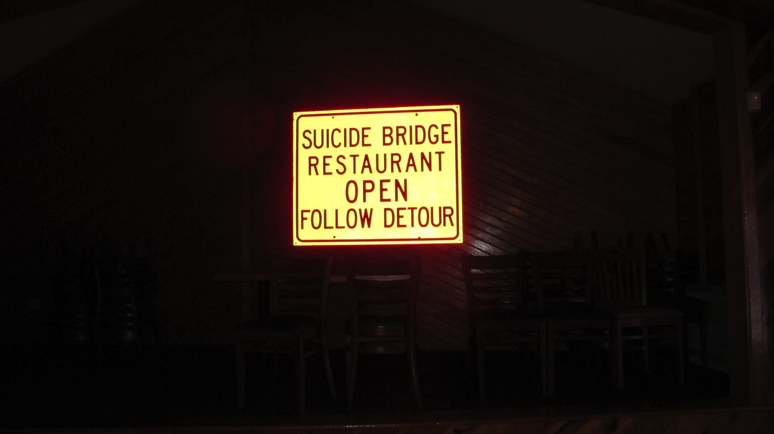
Suicide Bridge
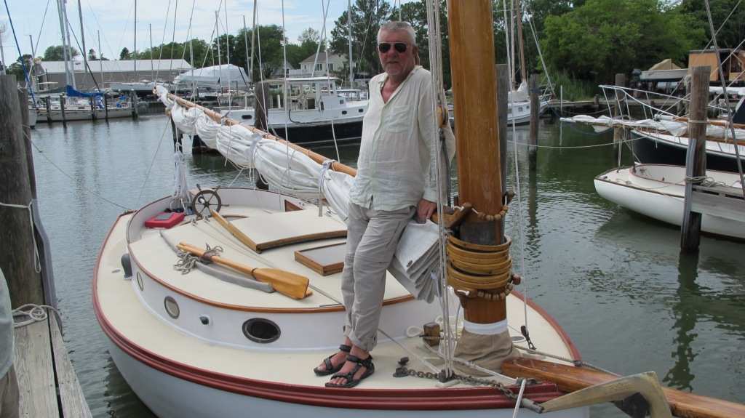
Chillin’ at Cutts and Case – Oxford MD
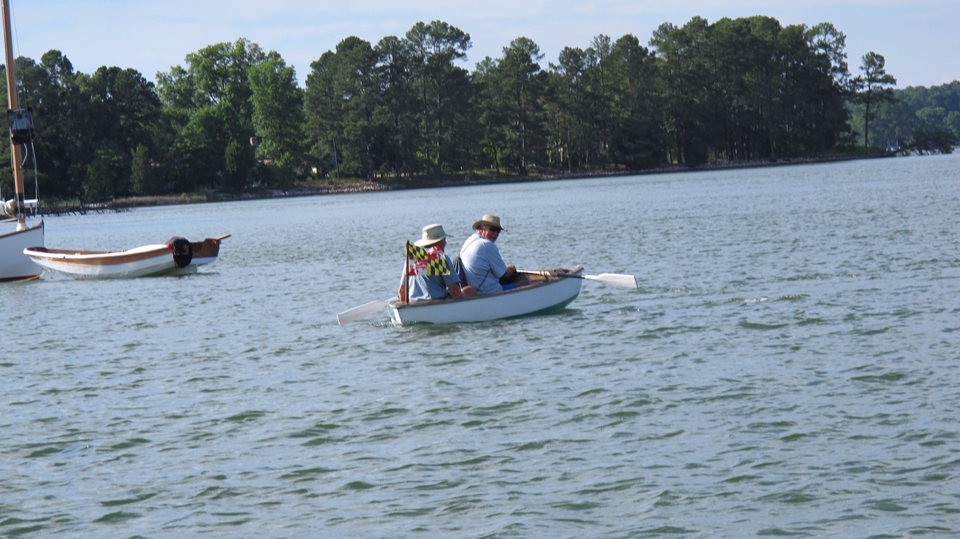
MD State Dinghy and Crew

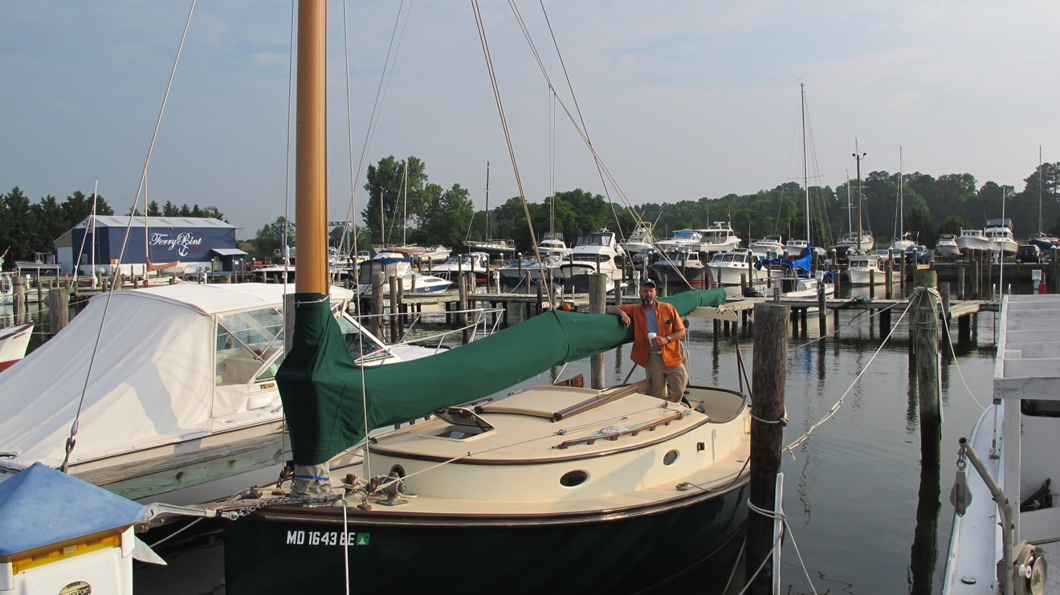
Wanderer After Her Winter Facelift
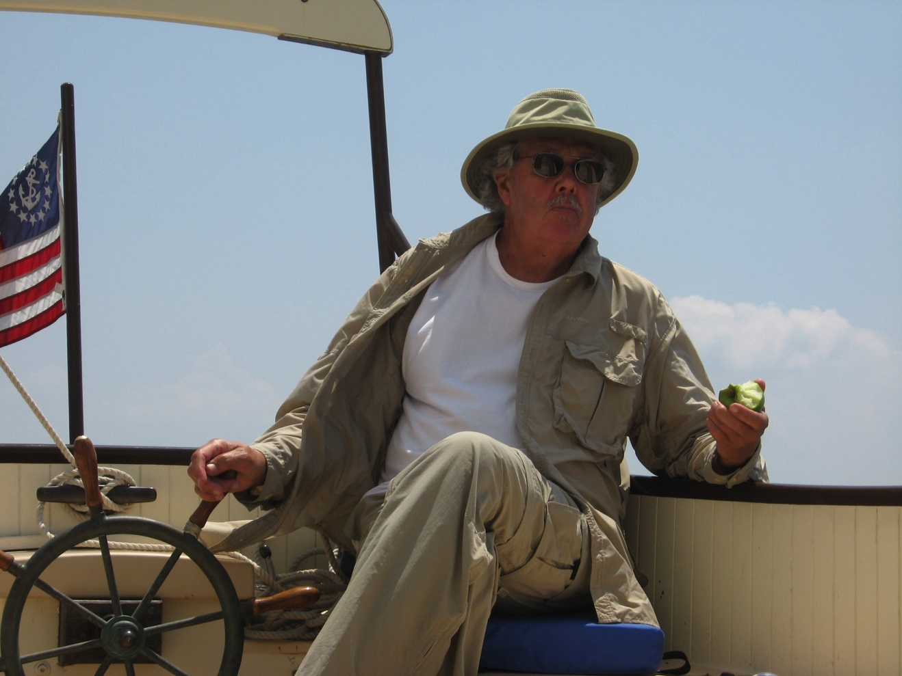
The Mate (Aboard Wanderer) Was a Mighty Sailing Man

